Carbon Aware Deep Reinforcement Learning Platform: System Architecture
What we've built is not a single script - it's a layered AI/ML system with clear separation of concerns. Below is a complete architectural map, a component inventory, and an honest assessment of what's solid, what's missing, and where the risks lie.
1. High-Level System Architecture (files: High-Level System Architecture.jpg, High-Level System Architecture.png).
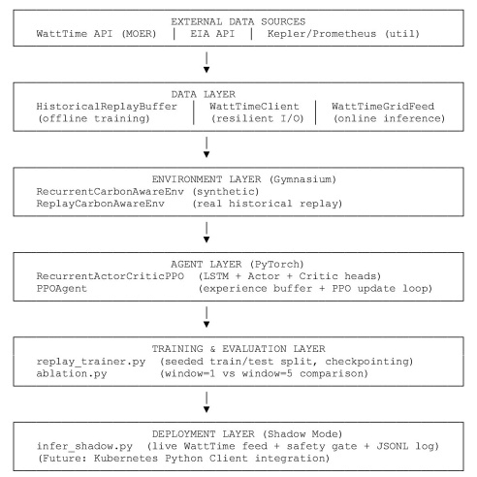
2. Component Inventory
№ | File / Module | Role | Status
1 | Fitness function (multi-objective, adaptive weights) | Defines what "good" means | Complete
2 | Discrete Hybrid PSO-DE | Classical swarm optimizer | Complete (superseded by DRL)
3 | RBF Surrogate | Accelerates swarm with ML approximation | Complete (swarm path)
4 | Simulation engine (synthetic grid) | 7-day carbon/migration/SLA dashboard | Complete
5 | RecurrentCarbonAwareEnv | Gym env with 5-step LSTM window | Complete
6 | RecurrentActorCriticPPO | LSTM + Actor/Critic neural net | Complete
7 | PPOAgent | PPO training loop with clipping | Complete
8 | WattTimeClient | Auth, retry, backoff, token refresh | Complete
9 | WattTimeGridFeed | Live observation bridge with staleness checks | Complete
10 | infer_shadow.py | Shadow-mode runner with safety gate | Complete
11 | HistoricalReplayBuffer | Offline data loader (WattTime + synthetic) | Complete
12 | ReplayCarbonAwareEnv | Replay-based env for training | Complete
13 | replay_trainer.py | Seeded train/test split + checkpointing | Complete
14 | ablation.py | window=1 vs window=5 comparison | Complete
15 | Kubernetes integration | Real scheduler binding | ❌ Not started
16 | Statistical validation | Multi-seed runs, confidence intervals | ❌ Not started
17 | Learning-curve visualisation | Paper-ready matplotlib figures | ❌ Not started
18 | Embodied-carbon accounting | Hardware utilisation trade-offs | ❌ Not modelled

3. Data Flow - One Scheduler Tick (file - data_flow.txt)
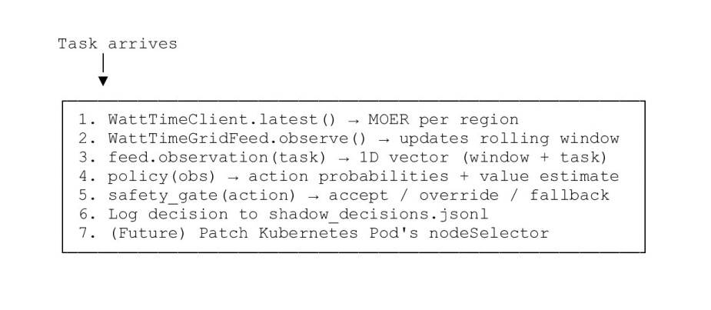
4. Key Architectural Decisions - and Why They Matter
Decision | Rationale | Trade-off
PPO over DQN | Handles continuous state + discrete action; stable; sample-efficient | Slightly more complex than DQN
LSTM over Transformer | Lighter, easier to stabilise in RL, sufficient for 5-step windows | May miss very-long-range dependencies
Shadow mode before execution | Safety gate decouples the AI from real-world consequences | Slower path to "real" deployment
Replay training on historical MOER | Reproducible, no live-environment risk, enables ablations | Distribution shift risk at deployment
MOER (marginal) not average CI | Correct signal for schedulable load shifting | Harder to explain to non-technical stakeholders
Adaptive weighting in fitness | Lets the system respect SLAs without hard constraints | Requires careful tuning of α
Separate swarm + DRL paths | Lets you compare paradigms in the same paper | Larger codebase to maintain
5. What's Solid - and What's Fragile
a) Solid Foundations:
- Clean separation between data, environment, agent, and deployment layers;
- Reproducible training via seeded task generation and fixed train/test splits;
- Safety gate at inference time — the neural net proposes, the gate disposes;
- Defensible metrics: net carbon savings, migration ROI, SLA compliance, policy calibration;
- Ablation-ready design - window size, task seed, and replay window are all parameterised.
b) Fragile / Risky Areas
- Unit consistency: g CO₂e/MWh vs g CO₂e/kWh - one missed /1000 corrupts the entire experiment;
- Distribution shift: the LSTM is trained on one period of grid behaviour and deployed on another. No drift detection yet;
- Single-seed evaluation: current ablation runs once. A reviewer will ask for variance across 5+ seeds;
- Synthetic fallback: the duck-curve generator is plausible but not validated against real MOER statistics;
- Safety gate is minimal: only checks staleness, capacity, and anti-flapping. No carbon-budget enforcement, no rollback.
6. Open Questions before Deployment
a) Statistical rigor: How many seeds do we need to claim significance? (Typically 5-10 with bootstrap CIs.);
b) Drift detection: When should we refuse to act and retrain? (e.g., KL divergence between recent and training-state distributions);
c) Embodied carbon: Does packing tasks tightly onto fewer nodes (higher utilization) beat spreading them across cleaner grids? We haven't modelled this trade-off;
d) Migration cost realism: our flat 15.0 gCO₂e penalty is a placeholder. Real migration cost depends on VM size, network path, and destination CI;
e) Forecast integration: the current system is reactive to MOER. Adding WattTime's forecast endpoint (/forecast) would let the LSTM be compared against explicit predictions;
f) Multi-objective Pareto analysis: we collapse carbon/migration/SLA into a single reward. A Pareto-front analysis would be more informative.
7. Where we are - and where we could go from here
Current state: a complete, reproducible, research-grade AI/ML pipeline for carbon-aware scheduling, with offline training, held-out evaluation, shadow-mode inference, and a clear ablation story.
Three natural next steps, in order of increasing ambition:
Step | Effort | Impact
A. Learning-curve plots + multi-seed stats | ~1 day | Turns the ablation into a publishable figure
B. Kubernetes Python Client binding | ~2–3 days | Moves the project from simulation to real deployment
C. Forecast-aware agent (MOER + /forecast) | ~1 week | Lets you compare reactive vs predictive scheduling head-to-head

8. Production Considerations
Concern | Mitigation
Single replica | Controller MUST run with replicas: 1 to avoid two controllers binding the same Pod. Use a leader-election lease if you need HA.
Race with default scheduler | Pods without schedulerName: carbon-aware may be picked up by the default scheduler. Either set a custom schedulerName (and disable default) OR use a mutating admission webhook to clear the default.
Stale WattTime data | The safety gate already refuses to act if feed.is_healthy() is false. Pods queue until data recovers.
Cold-start latency | The 24-hour warm-up takes ~30s. During this time, the controller still runs but the LSTM has partial memory.
Observability | Every decision is written to the Pod's annotations. You can query them with `kubectl get pods -o json
Rollback | If the controller crashes, Pending Pods stay Pending. A human can delete the annotation and let the default scheduler handle them.

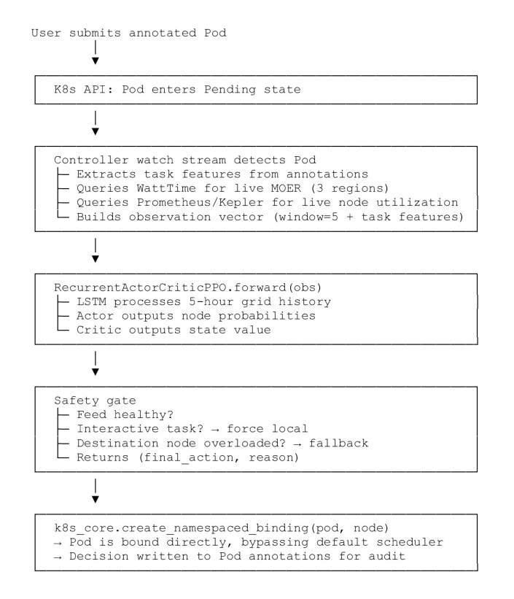
9. A complete, reproducible experimental pipeline:
Layer | Component
Data | HistoricalReplayBuffer (WattTime or synthetic)
Environment | ReplayCarbonAwareEnv (gymnasium-compatible)
Agent | RecurrentActorCriticPPO + PPOAgent
Training | train_agent with seeded train/test split
Evaluation | Held-out ablation with publication-ready table
Deployment | Shadow-mode runner from the previous step

