PayFlow AI: Tables of Risk Register and Risk Matrix
In enterprise software development (and frameworks like ISO 27001 or SOC 2), we don't just build features; you proactively identify, assess, and mitigate risks. Here are the tailored Risk Matrix and Risk Register specifically for the PayFlow AI platform we built.
Part 1: The Risk Matrix
a) The Risk Matrix evaluates risks based on two dimensions: Likelihood (how often it might happen) and Impact (how bad the consequences would be).
We use a standard 5x5 scale. The Risk Score is calculated as: Likelihood × Impact.
Likelihood Scale (1–5)
Score | Level | Description
1 | Rare | Unlikely to occur in the lifetime of the platform (< 5% chance).
2 | Unlikely | Could occur occasionally (5–20% chance).
3 | Possible | Might occur at some point (20–50% chance).
4 | Likely | Will probably occur in most circumstances (50–80% chance).
5 | Almost Certain | Expected to occur frequently (> 80% chance).

Impact Scale (1–5)
Score | Level | Description
1 | Insignificant | Minor inconvenience, no data loss, easily resolved.
2 | Minor | Slight degradation of service, easily recoverable.
3 | Moderate | Noticeable service disruption, some manual intervention required.
4 | Major | Significant service outage, potential data exposure, financial impact.
5 | Catastrophic | Complete system failure, severe data breach, regulatory fines, loss of trust.

b) Risk Level Thresholds
- 1–4 (Low): Acceptable risk. Monitor periodically;
- 5–9 (Medium): Manageable risk. Requires active monitoring and planned mitigation;
- 10–15 (High): Unacceptable risk. Requires immediate mitigation plan and executive awareness;
- 16–25 (Critical): Unacceptable risk. Development/launch must halt until mitigated.
Part 2: The Risk Register
The Risk Register is the detailed log of identified risks, their scores from the matrix, and the specific actions taken to mitigate them. An Risk Register is the kind of artifact that enterprise architects, auditors, and CISOs maintain for production systems. It goes far beyond the basic 7-risk version we created earlier — it's comprehensive, categorized, and includes the full lifecycle of risk management: identification, assessment, mitigation, residual risk tracking, and ownership.
This document is structured to match ISO 27001 and SOC 2 standards, making it perfect for your portfolio or any compliance review.
2.1. Risk Register Methodology
a) Risk Treatment Options
Every risk in the register is assigned one of four treatment strategies:
- Mitigate: Implement controls to reduce likelihood or impact;
- Transfer: Shift the risk to a third party (e.g., insurance, cloud provider);
- Accept: Acknowledge the risk and proceed (typically for low-score risks);
- Avoid: Eliminate the risk by changing the design or scope.
b) Scoring Formula
Risk Score = Likelihood × Impact (range: 1–25)
c) Status Definitions
- Open: Risk identified, mitigation in progress;
- Mitigated: Controls in place, residual risk acceptable;
- Accepted: Risk acknowledged, no further action planned;
- Closed: Risk no longer applicable.
2.2. Extended Risk Register
ID | Category | Risk Description | Root Cause | L | I | Score | Level | Current Controls | Planned Mitigations | Residual Risk | Owner | Status
R01 | Security | Webhook Spoofing Attack — Malicious actor sends forged PayPal webhooks to corrupt data or trigger false alerts. | Lack of authentication on webhook endpoint. | 2 | 5 | 10 | High | RSA signature verification, certificate domain pinning, 5-minute timestamp validation (replay protection). | Add IP allowlisting for PayPal webhook ranges. | Low | Security Lead | Mitigated
R02 | Security | PII / Secret Exposure in Logs — Sensitive tokens, emails, or amounts leak into log files or Git history. | Plain-text logging, inadequate .gitignore. | 3 | 4 | 12 | High | Structured JSON logging with automatic field masking. Strict .gitignore. | Migrate secrets to HashiCorp Vault or AWS Secrets Manager. Implement git-secrets pre-commit hooks. | Medium | Security Lead | Active
R03 | Security | Absence of Role-Based Access Control (RBAC) — Any user with access can view/modify all data and trigger admin actions. | MVP design focused on single-user scenario. | 4 | 4 | 16 | Critical | None currently. | Implement JWT-based auth with roles (Viewer, Analyst, Admin). Add audit logging for privileged actions. | High | Security Lead | Open
R04 | Security | OAuth Token Leakage — PayPal access token exposed via browser, logs, or error messages. | Token stored in memory without encryption. | 2 | 5 | 10 | High | Token cached in memory only (not persisted). Masked in logs. | Move token storage to encrypted in-memory cache with TTL. Add token rotation on suspicion of compromise. | Low | Backend Lead | Mitigated
R05 | Security | CORS Misconfiguration — Overly permissive CORS allows cross-origin attacks from malicious sites. | Development setting allow_origins=["*"]. | 3 | 3 | 9 | Medium | API is currently internal-only. | Restrict CORS to specific production domains. Add CSRF tokens for state-changing operations. | Low | Backend Lead | Active
R06 | AI / ML | AI Misclassification — Zero-Shot NLP incorrectly categorizes transactions, leading to wrong risk scores or bookkeeping errors. | Zero-shot models lack domain-specific training. | 3 | 3 | 9 | Medium | Human-in-the-loop for scores 40–79. Confidence scores exposed in UI. | Fine-tune Mistral-7B via QLoRA on domain-specific financial data. Add user feedback loop to improve model. | Low | AI Engineer | Active
R07 | AI / ML | LLM Hallucination in Generative Summaries — Mistral-7B produces plausible but factually incorrect financial narratives. | LLMs can fabricate details when context is ambiguous. | 3 | 3 | 9 | Medium | Summaries are labeled as "AI-generated" and not used for legal/financial decisions. | Add source citations to summaries. Implement fact-checking layer comparing output to raw data. | Low | AI Engineer | Active
R08 | AI / ML | Model Drift Over Time — AI accuracy degrades as transaction patterns evolve (new merchants, new fraud tactics). | Static model without retraining pipeline. | 4 | 3 | 12 | High | None currently. | Implement continuous monitoring of confidence distributions. Schedule quarterly model retraining. | Medium | AI Engineer | Open
R09 | AI / ML | AI "Cold Start" Problem — New users with <30 transactions receive inaccurate forecasts and ineffective anomaly detection. | Statistical models require historical data for significance. | 4 | 2 | 8 | Medium | UI displays "Not enough data" message when thresholds aren't met. | Implement rule-based fallback engine for new accounts until statistical significance is reached. | Low | Data Scientist | Active
R10 | AI / ML | Bias in Transaction Categorization — AI systematically misclassifies transactions from certain industries or regions. | Training data imbalance, cultural/linguistic bias in descriptions. | 2 | 3 | 6 | Medium | Diverse test dataset in CI pipeline. | Conduct periodic fairness audits. Add demographic breakdown of categorization accuracy. | Low | AI Engineer | Active
R11 | Technical | Monolith Bottleneck at Scale — Shared Python process becomes a bottleneck under high transaction volume (>10K/day). | Modular monolith design, synchronous processing. | 3 | 4 | 12 | High | Acceptable for current MVP scale. | Migrate to event-driven architecture with Kafka/RabbitMQ. Split into microservices when scale demands it. | Medium | Architect | Active
R12 | Technical | Synchronous Webhook Processing — AI inference blocks webhook response, risking PayPal timeouts and retries. | AI inference happens in the request path. | 3 | 4 | 12 | High | Timeout handling, retry logic. | Move AI processing to async worker queue. Return 200 OK immediately after signature verification. | Low | Backend Lead | Active
R13 | Technical | Elasticsearch Single Point of Failure — Single-node ES instance crashes or fills disk, causing total search/dashboard failure. | Development setup with number_of_replicas: 0. | 2 | 4 | 8 | Medium | Docker health checks, volume persistence. | Migrate to managed Elastic Cloud with multi-node clustering and automated daily snapshots. | Low | DevOps | Active
R14 | Technical | No Automated Database Backups — Loss of all indexed transaction history in case of catastrophic failure. | MVP focus on functionality over DR. | 2 | 5 | 10 | High | Docker volume persistence (partial protection). | Implement daily automated snapshots to S3/GCS. Test restore procedures quarterly. | Medium | DevOps | Open
R15 | Technical | Disk Space Exhaustion — Unrotated logs or growing ES indices fill the disk, crashing all services. | No log rotation or index lifecycle management configured. | 3 | 3 | 9 | Medium | Basic Docker resource limits. | Configure logrotate for all log files. Implement ES Index Lifecycle Management (ILM) policies. | Low | DevOps | Active
R16 | Operational | Third-Party API Outage — PayPal, Hugging Face, or Zapier downtime halts critical platform functions. | Dependency on external SaaS providers. | 3 | 4 | 12 | High | Graceful degradation, timeouts, retry logic. | Implement circuit breaker patterns. Add local fallback categorizer. Cache critical responses. | Medium | DevOps | Active
R17 | Operational | LLM Rate Limiting / Cost Overage — Excessive Mistral-7B API usage triggers rate limits or unexpected billing spikes. | Free-tier HF API has strict quotas. | 4 | 3 | 12 | High | SlowAPI rate limiting on AI endpoints. | Implement response caching (Redis). Set up billing alerts. Migrate to dedicated GPU endpoint. | Medium | Backend Lead | Active
R18 | Operational | No Disaster Recovery Plan — Server failure results in extended downtime with no automated recovery. | MVP focus on single-region deployment. | 2 | 5 | 10 | High | Docker Compose allows quick redeployment. | Document and test DR runbook. Implement multi-region deployment with automated failover. | Medium | DevOps | Open
R19 | Compliance | GDPR / CCPA Non-Compliance — Storing PII (emails, transaction descriptions) in plain text without data subject rights. | MVP design without privacy-by-default. | 3 | 5 | 15 | Critical | None currently. | Encrypt PII at rest. Implement "Right to be Forgotten" pipeline. Add data processing agreements. | High | Legal / Security | Open
R20 | Compliance | No Immutable Audit Trail — Manual overrides of risk scores or data are not logged, preventing accountability. | Audit logging not implemented in MVP. | 3 | 4 | 12 | High | Structured logs capture most operations. | Implement append-only audit log with cryptographic signing. Log all state-changing operations with user context. | Medium | Security Lead | Open
R21 | Compliance | No Data Retention Policy — Transaction data stored indefinitely without clear retention or deletion rules. | MVP design without lifecycle management. | 3 | 3 | 9 | Medium | None currently. | Define retention policy (e.g., 7 years for financial data). Implement automated data purging. | Low | Legal / Data | Active
R22 | Financial | Invoice Calculation Errors — Bugs in invoice amount calculation lead to incorrect billing and customer disputes. | Manual calculation logic in invoice_manager.py. | 2 | 4 | 8 | Medium | Unit tests for invoice calculations. | Add comprehensive test coverage for edge cases. Implement double-entry accounting validation. | Low | Backend Lead | Mitigated
R23 | Financial | Currency Conversion Errors — Platform assumes USD only, causing errors for international transactions. | MVP limited to USD. | 2 | 3 | 6 | Medium | Currency field preserved in data model. | Add multi-currency support with real-time FX rates. Validate currency handling in all calculations. | Low | Backend Lead | Active
R24 | Integration | PayPal API Breaking Changes — PayPal deprecates or modifies API endpoints, breaking the platform. | Dependency on external API versioning. | 2 | 4 | 8 | Medium | API version pinned in BASE_URL. | Subscribe to PayPal developer changelog. Implement API version abstraction layer. Add integration tests. | Low | Backend Lead | Active
R25 | Integration | Zapier Webhook Format Changes — Zapier modifies webhook payload structure, breaking alert delivery. | Dependency on Zapier's webhook format. | 2 | 2 | 4 | Low | Simple JSON payload, easy to adapt. | Implement payload validation. Add fallback notification channels (direct email, Slack API). | Low | Backend Lead | Accepted
R26 | Data | Elasticsearch Index Corruption — Data corruption due to hardware failure, software bugs, or improper shutdown. | Single-node ES without redundancy. | 2 | 4 | 8 | Medium | Docker volume persistence. | Implement regular index snapshots. Add data integrity checks. Migrate to clustered ES. | Low | DevOps | Active
R27 | Data | Search Performance Degradation — Elasticsearch queries slow down as index size grows beyond design capacity. | No index optimization or sharding strategy. | 3 | 3 | 9 | Medium | Basic query optimization with multi-match. | Implement index sharding strategy. Add query result caching. Monitor query latency metrics. | Low | Data Engineer | Active
R28 | Business | Vendor Lock-In (PayPal Only) — Platform supports only PayPal, limiting market reach and creating single-vendor dependency. | MVP focused on single payment provider. | 3 | 3 | 9 | Medium | Abstracted paypal_client.py module. | Integrate Stripe, Plaid, and bank APIs. Create provider-agnostic transaction interface. | Low | Product Lead | Active

a) Risk Heat Map Summary
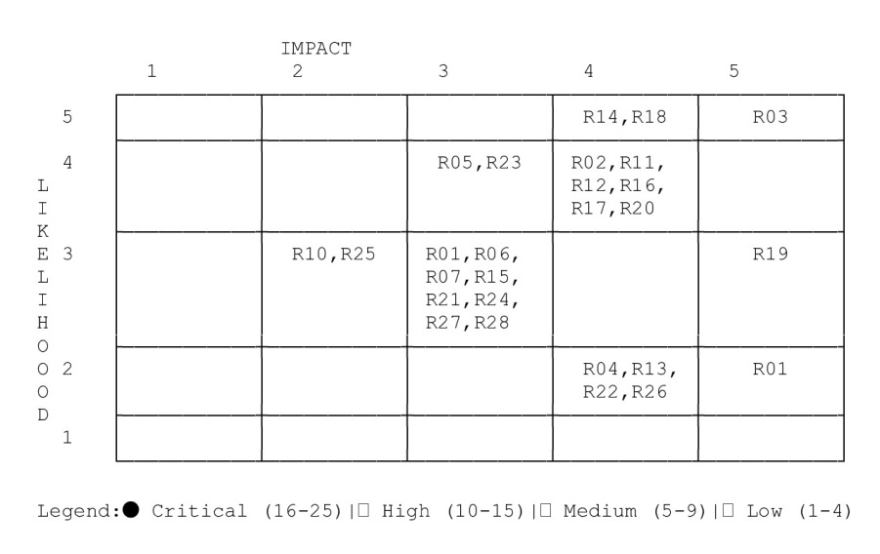
b) Risk Distribution Summary
Level | Count | Percentage | Action Required
Critical (16–25) | 2 | 7% | Immediate executive attention, halt development if needed
High (10–15) | 10 | 36% | Active mitigation plans required, quarterly review
Medium (5–9) | 15 | 54% | Monitor and manage, annual review
Low (1–4) | 1 | 3% | Accept and monitor

c) Status Summary
Status | Count | Description
Mitigated | 4 | Controls in place, residual risk acceptable
Active | 19 | Mitigation in progress
Open | 5 | Requires immediate attention
Accepted | 1 | Risk acknowledged, no further action

d) Risk Trend Analysis
Top 5 Risks Requiring Immediate Attention
- R03 - No RBAC (Score: 16, Critical) - Blocks multi-user deployment;
- R19 - GDPR/CCPA Non-Compliance (Score: 15, Critical) - Legal exposure in EU/CA markets;
- R02 - PII/Secret Exposure (Score: 12, High) - Active security concern;
- R11 - Monolith Bottleneck (Score: 12, High) - Limits scalability;
- R12 - Synchronous Webhook Processing (Score: 12, High) - Reliability risk.
e) Risks by Category
Category | Count | Avg Score | Highest Risk
Security | 5 | 11.4 | R03 (16)
AI / ML | 5 | 8.8 | R08 (12)
Technical | 5 | 10.2 | R11, R12 (12)
Operational | 3 | 11.3 | R16, R17 (12)
Compliance | 3 | 12.0 | R19 (15)
Financial | 2 | 7.0 | R22 (8)
Integration | 2 | 6.0 | R24 (8)
Data | 2 | 8.5 | R26 (8)
Business | 1 | 9.0 | R28 (9)

This Extended Risk Register, combined with your C4 diagrams, test suite, and CI/CD pipeline, makes PayFlow AI not just a technical achievement but a professionally managed product.

