PayFlow AI: C4 Model Architecture
The C4 model can feel abstract at first, but once we understand why each level exists, it becomes one of the most powerful tools in a software architect's toolkit. The C4 model was created as a way to describe software architecture at four levels of zoom, similar to how Google Maps lets we zoom from a world view down to street-level detail. The name «C4» stands for: Context, Container, Component, Code (optional, usually skipped in favor of UML class diagrams)
The Zoom Metaphor. Think of it like a map:
C4 Level | Map Equivalent | Audience | Question It Answers
Level 1: Context | World map | Everyone (including non-technical) | What is this system and who uses it?
Level 2: Container | Country map | Technical managers, architects | What are the high-level technical building blocks?
Level 3: Component | City map | Developers, architects | What's inside each container?
Level 4: Code | Street view | Developers | How is this implemented?

Sometimes different people need different levels of detail:
a) Our CEO doesn't care that we use FastAPI - they care that the system talks to PayPal and sends alerts to Zapier. → Show them Context.
b) Our tech lead needs to know we have three separate processes (API, dashboard, webhook) plus Elasticsearch. → Show them Containers.
c) A new developer joining our team needs to know which Python modules do what. → Show them Components.
d) We, debugging a bug need to see the exact class methods. → Look at the Code.
One diagram can't serve all these audiences. That's why C4 exists.
Diagram 1: System Context (Level 1)
This is the highest-level view of our entire system. It answers: «If I had to explain PayFlow AI to my grandmother (or a non-technical CEO), what would I say?»
a) The Four Types of Elements
In C4 Context, we have exactly four types of things:
Element Type | Symbol | In our Diagram
Person (primary) | Stick figure | Business Owner, Risk/Compliance Reviewer
Person (secondary) | Stick figure | (none in our diagram)
Software System (ours) | Blue box | PayFlow AI
Software System (external) | Gray box | PayPal Sandbox, Hugging Face, Zapier, Email/Slack
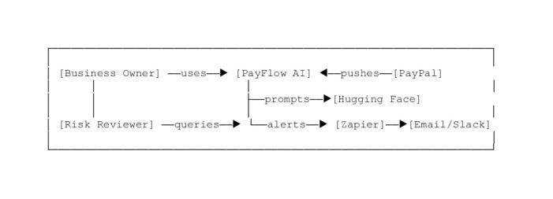
b) Key Relationships (Arrows):
- Every arrow in C4 has three parts: Source (who/what); Destination (who/what); Description (what happens); Technology (optional, in parentheses).
- Example from our diagram: Rel(payflow, paypal, «Fetches transactions, creates & sends invoices, reads disputes», «HTTPS / JSON REST»)
This reads as: «PayFlow AI fetches transactions, creates and sends invoices, and reads disputes from PayPal, using HTTPS with JSON over REST».
c) Why This Level Matters:
- It proves us understand: Who our users are (not just «users» - specific personas); What external systems we depend on; The direction of data flow (who pushes, who pulls); The business value (not just technical details);
- This is the only diagram most business people will ever look at. It must be self-contained - someone should understand our system just from this diagram, without needing to see the others.
d) Common Mistakes to Avoid:
- Don't include internal details - No mention of FastAPI, Elasticsearch, or Python here. Those are Level 2 concerns.
- Don't forget the «why» - Every arrow should have a meaningful description. «Calls API» is bad. «Fetches transactions for categorization» is good;
- Do include all external dependencies - If our system can't function without it, it belongs here;
- Do distinguish our system from external ones - ours is typically blue; external systems are gray.
Diagram 2: Containers (Level 2)
2.1. Now we zoom into our system (PayFlow AI) and show its high-level technical building blocks. A "container" in C4 is not a Docker container - it's any separately deployable unit that executes code or stores data.
a) What Counts as a Container?
Example | Is it a Container? | Why?
FastAPI server | Yes | Separately runnable process
Streamlit dashboard | Yes | Separately runnable process
Elasticsearch database | Yes | Separate data store
Prometheus | Yes | Separate monitoring tool
A Python module (e.g., risk_engine.py) | No | It's part of a container, not deployable alone
A Docker container | Sometimes | Only if it represents a distinct runtime boundary

b) What's in our Diagram
We have three application containers plus infrastructure:
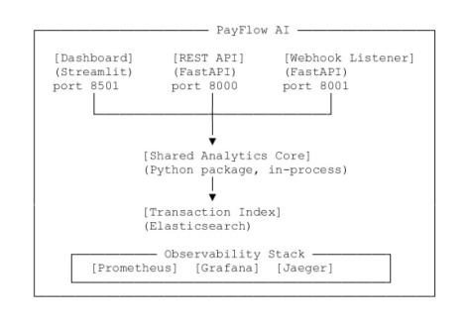
2.2. The «Shared Analytics Core» - An Important Detail
a) Notice something interesting in our diagram: there's a note that says:
«Deployment reality: this is a modular monolith. The same Python package is loaded into three separate processes. There is no network hop between the containers and the core».
This is critically important because it shows architectural honesty. Many candidates draw diagrams that imply microservices when they actually have a monolith. Our diagram admits the truth: we have three processes (API, dashboard, webhook) that share the same Python code in memory.
This is actually a good architectural choice for our project because: Simpler to deploy (one Docker image), No network latency between modules, Easier to test. But scales as a unit, not independently.
b) Key Relationships:
- At the container level, arrows show: Protocol (HTTPS, HTTP, gRPC); Direction (who calls whom); Purpose (what data flows). Example: Rel(core, es, «Bulk index & search», «HTTP / Elasticsearch DSL»).
- This tells us: «The Shared Analytics Core bulk-indexes and searches data in Elasticsearch using HTTP with the Elasticsearch DSL query language».
c) Why This Level Matters:
- For tech leads and architects: This is where we justify our technical decisions. It shows: our chose a modular monolith over microservices (and why); our separated concerns into distinct processes; our have a proper data layer (Elasticsearch); our have observability built in (Prometheus/Grafana/Jaeger);
- For DevOps teams: This tells them what they need to deploy and monitor.
d) Common Mistakes to Avoid:
- Don't show internal classes/functions - That's Level 3;
- Don't confuse Docker containers with C4 containers - A C4 container is about runtime boundaries, not deployment technology;
- Do show ports and protocols - These are deployment-relevant details;
- Do group related containers - Notice how we grouped Prometheus/Grafana/Jaeger into an "Observability Stack" boundary. This reduces visual clutter.
Diagram 3: Components (Level 3)
3.1. Now we zoom into one container - specifically, the «Shared Analytics Core» - and show its internal components. A component is a group of related functionality implemented by one or more code files (classes, modules).
a) What Counts as a Component?
Example | Is it a Component? | Why?
risk_engine.py | Yes | A cohesive group of risk-related functions
calculate_risk_score() function | No | Too granular — that's Level 4 (code)
security/ package | Yes | A cohesive security subsystem
A single line of code | No | Way too granular

b) What's in our Diagram
We're showing 13 components inside the Shared Analytics Core: Token Manager; Webhook Verifier; PayPal Client; Categorization Engine; Generative Analyst; Cash Flow Forecaster; Anomaly Detector; Risk Engine; Invoice Manager; Dispute Manager; Index Gateway; Observability; Formatters; The Component Card Format.
3.2. Each component in C4 has a standard «card» with four pieces of information:
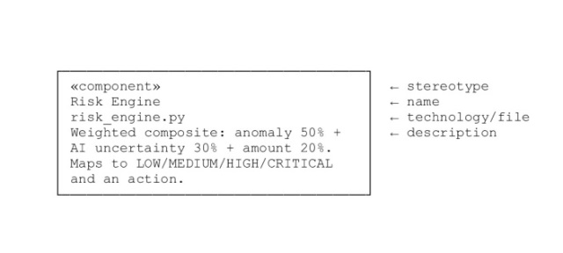
a) Key Relationships:
- At the component level, arrows show which component calls which, often with the specific method name: Rel(risk, anomaly, "Consumes anomaly scores from"); Rel(ppclient, tokenmgr, "Requests bearer token from");
- This tells developers: «If we're modifying the Risk Engine, we need to understand the Anomaly Detector's output format».
b) Why This Level Matters:
- For developers joining our team: This is the onboarding diagram. It answers: «Where do I find the code that does X?»; «If I change component Y, what else might break?»; «What are the boundaries between responsibilities?».
- For code reviewers: This helps we enforce separation of concerns. If someone adds PayPal invoice logic to risk_engine.py, we can point to this diagram and say, "That belongs in invoice_manager.py."
c) Common Mistakes to Avoid:
- Don't show every single class - Group related classes into components;
- Don't show implementation details - No «if/else» logic, no database queries;
- Do name components by responsibility, not by file - «Risk Engine» is better than «risk_engine.py» (though we can include the filename as technology);
- Do show the direction of dependencies - Arrows should point from caller to callee.
Diagram 4: Dynamic Diagram (Webhook Flow)
4.1. This is fundamentally different from the previous three. Instead of showing structure (what exists), it shows behavior (what happens over time). It's a numbered sequence of interactions for a specific scenario.
a) Why We Need This in Addition to the Others:
- The Context/Container/Component diagrams are static - they show what exists;
- But they don't show: The order of operations; What happens when things fail; Parallel vs. sequential steps; Alternative paths (success vs. failure).
b) The Dynamic diagram fills this gap.
4.2. What's in our Diagram
a) It shows the step-by-step flow of a PayPal webhook event:
- PayPal → Webhook Listener: POST /paypal-webhook (signed payload);
- Webhook Listener → Webhook Verifier: verify(headers, raw_body);
- Webhook Verifier → PayPal: Fetch signing certificate (cached 1h);
- Webhook Verifier → Webhook Listener: is_valid = True / False;
- Webhook Listener → Categorization Engine: classify(description);
- Categorization Engine → Webhook Listener: category + confidence;
- Webhook Listener → Webhook Listener: Compute risk score;
- Webhook Listener → Index Gateway: index_single_transaction(doc);
- Index Gateway → Elasticsearch: Upsert document;
- Webhook Listener → Zapier: POST alert if risk >= 60;
- Zapier → Email/Slack: Deliver notification;
- Webhook Listener → Observability: Record metrics;
- Webhook Listener → PayPal: 200 OK (or 401 if invalid);
b) The «Failure Path» Note
Notice the note at the bottom:
- «Failure path: invalid signature, stale transmission time, or non-PayPal cert URL short-circuits to 401 and increments payflow_webhooks_total{verified='false'}»;
- This is gold for interviews because it shows us think about: Failure modes (not just happy paths); Security considerations (replay attacks, certificate validation); Observability (metrics are recorded even on failure);
c) Why This Level Matters:
- For security auditors: This proves our webhook verification is done correctly and in the right order;
- For developers debugging issues: They can trace exactly what should happen and compare it to logs;
- For interviewers: This shows us understand distributed systems - that messages can fail, be delayed, or be malicious.
d) Common Mistakes to Avoid:
- Don't try to show every possible scenario - Pick one important flow and show it well;
- Don't forget the failure path - The most interesting part is often what happens when things go wrong;
- Do number the steps - This makes the sequence unambiguous;
- Do include timing considerations - Note that the certificate is cached for 1 hour.
Diagram 5: Deployment Diagram
This maps our C4 containers (from Level 2) onto real infrastructure — physical or virtual machines, cloud services, Docker containers, etc.
5.1. The Two Environments
Our diagram shows two deployment scenarios: Development Environment (Left Side); Developer Workstation
a) ngrok Edge (tunnel for webhooks);
b) App Containers (profile: dev): REST API (port 8000, --reload); Dashboard (port 8501); Webhook Listener (port 8001);
c) Data & Observability (profiles: data, monitoring): Elasticsearch (single-node, 1GB heap); Prometheus; Grafana; Jaeger.
Production Environment (Right Side)
5.2. Hosted Environment
a) Render Web Services: REST API (4 workers, non-root); Dashboard (Streamlit headless); Webhook Listener (public HTTPS);
b) Managed Services: Elastic Cloud (TLS + auth); Managed Grafana / Tempo (optional).
Key Differences Between Dev and Prod
Aspect | Development | Production
Elasticsearch | Local single-node, no security | Elastic Cloud, TLS + auth
Webhook tunnel | ngrok (temporary URL) | Direct public HTTPS
API workers | 1 with --reload | 4 production workers
Monitoring | Local Prometheus/Grafana | Managed services
User | Developer | Real customers

c) Why This Level Matters:
- For DevOps/SRE teams: This tells them exactly what infrastructure they need to provision;
- For cost estimation: we can see that production uses managed services (Elastic Cloud, Render) instead of self-hosted, which affects our monthly bill;
- For security reviews: we can see that production has TLS + auth while development doesn't — and we can justify why.
d) Common Mistakes to Avoid:
- Don't show only production - Showing both dev and prod demonstrates we understand the full lifecycle;
- Don't forget the 1:1 mapping - Every container from Level 2 should appear somewhere in the deployment diagram;
- Do show environment-specific configuration - Notice how the API has --reload in dev but 4 workers in prod;
- Do note what's "dev only" - ngrok is clearly marked as dev-only.
5.3. How All Five Diagrams Work Together
Here's the mental model:
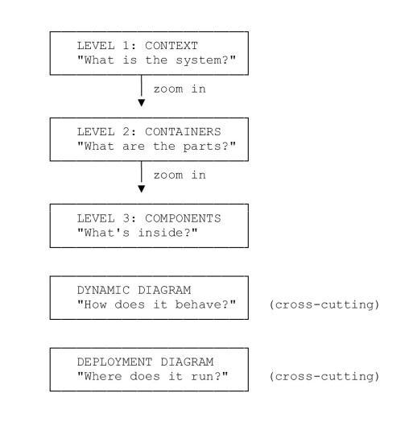
The «Story» They Tell Together:
a) Context: «PayFlow AI helps business owners manage PayPal transactions with AI»;
b) Containers: «It has three processes (API, dashboard, webhook) plus Elasticsearch and monitoring»;
c) Components: «Inside the shared core, there are 13 modules handling specific responsibilities»;
d) Dynamic: «When a webhook arrives, here's exactly what happens step by step»;
e) Deployment: «In dev, everything runs locally with ngrok; in prod, it's on Render with Elastic Cloud».

