Strategic Roadmap: Autonomous Physical AI Platform
This is a comprehensive, enterprise-grade Project Roadmap for the Autonomous Physical AI Platform. This roadmap is designed for executive stakeholders, project managers, and engineering leads. It breaks down the massive undertaking into logical, phased milestones over an 18-month horizon, balancing rapid innovation with the rigorous safety and compliance requirements of the oil and gas industry.
Target Asset: Oil Pipeline Segment (Pilot) → Fleet-Wide Deployment
Timeline: 18 Months
Objective: Transition from reactive human monitoring to proactive, autonomous, and compliant pipeline integrity management.
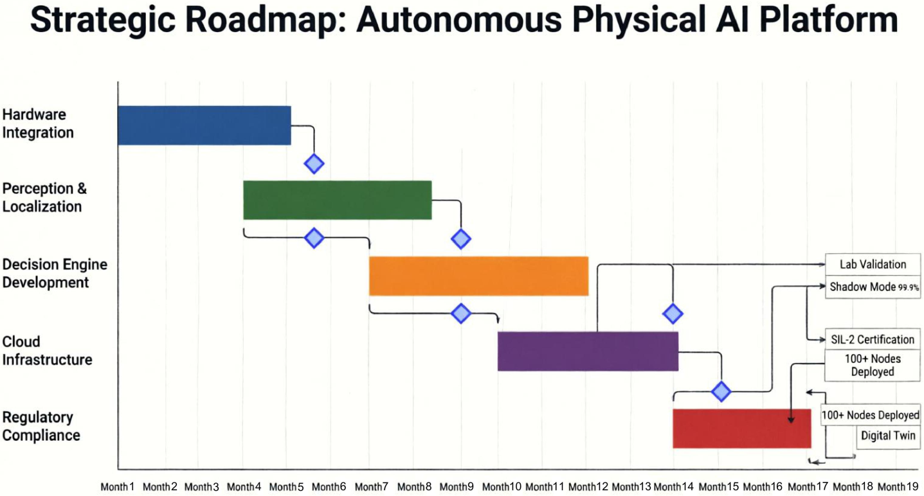
Phase 1: Foundation & Lab Validation (Months 1–3)
Focus: Finalizing architecture, training models, and validating the system in a controlled, simulated environment.
Key Workstreams:
a) AI/ML Development:
Train the Sentinel Transformer and Cascade GNN on historical normal operations data.
Generate synthetic "Black Swan" scenarios using the Cosmos pipeline to stress-test the models.
Optimize models for NVIDIA Jetson Orin using TensorRT (FP16 quantization).
b) OT & Hardware:
Procure and configure NVIDIA Jetson Orin development kits and simulated 11-modal sensor rigs.
Establish the local ZeroMQ mesh and Modbus TCP simulation environment.
c) Security & Compliance:
Generate and test mTLS certificate infrastructure (CA, server, client certs).
Draft the initial Hazard and Risk Analysis (HARA) for IEC 61508 SIL-2 pre-assessment.
d) Enterprise Integration:
Set up the Nebius AI Cloud Kubernetes cluster (Terraform/Helm).
Establish sandbox connections to SAP/Maximo test environments.
Milestones:
Core Multi-Agent software stack passes 100% of automated unit/integration tests.
Edge inference latency confirmed at < 5 ms (P99) on Jetson Orin.
Successful end-to-end simulation of a "Black Swan" event in the lab.
Phase 2: Field Pilot & "Shadow Mode" (Months 4–6)
Focus: Deploying the system on the live EMPCO Mustang Segment (346 km) without granting it physical control, building operational trust.
Key Workstreams:
a) OT & Hardware Deployment:
Install hardened Jetson Orin enclosures and integrate with existing physical sensors (Coriolis, Fiber DTS, Pressure) at 3 pilot nodes.
Establish secure, redundant WAN connectivity to the Nebius Cloud.
b) AI/ML Operations:
Deploy models to edge devices via NVIDIA Fleet Command.
Activate Shadow Mode: The AI perceives anomalies and proposes SCADA actions, but humans execute them. The system logs the AI's proposal vs. the human's actual action.
c) Enterprise Integration:
Activate the Dynamic Risk Engine to calculate real-time PoF and CoF for the pilot nodes.
Begin generating draft PHMSA reports and SAP work order recommendations for human review.
Milestones:
30 days of continuous, uninterrupted edge operation.
99.9% Alignment Rate between AI recommendations and human operator decisions in Shadow Mode.
Successful generation of the first automated, AI-drafted PHMSA compliance report.
Phase 3: Safety Certification & Partial Autonomy (Months 7–9)
Focus: Achieving regulatory and functional safety approvals to enable the system to take physical action in controlled scenarios.
Key Workstreams:
a) Security & Compliance:
Undergo formal IEC 61508 SIL-2 certification audit for the Deterministic Safety Interlock module.
Engage with PHMSA regulators to present the "Shadow Mode" alignment data and autonomous safety architecture.
b) AI/ML Operations:
Transition from Shadow Mode to Recommendation Mode (AI auto-generates SAP work orders, humans approve).
Activate Federated Learning: Pilot nodes begin sending encrypted weight deltas to the Nebius Cloud Aggregator to improve the global model without exposing raw data.
c) OT & Hardware:
Enable Limited Autonomy: Grant the system authority to autonomously execute non-critical actions (e.g., reducing pump flow rate by 20%) when the Safety Interlock validates it.
Milestones:
IEC 61508 SIL-2 Certificate of Compliance issued for the Safety Interlock.
First successful Federated Learning aggregation round completed across pilot nodes.
Regulatory approval granted for autonomous flow-reduction actions.
Phase 4: Fleet-Wide Scaling & Full Autonomy (Months 10–12)
Focus: Expanding the proven pilot to the broader network and enabling full autonomous emergency shutdowns in High Consequence Areas (HCAs).
Key Workstreams:
a) OT & Hardware Deployment:
Mass deployment of Jetson Orin nodes to 100+ high-risk segments across the midstream network.
Standardized, automated provisioning via Ansible/Terraform.
b) AI/ML Operations:
Transition to Full Autonomous Mode for critical actions (e.g., ESDV closure) in designated HCAs, bounded strictly by the Safety Interlock.
Global model converges, showing a 15% improvement in anomaly detection accuracy due to Federated Learning across diverse environments.
c) Enterprise Integration:
Full, automated SAP/Maximo integration: Priority 1 (Emergency) work orders are auto-approved and dispatched to field crews without human intervention.
Milestones:
100+ edge nodes actively participating in the Federated Learning network.
First real-world autonomous leak isolation executed and validated (zero human delay).
30% reduction in manual pipeline inspection OPEX due to Dynamic Risk-Based Inspection scheduling.
Phase 5: Future Horizons & Continuous Innovation (Months 13–18+)
Focus: Leveraging the established Physical AI foundation to unlock next-generation operational capabilities.
Key Initiatives:
a) Digital Twin Integration (NVIDIA Omniverse):
Ingest real-time edge telemetry into a 3D, physics-accurate virtual replica of the pipeline network for immersive VR control room monitoring and "what-if" cascade simulations.
b) Voice-First Control Rooms (NVIDIA Riva):
Deploy natural language processing allowing operators to command the system verbally during high-stress emergencies (e.g., "System, isolate Segment 4 and dispatch the HAZMAT team").
c) Autonomous Physical Repair:
Begin R&D integration with in-pipe crawling robots and drone swarms, using the platform's precise geolocation and anomaly data to guide autonomous sealing/clamping operations.
Milestones:
Omniverse Digital Twin prototype operational for the Mustang Segment.
Voice-command interface successfully tested in control room simulations.
Publication of a joint industry paper on the ROI and safety metrics of the deployed Physical AI platform.
Critical Success Factors & Risk Mitigation
Risk Area | Potential Challenge | Mitigation Strategy
Operational Trust | Operators may distrust AI recommendations, leading to "alert fatigue." | Shadow Mode for 6 months to prove 99.9% alignment with human expertise before granting any physical control.
Regulatory Hurdles | PHMSA may be hesitant to approve autonomous valve closure. | Proactive engagement; present the Deterministic Safety Interlock as a non-AI, mathematically verifiable SIL-2 safety layer.
Connectivity Loss | Remote edge nodes lose WAN connection to the Nebius Cloud. | Architecture is designed for 72 hours of fully autonomous edge survival; Swarm Mesh allows local nodes to protect each other.
Data Privacy | Legal/Compliance teams block raw sensor data from going to the cloud. | Federated Learning ensures raw data never leaves the Jetson Orin; only encrypted mathematical gradients are transmitted.

How to Use This Roadmap
Executive Alignment: Use this as the central artifact in your steering committee meetings to ensure IT, OT, Security, and Business units are synchronized.
Budgeting: Map the CapEx (Hardware, Cloud, Licensing) and OpEx (Engineering, Certification audits) to Phases 1, 2, and 4 respectively.
Vendor Management: Use the timeline to coordinate with NVIDIA (Jetson/Fleet Command), Nebius AI (Cloud infrastructure), and SAP (integration APIs).

