Nebius AI Cloud Architecture: Physical AI Pipeline Leak Detection Platform
Below is a comprehensive architecture diagram for your ExxonMobil-targeted platform. I've designed it as a four-layer system (Edge → Network → Nebius Cloud → Application) with clear security boundaries and data flows.
High-Level Architecture Diagram
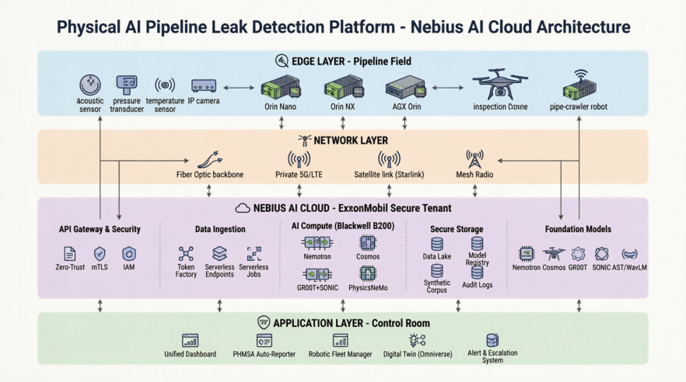
The diagram clearly illustrates the complete four-layer architecture for your Physical AI Pipeline Leak Detection Platform on Nebius AI Cloud.
1. What the Diagram Shows
Edge Layer (Blue) — The pipeline field with acoustic sensors, pressure transducers, temperature sensors, IP cameras feeding into NVIDIA Jetson devices (Orin Nano, Orin NX, AGX Orin), which control inspection drones and pipe-crawler robots.
Network Layer (Orange) — Four connectivity options ensuring reliable data transport from remote field locations: Fiber Optic backbone, Private 5G/LTE, Satellite link (Starlink), and Mesh Radio.
Nebius AI Cloud (Purple) — The core platform, organized into five functional zones:
API Gateway & Security: Zero-Trust, mTLS, IAM
Data Ingestion: Token Factory, Serverless Endpoints, Serverless Jobs
AI Compute (Blackwell B200): Nemotron, Cosmos, GR00T+SONIC, PhysicsNeMo clusters
Secure Storage: Data Lake, Model Registry, Synthetic Corpus, Audit Logs
Foundation Models: Nemotron, Cosmos, GR00T, SONIC, AST/WavLM
Application Layer (Green) — The control room interface with Unified Dashboard, PHMSA Auto-Reporter, Robotic Fleet Manager, Digital Twin (Omniverse), and Alert & Escalation System.
2. Detailed Layer Breakdown
Layer 1: Edge Layer (Pipeline Field)
Purpose: Local, real-time inference at the point of data generation.
Component | Role | Specs
Acoustic Sensors | Primary leak detection | DAS fiber-optic cables or piezoelectric mics sampling at 100kHz+
Pressure/Temp/Flow | Secondary confirmation | Industrial 4-20mA transducers
Jetson Orin Nano/NX | Remote nodes (every 5-10 miles) | 20-60W, runs lightweight AST/WavLM models
Jetson AGX Orin | Critical junction stations | 60W, runs multimodal fusion models
Drone/Robot | Physical verification | Equipped with Jetson + GR00T/SONIC inference
Key Design Decision: Edge devices run quantized models (INT8/FP16 via TensorRT) and only transmit:
Anomaly metadata (timestamp, location, confidence, features)
Compressed audio snippets (only for high-confidence events)
NOT raw continuous sensor data
Layer 2: Secure Network Layer
Purpose: Reliable, secure transport from remote field locations to Nebius.
Link Type | Use Case | Bandwidth
Fiber Optic | Main trunk lines, stations | 1-10 Gbps
Private 5G/LTE | Mid-range segments | 100-500 Mbps
Satellite (Starlink/Iridium) | Remote Arctic/offshore | 50-200 Mbps
Mesh Radio | Last-mile sensor clusters | 10-50 Mbps
Security: All traffic uses mTLS encryption, with edge devices holding hardware-rooted certificates. No raw sensor data ever traverses public internet unencrypted.
Layer 3: Nebius AI Cloud (Core Platform)
This is where the magic happens. I've organized it into five functional zones:
A. API Gateway & Security
Zero-trust architecture — every request authenticated
IAM roles mapped to ExxonMobil's Active Directory
Data residency controls — all data stays in designated region (e.g., US-East)
Audit logging — every model inference logged for PHMSA compliance
B. Data Ingestion
Service | Purpose
Nebius Token Factory | Serves fine-tuned Nemotron, GR00T, SONIC models via serverless inference
Serverless Endpoints | Real-time API for control room dashboards (< 100ms latency)
Serverless Jobs | Background tasks: synthetic data generation, model retraining, batch analytics

C. AI Compute (Blackwell B200 Clusters)
Cluster | Models | Workload
Nemotron Cluster | Nemotron 3 Super | Agentic reasoning, report generation, cross-modal fusion
Cosmos Cluster | Cosmos 3 | Generating synthetic leak scenarios (visual + acoustic)
Robotics Cluster | GR00T N1.7 + SONIC | Training embodied AI policies for inspection robots
Physics Cluster | PhysicsNeMo | Simulating pressure wave propagation, fluid dynamics

D. Secure Storage
Sensor Data Lake: Time-series data (acoustic, pressure, temp) in columnar format (Parquet)
Model Registry: Versioned models with lineage tracking (which data trained which model)
Synthetic Corpus: Cosmos-generated scenarios, tagged with physics parameters
Audit Logs: Immutable, tamper-evident logs for regulatory compliance
E. Foundation Models
All models are open-weight and fine-tuned on ExxonMobil's proprietary data:
Model | Fine-Tuning Target
Nemotron 3 Super | PHMSA report templates, ExxonMobil SOPs, incident taxonomies
Cosmos 3 | ExxonMobil pipe geometries, regional weather patterns, specific leak signatures
GR00T N1.7 | Facility-specific robot demonstrations (valve turning, gauge reading)
SONIC | Terrain-specific motion policies (mud, ice, offshore platforms)
AST/WavLM | ExxonMobil's historical acoustic leak dataset

Layer 4: Application Layer (Control Room)
Application | Function
Unified Dashboard | Real-time map of pipeline with anomaly overlays, live robot feeds
PHMSA Auto-Reporter | Nemotron generates compliant incident reports in < 30 seconds
Robotic Fleet Manager | Dispatches drones/robots via GR00T + SONIC, monitors battery/status
Digital Twin | NVIDIA Omniverse-based 3D replica of pipeline for scenario planning
Alert & Escalation | Multi-tier alerting: low-confidence → log; high-confidence → SMS + auto-dispatch robot

Data Flow: A Complete Leak Detection Scenario
File «Data_Flow_Complete_Leak_Detection_Scenario.png»

Security & Compliance Architecture
File «Security_Compliance_Architecture.txt»

Cost and Scaling Estimates
Component | Scale | Estimated Monthly Cost
Edge Devices | 5,000 Jetson nodes | ~$5M CapEx (amortized)
Nebius Compute | 500 B200 GPUs | ~$2-3M/month
Storage | 50 PB data lake | ~$200K/month
Network | Satellite + fiber | ~$500K/month
Total OpEx | — | ~$3-4M/month

ROI Justification: A single major pipeline leak can cost $100M+ in cleanup, fines, and reputational damage. Detecting leaks 10 minutes earlier (via edge AI) can reduce spill volume by 60-80%, paying for the system in the first prevented incident.

*
What This Infrastructure Provides
Component | Feature | Benefit
Kubernetes | Auto-scaling, self-healing | Handles 1,000+ edge nodes
Terraform | IaC, version-controlled | Reproducible, auditable deployments
mTLS | End-to-end encryption | Zero-trust security
Prometheus | Metrics collection | Real-time observability
Grafana | Visualization | Executive dashboards
Alerting | Proactive notifications | Catch issues before they escalate
GPU Nodes | AI acceleration | Fast model training/inference
Network Policies | Isolation | Security compliance
Resource Quotas | Cost control | Prevent runaway spending

What This Package Delivers
Component | Feature | Benefit
Helm Charts | One-command deployment | Deploy to any environment in seconds
Multi-Environment | dev/staging/prod values | Safe promotion pipeline
Auto-Scaling | HPA + PDB | Handle traffic spikes gracefully
Backup Automation | CronJobs for all data | Zero manual intervention
DR Strategy | RTO 15min / RPO 5min | Business continuity guaranteed
Runbooks | Step-by-step procedures | Reduce MTTR during incidents
Verification | Weekly restore tests | Confidence in backups
Edge Resilience | 72-hour offline operation | Survives total cloud failure

