The Adventures of
Yolo

© 2013 by Andrew Geyster, Andrew Shaffer James Stegner

Table of Contents

    - Project Overview 3

    - Executive Summary 5

    - Controls 9

    - Interface 10

    - Artificial Intelligence 12

    - Scoring & Cheats 14

    - Asset List 15

    - Technical Summary 18

Project Overview

Team Contact Information

- Andrew Geyster: ageyster@gmu.edu
- Andrew Shaffer: ashaffe8@gmu.edu
- James Stegner: jstegner@gmu.edu

Production Team

- Producer – Andrew Shaffer
- Assistant Producers:
  - Andrew Geyster
  - James Stegner

Design Team

- Design Lead – Andrew Shaffer
- Lead Level Designer - Andrew Geyster
- Additional Level Designers:
  - Andrew Shaffer
  - James Stegner

Programming Team

- Tech Lead – James Stegner
  - Enemy AI and Player controls - Andrew Shaffer
  - Game Engine – James Stegner
  - Menus/Integration - Andrew Geyster

Visuals

- Art Assets and Animation – Andrew Shaffer
  - Ship and effects licensed for use by GraphicsForGames.com
  - Background images created with Genetica Viewer 3.5
  - Additional background images created by Andrew Shaffer

Audio

- Music Composition - James Stegner
- Sound effects created with Bxfr (www.bfxr.net)

QA Team

- QA Lead – James Stegner
- Additional Testers
  - Andrew Geyster
  - Andrew Shaffer

External Contractors

- www.Graphicsforgames.com (ship and effects)
- Spiral Graphics Inc. (backgrounds)
- www.bfxr.net (sound effects)

Executive Summary

High Concept

- Defend planet Earth from space invaders using an experimental drone spaceship in this top-down shoot-em up action game. To survive, you must constantly alter the offensive and defensive capabilities of these drones. Oh yeah.. you only have one life.

The Hook

- You only have one life.. so make it count.

Story Synopsis and Setting

- TAOY takes places in the near distant future where advancements drone and aerospace have attracted the attention of other alien races. Some of which are hostile. Battles will take place on Earth and space.

Core Gamplay

- Defend Earth in this single-player game by defeating the alien armada across 4 missions featuring the experimental drone carrier in a top-down 2-D “bullet-hell” style shooter.

Game Features

- Offers constant replayability by offering different drone configurations and weapon loadouts.
- Play through campaign mode to save the Earth..
- Or see how long you can last in Survival mode.

Project Scope

- Number of distinct locations – 4
- Number of levels/missions - 4
- Number of weapons - 3
- Number of vehicles - 7

Target Audience

- This game is intended for the more hardcore shooter audience with the emphasis place on leaderboard tracking for prestige.

Story
- In the near distant future, advancements in drone and aerospace technology have attracted the attention of other alien races. Yolo Johnson is a world-renowned fighter pilot and astronaut currently returning from the maiden test flight of the most recent iteration America’s drone-deployment fighter to find that the planet under attack. It is up to Yolo and his experimental ship to push back the alien attack and defeat their armada orbiting the planet.

Setting

Area #1: The Amazon River
  - Fight a small group of scout ships for the enemy along the lush Amazon River as you make your way back to defend the United States!

Area #2: Atlantic Ocean
  - Continue flight back over the Gulf of Mexico as you battle alien ships advancing on South America!

Area #3: Over Washington D.C.
  - Encounter heavy resistance over what’s left of Washington D.C!

Area #4: Earth’s Orbit
  - Take the fight to the alien armada currently in Earth’s orbit!
Player Character

Drone Deployment Fighter
  - Controls up to 3 drones that have multiple attack patterns and weapons

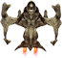

Drones
  - Deployment Configurations
    - Standard Attack Formation around ship
    - Condensed Attack Formation for concentrating fire
    - Rotation – drones continuously rotate around ship
    - Snake – drones follow behind ship
    - Contract/Widen – drone positions can change to concentrate fire or spread out fire pattern.

Weapon Types

Spray – standard projectiles
  - Low damage
  - Fast fire rate
  - Good for shooting down all types of ships

Torpedo – missile projectiles
  - Fired in volleys
  - Specializes is taking down largers ships.
  - Explosions also destroy enemy projectiles.

Laser – strong but thin projectiles
  - Pierces all enemies.
  - Continuously damage enemies.
Enemy Ships

Kamikaze
  - Small, fast and maneuverable ship attempts to ram the player



Fighter
  - Small fast, and maneuverable ship that attempts that shoots anything it its path.



Gunship
  - Medium-sized ship with average speed that attempts to shoot projectiles at the enemy player.



Bomber
  - High-health ship with less than average speed that fires missiles and torpedoes at the player



Controls

PC Keyboard Commands

Menu Screen

Menu Commands
  - Cursor Up – W
  - Cursor Down – S
  - Confirm – Enter
  - Exit game - Escape

Equipment Select Screen

Keys for selecting drone weapon and behavior
  - Cursor Up - W
  - Cursor Down - S
  - Cursor Left - A
  - Cursor Right – D
  - Confirm Loadout– Enter
  - Return to main menu - Escape

In Battle

Keys for movement controls
  - Up - W
  - Down - S
  - Left - A
  - Right – D
  - Primary fire – Spacebar
  - Change Drone Position – H
  - Return to main menu - Escape
Interface

HUD

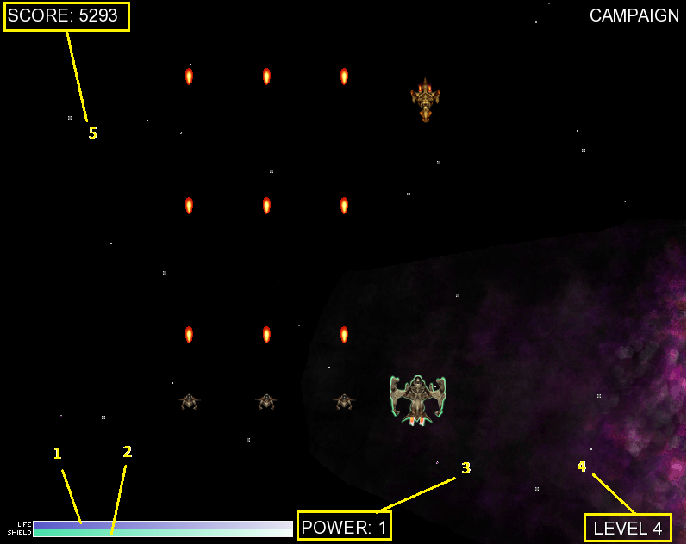

- 1 - Health
- 2- Shield
- 3 - Weapon Level
- 4 - Stage Level
- 5 - Score

Menus

Game screen flow diagram

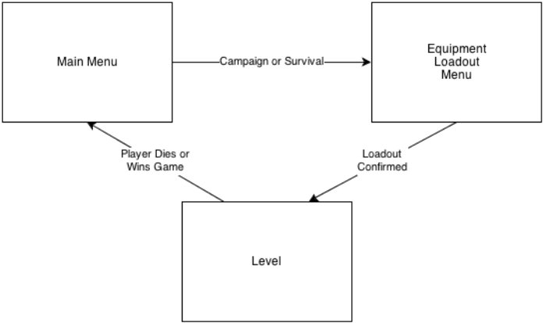
Main Menu

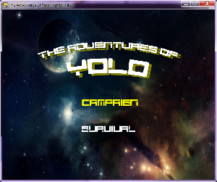
- Campaign – Fight through 4 levels.
- Survival – Fight endless waves of enemies in pursuit of the high score.

Equipment Loadout Menu

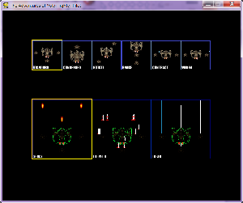

- Drone Behavior
- Drone Weapon

Artificial Intelligence
Kamikaze

Statistics
  - Health – Low
  - Speed – Fast

Movement
  - Y-Axis
    - Continuously moves down
  - X-Axis
    - Veers in direction of player ship

Firing States
  - None

Fighter

Statistics
  - Health – Low
  - Speed – Fast

Movement
  - Y Axis
    - Continuously moves down
    - Either straight down or random strafing
  - X-Axis
    - None

Firing States
  - Straight Down

Gunship/Bomber

Statistics
  - Health – Medium/High
  - Speed – Medium/High

Movement
  - Y-Axis
    - Continuously moves down
    - Stops periodically
    - Stops permanently
  - X-Axis
    - Moves straight
    - Veers

Firing States
  - Straight Down
  - At player

Scoring & Cheats

Score

- Score is calculated by the number of enemies destroyed.
  - Values are based on the health of the ship.
- The player may see their current score while playing the game
- Score is also displayed
  - At the end of a level in Campaign Mode.
  - When the player dies.

Cheats (Always On)

Instant Weapon Powerup

  - Press the P button to instantly powerup your weapon one level.

Skip Campaign Level

  - Press the I button to instantly warp to the next level in Campaign Mode.

Asset List

Art

Model & Texture List

Characters
  - Player character
    - Ship
    - Drones
  - Bad guys
    - Kamikaze
    - Fighter
    - Gunship
    - Bomber

Environmental Objects
  - Backgrounds
    - Amazon
    - Ocean
    - Cityscape
    - Space

Animation list

Player
  - Ship
    - Shield Regenerated
    - Ship Destroyed
  - Drone
    - Lasers
  - Projectiles
    - Missiles Destroyed

Enemy
  - Ship
    - Ship Destroyed
  - Projectiles
    - Standard projectiles moving
    - Torpedos moving
    - Torpedos destroyed
Weapon effects list
  - Player
    - Enemy missle hits ship - Explosion
  - Enemy
    - Player Missle hits ship – Explosion

Environmental effects
  - Explosions
    - Destruction of Missles
    - Destruction of Ships

Interface Art

- Main Menu Text
- Ship Loadout Menu
  - Weapon Choice
  - Drone Behavior Choice
- Game Menu
  - Life/Shield Bar

Sound

Environmental Sounds

- Explosions
  - Missles
  - Enemy Missles
  - Player Ship
  - Enemy Ships

Weapon Sounds

- Player weapon hits enemy ship
- Enemy weapon hits player ship

Music

- Level 1
  - Name: Shoot At Anything
  - Composer: James Stegner
  - Licensed for use by James Stegner
  - Length: 8:36
  - Loops: Yes

- Level 2 & Main Menu Music
  - Name: Dues Ex: sonic Augmentation
  - Composer: OCRemix & Montreal Eidos
  - Licensed for use in non-commercial products
  - Length: 3:36
  - Loops: Yes

- Level 3
  - Name: Death Angel
  - Composer: James Stegner
  - Licensed for use by James Stegner
  - Length: 2:22
  - Loops: Yes

- Level 4
  - Name: Feeling Dark (Behind The Mask)
  - Composer: 7OOP3D
  - Licensed for use in non-commercial products
  - Length:7:25
  - Loops: Yes

Technical Summary
Single-Player

- PC
  - Minimum system requirements
    - Operating System: Windows XP/2000/Vista/7, Intel Max OSX 10.5.8+, or Linux (x86 or x86_64)
    - Processor 2Ghz
    - Ram: 1 GB
  - Recommended system requirements
    - Operating System: Windows XP/2000/Vista/7, Intel Max OSX 10.5.8+, or Linux (x86 or x86_64)
    - Processor 3.6Ghz
    - Ram: 2 GB

