# Progress report #2 - 26.02.2020

## Main purpose / focus

Automation of JSDoc documentation.  
Restructure Voxelizer core code base / planning.

## Planned activities

1. Create JSDoc GitHub Action.
   1. Publish to GitHub Marketplace.
   2. Upload generated docs to GitHub Pages automatically.
   3. Support JSDoc 3rd party templates.
2. Automatically run tests
3. Automatically publish new JS packages (e.g. on npm)
4. Restructure code base of Voxelizer

## Completed work

1. Created [JSDoc GitHub Action](https://github.com/andstor/jsdoc-action/tree/master).
   1. Supports 3rd party JSDoc templates.
   2. Published to GitHub Marketplace, see [here](https://github.com/marketplace/actions/jsdoc-action).

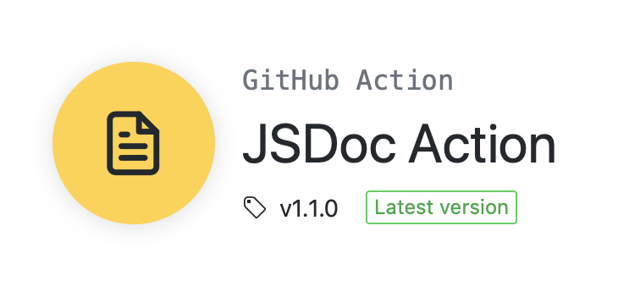

* 1. Documented simple solution to upload docs to GitHub Pages.  
     It can also easily be combined with other deployment actions.
  2. Added link to the jsdoc-action in the main JSDoc repository [README file](https://github.com/jsdoc/jsdoc).  
     See approved [pull request](https://github.com/jsdoc/jsdoc/pull/1745).

1. Restructured Voxelizer codebase / planned ahead.

Voxelizer engine diagram: