Swings and biorhythms-parametrically forced oscillators
Leon Avery, Andreas Sundström

How to pump a swing

Introduction to Floquet Theory
In the previous sections we showed that, in the linear approximation, a swing with periodically varying length has solutions whose amplitude increases or decreases exponentially in time. Although we didn’t show this, there are also solutions that show no steady change in amplitude with time. Which type of solutions one gets depends on the ratio of the frequency of the length oscillation to the free-running frequency of the unperturbed swing, and also on the magnitude of the length oscillation. As a general rule, exponential growth occurs when the forcing entrains the oscillation of the swing in such a way that the motions that deliver energy occur at the most effective phase of each cycle. This is more likely to happen if the ratio is an integer (as we showed, 2 is particularly effective), and when is larger.
Floquet Theory is a general approach to understanding systems of linear ODEs with periodic parametric forcing. Specifically, it applies to systems of the form

(1)

where the matrix is a -periodic function of time:

(2)

Every solution of (1) is encompassed in its principal fundamental matrix solution , defined as the solution to the matrix IVP

(3)

Here is the identity matrix. Specifically, the solution of (1) is .

Define the monodromy matrix . The monodromy matrix turns out to be independent of , so it can be computed as . The eigenvalues of , , are called the characteristic multipliers. The determinant of (the product of the characteristic multipliers) is given by,

(4)

They multipliers determine the character (e.g. stable or exponentially growing) of solutions of (1). In particular,

(5)

The characteristic exponents , defined by determine the growth rate of solutions. In particular, if , solutions associated with it will decay exponentially; if , solutions associated with it will grow exponentially, and if , solutions associated with it will be stable. (Strictly speaking, the previous statements hold only if the geometric multiplicity of each eigenvalue of equals its algebraic multiplicity. When this is not the case, polynomial factors can also arise.) There will be, associated with each characteristic exponent , a solution of the form

 | , | (6)

where is a -periodic vector function of time.
A particularly interesting case arises when is a periodic perturbation of a constant matrix that itself has -periodic solutions, i.e.

(7)

with -periodic. For instance, the varying length swing is of this form, with

(8)

is traceless, and since is periodic, the integral of over one cycle is . Thus the monodromy matrix for the swing has determinant 0. The character of the solutions can be determined from . If , the multipliers form a complex conjugate pair, each with absolute value 1, and solutions are stable. If, however, , the multipliers are real and different, and since their product is 1, one must be greater than one. In this case, there is an exponentially growing solution. Finally, in the border case, , the multipliers are equal , either both 1 or both . The values of for which that holds define the boundaries of the Floquet tongues, within which exponentially growing solutions occur.

Circadian rhythms
Every human being, and indeed many or most living things, contains at least one internal clock (Ko and Takahashi, 2006; Partch et al., 2014; Rosato et al., 2006). Biological clocks with a period of approximately 24 hours are called circadian clocks (meaning “about a day”). The consequences of an incorrectly working clock become obvious when one flies from Canada to Japan.
The circadian clock is a chemical limit cycle oscillator. Ronald Konopka and Seymour Benzer (1971), working in the fruit fly Drosophila melanogaster discovered a gene period (per), that affects the period of the fly’s circadian clock. We now know that per is a central component of the clock. The clock works by negative feedback with delay. per contains the information for making a protein, called PER. To make PER protein, the per gene must be transcribed to produce a messenger RNA (mRNA), which is translated into PER protein in the cytoplasm (that part of the cell outside the nucleus). The PER protein then moves into the nucleus (where the genes are) and represses transcription of the per gene.

An ODE model of a circadian oscillator
A minimal circadian clock model has three ODEs describing the dynamics of PER mRNA, cytoplasmic PER protein, and nuclear PER protein (Pfeuty et al., 2011). This three ODE model, which we will use, is as follows,
(9)

Here is concentration of per mRNA, and and the concentrations of PER protein in the cytoplasm and nucleus. The first equation describes the synthesis and degradation of the mRNA. Synthesis occurs at rate in the absence of nuclear PER, but is inhibited by PER. Degradation follows standard Michaelis-Menten kinetics. In the second equation we see that cytoplasmic PER protein is made at a rate that depends on the mRNA concentration and is degraded. The final two terms of the second equation and both terms of the third describe exchange of PER protein between cytoplasm and nucleus.
With dark parameter values , , , , , , , , , , the free-running period becomes . This system is easily solved numerically (Figure 1).

Entrainment: setting the clock
The clock is not useful unless it can be set. Real circadian clocks are quite inaccurate, with typical free-running periods of about 25.5 h, so they need to be set daily. In practice, environmental light levels affect the parameters of the differential equations (9) in such a way as to establish a consistent relationship with the day/night cycle. This process is called entrainment. Our next goal is to understand how entrainment occurs.

Dimensional reduction: phase
To analyze this system, we simplify it from three dimensions to one by focusing on the limit cycle . Our goal is to assign to every point near a phase ( is the free-running period of the clock), and then to study the evolution of this scalar function of time.
Begin by writing the ODE system in generic form (10). ( and p is the parameter vector .

(10)

Now define as the solution to the autonomous system (10). We assign phase 0 to some arbitrary point in , then define at other locations by

(11)

That is, phase always advances by one hour for every hour that passes. (Later, when we have external periodic forcing, we will scale so that its period is different from .) (11) is sufficient to define on (up to the choice of zero). To define outside , we require to be continuous and differentiable. The limit cycle is attractive. If you start anywhere in its basin of attraction, you will eventually approach the cycle arbitrarily closely. At that point must, by continuity, be close to the phase of the nearest point in . is therefore approximately defined, and by extrapolation, is approximately defined at every point on the trajectory that led to . To first order, near is defined by the gradient of on , as follows.
Choose a point with , and call the gradient of there . Let be a unit vector, and . Define . Then

(12)

Now, project both and forward in time by , to new points and .

(13)

We used that the flow at is , where is the Jacobian of the flow field at . Now, we’re in position to find the gradient at the new location, using

(14)

Plugging in (13) and equating terms of (details fell casualty to the page limit) gives

(15)

is the identity matrix. Now remember, is an arbitrary unit vector. (15) must be true for all . This is possible only if the vector is multiplied by is the same on both sides. Since , . Thus, to ,

(16)

The final line is a first-order approximation to . Thus, we end up at last with

 | , | (17)

valid in . Other than complexity, there is no obvious obstacle to continuing this analysis to higher order, but we have not done so.
We now have a linear ODE in . We need only an initial condition.
Remember that circulates around at a rate that we have determined (analytically or numerically), so can just as well be written . Thus (17) is a periodic nonautonomous linear system of ODEs in . As described above, this system has a general solution that can be expressed as a power of its monodromy matrix times a periodic function of time. That is, its principal fundamental solution matrix can be written as

(18)

Vector is a solution to (17). must be a periodic function of time on . In particular,

(19)

That is, must be an eigenvector of the monodromy matrix with eigenvalue 1, i.e., 1 must be a characteristic multiplier. Indeed, there is a straightforward argument that it is (Ward).

Phase response curves
Light does not directly affect —it affects the parameters of the differential equations (9). We now suppose that the parameter vector varies with time,

(20)

Effect vector is of order of magnitude 1 giving the direction of the parameter changes induced by light. Light function is normalized so as to be order of magnitude 1 and specifies how light varies over the course of a day—e.g. 12 h on, 12 h off. It is periodic with period . We scale the phase defined by (11) so that, instead of running from 0 to , it runs from 0 to . Now, let be the phase at dawn on day . Then, n constant darkness,

(21)

is a measure of the difference between and . For instance, with , —the clock loses a little less than an hour a day in the darkness. Now, what happens if we turn on the lights, i.e. allow ? The dawn-to-dawn effect on phase depends on the phase of the clock at dawn. It is given by the phase response curve (PRC), , defined by

(22)

PRC intrinsically depends on , , and and . This difference equation has a fixed point if . This fixed point is stable if . Because of its importance to stability, Pfeuty et al (2011) give a name: . Thus, we expect entrainment if two conditions are met: the PRC attains the value for some , and .

We have everything we need to calculate the PRC. Phase changes as follows,

(23)

(Figure 2B) is called the infinitesimal impulse phase response curve (IPRC) and gives the response of phase to an infinitesimal delta-function light stimulus at phase . The PRC is calculating by convolving with

(24)

The approximation in the second step is valid if . The final version holds in the common situation in which light is only available during “daytime”, defined as the period from dawn () until sunset ), so that outside .

Robustness
The PRC and the IPRC are products of evolutionary design. Both the effect of light on the parameter values, , and the magnitude of that effect, , are the result of evolutionary pressures. A minimal criterion for a working clock is that it should be stably entrained by the light cycle, and the previous section described the mathematical requirements to accomplish that goal. But there’s more: In real life, the light curve is variable. It varies because of the season, the weather, and the behavior of the animal. A well-working circadian clock should not be excessively sensitive to such variations. Variations in the light curve are modeled as perturbations of :

(25)

and are normalized to order of magnitude 1, and is small compared to 1. and are now functions of . Robustness requires that they not be excessively sensitive to .
Pfeuty et al (2011) develop two measures of robustness,

(26)

To estimate these, we begin with the PRC

(27)

and are the convolutions of the IPRC with and according to (24). Now, is constant. Thus, expanding (27) around ,

(28)

Neglecting terms, we can solve for an estimate of robustness measure ,

(29)

where . By similarly expanding , we obtain an estimate of ,

(30)

Pfeuty et al (2011) show using these measures that some IPRCs give rise to more robust PRCs than others. In particular, the main characteristics of a robust IPRC are that it possess a “dead zone” that cover most of the day time (this makes the PRC insensitive to variations in the daytime light profile), and that it have sharply negative slope near the beginning and end of the night.
A great advantage of the PRC and IPRC as ways of characterizing circadian clocks is that they can be directly measured. Pfeuty et al (2011) cull a dozen IPRCs from the literature, and show that they are indeed robust.

Figures

A.  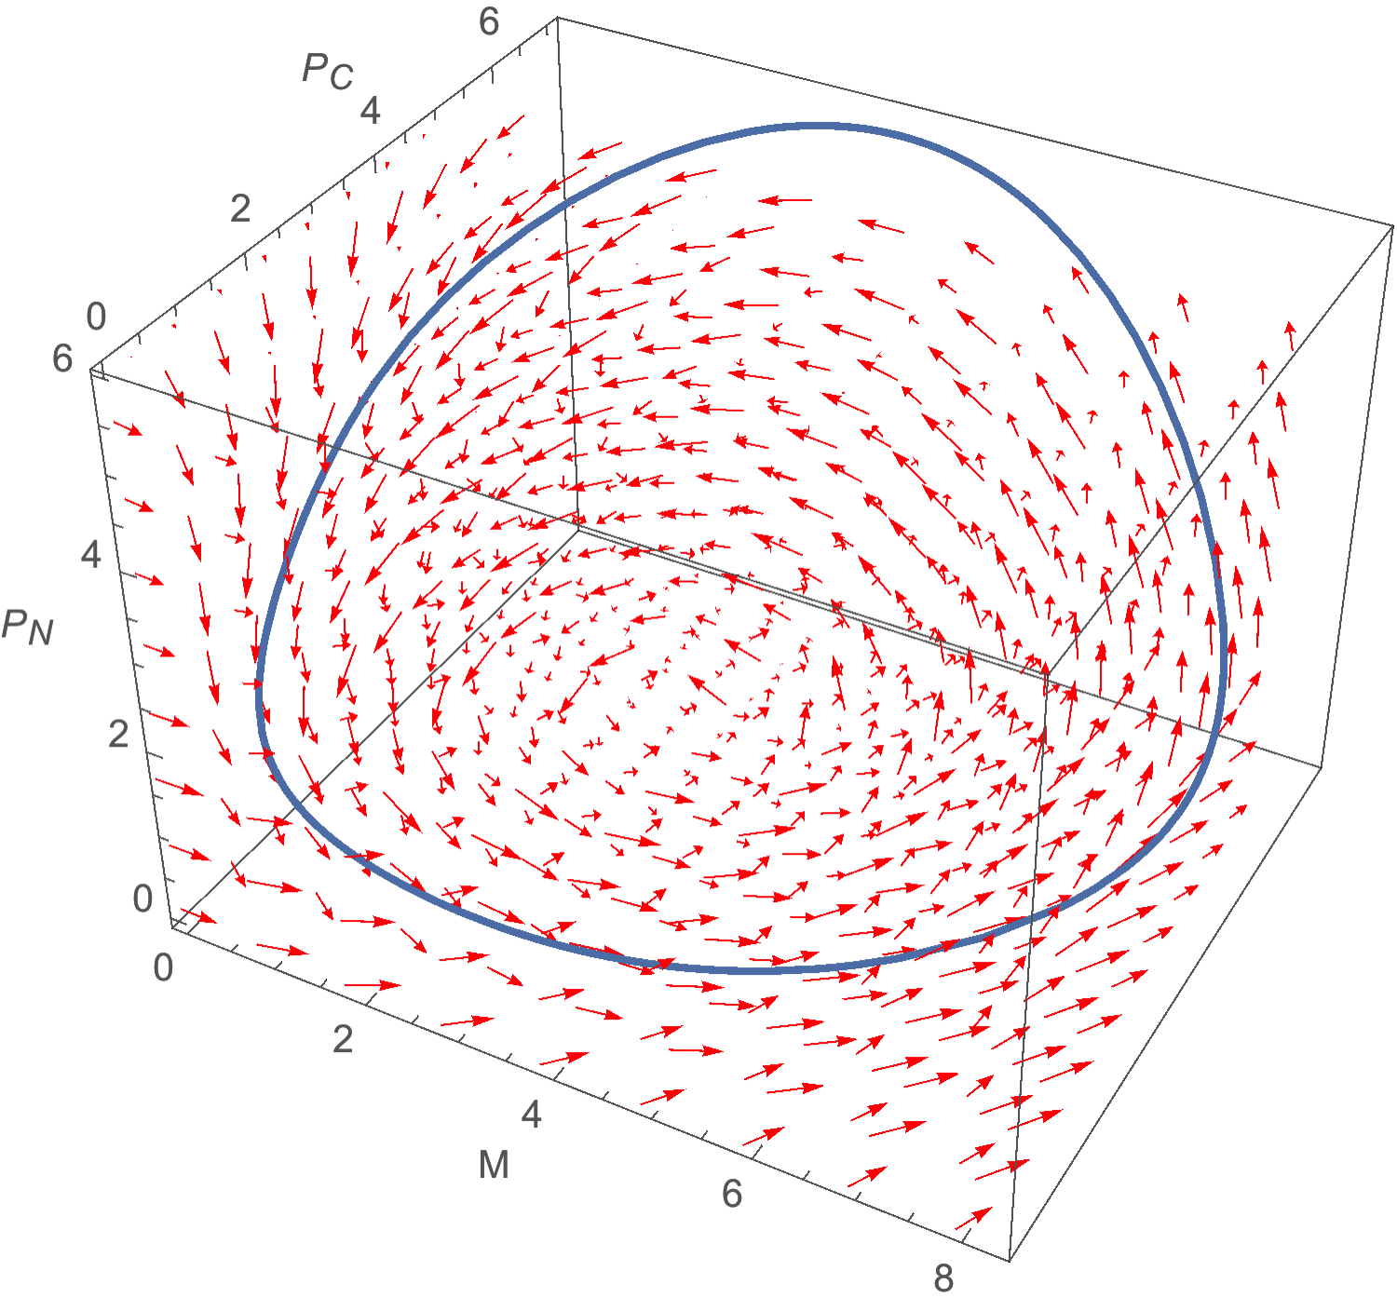 | B.  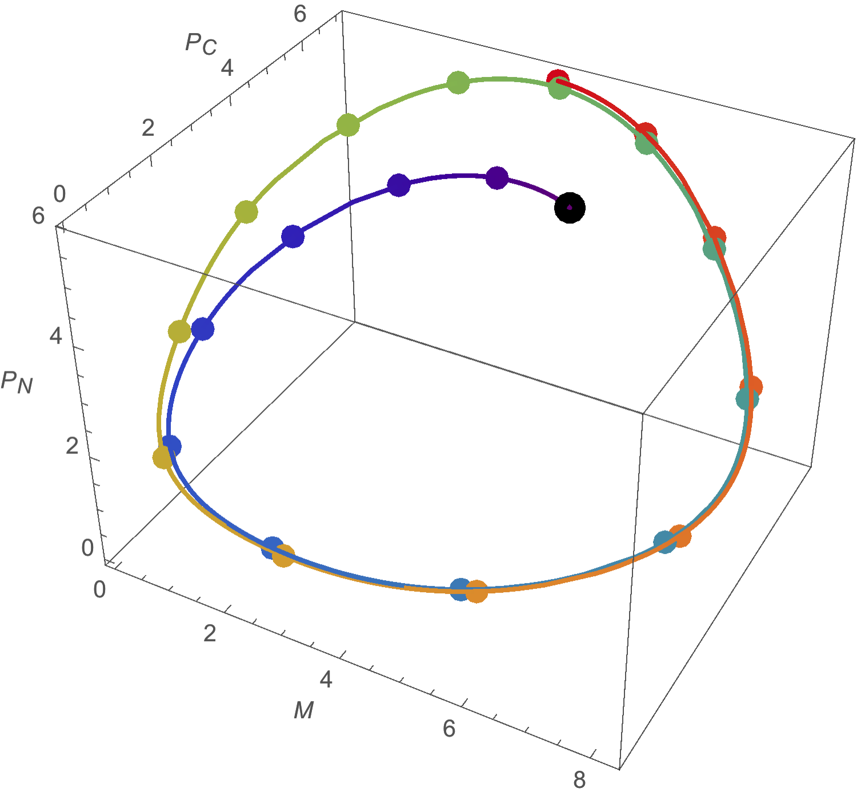
Figure 1: Numerical solution of the ODE model
A. Flow vector field corresponding to the system (9). Flow vectors are shown in red, the limit cycle in blue. B. Numerical solution for 48h starting from a randomly chosen point (black), showing convergence to . Colored dots are placed every two hours, with color changing from purple to red with the passage of time.

A.  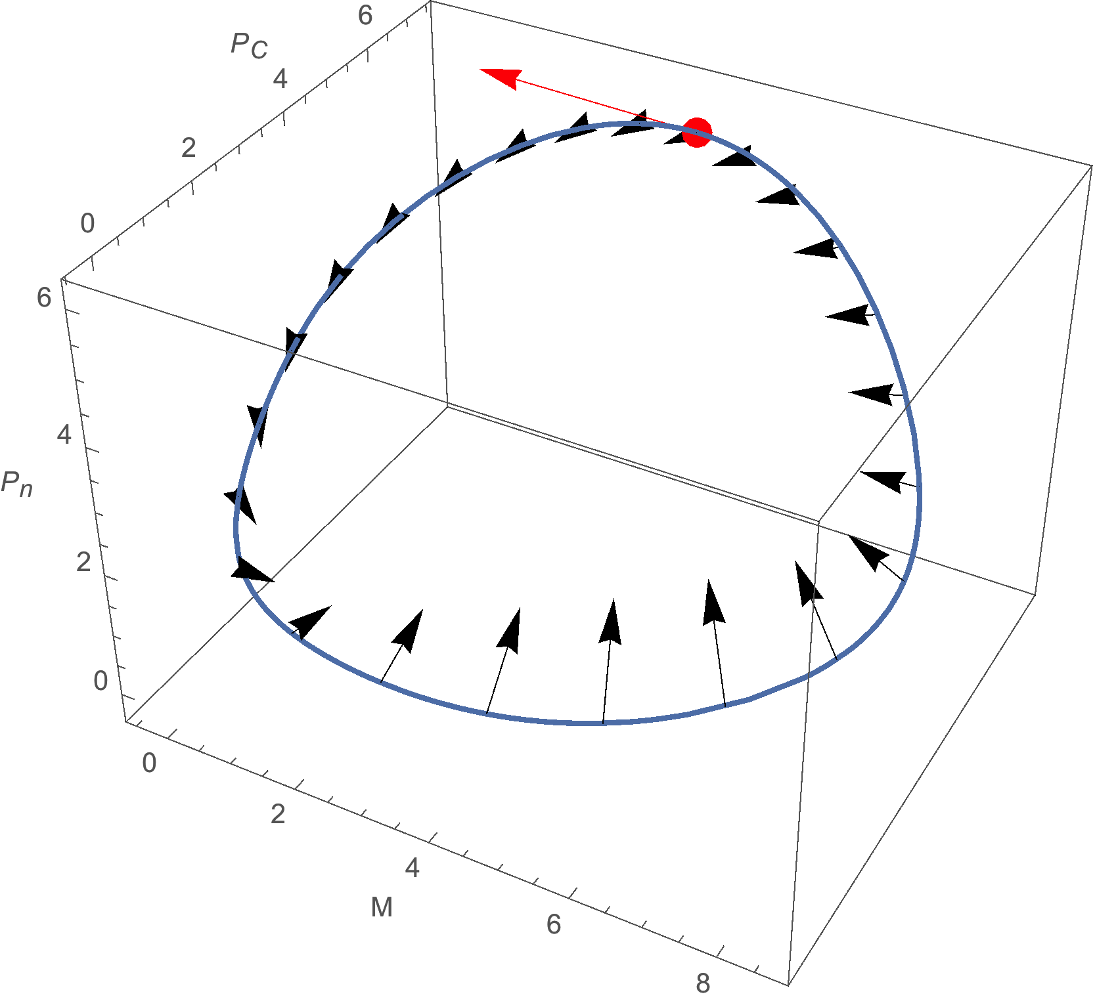 | B.
 | C.
Figure 2: for the Pfeuty et al (2011) system.
A. In blue is the limit cycle. The red arrow shows the direction of progress around the cycle. The 24 black arrows show numerically computed phase gradients at each hour around the cycle. B. The corresponding IPRC, computed using being a change of in parameter . The gray bar corresponds to daytime , based on the resulting PRC in part C. This panel approximately reproduces the left-hand panel of Pfeuty et al (2011), Figure 3A. C. The corresponding PRC with , . With , there is a stable fixed point . This figure approximately reproduces the left-hand panel of Pfeuty et al (2011), Figure 2A.

Figure 3: Experimental IPRCs show robustness characteristics
This is a copy of Pfeuty et al (2011), Figure 5.
A. Experimentally measured IPRCs collected from the literature. B. Estimated IPRCs from fitting the data in A. C. a-j: Estimated robustness measure computed for experimental IPRCs in B. m: range of for all coupling schemes for the computation al model. Horizontal line: for an IPRC that is linearly decreasing during daytime.

Bibliography
Ko, C.H., and Takahashi, J.S. (2006). Molecular components of the mammalian circadian clock. Hum. Mol. Genet. R271-7.
Konopka, R.J., and Benzer, S. (1971). Clock Mutants of Drosophila melanogaster. 68, 2112–2116.
Partch, C.L., Green, C.B., Takahashi, J.S., Lowrey, P., Takahashi, J., Kang, T.H., al., et, Kang, T.-H., al., et, Ko, C., et al. (2014). Molecular architecture of the mammalian circadian clock. Trends Cell Biol. 24, 90–99.
Pfeuty, B., Thommen, Q., and Lefranc, M. (2011). Robust Entrainment of Circadian Oscillators Requires Specific Phase Response Curves.
Rosato, E., Tauber, E., and Kyriacou, C.P. (2006). Molecular genetics of the fruit-fly circadian clock. Eur. J. Hum. Genet. 14, 729–738.
Ward, M.J. Basic Floquet Theory (http://www.math.ubc.ca/~ward/teaching/m605/every2_floquet1.pdf).

