## Original Paper

# Using Social Vulnerability Indices to Predict Priority Areas for Prevention of Sudden Unexpected Infant Death in Cook County, IL: Cross-Sectional Study

## Abstract

**Background:** Incidence of Sudden Unexpected Infant Death (SUID) in the United States has persisted at roughly the same level since the mid-2000’s despite intensive prevention efforts. Disparities in outcomes across racial/socioeconomic lines also persist. These disparities are reflected in the spatial distribution of cases.

**Objective:** We sought to characterize communities where SUID occurred in Cook County, IL from 2015-2019 and predict where it would occur in 2021-2025.

**Methods:** This cross-sectional retrospective study used geocoded medical examiner data from 2015-2019 to identify SUID cases in Cook County, IL and aggregated them to census tracts, then to “communities” as the unit of analysis. We compared demographic factors in communities affected by SUID versus those unaffected. We used social vulnerability indicators from 2014 to train a prediction model for SUID Case Counts in each given community for 2015-2019. We applied indicators from 2020 to the trained model to make predictions for 2021-2025.

**Results:** The analysis was based on 325 cases of SUID in 199 communities. Communities affected by SUID exhibited higher median proportions of Non-Hispanic Black residents at 32% (IQR 6-79) vs. 3% (IQR 2-10) and lower proportions of Non-Hispanic White residents at 17% (IQR 4-49) vs. 60% (IQR 31-76). A map of communities in Cook County affected by SUID (2015-2019) showed clusters in the South and West regions of the county. Our predictive model showed moderate accuracy when assessed on the training data (Nagelkerke’s R2 of 70.2%). It predicted Austin (17), Englewood (14), Auburn Gresham (12), Chicago Lawn (12), and South Shore (11) to have the largest case counts from 2021-2025.

**Conclusions:** Sharp racial and socioeconomic disparities in SUID incidence persisted within Cook County from 2015-2019. Our predictive model and maps identified precise regions within the county for local health departments to target for intervention.

**Keywords:** Sudden Unexpected Infant Death, Sudden Infant Death Syndrome, GIS, Pediatrics, Social Determinants of Health, Structural Racism

## Introduction

### Background

Sudden Unexpected Infant Death (SUID) exacts a severe, lasting toll. The National Institute of Child Health and Human Development (NICHD) defines SUID as “the death of an infant younger than 1 year of age that occurs suddenly and unexpectedly” [1]. At the familial level, loss of an infant may put bereaved caregivers–especially birth mothers–at heightened risk for Prolonged Grief Disorder where the process of healing and acceptance evades realization [2]. At the societal level, Sudden Infant Death Syndrome (a large subset of SUID cases) contributes to 20% of all post-neonatal infant mortality in the United States [3].

Previous research has demonstrated that SUID varies unequally in incidence across communities within major metropolitan regions [4–6]. Within Cook County specifically, Guest et al. (1998) demonstrated that this geographic variation was significantly associated with the community-level factors of racial segregation and unemployment [7].

To counteract these negative socioeconomic influences and reduce community incidence of SUID in a just manner, public health practitioners must precisely target their interventions in space and time. Without spatiotemporal precision, practitioners risk exacerbating inequity by bolstering communities already well-resourced, while neglecting the communities in highest need [8].

### Objectives

In this study of Cook County, IL, we sought to precisely describe where SUID occurred in the recent past (2015-2019) and to project where these deaths would occur in the near future (2021-2025). Geospatially, previous analyses have not provided sufficient detail to name specific places within the county to target at highest priority [4–6, 9]. We afforded greater detail by aggregating information at the census tract level into “communities” as our primary unit of analysis. We enabled public health practitioners and community organizations to take advantage of greater detail by generating interactive maps that could pan and zoom to areas of high risk.

While these analytic efforts were specific to Cook County, we designed an open source coding workflow that could be adapted to generate maps and predictive models for other jurisdictions [10]. We hope these tools will enable communities most afflicted by SUID to get assistance in a timely, targeted manner.

## Methods

### Study Design

We conducted a cross-sectional retrospective study concerning case counts of SUID in “communities” of Cook County, IL.

We used the concept of “communities” in order to:

1. Increase the geographic catchment area for case counts (incidence in census tracts was too low to make meaningful case count predictions)
2. Lend semantic meaning to the geographic unit of analysis, that is, being able to name each unit rather than using a numeric identifier

Communities were spatial joins of census tracts based on tags generated by the OpenCage geocoding service for the centroid of each tract [23]. Within city limits, census tract joins roughly correlated to Chicago “Community Areas” [<https://data.cityofchicago.org/Facilities-Geographic-Boundaries/Boundaries-Community-Areas-current-/cauq-8yn6>], while outside of Chicago, the joins correlated to local municipality boundaries.

Although aggregating to “communities” lent the benefits listed above, it came at the cost of less precision for covariates, which were aggregated by taking simple sums of their estimates at the census tract level without taking into account variations in their margins of error.

### Primary Outcome

The primary outcome of interest was SUID case count in each community. We translated The NICHD’s definition of SUID [1] into a SQL query of the Cook County Medical Examiner Office’s Archive (Figure 1). Each case identified by the query was validated by team members from the SUID Case Registry for Cook County. Each validated case was geocoded confidentially using ArcGIS Pro geocoding tools behind Cook County’s firewall. Geocoded cases were spatially joined by intersection with census tracts and aggregated to case counts. These anonymized case counts at the census tract level, were further aggregated to the community level as described above.

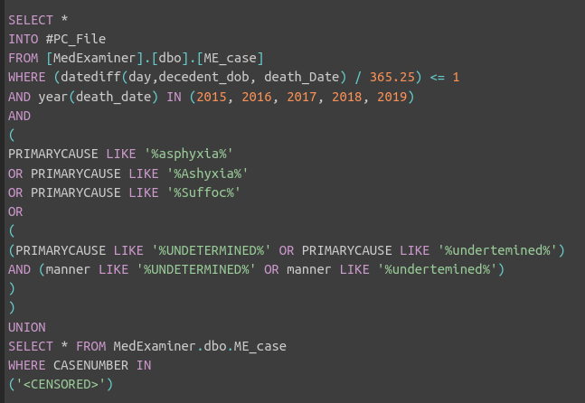

**Figure 1.** SQL Query for Identifying Prospective Cases of SUID from the Cook County Medical Examiner’s Case Archive. *The “WHERE CASENUMBER IN” clause is censored, but contained a list of additional case numbers recommended for inclusion by team members from the SUID Case Registry for Cook County.*

### Temporal Setting

The year of origin for each data variable was context-specific. SUID Case Counts were observed from 2015-2019. A descriptive comparison of census tracts with and without SUID present was performed on variables from contemporaneous years. We retrospectively trained a model predicting SUID Case Counts from 2015-2019 using predictor co-variates from 2014. Using the trained model, we made prospective predictions for SUID Case Counts from 2021-2025 with co-variates from 2020.

### Coding Pipeline

We performed all steps in the data pipeline downstream from the SQL query in the R computing environment [13] using the {tidyverse} suite of packages (by convention, package names in R are enclosed with curly brackets) [14]. We utilized additional data cleaning convenience functions from the {janitor} and {RSocrata} packages [15, 16]. The pipeline was orchestrated by specification using the {targets} package [17].

We generated data tables for publication using the {gt} package and its companion {gtsummary} [18, 19].

We performed geospatial manipulation and mapping with the {sf}, {leaflet}, {tmap}, {opencage}, and {tigris} packages [20–24] along with their back-end infrastructure [25–32].

### Statistical Analysis

#### Descriptive Comparison

We compared communities with and without observed cases of SUID using median values (and interquartile ranges) of demographic variables. Median values were reported because most of the variables did not approximate normal distributions.

#### Predictive Modeling

We sourced all predictive co-variates from U.S. Census’ “American Community Survey” (ACS) and from the Center for Disease Control’s associated “Social Vulnerability Index” (SVI), which has four thematic domains [11, 12].

We modeled SUID case counts in each census tract using maximum likelihood estimation via the {MASS} R package [33]. We used the negative binomial family of generalized linear models instead of the Poisson family because over-dispersion was detected. Selection of model form and predictors along with evaluation of performance is described in detail in Supplement 1. Briefly, we started with total population as an offset variable for use in the model. Next, to consider other predictor candidates, we calculated the Pearson correlation coefficient between SUID count and each variable in the pool used to calculate SVI [12]. One to two promising variables from each SVI thematic domain were assessed in the model using an additive step-wise fashion. The performance parameters assessed were Akaike/Bayesian Information Criteria (AIC; BIC), root mean squared error (RMSE), and Nagelkerke’s R2 using the {EasyStats} suite of R packages [34]. All predictor variables were log-transformed in the final model in order to reduce the influence of extreme values.

## Results

### Case Identification

Our SQL query identified 333 prospective cases of SUID from the medical examiner archives. Representatives from the SUID Case Registry of Cook County reviewed the cases and recommended retaining 325.

### Geospatial Aggregation

We spatially aggregated cases into counts within 199 communities. 49% of communities (97/199) observed at least one case of SUID from 2015-2019. Table 1 shows the full distribution of case counts.

**Table 1**. Distribution of SUID Case Counts in Census Tracts of Cook County, IL, 2015-2019

| SUID Case Count | Frequency | Percent |
| --- | --- | --- |
|  |  |  |
| 0 | 102 | 51.3 |
| 1 | 36 | 18.1 |
| 2 | 24 | 12.1 |
| 3 | 8 | 4.0 |
| 4 | 7 | 3.5 |
| 5 | 3 | 1.5 |
| 6 | 4 | 2.0 |
| 7 | 5 | 2.5 |
| 8 | 1 | 0.5 |
| 9 | 2 | 1.0 |
| 10 | 3 | 1.5 |
| 11 | 1 | 0.5 |
| 12 | 0 | 0.0 |
| 13 | 0 | 0.0 |
| 14 | 1 | 0.5 |
| 15 | 0 | 0.0 |
| 16 | 0 | 0.0 |
| 17 | 2 | 1.0 |

### Mapping SUID Case Counts

We generated an interactive map of SUID case counts (Figure 2). Broadly speaking, the map showed subjective clusters of cases on the West and South Sides of Chicago as well as the South Suburbs of Cook County. The top ten communities with the largest case counts were all located in Chicago city limits: Austin (17), Englewood (17), West Englewood (14), West Pullman (11), and Humboldt Park (10), New City (10), Roseland (10), North Lawndale (9), South Shore (9), and the Near North Side (8). The community outside of city limits with the largest case count was Chicago Heights (7).

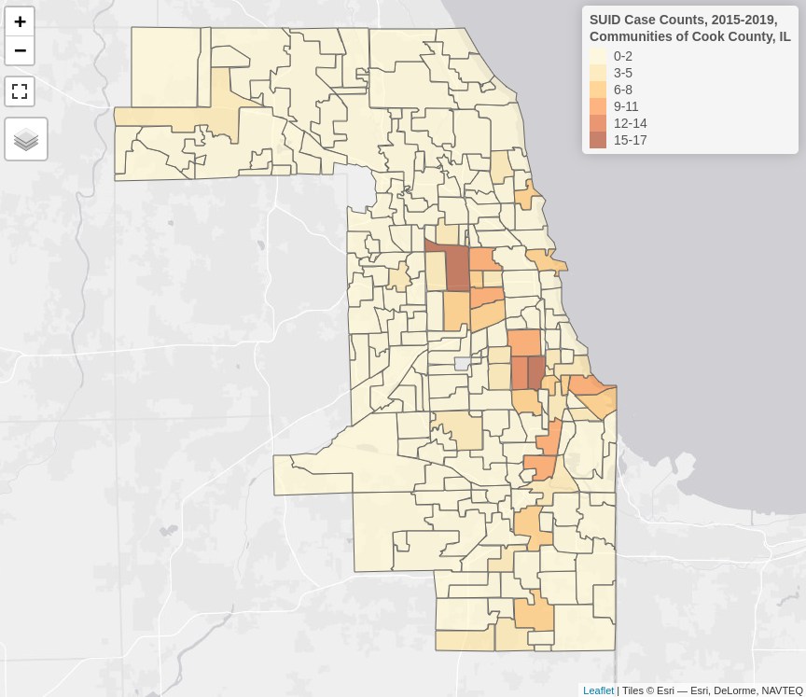

**Figure 2.** Overview of SUID Case Counts, 2015-2019, Communities of Cook County, IL.

### Comparing Tracts With and Without SUID

Table 2 compares demographics of communities with at least one case of SUID versus those without. There were no meaningful differences in age or sex composition, however, communities with SUID present exhibited lower composition of Non-Hispanic White residents at 17% (IQR 4-49) vs. 60% (IQR 31-76) (Figure 3) and higher composition of Non-Hispanic Black residents at 32% (IQR 6-79) vs. 3% (IQR 2-10) (Figure 4), although the interquartile ranges for these estimates overlapped. Variables algorithmically selected for use in the predictive model also showed meaningful differences.

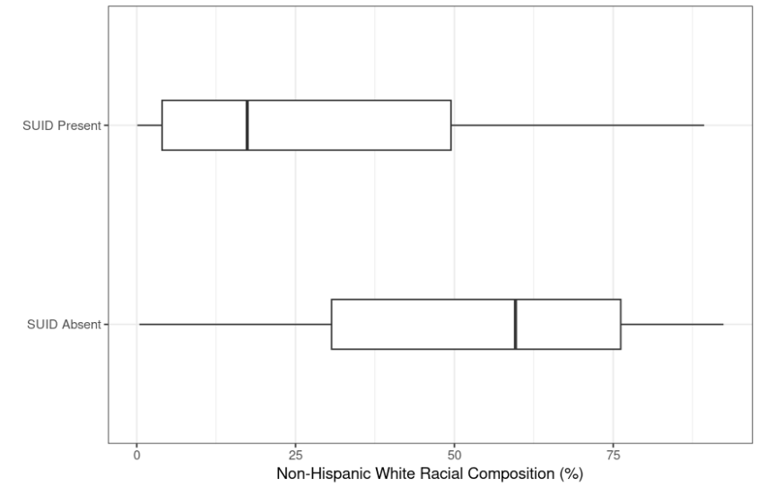

**Figure 3.** Comparing White Racial Composition in Communities of Cook County, IL by Presence of SUID.

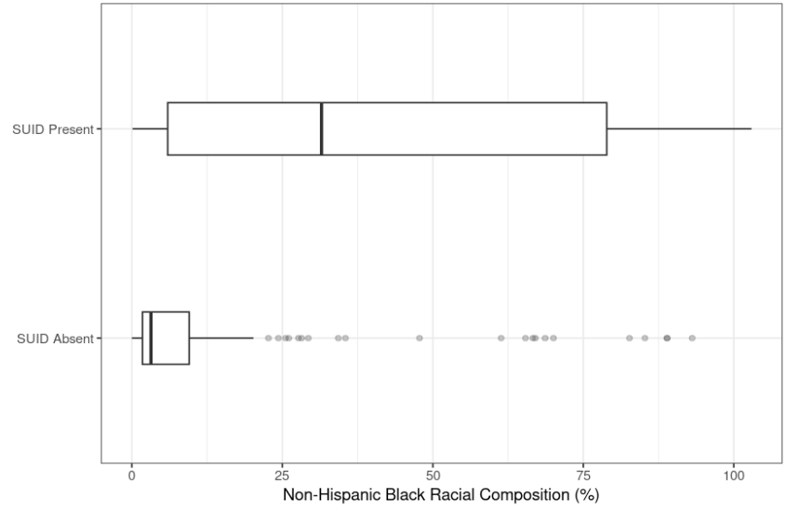

**Figure 4.** Comparing Black Racial Composition in Communities of Cook County, IL by Presence of SUID.

**Table 2**. Comparing Communities of Cook County, IL by Presence of SUID (2015-2019)

|  | Variable | No SUIDa | SUID Presenta |
| --- | --- | --- | --- |
|  |  | n = 102 | n = 97 |
|  |  |  |  |
| **Age** |  |  |  |
|  | Median Age (years) | 40 (36, 43) | 37 (34, 40) |
| **Sex** |  |  |  |
|  | Sex Ratio (males per 100 females) | 96 (91, 101) | 91 (84, 97) |
| **Race/Ethnicity** |  |  |  |
|  | Non-Hispanic White, Alone (%) | 60 (31, 76) | 17 (4, 49) |
|  | Non-Hispanic Black, Alone (%) | 3 (2, 10) | 32 (6, 79) |
|  | Asian, Any (%) | 5 (2, 11) | 2 (1, 6) |
|  | American Indian and Alaska Native, Any (%) | 1 (0, 1) | 1 (0, 1) |
|  | Hispanic, Any (%) | 14 (7, 33) | 14 (4, 28) |
| **Modeling Variables** |  |  |  |
|  | Total Population | 14,426 (8,446, 26,577) | 23,810 (13,811, 47,181) |
|  | Total People Living Below Poverty | 1,252 (578, 2,692) | 4,354 (1,873, 8,421) |
|  | Total Crowded Households | 116 (38, 330) | 284 (116, 639) |

aMedian (IQR)

### Modeling SUID Case Counts

We fit a negative binomial regression model to predict SUID case counts for each community of Cook County based on total population, total people living below the poverty line, and total households with more occupants than rooms (“crowded” households; Table 3). The model was retrospectively trained on SUID case counts for 2015-2019 with predictor variables from the 2014 SVI/ACS. Figure 5 depicts goodness of fit for the model on the training data, showing that it captured mid-range counts well, but under-predicted the number of communities with zero cases, over-predicted those with one case, and under-predicted those with counts over 6. See Supplement 1 for further details on model selection and evaluation of performance.

**Table 3**. Exponentiated Parameters for the Negative Binomial Regression Model Predicting SUID Case Counts in Communities of Cook County, IL.

| Parameter | RRa | SE | 95% CI | z-score | p-value |
| --- | --- | --- | --- | --- | --- |
|  |  |  |  |  |  |
| Intercept | 0.00134 | 0.00165 | (1.12e-04, 0.01) | -4.30 | < .001 |
| log(Total Crowded Households) | 0.68792 | 0.07917 | (0.55, 0.87) | -2.59 | 0.001 |
| log(Total People Living Below Poverty) | 6.06547 | 1.01710 | (4.42, 8.44) | 8.58 | < .001 |
| log(Total Population) | 0.55181 | 0.09339 | (0.40, 0.77) | -2.80 | < .001 |

aRR = Risk Ratio, interpreted as the magnitude by which you would multiply the risk with a unit increase of 1 for each covariate

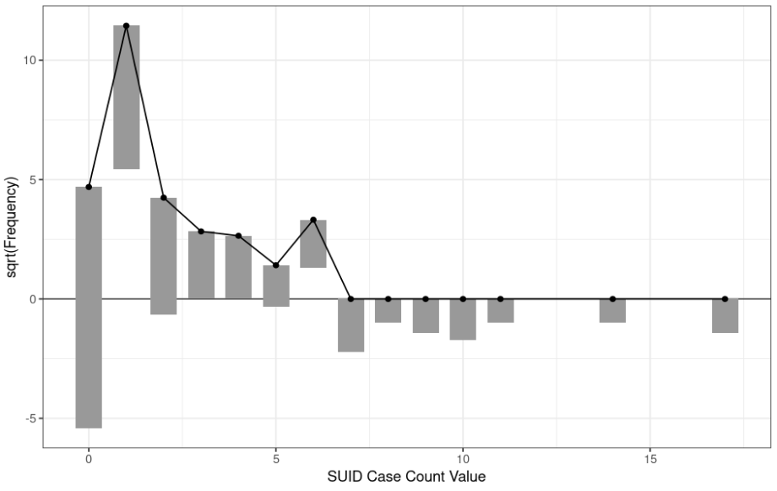

**Figure 5.** Rootogram Depicting Goodness of Fit for the Negative Binomial Regression Model Predicting SUID Case Counts in Communities of Cook County, IL. *Observed case counts are the bars “hanging” from predicted case counts pinned at the dots. For aggregate under-predictions, the bar will hang below zero, for aggregate over-predictions, the bar will hang above zero.*

The median difference between predicted and observed case counts in the training data was 0.24 (IQR -0.57, 0.60). All five communities with the highest observed case counts (Austin, Englewood, Humboldt Park, West Englewood, and West Pullman) were also among the communities with the most significant individual under-predictions (ranging from 4.05 to 7.61 less than that observed). On the other end of the spectrum, the five communities with the most significant individual over-predictions were Chicago Lawn, Douglas, Grand Boulevard, Kenwood, and Rogers Park (ranging from 2.94 to 4.77 more than that observed; Data Available in Supplement 2).

### Prospective Model Predictions

We applied predictor variables from the 2020 SVI/ACS to our trained model to predict case counts for 2021-2025. Most of the the top ten communities predicted to have the highest case counts for 2021-2025 were the same as those observed in the top ten for 2015-2019 except for Auburn Gresham, Chicago Lawn, and South Lawndale with predicted changes of +5, +8, and +3 respectively (Table 10). Figure 6 depicts these communities in spatial relation to each other.

**Table 4**. Top 10 Predicted Case Counts, Communities of Cook County, IL, 2021-2025

|  | 2021-2025 | | 2015-2019 | | |
| --- | --- | --- | --- | --- | --- |
| Community | Predicted  Count | Predicted Changea | Predicted  Count | Observed  Count | Residualb |
|  |  |  |  |  |  |
| Austin | 17 | +0 | 11 | 17 | -6 |
| Englewood | 14 | -3 | 9 | 17 | -8 |
| Auburn Greshamc | 12 | +5 | 7 | 7 | +0 |
| Chicago Lawnc | 12 | +8 | 7 | 4 | +3 |
| South Shore | 11 | +2 | 8 | 9 | -1 |
| Humboldt Park | 10 | +0 | 6 | 10 | -4 |
| North Lawndale | 10 | +1 | 8 | 9 | -1 |
| South Lawndalec | 10 | +3 | 7 | 7 | +0 |
| New City | 9 | -1 | 5 | 10 | -5 |
| West Englewood | 9 | -5 | 7 | 14 | -7 |

a(Prediction from 2021 to 2025) - (Observation from 2015 to 2019)

b(Prediction from 2015 to 2019) - (Observation from 2015 to 2019)

cNew to the Top 10 (Not in the Top 10 for Observed Case Counts from 2015 to 2019)

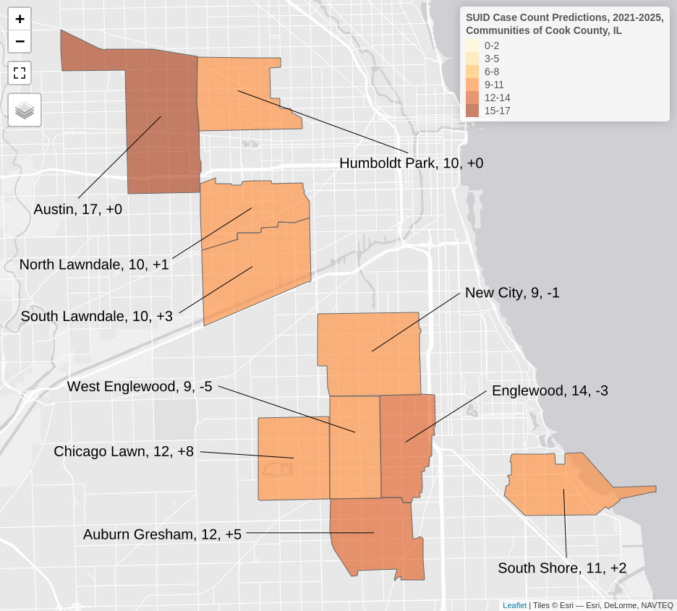

**Figure 6**. Top 10 Predicted Case Counts, 2021-2025, Communities of Cook County, IL. Labels = Community Name, Predicted Case Count, Predicted Change from 2015-2019.

## Discussion

### Principal Results

Our process for querying data from the Cook County Medical Examiner was able to identify cases of SUID from 2015-2019 with a high degree of fidelity to those identified by the county’s official registry. We aggregated these cases to the “community” level and found that those containing a case of SUID during the study period also had subjectively higher proportions of Black residents and lower proportions of White residents. We built a negative binomial regression model to predict SUID Case Counts and achieved moderate accuracy, especially within the mid-range of case counts. As an aide for deciding where to target preventive services, we mapped communities most affected by SUID. Our results suggested intervention programs should focus prevention efforts on North and West Sides of Chicago and in the South Suburbs of Cook County. The top ten communities predicted to have the highest case counts were also in these general areas. Chicago Lawn was predicted to emerge with the largest predicted increase of +8 cases. Other institutions in other regions can adapt this analytic workflow to determine priority areas for their own jurisdictions.

### Implications

We suggest our analytic outputs be used in different ways based on their temporal context. Within the model training period of 2014-2019, residuals between retrospective predictions and observations represent promising routes of inquiry for expanding understanding of community-level ecological factors affecting SUID incidence. For example, public health practitioners might consider intensive qualitative inquiry in the communities most under-predicted (like Austin and Englewood) to identify new risk factors and in communities most over-predicted (like Douglas and Grand Boulevard) to identify new protective factors unaccounted for by the model. After the model training period in 2020-2025, our prospective predictions represent opportunities to anticipate shifting dynamics in the communities most affected by SUID.

Regardless of temporal context, all results from this study can be used to guide a targeted, local approach to SUID prevention. Turman and Swigonski [35] proposed one framework for such an approach. Both high-level goals of their framework hinged on identifying specific zip codes with the highest infant mortality rates in Central Indiana. The first goal focused on developing infrastructure in those zip codes to support healthy pregnancies and infants. For example, they increased the capacity of local early childhood education programs, which both provided childcare for mothers seeking employment and served as vehicles for education on safe sleep practices. The second goal focused on training women from those zip codes as grass roots maternal child health leaders. Leaders developed narrative storytelling about their experiences with infant loss and were connected with local lawmakers to advocate for revised State policies. Special attention was paid toward recruiting women leaders from marginalized, minority populations. This framework is just as applicable to Cook County as to Central Indiana. Many of the key institutional partners like a local Fetal Infant Mortality Review Board are already in place and could use the maps and predictions from this study to identify targeted communities most at risk.

### Comparison with Prior Work

Our findings are consistent with the broader body of research on demographics related to infant mortality. Several other studies have also identified correlation between infant mortality and community-level factors like alcohol/drug use, education, employment, immigration, insurance, involvement of child protective services, poverty, racism, and racial segregation [5, 7, 36–39]. Some studies have posited direct causal relationships between these factors and infant mortality, but the evidence is still equivocal. Both Hearst et al. [39] and Johnson et al. [38] used propensity score matching as a means of isolating such causal effects, the former for residential segregation on Black infant mortality and the latter for neighborhood poverty on American Indian infant mortality. Both were unable to detect an influence, but emphasized that their inability to detect effects may have been due to limitations in size of sampling pools to achieve adequate counterfactual comparisons. Our study does not attempt to identify causal effects and instead focuses on helping local health departments to target precise regions of their jurisdictions for intervention.

Our study advances geospatial research on SUID in three major ways. First, we added finer detail to the available Chicago-based maps by using census tracts and “communities” as areal units, with the added benefit that these can be linked to census-derived demographics. Second, we added interactive capability to our maps for greater utility to practitioners wanting to explore the data first-hand. Third, to our knowledge this is the first study to have made prospective predictions on spatial incidence of SUID, helping to anticipate changing dynamics in regions of interest. In comparison, Briker et al. [4] performed a different, but complementary analysis of Cook County data, visualizing SUID incidence in 2015-2016 by kernel density estimation (KDE). Relative to our method of displaying counts per “community” areal unit, KDE has the advantage of smoothing out random variation observed in the data to make clusters more apparent. With this method, these authors also found strong clusters of SUID on the West and South Sides of Chicago. The comparative disadvantages of this technique are that the visualized kernels do not have one-to-one matches with real-world administrative boundaries and the units of intensity are less interpretable than counts. Also, because the map in Briker et al. was not interactive, it was more difficult to ascertain specific high-risk communities. In another study, Drake et al. [5] used KDE to visualize SUID incidence in Harris County, TX and this approach had the same advantages and disadvantages as described above. Fee and Tarrell [6] used analogous techniques to those used in our study by visualizing incidence in administrative areal units of Douglas County, NE. These authors also were able to correlate incidence with other variables, although their variables were more relevant to individual-level risk (e.g. prenatal care and tobacco use) rather than the population-level approach used in our study. In an older seminal study, Grimson et al. [9] focused on demonstrating statistical methods for identifying geospatial clusters. Their work is relevant to our study because the authors used SUID incidence as their example use-case, but our study was not focused on identifying statistically significant clusters and was more finely detailed on a smaller geographic scale.

### Limitations

Our study has limitations. First, a Durbin-Watson test of our model for autocorrelated residuals rejected the null hypothesis, suggesting that observations were not independent from each other. This was at least partially due to the interconnected nature of census tracts in physical space. Indeed, a Moran I test also rejected the null hypothesis, suggesting presence of spatial autocorrelation. Second, our model did not account for measurement error in our covariates, which are estimated by the ACS using sub-samples of the population. Failure to account for the margins of error and for spatial autocorrelation risked introducing systematic bias into our model predictions [40]. This was likely compounded by aggregating estimates for census tracts into the “community” areal unit. Trade-offs to this approach are described in the Methods section.

One means of addressing these first two limitations would be to implement a hierarchical Bayesian model of spatial measurement error [41]. We attempted to do so using the {geostan} R package [42], but preliminary attempts yielded warnings from the software that sampling chains did not converge–-significantly raising the risk of inaccurate parameter estimates. An additional limitation, which may have contributed to non-convergence, was that we did not have access to estimates of the true denominator for incidence of SUID (the count of live-births in each areal unit during the study period). The model implemented in {geostan} requires an “offset” denominator variable, so we used population counts of children under 5 as proxy, but this may have contributed additional imprecision that hampered the sampling algorithm’s ability to converge.

A final limitation was that not enough time had passed to empirically assess our model’s prospective predictions. Decision-makers at local health departments might be more confident in the model’s performance if they could see how it fared at predicting outside of the training dataset. We suggest mitigating this limitation by comparing prospective predictions with retrospective observations, both of which together make a more compelling argument for risk than either piece of information alone.

### Conclusions

Cook County, IL is still beset by racial and socioeconomic disparities in SUID outcomes. Our process for compiling and analyzing cases will allow intervention programs to more quickly address such disparities with efforts targeted to regions of the county most in need of prevention services.

## Acknowledgements

### Authors’ Contributions

DR contributed to conceptualization, primary analysis, original draft preparation, and review/editing. HZ contributed to data curation, analysis, and review/editing. WT contributed to conceptualization, supervision, and review/editing.

### Funding Information

This work was supported by a grant to Cook County Health from the US Department of Justice's Office for Victims of Crime: Reducing Child Fatalities and Recurring Child Injuries Caused by Crime Victimization. Award #2019-V3-GX-K004.

### Financial Disclosure

The authors have no disclosures to make.

### Other Acknowledgments

Thank you to Kyran Quinlan and his team at the SUID Case Registry for Cook County for reviewing cases identified by our querying method. Thank you to Joseph Feinglass, Phil Fontanarosa, and Sijia Wei for early feedback on this manuscript.

## Conflicts of Interest

None Declared

## Abbreviations

ACS: American Community Survey

AIC: Akaike information criteria

BIC: Bayesian information criteria

CI: confidence interval

IQR: interquartile range

IRR: incidence rate ratio

KDE: kernel density estimation

RMSE: root mean squared error

SE: standard error

SQL: structured query language

SUID: sudden unexpected infant death

SVI: Social Vulnerability Index

## References

1. Common SIDS and SUID Terms And Definitions | Safe to Sleep®, <https://safetosleep.nichd.nih.gov/safesleepbasics/SIDS/Common> (accessed 25 October 2022).

1. Goldstein RD, Lederman RI, Lichtenthal WG, et al. [The Grief of Mothers After the Sudden Unexpected Death of Their Infants](https://doi.org/10.1542/peds.2017-3651). Pediatrics 2018; 141: e20173651. PMID: 29712764. DOI: 10.1542/peds.2017-3651.

1. GBD Compare. Institute for Health Metrics and Evaluation, <http://vizhub.healthdata.org/gbd-compare> (accessed 19 November 2021).

1. Briker A, McLone S, Mason M, et al. [Modifiable sleep-related risk factors in infant deaths in Cook County, Illinois](https://doi.org/10.1186/s40621-019-0203-1). Injury Epidemiology 2019; 6: 24. PMID: 31333990. DOI: 10.1186/s40621-019-0203-1.

1. Drake SA, Wolf DA, Yang Y, et al. [A Descriptive and Geospatial Analysis of Environmental Factors Attributing to Sudden Unexpected Infant Death](https://doi.org/10.1097/PAF.0000000000000455). Am J Forensic Med Pathol 2019; 40: 108–116. PMID: 30570520. DOI: 10.1097/PAF.0000000000000455.

1. Fee CE, Tarrell A. Geographical Analysis of Sudden Infant Death Syndrome (SIDS) and Associated Risk Factors in Douglas County, Nebraska. <https://digitalcommons.unmc.edu/cgi/viewcontent.cgi?article=1001&context=emet_posters> (2017, accessed 22 August 2022).

1. Guest AM, Almgren G, Hussey JM. [The ecology of race and socioeconomic distress: Infant and working-age mortality in Chicago](https://www.proquest.com/docview/222957277/abstract/1892CA4013C14090PQ/1). 1998; 23–34. PMID: 9512907.

1. Horton R. [Offline: In defence of precision public health](https://doi.org/10.1016/S0140-6736(18)32741-7). Lancet 2018; 392: 1504.

1. Grimson RC, Wang KC, Johnson PWC. [Searching for hierarchical clusters of disease: Spatial patterns of sudden infant death syndrome](https://doi.org/10.1016/0160-8002(81)90004-6). Social Science & Medicine Part D: Medical Geography 1981; 15: 287–293.
2. Riggins, DP. https://github.com/andtheWings/cook_county_sids_mortality.

1. American Community Survey Data Products, <https://www.census.gov/programs-surveys/acs/>.

1. Social Vulnerability Index Data Products, <https://www.atsdr.cdc.gov/placeandhealth/svi/index.html>.

1. R Programming Language. R Foundation, https://www.r-project.org/

1. Tidyverse R Package Suite. Posit Software, PBC, <https://www.tidyverse.org/>.

1. Firke S. Janitor R Package, <https://sfirke.github.io/janitor/>.

1. Devlin H, Schenk T, Leynes G, et al. RSocrata Package, <https://cran.r-project.org/web/packages/RSocrata/index.html>.

1. Landau WM. Targets R Package. rOpenSci, <https://docs.ropensci.org/targets/>.

1. Iannone R, Cheng J, Schloerke B, et al. Gt R Package. Posit Software, PBC, <https://gt.rstudio.com/>.

1. Sjoberg DD, Larmarange J, Curry M, et al. Gtsummary R Package, <https://www.danieldsjoberg.com/gtsummary/>.

1. Pebesma E. Sf R Package. R consortium, <https://r-spatial.github.io/sf/index.html>.

1. Leaflet R Package. Posit Software, PBC, <https://rstudio.github.io/leaflet/>.

1. Tennekes M. Tmap: Thematic maps in R, <https://r-tmap.github.io/tmap/>.

1. Possenriede D, Sadler J, Salmon M. Opencage R Package. rOpenSci, <https://docs.ropensci.org/opencage/index.html>.

1. Walker K. Tigris R Package, <https://cran.rstudio.com/web/packages/tigris/>.

1. CARTO basemap styles. Carto, <https://github.com/CartoDB/basemap-styles>.

1. Warmerdam F, Rouault E. GDAL. Open Source Geospatial Foundation, <https://gdal.org/>.

1. GEOS. Open Source Geospatial Foundation, <https://libgeos.org/>.

1. Agafonkin V. Leaflet, <https://leafletjs.com/>.

1. OpenCage Geocoding API. OpenCage GmbH, <https://opencagedata.com/>.

1. OpenStreetMap. OpenStreetMap Foundation, <https://www.openstreetmap.org/>.

1. PROJ. Open Source Geospatial Foundation, <https://proj.org/index.html>.

1. TIGER Data Products, <https://www.census.gov/programs-surveys/geography/guidance/tiger-data-products-guide.html>.

1. Ripley B, Venables B, Bates DM, et al. MASS R Package, <https://cran.r-project.org/web/packages/MASS/index.html>.

1. Lüdecke D, Makowski D, Mattan, Ben-Shachar S, et al. Easystats R Package Suite, <https://easystats.github.io/easystats/>.

1. Turman JE, Swigonski NL. Changing Systems That Influence Birth Outcomes in Marginalized Zip Codes. Pediatrics; 148. Epub ahead of print July 2021. DOI: [10.1542/peds.2020-049651](https://doi.org/10.1542/peds.2020-049651).

1. Chambers BD, Arabia SE, Arega HA, et al. [Exposures to structural racism and racial discrimination among pregnant and early post-partum Black women living in Oakland, California](https://doi.org/10.1002/smi.2922). Stress Health 2020; 36: 213–219.

1. Bandoli G, Baer RJ, Owen M, et al. [Maternal, infant, and environmental risk factors for sudden unexpected infant deaths: Results from a large, administrative cohort](https://doi.org/10.1080/14767058.2021.2008899). J Matern Fetal Neonatal Med 2022; 35: 8998–9005.

1. Johnson PJ, Oakes JM, Anderton DL. [Neighborhood Poverty and American Indian Infant Death: Are The Effects Identifiable?](https://doi.org/10.1016/j.annepidem.2008.02.007) Annals of Epidemiology 2008; 18: 552–559.

1. Hearst MO, Oakes JM, Johnson PJ. [The Effect of Racial Residential Segregation on Black Infant Mortality](https://doi.org/10.1093/aje/kwn291). American Journal of Epidemiology 2008; 168: 1247–1254.

1. Bazuin JT, Fraser JC. [How the ACS gets it wrong: The story of the American Community Survey and a small, inner city neighborhood](https://doi.org/10.1016/j.apgeog.2013.08.013). Applied Geography 2013; 45: 292–302.

1. Bernardinelli L, Pascutto C, Best NG, et al. [Disease mapping with errors in covariates](https://doi.org/10.1002/(sici)1097-0258(19970415)16:7%3c741::aid-sim501%3e3.0.co;2-1). Stat Med 1997; 16: 741–752.

1. Connor Donegan. Geostan R Package, <https://connordonegan.github.io/geostan/>.