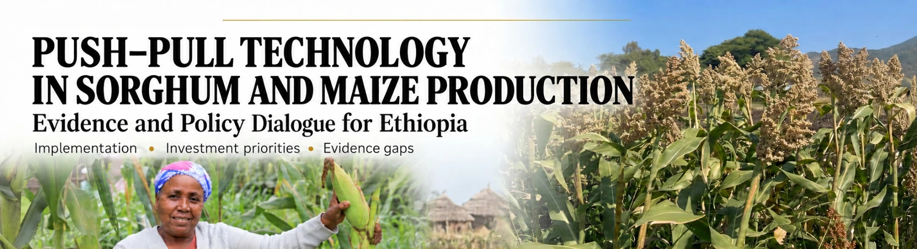
Push–Pull Technology Policy Dialogue
Sorghum and Maize Production Systems
Monday, 9 November 2026 • Adulala Resort, Bishoftu, Ethiopia
Event period 8–10 November 2026, including arrival and departure
PROGRAMME
TIME | SESSION / ACTIVITY | SPEAKER / RESPONSIBLE PERSON
08:30–08:45 | Registration | Organisers
08:45–09:00 | Welcome address | Ato Ghebremedhin
09:00–09:15 | Opening remarks | Dr. Tadele
09:15–09:30 | Introduction of participants | All participants
09:30–10:30 | Presentation: Push–pull technology for sorghum production — policy implications and scaling priorities | Dr. Getnet
10:30–11:00 | Tea and health break | Organisers
11:00–12:30 | Questions, answers and plenary discussion on the sorghum presentation | All participants  Facilitator: To be confirmed
12:30–14:00 | Lunch break | Organisers
14:00–14:30 | Summary of the morning discussions and key issues raised | Facilitator: To be confirmed
14:30–15:30 | Presentation: Push–pull technology for maize production — policy implications and scaling priorities | Speaker: To be confirmed
15:30–16:00 | Tea and health break | Organisers
16:00–17:30 | Questions, answers and plenary discussion on the maize presentation | All participants  Facilitator: To be confirmed
17:30–18:00 | Synthesis of the dialogue, key conclusions and closing remarks | Dr. Tadele
18:30 onwards | Dinner with participants | Organisers
■ Shaded rows indicate tea breaks and meals.

