# Lab 4

The points were loaded into 2 separate lists and sorted by increasing x and y values. The minimum x and y values are -23.763 and -24.285 respectively. The maximum x and y values are 44.585 and 44.745 respectively. Therefore, the bounding box containing these points has its bottom left vertex at (-23.763, -24.285) and its top right vertex at (44.585,44.745). The results for the lab can be seen below. Each new line represents each iteration run when the bounding box has been halved. The output is in the format (density, number of points in the bounded box, area)

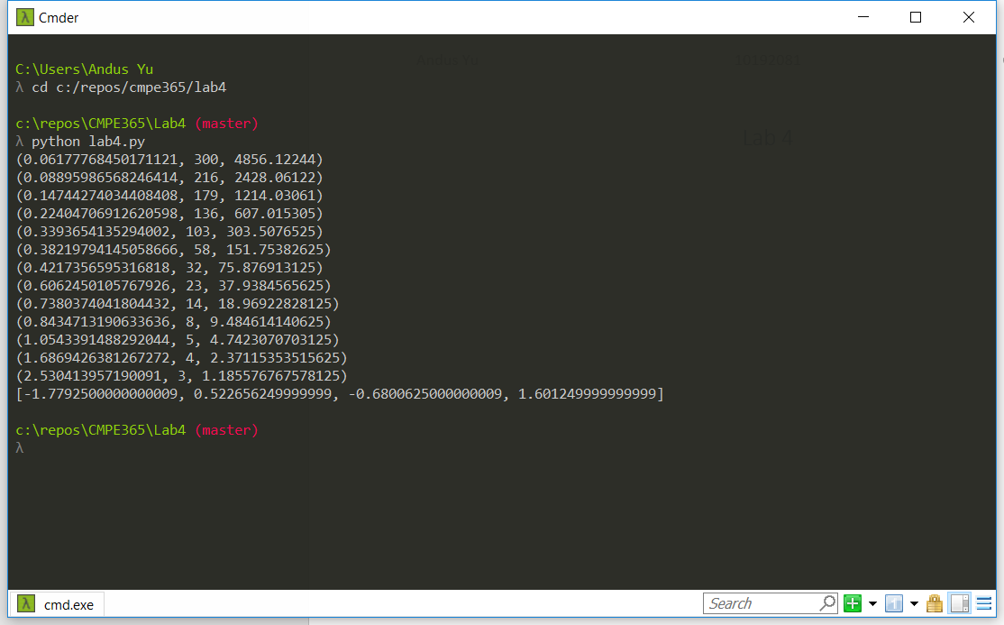

As seen in the above results, the bounding box starts with a density of 0.0617 points per unit2, with 300 points within ~4856 units2. The density increases as the area is reduced by half after each iteration. The maximum density without having the area of the bounded box go below 1 is ~2.53 points per unit2. The lower limit for the area was set to 1, otherwise results that were not logical would appear. For example, having 1 point in 0.5 units2 will give a density of 2 points per unit2. Furthermore, as the area keeps decreasing by half, it will approach 0. Therefore, the program will not terminate and the maximum density would approach infinity.