Computer Vision-Based Structural Analysis of Textile Medical Implants
Andrey Dyagilev1*[0000-0001-6293-4819], Saskia Hesse1, Pauline Riedl1,
Caroline Emonts1[0000-0001-6252-8351] and Thomas Gries1[0000-0002-2480-8333]
1 Institut für Textiltechnik (ITA), RWTH Aachen University, Otto-Blumenthal-Straße 1, 52074 Aachen, Germany
* andrei.dziahileu@ita.rwth-aachen.de
Abstract. Textile medical implants exhibit complex fibrous architectures whose structural characteristics can directly affect their functional performance and manufacturing quality. Reliable and reproducible characterization of these structures is therefore essential for quality assessment and process monitoring. This study presents a computer vision-based framework for the automated structural analysis and statistical quality assessment of textile medical implants using microscopy images. The proposed approach was applied to two structurally distinct implant types: woven polyethylene terephthalate vascular grafts and braided Nitinol vascular stents. Image-processing and machine-learning methods were used to identify architecture-specific structural features. For the woven grafts, the framework quantifies parameters describing yarn arrangement and geometry, while for the braided stents, parameters such as braiding angle and cell geometry are extracted. The resulting structural descriptors are statistically evaluated to characterize their distributions and spatial variability and to identify deviations from the expected structural characteristics. In addition, machine-learning models are investigated for automated classification based on the extracted structural information and image data. The results demonstrate the potential of the proposed framework to provide objective and reproducible quantitative information on textile implant architectures. By combining automated feature extraction, statistical characterization, and machine-learning-based analysis, the approach provides a basis for structural quality assessment and can support data-driven quality and process-control decisions in the manufacturing of textile medical implants.
Keywords: computer vision, textile medical implants, structural quality assessment, image analysis, machine learning, statistical analysis.
- Introduction
Textile-based materials are widely used in medical implants because their fibrous architectures can be tailored to provide specific mechanical and functional properties. Weaving and braiding technologies are employed in vascular grafts and stent structures, where parameters such as porosity, compliance, and structural arrangement can influence implant performance [1, 2]. The resulting textile architectures are therefore not only manufacturing features but also important characteristics for the functional assessment and quality control of medical implants.
Woven and braided architectures are particularly relevant for vascular implants. Woven grafts consist of interlaced warp and weft yarns, with structural parameters such as yarn density, spacing, and pore geometry affecting permeability and related functional properties [3]. Braided implants, in contrast, consist of interlaced filaments or wires, where parameters such as braiding angle, filament diameter, and strand configuration influence porosity and mechanical behaviour [4, 5]. Despite these architectural differences, both types of implants depend on the precise spatial organization of their constituent elements. Local variations in filament spacing, orientation, pore geometry, and density may occur during manufacturing and can result in structural variability.
Microscopy-based image analysis provides a suitable means of quantitatively characterizing such structural features. For woven structures, relevant descriptors include yarn density, spacing, orientation, and pore geometry, whereas braided structures can be characterized using parameters such as braiding angle, filament diameter, and strand configuration [4]. Previous studies have demonstrated the automated analysis of textile structures using image-processing techniques, including the measurement of yarn spacing and orientation [6], as well as image-based characterization of porosity-related parameters in woven fabrics [7]. These studies demonstrate the feasibility of extracting quantitative structural information directly from images.
Computer vision and machine learning have further expanded the possibilities for automated textile analysis. Image-processing methods have been used for the recognition and measurement of woven structural parameters, including fabric density and weave patterns [8, 9]. Convolutional neural networks have also been applied to the recognition of textile structures directly from images [10], while neural approaches have been investigated for extracting geometric yarn information [11]. More recent work has demonstrated the combination of computer vision and deep learning for quantitative yarn quality analysis [12]. These developments indicate that automated image-based methods can provide objective and reproducible information for structural characterization and quality assessment.
However, existing approaches mainly focus on individual structural parameters or specific recognition tasks, with particular emphasis on conventional woven textile structures [6, 8]. Less attention has been given to frameworks that combine architecture-specific structural feature extraction with statistical characterization of spatial variability and subsequent automated quality classification. This is particularly relevant for textile medical implants, where structurally different architectures require different quantitative descriptors while sharing the need for objective and reproducible assessment. In addition, manufacturing quality cannot be adequately described by nominal parameter values alone, since local deviations and spatial variability may provide important information about structural uniformity.
To address this gap, this study develops and evaluates a computer vision-based framework for the automated structural analysis and quality assessment of textile medical implants. The framework combines image-based extraction of architecture-specific structural descriptors with statistical analysis of their distributions and spatial variability. Two structurally distinct implant types are considered: woven polyethylene terephthalate vascular grafts and braided Nitinol vascular stents. For the woven grafts, the analysis focuses on parameters describing yarn arrangement and geometry, whereas for the braided stents, parameters such as braiding angle and cell geometry are extracted. In addition, Random Forest, Multilayer Perceptron, and Convolutional Neural Network models are investigated for automated structural quality classification. The overall objective is to establish a quantitative and reproducible basis for structural quality assessment that can support data-driven quality control and process monitoring in the manufacturing of textile medical implants.
- Materials and Methods
Fig. 1. Structural analysis and quality assessment pipeline.
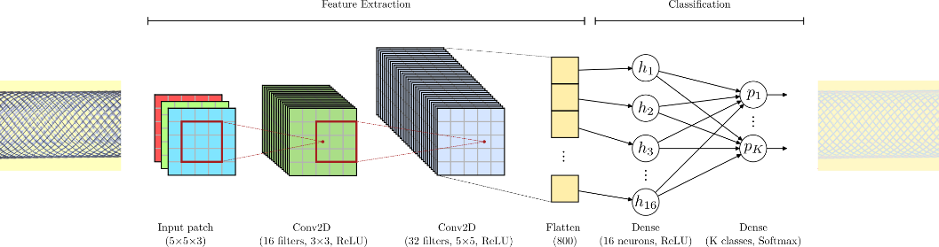
Fig. 2. CNN architecture for implant structure segmentation.

- Results and Discussion
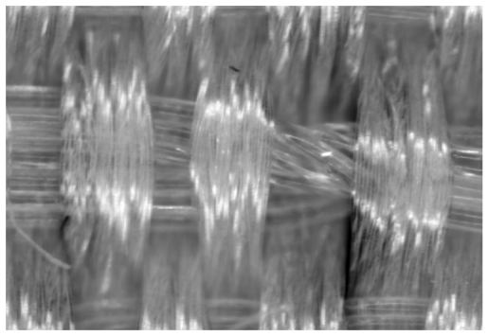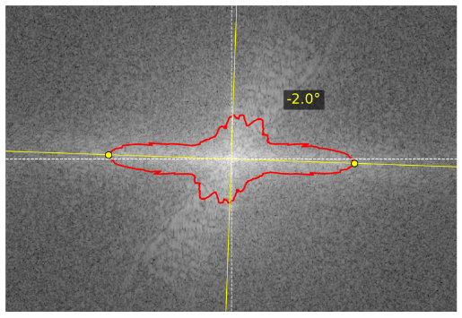
Fig. 3. Orientation correction of a vascular graft image using 2D FFT analysis.
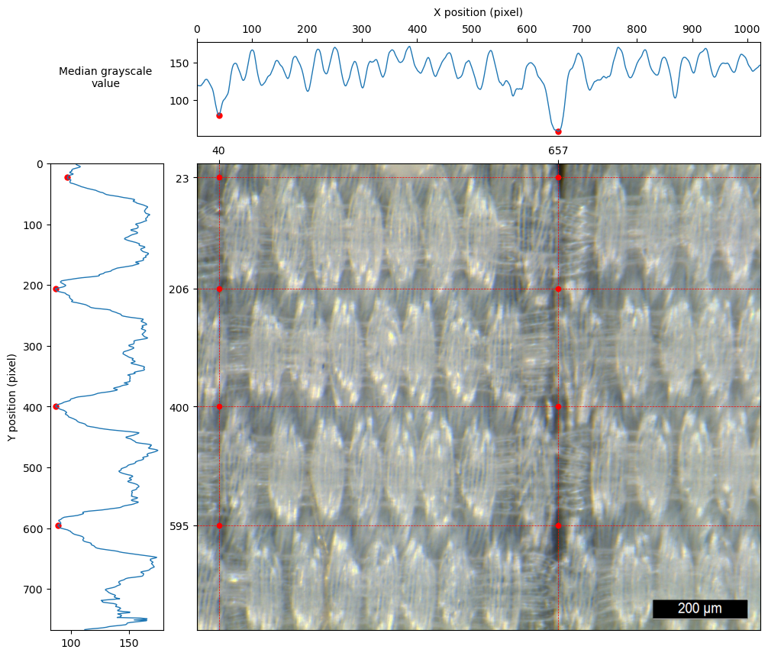
Fig. 4. Detection of weave repeat boundaries.

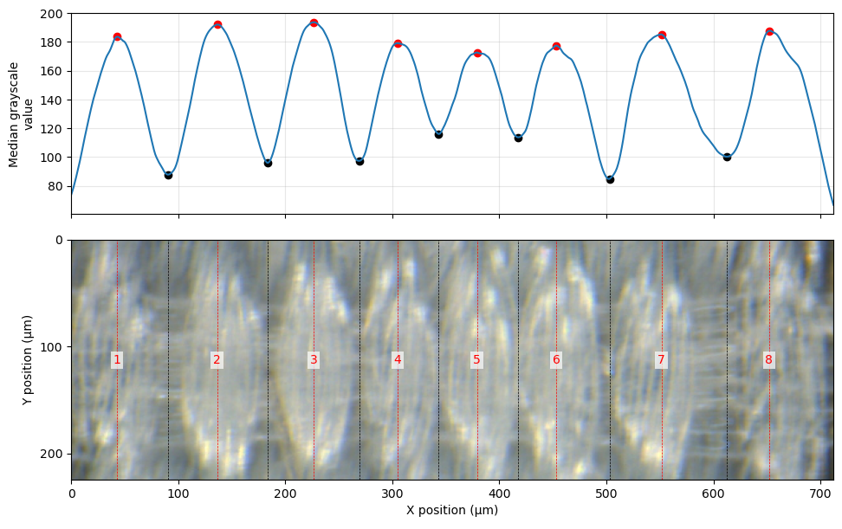
Fig. 5. Identification of individual yarn elements.
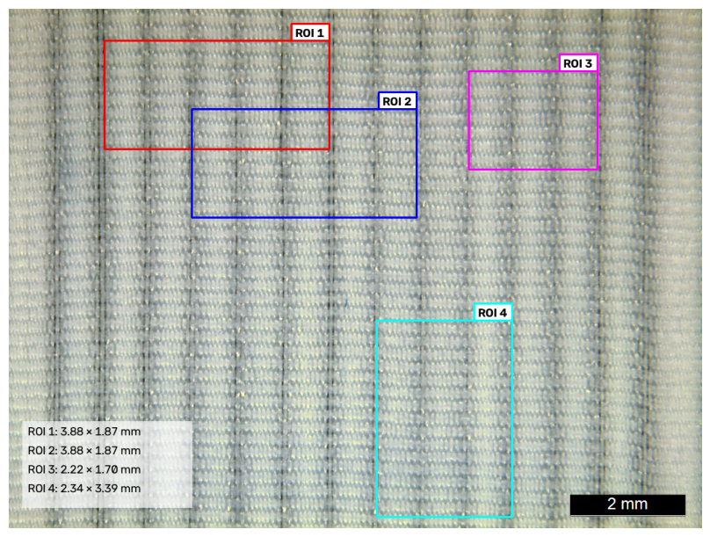
Fig. 6. Selection of regions of interest for local structural analysis.

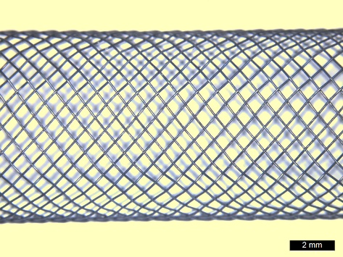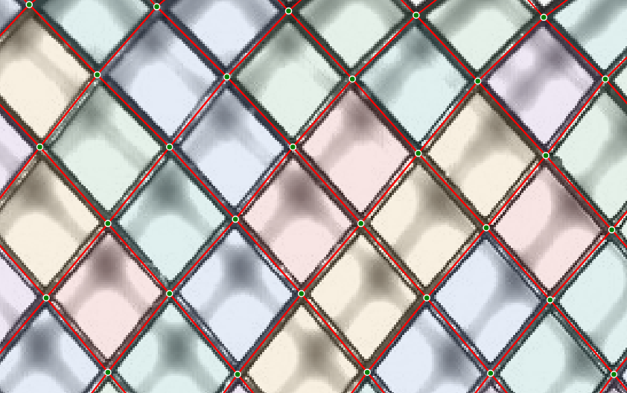

Fig. 7. Detection of braid cells in a Nitinol vascular stent: (a) stent surface and (b) enlarged view with detected braid lines and intersection points.

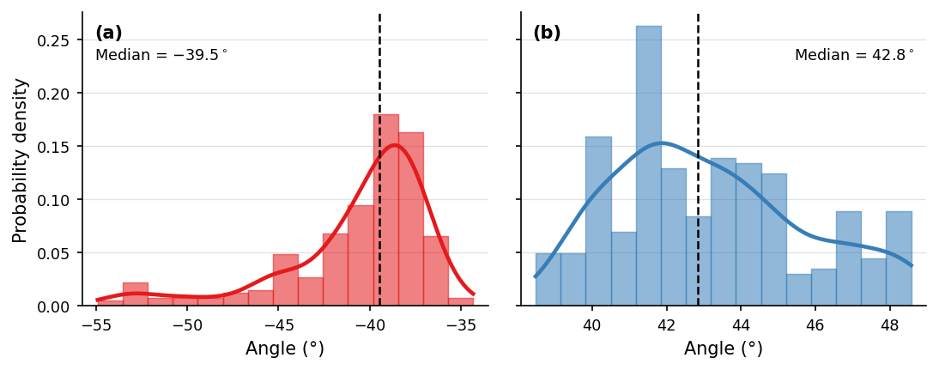

Fig. 8. Distribution of braiding angles for the two wire families: (a) negative and (b) positive angles.

- Conclusions
The developed computer vision framework was applied to two structurally distinct types of textile medical implants: woven vascular grafts and braided Nitinol vascular stents. For the woven grafts, the framework enables the extraction of structural descriptors related to yarn arrangement and geometry, while for the braided stents, architecture-specific parameters such as braiding angle and cell geometry are quantified from microscopy images.
The extracted structural descriptors are subsequently evaluated using statistical methods to characterize their distributions and spatial variability. This enables the assessment of structural uniformity and the identification of deviations from the expected structural characteristics. The resulting quantitative information can support quality assessment and provide a basis for data-driven decisions in manufacturing and process control.

  - A Subsection Sample
Please note that the first paragraph of a section or subsection is not indented. The first paragraphs that follows a table, figure, equation etc. does not have an indent, either.
Subsequent paragraphs, however, are indented.

Sample Heading (Third Level). Only two levels of headings should be numbered. Lower level headings remain unnumbered; they are formatted as run-in headings.

Sample Heading (Forth Level). The contribution should contain no more than four levels of headings. The following Table 1 gives a summary of all heading levels.
Table 1. Table captions should be placed above the tables.
Heading level | Example | Font size and style
Title (centered) | Lecture Notes | 14 point, bold
1st-level heading | 1 Introduction | 12 point, bold
2nd-level heading | 2.1 Printing Area | 10 point, bold
3rd-level heading | Run-in Heading in Bold. Text follows | 10 point, bold
4th-level heading | Lowest Level Heading. Text follows | 10 point, italic
Displayed equations are centered and set on a separate line.
x + y = z (1)
Please try to avoid rasterized images for line-art diagrams and schemas. Whenever possible, use vector graphics instead (see Fig. 3).

Fig. 9. A figure caption is always placed below the illustration. Short captions are centered, while long ones are justified. The macro button chooses the correct format automatically.
For citations of references, we prefer the use of square brackets and consecutive numbers. Citations using labels or the author/year convention are also acceptable. The following bibliography provides a sample reference list with entries for journal articles [1], an LNCS chapter [2], a book [3], proceedings without editors [4], as well as a URL [5].
Acknowledgments. A third level heading in 9-point font size at the end of the paper is used for general acknowledgments, for example: This study was funded by X (grant number Y).
Disclosure of Interests. It is now necessary to declare any competing interests or to specifically state that the authors have no competing interests. Please place the statement with a third level heading in 9-point font size beneath the (optional) acknowledgments, for example: The authors have no competing interests to declare that are relevant to the content of this article. Or: Author A has received research grants from Company W. Author B has received a speaker honorarium from Company X and owns stock in Company Y. Author C is a member of committee Z.

References
- Singh, C., Wong, C.S., Wang, X.: Medical textiles as vascular implants and their success to mimic natural arteries. Journal of Functional Biomaterials. 6, 500–525 (2015). https://doi.org/10.3390/jfb6030500
- Bakare, A., Mohanadas, H.P., Tucker, N., Ahmed, W., Manikandan, A., Faudzi, A.A.M., Mohamaddan, S., Jaganathan, S.K.: Advancements in textile techniques for cardiovascular tissue replacement and repair. APL Bioengineering. 8, (2024). https://doi.org/10.1063/5.0231856
- Guan, G., Yu, C., Fang, X., Guidoin, R., King, M.W., Wang, H., Wang, L.: Exploration into practical significance of integral water permeability of textile vascular grafts. Journal of Applied Biomaterials & Functional Materials. 19, (2021). https://doi.org/10.1177/22808000211014007
- Rebelo, R., Vila, N., Fangueiro, R., Carvalho, S., Rana, S.: Influence of design parameters on the mechanical behavior and porosity of braided fibrous stents. Materials & Design. 86, 237–247 (2015). https://doi.org/10.1016/j.matdes.2015.07.051
- Zheng, Q., Mozafari, H., Li, Z., Gu, L., An, M., Han, X., You, Z.: Mechanical characterization of braided self-expanding stents: Impact of design parameters. Journal of Mechanics in Medicine and Biology. 19, 1950038 (2019). https://doi.org/10.1142/S0219519419500386
- Kang, T.J., Choi, S.H., Kim, S.M., Oh, K.W.: Automatic structure analysis and objective evaluation of woven fabric using image analysis. Textile Research Journal. 71, 261–270 (2001). https://doi.org/10.1177/004051750107100312
- Zupin, Ž., Štampfl, V., Kočevar, T.N., Gabrijelčič Tomc, H.: Comparison of measured and calculated porosity parameters of woven fabrics to results obtained with image analysis. Materials. 17, 783 (2024). https://doi.org/10.3390/ma17040783
- Meng, S., Pan, R., Gao, W., Yan, B., Peng, Y.: Automatic recognition of woven fabric structural parameters: A review. Artificial Intelligence Review. 55, 6345–6387 (2022). https://doi.org/10.1007/s10462-022-10156-x
- Xiang, J., Pan, R.: Automatic recognition of density and weave pattern of yarn-dyed fabric. AUTEX Research Journal. 23, 504–513 (2022). https://doi.org/10.2478/aut-2022-0025
- Xiao, Z., Liu, X., Wu, J., Geng, L., Sun, Y., Zhang, F., Tong, J.: Knitted fabric structure recognition based on deep learning. The Journal of The Textile Institute. 109, 1217–1223 (2018). https://doi.org/10.1080/00405000.2017.1422309
- Trunz, E., Klein, J., Müller, J., Bode, L., Sarlette, R., Weinmann, M., Klein, R.: Neural inverse procedural modeling of knitting yarns from images. Computers & Graphics. 118, 161–172 (2024). https://doi.org/10.1016/j.cag.2023.12.013
- Pereira, F., Lopes, H., Pinto, L., Soares, F., Vasconcelos, R., Machado, J., Carvalho, V.: Yarn quality analysis by using computer vision and deep learning techniques. Textile Research Journal. 96, 240–265 (2025). https://doi.org/10.1177/00405175251331205

