Computer Vision-Based Structural Analysis of Textile Medical Implants
Andrey Dyagilev1*[0000-0001-6293-4819], Saskia Hesse1, Pauline Riedl1,
Caroline Emonts1[0000-0001-6252-8351] and Thomas Gries1[0000-0002-2480-8333]
1 Institut für Textiltechnik (ITA), RWTH Aachen University, Otto-Blumenthal-Straße 1, 52074 Aachen, Germany
* andrei.dziahileu@ita.rwth-aachen.de
Abstract. Textile medical implants exhibit complex fibrous architectures whose structural characteristics are relevant to their functional performance and manufacturing quality. However, the quantitative assessment of such structures is challenging because woven and braided implants require different structural descriptors, while local deviations may vary within and between implant specimens. Microscopy-based image analysis provides a means of characterizing textile structures, but existing approaches mainly address individual structural parameters or specific textile architectures. This study investigates a computer vision-based approach for the quantitative structural analysis of textile medical implants using microscopy images. The approach is applied to two structurally distinct implant types: woven polyethylene terephthalate (PET) vascular grafts and braided Nitinol vascular stents. For the woven grafts, weave repeats and individual yarn elements were identified and characterized using geometric parameters such as position, spacing, width, orientation, and dimensions. For the braided stents, pixel-wise classification and surface unwrapping were used to identify wire trajectories, intersection points, braid cells, and braiding angles. The extracted parameters were statistically characterized to assess local and spatial variability within the analyzed structures. The results demonstrate the feasibility of obtaining architecture-specific geometric descriptors from microscopy images and using them to quantify structural variations. The approach provides a basis for objective comparison of implant regions and specimens, while further validation is required to establish quantitative criteria for manufacturing quality assessment.
Keywords: computer vision, textile medical implants, structural analysis, microscopy image analysis, woven structures, braided structures.
- Introduction
Textile-based materials are widely used in medical implants because their fibrous architectures can provide specific mechanical and functional properties. Weaving and braiding are employed in vascular grafts and stents, where parameters such as porosity, compliance, and structural arrangement influence implant performance [1, 2]. Woven grafts are characterized by yarn density, spacing, and pore geometry, which affect permeability [3], while braided implants are described by parameters such as braiding angle, filament diameter, and strand configuration, which influence porosity and mechanical behaviour [4, 5]. Local variations in these parameters may result in structural variability and are therefore relevant to implant quality assessment.
Microscopy-based image analysis enables quantitative characterization of such structural features. Automated methods have been used to measure yarn spacing and orientation [6] and to characterize porosity-related parameters in woven fabrics [7]. Computer vision approaches have further enabled the recognition and measurement of woven structural parameters, including fabric density and weave patterns [8, 9]. Convolutional neural networks have been applied to textile structure recognition [10], while neural methods have also been investigated for extracting geometric yarn information [11]. More recent work has combined computer vision and deep learning for quantitative yarn quality analysis [12], demonstrating the potential of automated image-based methods for objective structural characterization and quality assessment.
However, existing approaches mainly focus on individual structural parameters or specific recognition tasks, with particular emphasis on conventional woven textile structures [6, 8]. Less attention has been given to image-based approaches that combine architecture-specific structural feature extraction with quantitative analysis of local and spatial variability. This is particularly relevant for textile medical implants, where woven and braided architectures require different structural descriptors while sharing the need for objective and reproducible characterization. Moreover, structural quality cannot be sufficiently described by nominal parameter values alone, as local deviations and spatial variability may provide additional information on structural uniformity.
To address this gap, this study investigates a computer vision-based approach for the quantitative structural analysis of textile medical implants using microscopy images. The approach combines image preprocessing, architecture-specific identification of structural elements, extraction of geometric descriptors, and statistical characterization of their variability. Two structurally distinct implant types are considered: woven polyethylene terephthalate (PET) vascular grafts and braided Nitinol vascular stents. For the woven grafts, the analysis focuses on yarn arrangement and geometry, whereas for the braided stents, wire trajectories, braiding angles, and braid-cell geometry are characterized. The extracted parameters provide a basis for comparing local structural characteristics and assessing structural uniformity across image regions and implant specimens.
- Materials and Methods
The study considers two structurally distinct types of textile medical implants: woven polyethylene terephthalate (PET) vascular grafts and braided Nitinol vascular stents. Their different architectures require architecture-specific procedures for the extraction and quantification of structural features from microscopy images.
The structural analysis and quality assessment are based on a sequential image-based workflow comprising image acquisition, preprocessing, structural feature extraction, quantitative analysis, and quality assessment (Fig. 1). The workflow provides a common basis for the analysis of both implant types while allowing the extraction of architecture-specific structural descriptors.

Fig. 1. Structural analysis and quality assessment pipeline.
The extracted geometric parameters are used to characterize local structural variability and to compare different image regions and implant specimens. Their statistical characteristics are subsequently considered for quality assessment.
- Results and Discussion
  - Woven PET Vascular Grafts
The acquired microscopy images of the woven PET vascular grafts were preprocessed using region-of-interest (ROI) selection, grayscale or CIELAB representations, local contrast enhancement, and orientation correction where required. The image representation was selected according to the contrast between the implant structure and the surrounding background. Local contrast enhancement was performed using Contrast Limited Adaptive Histogram Equalization (CLAHE), while ROI selection restricted the analysis to the relevant implant region.
Image orientation was estimated using two-dimensional Fast Fourier Transform (2D FFT) analysis. Dominant peaks in the frequency spectrum were used to determine the principal structural direction and the corresponding rotation angle. An example of orientation correction is shown in Fig. 2.

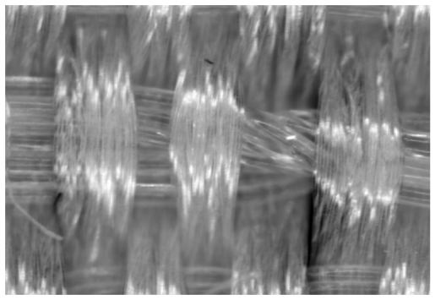 | 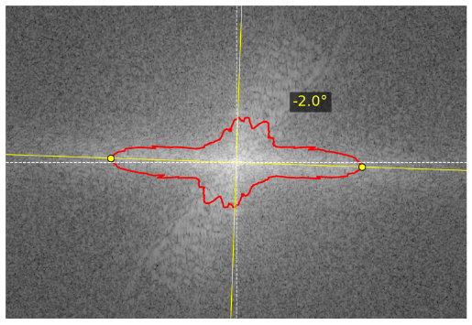
(a) | (b)
Fig. 2. Orientation correction of a vascular graft image using 2D FFT analysis.
The example in Fig. 2. shows dominant peaks in the FFT spectrum corresponding to the principal orientation of the woven structure. In this case, the detected orientation resulted in a rotation of -2° for image alignment.
For local structural analysis, multiple ROIs were selected within the preprocessed images. The ROIs were analyzed separately to characterize local structural properties, and the extracted parameters were compared to assess spatial variability and structural uniformity.
Structural feature extraction followed a sequential procedure in which the weave repeat was first identified and subsequently used as a reference for detecting individual yarn elements. The boundaries of the weave repeat were determined from periodic variations in image intensity using median intensity profiles along the x- and y-axes. The detected boundaries defined the spatial extent of the repeating unit and provided a coordinate reference for subsequent yarn identification, as shown in Fig. 3.
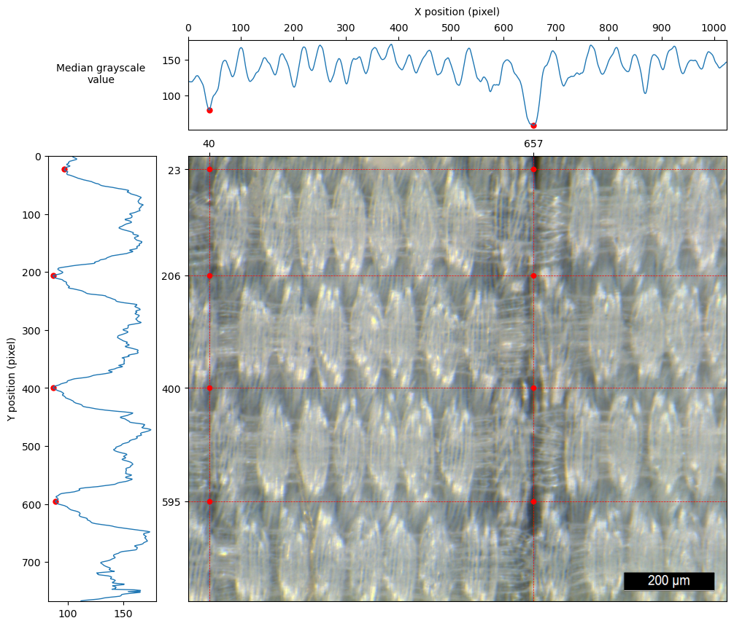
Fig. 3. Detection of weave repeat boundaries.
Within the identified weave repeat, local intensity profiles were used to detect individual yarn elements and their characteristic boundaries. The detected elements provided the basis for determining geometric parameters such as yarn position, spacing, width, orientation, and dimensions. The procedure can be applied iteratively across multiple weave repeats and image regions, providing a set of local geometric descriptors for quantitative and statistical analysis. An example of individual yarn identification within a weave repeat is shown in Fig. 4.
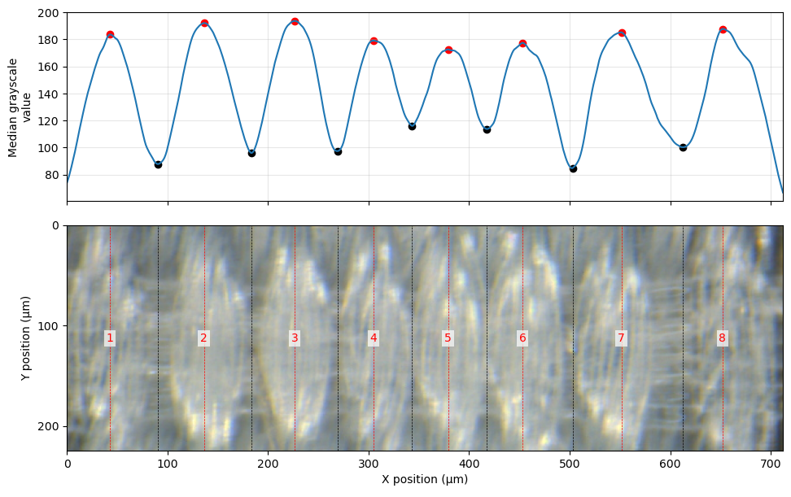
Fig. 4. Identification of individual yarn elements.
The resulting geometric descriptors characterize the local arrangement and geometry of the woven structure and provide the basis for subsequent analysis of structural variability and comparison between image regions and implant specimens.
  - Braided Nitinol Vascular Stents
For braided Nitinol vascular stents, structural elements were identified using a convolutional neural network (CNN) for pixel-wise classification. The network assigns class probabilities to individual pixels, enabling separation of the stent structure from the background and, where required, from different structural components. The resulting probability maps preserve the spatial information required for subsequent identification of wire trajectories and intersection points, despite shadows, illumination variations, and wire overlap. The CNN architecture is shown in Fig. 5.

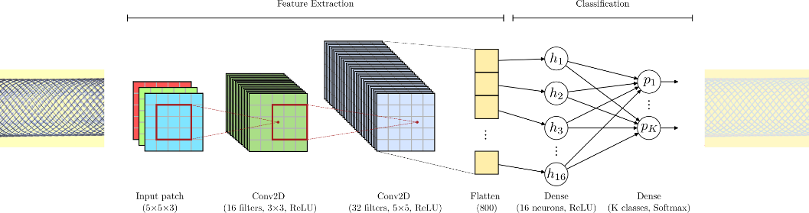
Fig. 5. CNN architecture for pixel-wise classification of implant structures.
The three-dimensional tubular geometry of the stent was considered in the geometric analysis. Since microscopy images represent a two-dimensional projection of the stent surface, direct measurements may introduce distortions, particularly for angular parameters. A surface-unwrapping procedure was therefore used to transform the visible stent surface into a planar representation, providing a consistent coordinate system for analyzing wire trajectories and their spatial relationships.
Following surface unwrapping, wire trajectories and intersection points were identified from the pixel-wise classification results. The two wire families were analyzed to determine the braiding angles, while the intersection points were used to identify braid cells. Their geometry was characterized using parameters such as cell area, characteristic dimensions, aspect ratio, and other shape-related descriptors.
An example of the detected wire network and braid cells is shown in Fig. 6.

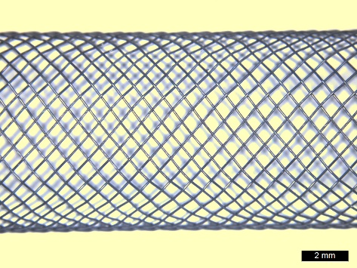 | 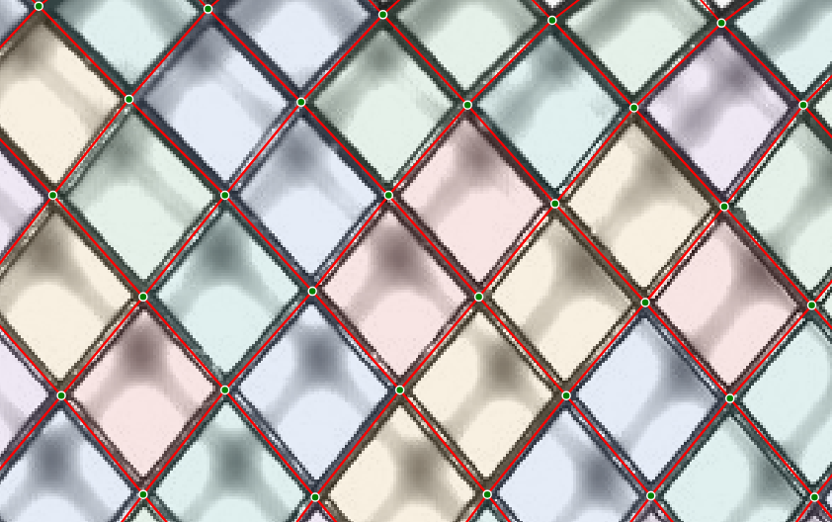
(a) | (b)
Fig. 6. Detection of braid cells in a Nitinol vascular stent: (a) stent surface and (b) enlarged view with detected braid lines and intersection points.
Geometric descriptors were determined for individual cells and local image regions. For the Nitinol stent shown in Fig. 6, braiding angles were analyzed separately for the two wire families, with the corresponding histograms shown in Fig. 7.

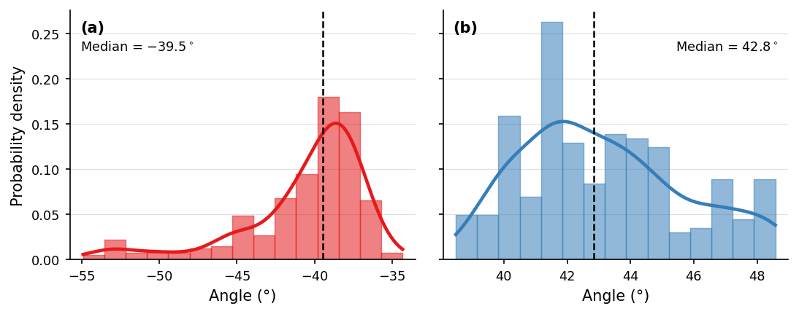
Fig. 7. Histograms of braiding angles for the two wire families: (a) negative and (b) positive angles.
The extracted parameters characterize the local geometry of the braided structure and can be compared across successive regions along the stent axis. Such comparisons quantify spatial changes in braiding angle, braid-cell geometry, and other structural parameters, providing a basis for assessing structural consistency.
  - Structural Comparison and Quality Assessment
The extracted geometric parameters enable quantitative comparison of different image regions and implant specimens. For woven PET grafts, yarn arrangement and geometry can be evaluated to characterize local structural variability, while braided Nitinol stents can be compared using braiding angles, braid-cell geometry, and other descriptors of the wire network.
Statistical characterization of the extracted parameters provides information on their variability within and between image regions. Local deviations from the prevailing structural characteristics can therefore be identified and used to assess spatial uniformity. Comparison between specimens can further be used to examine differences in structural characteristics.
The interpretation of the extracted parameters for quality assessment requires appropriate reference characteristics, such as nominal values, specified tolerances, or reference specimens. Considering these descriptors together with their spatial variability provides information on structural uniformity beyond individual parameter values.
Further validation across a larger number of specimens and manufacturing conditions is required to establish quantitative quality criteria and determine the sensitivity of the extracted descriptors to relevant manufacturing variations.
- Conclusions
A computer vision-based approach for the structural analysis of textile medical implants was investigated for two distinct architectures: woven polyethylene terephthalate (PET) vascular grafts and braided Nitinol vascular stents. Microscopy images enabled the identification of architecture-specific structural elements and extraction of geometric parameters describing their spatial organization.
For woven PET vascular grafts, weave repeats and individual yarn elements were identified, providing parameters such as yarn position, spacing, width, orientation, and dimensions. For braided Nitinol vascular stents, surface unwrapping and pixel-wise classification enabled the identification of wire trajectories, intersection points, braid cells, and braiding angles. The extracted parameters provide information on local structural characteristics and spatial variability.
The applicability of the approach depends on image quality and implant architecture. Image contrast, illumination, projection effects, and structural overlap may affect feature identification and geometric measurements. The extracted descriptors provide a basis for comparing image regions and implant specimens, while their use for manufacturing quality assessment requires appropriate reference characteristics and further validation.
Future work should focus on validating the extracted parameters across more specimens and manufacturing conditions and on investigating their relationship with spatial variability and manufacturing quality to establish criteria for quantitative structural quality assessment.

Disclosure of Interests. The authors have no competing interests to declare that are relevant to the content of this article.

References
- Singh, C., Wong, C.S., Wang, X.: Medical textiles as vascular implants and their success to mimic natural arteries. Journal of Functional Biomaterials. 6, 500–525 (2015). https://doi.org/10.3390/jfb6030500
- Bakare, A., Mohanadas, H.P., Tucker, N., Ahmed, W., Manikandan, A., Faudzi, A.A.M., Mohamaddan, S., Jaganathan, S.K.: Advancements in textile techniques for cardiovascular tissue replacement and repair. APL Bioengineering. 8, (2024). https://doi.org/10.1063/5.0231856
- Guan, G., Yu, C., Fang, X., Guidoin, R., King, M.W., Wang, H., Wang, L.: Exploration into practical significance of integral water permeability of textile vascular grafts. Journal of Applied Biomaterials & Functional Materials. 19, (2021). https://doi.org/10.1177/22808000211014007
- Rebelo, R., Vila, N., Fangueiro, R., Carvalho, S., Rana, S.: Influence of design parameters on the mechanical behavior and porosity of braided fibrous stents. Materials & Design. 86, 237–247 (2015). https://doi.org/10.1016/j.matdes.2015.07.051
- Zheng, Q., Mozafari, H., Li, Z., Gu, L., An, M., Han, X., You, Z.: Mechanical characterization of braided self-expanding stents: Impact of design parameters. Journal of Mechanics in Medicine and Biology. 19, 1950038 (2019). https://doi.org/10.1142/S0219519419500386
- Kang, T.J., Choi, S.H., Kim, S.M., Oh, K.W.: Automatic structure analysis and objective evaluation of woven fabric using image analysis. Textile Research Journal. 71, 261–270 (2001). https://doi.org/10.1177/004051750107100312
- Zupin, Ž., Štampfl, V., Kočevar, T.N., Gabrijelčič Tomc, H.: Comparison of measured and calculated porosity parameters of woven fabrics to results obtained with image analysis. Materials. 17, 783 (2024). https://doi.org/10.3390/ma17040783
- Meng, S., Pan, R., Gao, W., Yan, B., Peng, Y.: Automatic recognition of woven fabric structural parameters: A review. Artificial Intelligence Review. 55, 6345–6387 (2022). https://doi.org/10.1007/s10462-022-10156-x
- Xiang, J., Pan, R.: Automatic recognition of density and weave pattern of yarn-dyed fabric. AUTEX Research Journal. 23, 504–513 (2022). https://doi.org/10.2478/aut-2022-0025
- Xiao, Z., Liu, X., Wu, J., Geng, L., Sun, Y., Zhang, F., Tong, J.: Knitted fabric structure recognition based on deep learning. The Journal of The Textile Institute. 109, 1217–1223 (2018). https://doi.org/10.1080/00405000.2017.1422309
- Trunz, E., Klein, J., Müller, J., Bode, L., Sarlette, R., Weinmann, M., Klein, R.: Neural inverse procedural modeling of knitting yarns from images. Computers & Graphics. 118, 161–172 (2024). https://doi.org/10.1016/j.cag.2023.12.013
- Pereira, F., Lopes, H., Pinto, L., Soares, F., Vasconcelos, R., Machado, J., Carvalho, V.: Yarn quality analysis by using computer vision and deep learning techniques. Textile Research Journal. 96, 240–265 (2025). https://doi.org/10.1177/00405175251331205

