Computer Vision-Based Structural Analysis and Statistical Quality Assessment of Textile Medical Implants
Andrey Dyagilev^{1*}, Saskia Hesse¹, Pauline Riedl¹, Caroline Emonts¹ and Thomas Gries¹
¹ Institut für Textiltechnik (ITA), RWTH Aachen University, Aachen, Germany
*E-mail: andrei.dziahileu@ita.rwth-aachen.de

Keywords: computer vision, textile medical implants, quality assessment, structural parameter analysis, automated inspection
1. Introduction
Textile-based medical implants such as vascular grafts, stents, and soft tissue reinforcement devices rely on precisely defined structural architectures to achieve the required mechanical and functional properties. Textile manufacturing has enabled the realization of engineered structures with controlled features across multiple length scales [1, 2].
Woven and braided configurations are among the most relevant designs, exhibiting distinct structural behaviors ranging from ordered filament networks to deformation-adaptive helical geometries, as seen in braided stent architectures [2]. The growing structural complexity of such implants, together with stringent quality requirements, has motivated the development of automated image-based inspection approaches based on high-resolution microscopy and industrial quality control principles [3].
However, current inspection workflows remain largely manual, and existing image-based methods are typically limited to defect detection or segmentation tasks without robust integration into scalable quality assurance pipelines. Moreover, extracted image features are often evaluated deterministically, without statistical modeling of structural variability, limiting their usefulness for quantifying manufacturing deviations and ensuring reproducible quality metrics [3].
In this work, we propose a computer vision-based framework combining multi-scale feature extraction with statistical analysis of structural descriptors for automated and quantitative quality assessment of textile medical implants.
2. Material and Method
Microscopy images of textile medical implants served as the primary data source for this study. The investigated samples included woven polyethylene terephthalate (PET) vascular grafts and braided metallic stents manufactured from Nitinol wires. These implant classes exhibit distinct structural architectures and material compositions, providing a suitable basis for evaluating the proposed analysis framework.
The proposed analysis framework consists of a multi-stage processing pipeline including image preprocessing, segmentation of structural components, detection of relevant geometric elements, feature extraction, and statistical evaluation. Deep learning-based convolutional neural networks (CNNs) in combination with classical computer vision techniques were applied to segment implant structures and identify structural regions within microscopy images.
Based on the segmented data, geometric descriptors characterizing structural organization, such as filament spacing, orientation, pore geometry, and braid-related parameters, were extracted. These features were subsequently analyzed using statistical methods to quantify structural variability, assess homogeneity, and detect deviations associated with manufacturing-induced variations.
3. Results and Discussion
The proposed framework was applied to microscopy images of woven and braided implants, including polymer-based vascular grafts and braided metallic stents. The segmentation stage successfully identified and separated relevant structural components from the background (Fig. 1), enabling consistent representation of filament networks and braided wire architectures.
(a)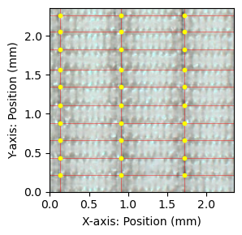 (b)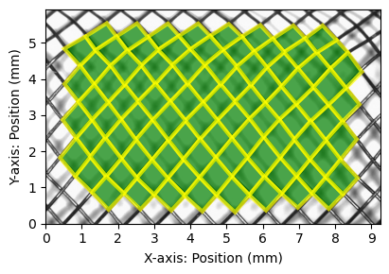
Figure 1. Automated structural detection in woven reinforcement (a) and vascular braided Nitinol (b) implants
Based on the segmented images, geometric descriptors were extracted to characterize local and global structural properties. The obtained features captured relevant characteristics such as filament spacing, structural orientation, pore geometry, and braid-related parameters, reflecting the inherent differences between implant architectures.
Statistical analysis of the extracted descriptors revealed measurable structural variability within and between samples. The observed distributions indicate differences in structural homogeneity, which are associated with manufacturing-induced variations and local geometric inconsistencies. These findings demonstrate the ability of the proposed framework to translate image-based information into quantitative structural representations.
Overall, the results confirm that the combination of deep learning-based image analysis and statistical evaluation enables objective characterization of textile medical implants and provides a basis for automated quality assessment and structural monitoring.
4. Conclusion
A computer vision-based framework for the automated quality assessment of textile medical implants was developed. The proposed workflow combines microscopy-based image acquisition, deep learning-based segmentation, geometric feature extraction, and statistical analysis of structural descriptors.
The framework enables quantitative evaluation of structural homogeneity and supports the identification of local and global anomalies resulting from manufacturing variability, providing deviation indicators for structural quality assessment. By integrating image analysis with statistical assessment, the proposed approach provides a reproducible and objective alternative to manual inspection procedures.
The developed methods can be applied to a wide range of textile medical implants and have the potential to support automated quality assurance, process monitoring, and digital quality documentation in advanced textile manufacturing.
References
[1] Singh C, Wong C S and Wang X 2015 Medical Textiles as Vascular Implants and Their Success to Mimic Natural Arteries Journal of Functional Biomaterials 6(3) 500–525 doi:10.3390/jfb6030500
[2] Rebelo R, Vila N, Fangueiro R and Carvalho S 2015 Influence of design parameters on the mechanical behavior and porosity of braided fibrous stents Materials & Design 86 237–247 doi:10.1016/j.matdes.2015.07.051
[3] Diers J and Pigorsch C 2023 A Survey of Methods for Automated Quality Control Based on Images International Journal of Computer Vision 131(10) 2553–2581 doi:10.1007/s11263-023-01822-w

