Butterfly scan

The algorithms and programs described here are in the repository on GitHub:

<https://github.com/andy-aa/butterfly_scan>

## Calculation of the body volume of a butterfly

The algorithm for estimating the volume of the body of a butterfly:

1. Converting a color image to black and white. Three-channel RGB image → Single-channel grayscale image → Single-channel black and white images. When converting an image to black and white, it is necessary to use an empirical coefficient that is in the range from 0 to 1. The empirical coefficient is a color code used to separate all colors in an image into two groups, black and white.

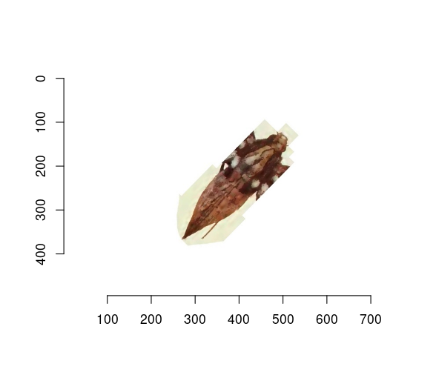

Color image

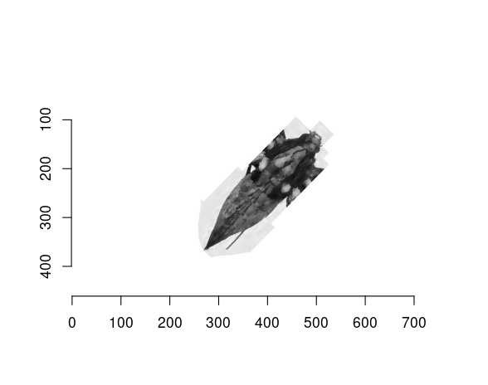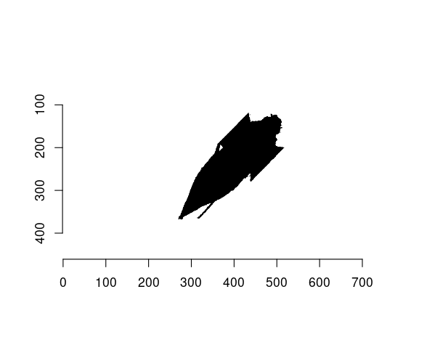

1. Search for the axis of rotation of an arbitrarily oriented body of a butterfly. The axis of rotation is a line connecting the two most distant points from each other. To reduce the search time, the convex hull of the figure is first constructed.

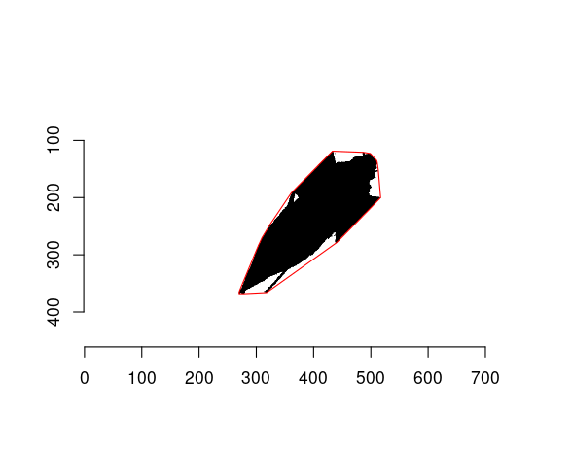

Convex hull

1. In the set of points of the convex hull, we need to find two points that have a maximum distance function: .

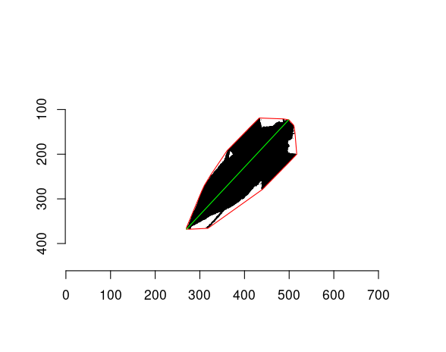

Axis of rotation

1. Finding the angle between the rotation axis and the x-axis. Rotate the image so that the rotation axis is perpendicular to the x-axis and parallel to the y-axis.

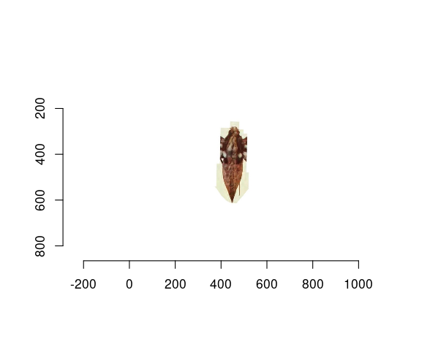 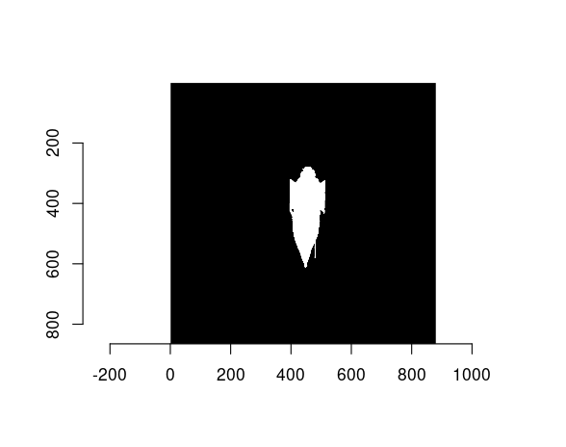

1. Dividing the silhouette (contour) into layers parallel to the x-axis. Finding the width of each layer. The width ($w_{i}$) of a layer is equal to the number of pixels in that layer multiplied by the physical size of a pixel. The layer height ($h$) is equal to the physical pixel size. Layer volume is: $v_{i}={\left(w_{i}/2\right)}^{2}*pi*h$. The total volume (V) is the sum of the volumes of its layers $V=\sum_{i=1}^{n}{v_{i}}$.

## Calculation of the moment of inertia of a butterfly wing

The algorithm for estimating the moment of inertia of a butterfly wing:

1. Converting a color image to black and white.

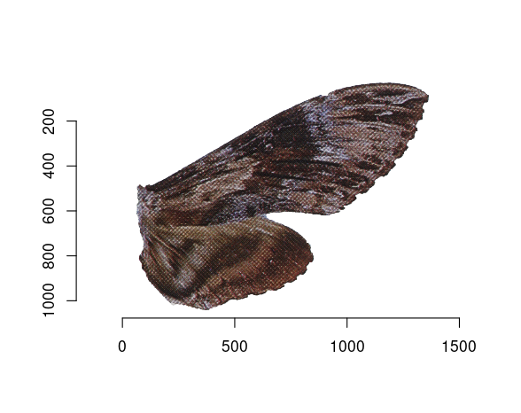 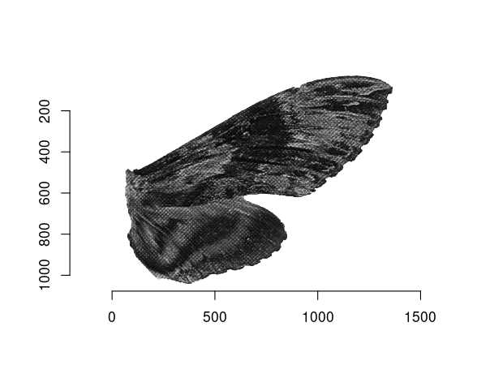 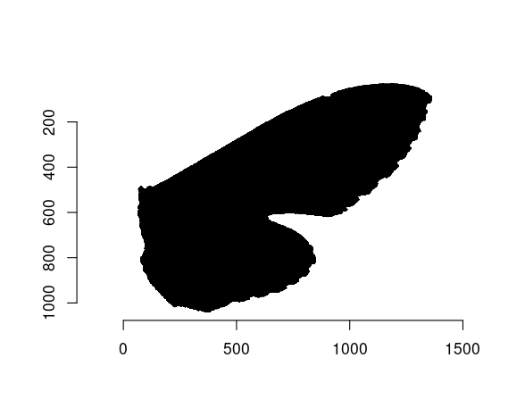

1. Calculation of the coordinates of the conditional center of mass. The classic formula for calculating the center of mass is:. In the case of a two-dimensional object, the formula takes the form: $x_{c}=\frac{\sum_{i=1}^{n}{m_{i}}x_{i}}{\sum_{i=1}^{n}{m_{i}}}$ and $y_{c}=\frac{\sum_{i=1}^{n}{m_{i}}y_{i}}{\sum_{i=1}^{n}{m_{i}}}$; If we take the mass of each point equal to 1, the formulas are noticeably simplified: $x_{c}=\overset{‾}{x}$ and $y_{c}=\overset{‾}{y}$.

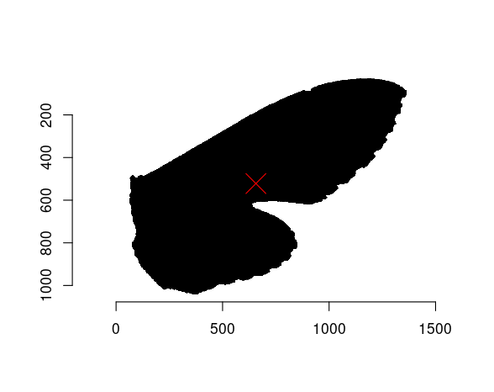

1. The classical formula for calculating the moment of inertia is: $J_{a}=\sum_{i=1}^{n}{m_{i}}r_{i}^{2}$, where $m_{i}$ is the mass of $i$-th point; $r_{i}$ is the distance from the $i$-th point to the axis. If we take the mass of each point equal to 1, and for the point of the axis we take the center of mass, the formula will take the form:

## Geometric classification and measurement of wing parameters

[1]

### Left wing of Hemaris diffinis

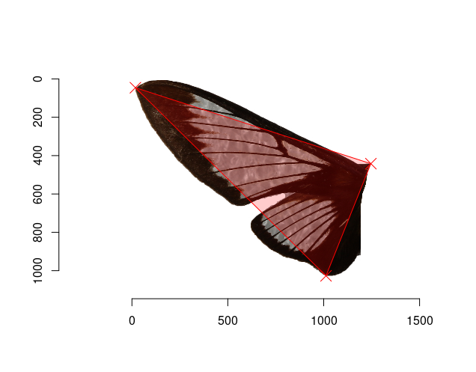

Threangle

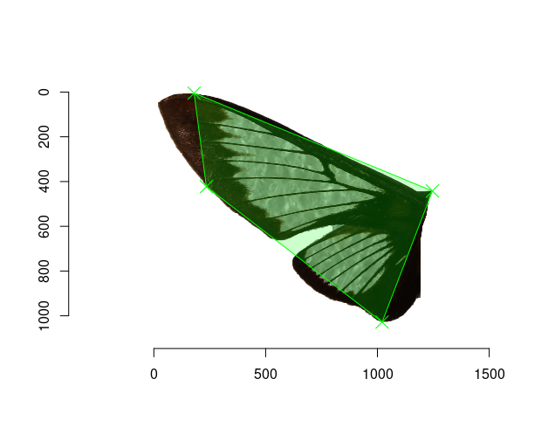

Quadrangle

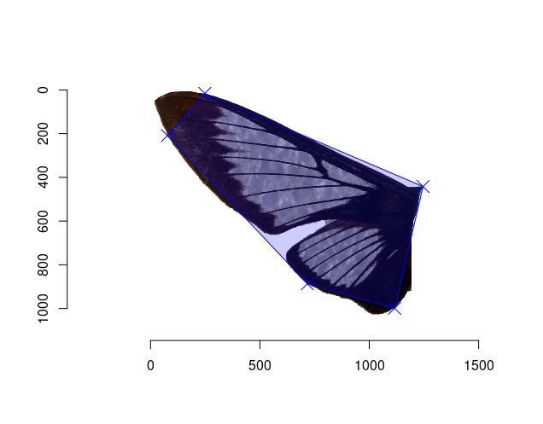

Pentagon

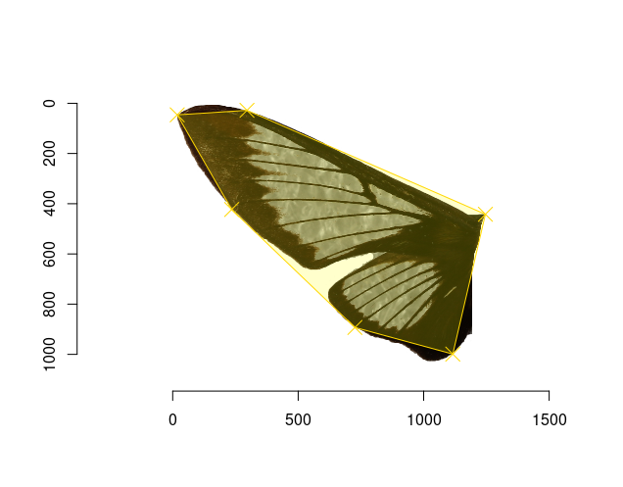

Hexagon

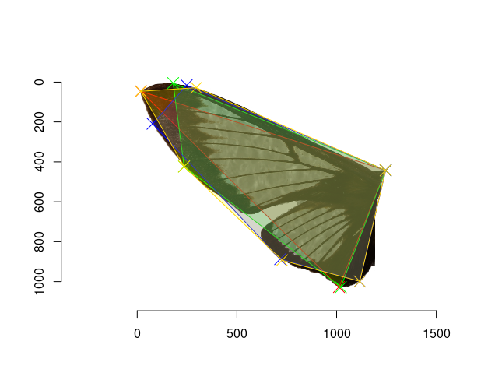

Superposition of polygons

### Left wing of Manduca rustica

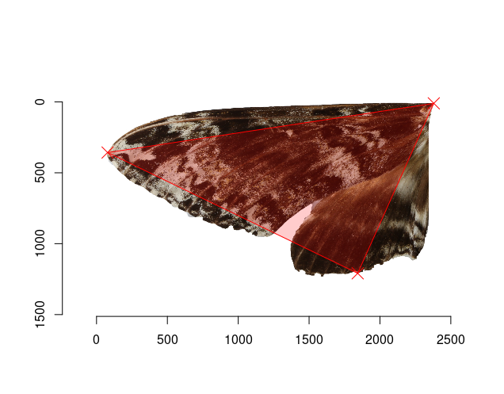

Threangle

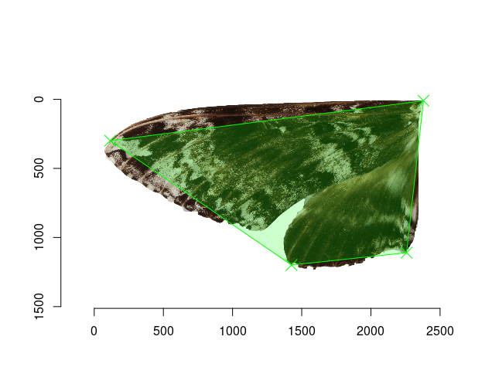

Quadrangle

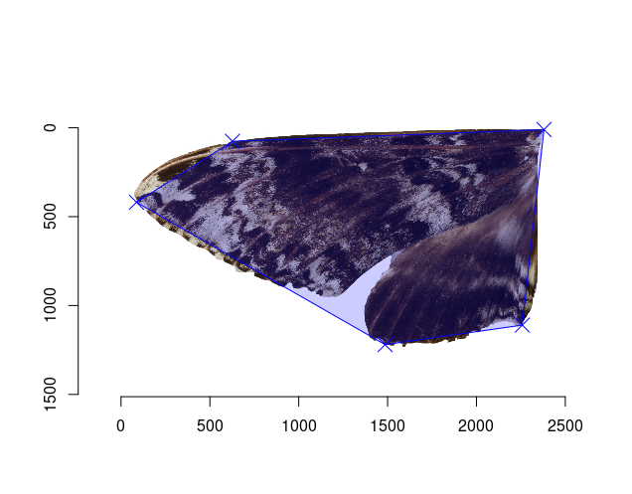

Pentagon

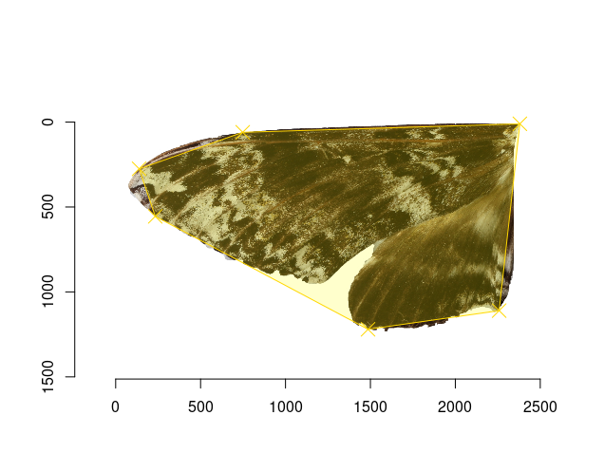

Hexagon

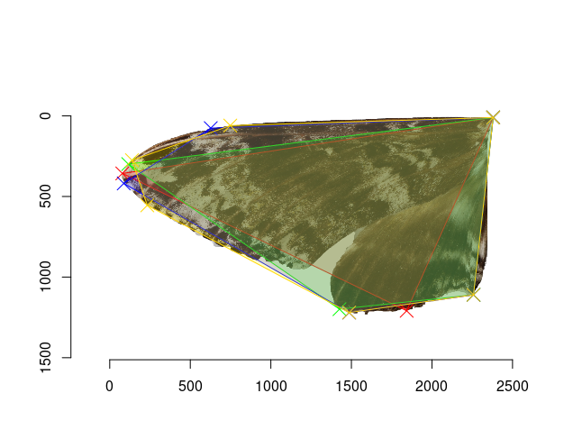

Superposition of polygons

[2]

## To be continued…

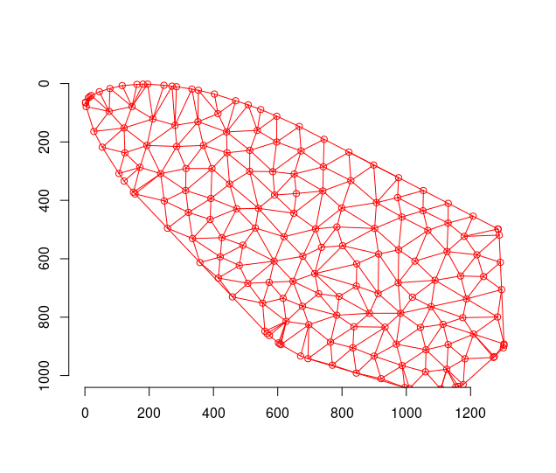 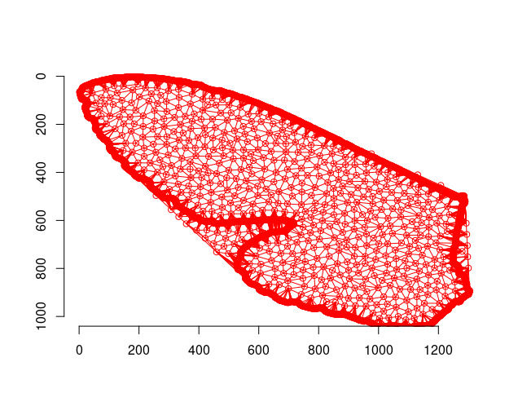

# References

1. Bronstein EM (2008) [Approximation of convex sets by polytopes](https://doi.org/10.1007/s10958-008-9144-x). *J Math Sci*.

2. Wikipedia.org (2022) [Computing the area of a triangle](https://en.wikipedia.org/wiki/Triangle#Using_coordinates).