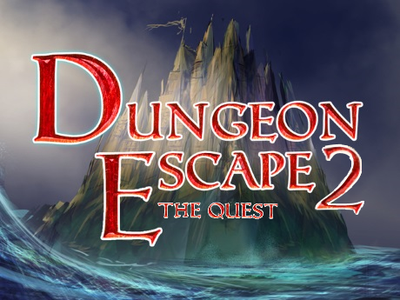

**& Dungeon Escape: Aniversary Edition**

**Instruction manual**

**Contents**

1. **Installation**
2. **Purpose**
3. **Instructions**
4. **Features**
5. **Gameplay**

**Installation**

**To install the games, take the DungeonEscapeSeries.zip file and extract it, after extraction run the shortcuts to link them to the current directory, then move them to wherever is convenient. You are now ready to play the Dungeon Escape games!**

**Purpose**

**The purpose of these games is to provide some slightly challenging fun to the user, by having them roleplay a user-created character in a medieval fantasy world, by solving logic puzzles and riddles, and make choices based on their perceived solutions.**

**Instructions**

**To play the games, run the executable jar and continue to character creation. After selecting your character’s name, class, and stats, you can continue to the actual game where, you get to make decisions based off circumstances that your scenario reveals. Correct decisions lead to another stage, incorrect decisions kill you, and neutral decisions either give you information or do nothing. After beating the main challenges there is a multi stage boss fight, where a powerful adversary appears that takes multiple stages to kill, and can kill you on each stage if you make the wrong combat choice. To beat the games successfully choose all correct answers until you get to the end of the game.**

**Features**

**Some features that the games do not explicitly mention from the GUI are:**

* **Beating Dungeon Escape: Aniversary Edition (DE) will create a save file**
* **Dungeon Escape 2: The Quest (DE2) can load the save files allowing a user to skip character creation**
* **Unlike DE, DE2 can do an internal reset, meaning you can play again without relaunching the program**
* **In DE2 achievement unlock is permanent between sessions**

**Gameplay**

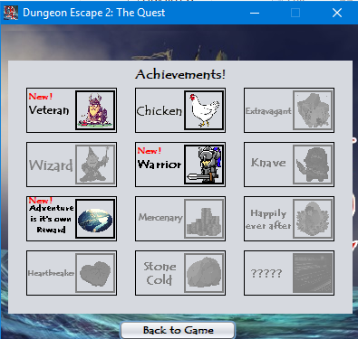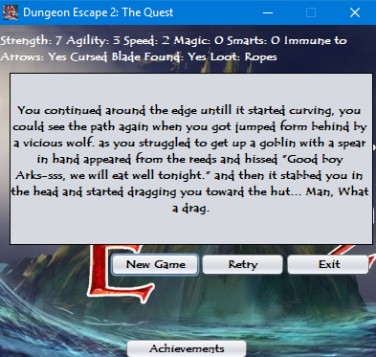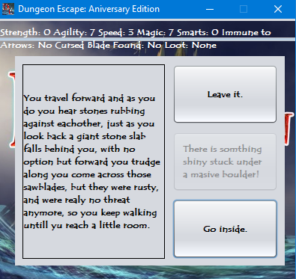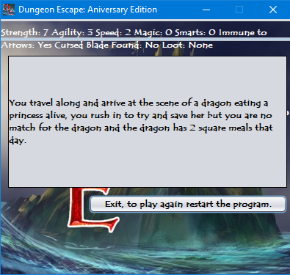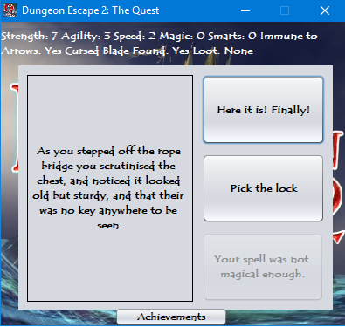**These are some screens you will see when playing the game!**