Scientific misconduct
Monkey business? Allegations of scientific misconduct at Harvard have academics up in arms.
The Economist, Aug 26th 2010

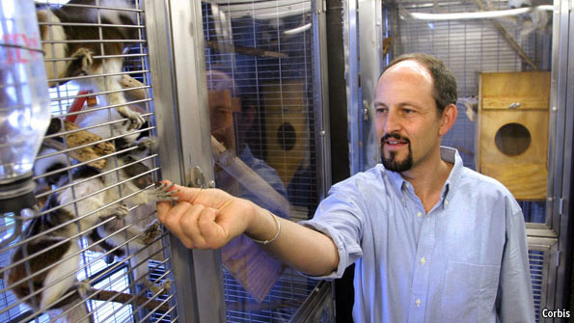
RARELY does it get much more ironic. Marc Hauser, a professor of psychology at Harvard who made his name probing the evolutionary origins of morality, is suspected of having committed the closest thing academia has to a deadly sin: cheating. It is not the first time the scientific world has been rocked by scandal. But the present furore, involving as it does a prestigious university and one of its star professors, will echo through common rooms and quadrangles far and wide.
The story broke on August 10th when the Boston Globe revealed that Dr Hauser had been under investigation since 2007 for alleged misconduct at Harvard’s Cognitive Evolution Laboratory, which he heads. This investigation has resulted in the retraction of an oft-cited study published in 2002 in Cognition, the publication last month of a correction to a paper from 2007 in the Proceedings of the Royal Society, and doubts about the validity of findings published in Science, also in 2007. All three studies purported to show that the cognitive abilities of some monkeys are closer to those of people than had previously been assumed. Dr Hauser was the only author common to all three papers.
An article in the Chronicle of Higher Education on August 19th added further spice. It offered unsettling accounts by (anonymous) graduate students and research assistants depicting Dr Hauser as brusquely dismissive of their attempts to discuss possible improprieties in data collection and interpretation.
This prompted Michael Smith, the hitherto taciturn dean of Harvard’s Faculty of Arts and Sciences, to react. In an open letter to the faculty on August 20th, he confirmed that an internal investigation had found Dr Hauser “solely responsible” for eight instances of scientific misconduct, involving the three published papers and five other pieces of research. Since some of the dubious work had been funded by the federal government, the matter has been referred to the Office of Research Integrity, the agency responsible for overseeing research practice. On the same day, Dr Hauser, who is on leave and refusing to be interviewed, issued a single contrite statement apologising for having made some “significant mistakes”.
Trials and errors
These would not be his first. In 1995 he claimed that cotton-top tamarins (with which he is pictured above) can recognise themselves in mirrors. At the time it was believed only humans and great apes could pass this test. Gordon Gallup, who invented the test in the 1960s and now teaches psychology at the State University of New York in Albany, found the results incredible and requested the filmed trials from which they had been drawn. After some pleading Dr Hauser sent him sample footage. What Dr Gallup saw apparently bore “no resemblance whatsoever” to the reported data, so he asked to examine the remaining videos, only to be told that these had been stolen. In 2001 Dr Hauser published another paper, admitting failure to replicate the earlier findings.
So far, none of this constitutes conclusive evidence of fraud. Slapdash lab work is not the same as fabricating data and Harvard has kept mum about the precise nature of the charges, citing concerns about privacy. Many researchers, however, fear that this silence itself makes things worse—and not just for Dr Hauser and Harvard. The uncertainty about which of his results (for he has been a prolific researcher) are up to snuff means others in the field are finding it hard to decide what to rely on in their own work. And despite Dr Hauser’s professed sole responsibility, a sizeable number of his present and former wards may unfairly be tainted by association.
At the least, then, Dr Hauser stands accused of setting the study of animal cognition back many years. Trying to discern an animal’s thought processes on the basis of its behaviour is notoriously tricky and subjective at the best of times. Now, his critics fear, no one will take it seriously. As Greg Laden, one of Dr Hauser’s former colleagues, laments in a blog, “the hubris and selfishness of one person can do more in the form of damage than an entire productive career can do in the way of building of our collective credibility.”
Others are less despondent, warning against conflating scientific misconduct with difficult science. One corner-cutting researcher does not impugn a whole field. Clive Wynne, editor of Behavioural Processes, which published an “obsessively” immaculate paper by Dr Hauser three days before the Globe’s revelations, says he is struck by how meticulous recent research in his discipline has been.
In general, scientists see themselves better placed than most to weed out cheats. The more startling a paper’s claims, the more likely it is that others will try to replicate it and, if the claims were specious, fail. Moreover, scientists want their work to be replicated; it is the only way it will stand the test of time, observes Robert Seyfarth, a primatologist and Dr Hauser’s former mentor.
Many researchers cite Harvard’s probe as further proof of science’s self-correcting mechanisms, and praise students for doughtily standing up to an authority figure of Dr Hauser’s distinction. Gerry Altmann, editor of Cognition, agrees, adding: “Although at the time it might appear that each transgression is major, its eventual impact on science is minor.”

