HW for Notes 4, General solutions Name __________________________

Rewrite the following equations to solve for the requested variable.

SHOW ALL WORK and BOX YOUR ANSWERS.

1. Given: 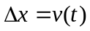 Solve for t:

2. Given: 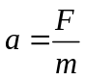 Solve for F:

3. Given: Solve for m:

4. Given: 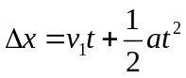 Solve for a:

5. Given: Solve for v₁:

6. Given: Solve for t:

7. Given: 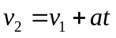 and

Solve for v₂ in terms of v₁, a, and ∆ x:

8. Given: 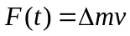 Solve for m:

9. Given: 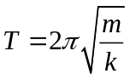 Solve for k:

10. Given: 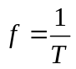 and

Solve for f in terms of m and k:

