0. Abstract
Bike-share systems (BSS) have become an essential component of urban mobility, yet operators continue to face challenges matching demand. This study addresses a key challenge for Bike Share Toronto: the difficulty in having enough bike-share station capacity to meet bike-share demand. Current rebalancing methods are often reactive and insufficient for proactive planning. The goal of this research is to predict the hourly demand for a proposed, new bike-share station using only data available before it is built (a "cold start" prediction). This provides BSS planners with a tool for station sizing and return on investment (ROI) assessment.
Four models were evaluated against a Multivariate Linear Regression (MLR) baseline: Random Forest (RF), XGBoost (XGB), and an Artificial Neural Network (ANN). The models were trained on Toronto data from January 2023 to September 2024, utilizing features such as temporal data, weather, transit access, and Points-of-Interest (POI) within a 400m radius. The XGBoost model performed the best with an RMSE of 1.2428 and an R^2 of 0.6126, slightly edging out the RF and ANN models. The MLR performed poorly, confirming the data's non-linear nature. Key findings from feature importance analysis were that time of day and distance to the city center (Union Station) were the strongest predictors. Surprisingly, restaurants and bars POIs were also strong indicators, suggesting a potential factor for new station locations. A primary limitation across all models was the under-prediction of peak demand hours, likely due to the highly zero-inflated nature of the hourly dataset. Future work should explore a two-stage modeling approach or the use of Graph Convolutional Networks (GCNs) to mitigate this issue and model network effects.

1. Introduction
Bike Share Toronto has experienced rapid growth in ridership for the past 4 years, increasing the number of trips by more than 1 million trips each year. Additionally, their station footprint is growing, with other 1000 active bike stations in 2025, compared to the 773 stations from the start of 2024 (Allen, 2024).
The problem for users of Toronto’s bike share system (BSS) is that it can be challenging to either find bikes or find open ports to park your bike, especially during peak hours. This is due to the nature of urban transportation where in 2024, a Toronto bike share report found that more than 80% of trips at peak hours tend to go in the same direction, towards the city center (Hanna, 2024).
Current rebalancing methods include using predictive models trained on past data to choose how to manually reallocate bikes, while also using points systems to incentivize users to bring bikes to stations that require more bikes, thus balancing the load. Nonetheless, this is still one of the major challenges experienced by BSSs across many cities, which is why much of the current literature surrounding BSSs, focuses on predicting demand to help be more proactive than reactive to system needs. However, I argue that one way to be more proactive than predicting demand for an existing station is to predict demand for a future station to minimize bike demand issues.
The goal of this study is to predict how busy a proposed bike-share station will be on a per-station hourly level before it is built. By only using data available before a station is built, the model helps identify the right station size, capacity, and expected return on investment (ROI) without relying on lag features or historical usage.
We'll be comparing various machine-learning models, using Multivariate Linear-Regressions as a baseline. The secondary goal of this study is to establish benchmark models and performances for future “cold start” bike share station prediction models to be built on. The results of this analysis are intended to assist in BSS planners with capacity planning and ROI assessment. The rest of this paper is structured as follows: Section 2 reviews related literature. Section 3 describes our datasets. Section 4 describes our data preprocessing and experiment methodology. Section 5 presents the experimental results and discusses implications and limitations, and Section 6 concludes.

2. Related Work
2.1 Bike-Share Demand Modeling Across Cities
Many existing studies focus on the BSSs of cities like New York, Seoul, Montreal, or Washington D.C. Their works have identified import predictors for predicting demand across an entire BSS such as temperature, wind-speed, and date/time-based features (Lainjo, 2022). They've also discovered indicators for station specific demand such as distance from Points of Interest (POI) and the socioeconomic level of surrounding neighbourhoods (Wang et al., 2021).
However, cross-city results are not always easily applicable as bike-share users' behaviours can be highly local. A literature review on existing BSS research in 2020, found that users across different systems reacted wildly differently to the same temperatures (Eren & Uz). This highlights the need for city-specific models, trained on local data rather than generalizing across systems.

2.2 Prior Work on Toronto's Bike-Share System
Several papers attempt to tackle the challenge of bike-share prediction using data from Toronto's Open Data Portal. Many of these papers are exploratory in nature or only predict system-wide ridership, rather than station level demand (El-Assi et al., 2015). This makes the results from these studies less suitable for application to real operations.
One study does take an in-depth look into the Toronto BSS, utilizing Graph Convolutional Networks to predict flow on a per-station basis (Mohseni et al., 2026). It considers station specific features like distance between stations, points of interest, socioeconomic levels, age, and more. However, this research relies on utilizing historical trips in between stations and is more suited for predicting real time demand for operational balancing rather than future station planning.

3. Data
This section outlines the four data sources that are integrated to construct an hourly, station-level dataset. This section is broken down into each of the four data sources and will cover each sources’ key features and limitations as well as what data quality issues they had and the data cleaning that we applied to it.

3.1 Data Sources
3.1.1 Bike Trips
This dataset is from the open data portal of the City of Toronto and is our primary source for Toronto bike share trips data (Open Data Portal 2025). This provides detailed data including start and end stations, timestamps, user type, and trip duration. This is also the source of our target variable, which will be a summation of the number of trips per-station on an hourly basis.

3.1.2 Bike Share Stations
We gather metadata on Toronto’s bike share stations through Toronto’s Public Bike System Feed (GBFS). Station attributes included capacity, latitude/longitude, and charging-station flags.

3.1.3 Weather
The weather observations were sourced from the Government of Canada’s weather service, that has a station located at Billy Bishop Airport (2025). Key features included temperature, humidity, precipitation, and wind speed.

3.1.4 Points-of-Interest (POI)
POI counts were collected using the Geoapify Places API and the longitude/latitude values sourced from the stations metadata (2025). We queried for a 400m (5 minute walk) radius around each station based off of urban planning best practices (El-Geneidy et al., 2013). Categories of POIs included the following: offices, restaurants and bars, parks, tourism, education, healthcare, and transit stops.

3.2 Data Limitations
3.2.1 Bike Trips
Some limitations of the trips dataset is that it only shows stations and hours where trips have occurred, meaning that there is no representation for most hours where there are no trips at a given station. Another limitation is that the most recent data is for September 30, 2024, meaning that we are missing more up to date data on recent station expansions and ridership trends.

3.2.2 Bike Share Stations
The only limitation of the bike stations dataset is that the feed only shows 2025 stations, many of which are not present in the 2023-2024 trips dataset. Similarly, many of the stations in the 2023-2024 trips dataset are not present in the station metadata. Manual reconciliation was required to gather the latitude/longitude data from station names.

3.2.3 Weather
A limitation of the weather data is that it only captures data for the area around Billy Bishop. Measurements for weather in areas beyond the downtown core like Scarborough or North York are likely off by at least a few hours.

3.2.4 POIs
The POI dataset has some limitations because it relies on the completeness of the API data source. Also, only searching in a 400m radius could have left some potential POIs not included, thus potentially reducing the effectiveness of the feature.

4. Methods
This section goes over any data preprocessing done, as well as steps for feature engineering, model selection, and experimental setup for training and evaluation.

4.1 Data Cleaning and Preprocessing
This section goes over the steps taken to clean and prepare the data for usage in analysis, training and so on. To clean the trips dataset, any trips shorter than 30 seconds were considered user errors and removed from the dataset. Based on the distribution, we also determined that any trips longer than 2 hours were likely from bikes that were not returned and removed those from the datasets as well. Any trips with both missing start or end station IDs and station names were removed since there was no way to replace this info. As for the weather data, null values were filled in using either linear interpolation or taking the median. The date time features for the weather data needed to be adjusted to account for Toronto’s Daylight Savings Time and match the trip records.

An analysis of the distributions of several of our features found them to be heavily zero-inflated with a strong right-skew. To adjust for these effects, a natural log transformation was applied to several features including the POI counts, precipitation, and the target variable.

4.2 Feature Engineering and Exploratory Data Analysis
During exploratory analysis of the 10.9 million trips recorded between January 2023 and September 2024, several strong temporal, spatial, and environmental patterns were identified that motivated our feature engineering strategy.

4.2.1 Temporal Features
Ridership exhibited strong seasonality with ridership peaking to roughly 900,000 in the summer and falling to 200,000 during the winter. There was also a clear, daily bi-modal pattern, as pictured in Figure 1, which corresponds to the morning and afternoon commute times.
<Figure 1>
Station-level activity varied substantially, with the busiest stations concentrated in office-dense downtown areas and showing strong weekday dominance, while the least busy stations displayed more irregular, weekend-oriented usage consistent with leisure activity near parks and recreational spaces.
This resulted in our decision to extract various measures of time and flags to capture trends we saw in our EDA. These included the day of the week, the hour of the day, whether it was morning or evening rush hour, and whether it was the weekend. Additionally, to capture the cyclical nature of time, we applied a cyclical encoding on all continuous time features.
We decided not to include time-lag features to our dataset as this data would not be available when attempting to predict a new bike-share station’s demand.

4.2.2 Weather
Weather conditions were also highly predictive. Likely the cause of the increase in ridership during the summer, ridership steadily increased with temperature until roughly 20–25°C. On the other hand, minimal precipitation, high humidity, and strong winds all tended to decrease ridership to some extent.

4.3.3 Spatial
Based on past research, we know that location plays a significant role in predicting bike share demand. To capture this trait, we calculated the geodesic distance in km from each station to the city center (Toronto Union Station) to capture centrality. We used the Haversine formula to do so.
We also wanted to capture neighbourhood data, which is why we applied a K-means clustering algorithm to the longitude and latitude of stations. With K = 5, we were able to find five distinct groups as pictured in Figure 2: Downtown Core, West End, East End, Scarborough, and Uptown. We applied one-hot encoding to these categories to add them to our model.

Figure 2 – Toronto Bike Stations K-Means Clustering
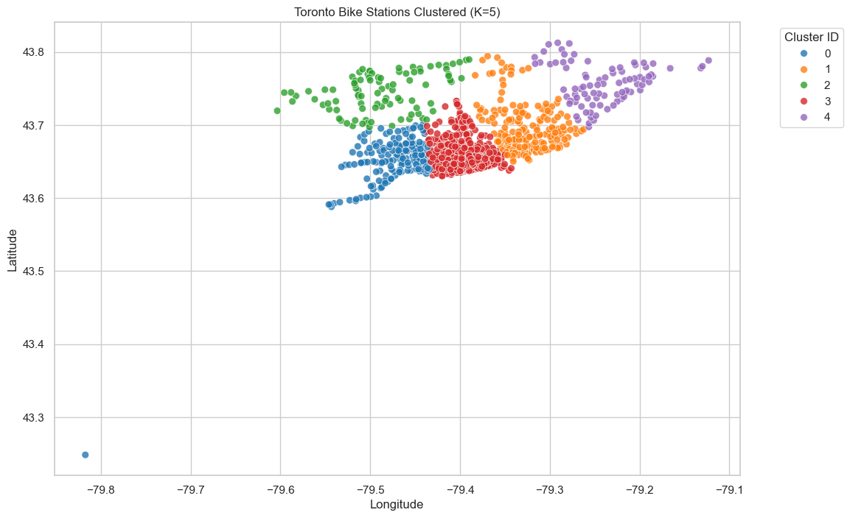
4.3.4 Final Join
To join these 4 datasets, I first constructed a time “skeleton” that contained all the hours from the beginning (2023-01-01) to the end (2024-09-30) of our dataset. Based on this, we merged all the other features, aggregating all the raw trip observations into two counts, trips_started and trips_ended. Trips_started is the target variable for the project and represents the number of trips started from a given station at a given time. Trips_ended was removed from the dataset for concerns about data leakage.

4.4 Feature Selection
For feature selection, we used a balanced approach combining both domain knowledge, Pearson Correlations, and Lasso Regressions. The Pearson correlation matrix highlighted features with a high degree of collinearity that we wanted to remove from our feature set such as dew point which was very similar to temperature. Similarly, all the temporal features with cyclical encodings of course had high collinearity with the base temporal values. Some other values like POI features also had some medium levels of collinearity but decided to keep them in favour of still capturing that information.
To confirm these results, we also tuned a Lasso regression using LassoCV from sci-kit-learn and used the model as an embedded feature-selection method. This expectedly demonstrated similar results.
We ultimately settled on two feature sets as pictured in Figure 3. One was for training on models that don’t do well with handling collinearity (ie. linear regressions, neural networks). The other set was for use with ensemble tree models that can handle some degree of collinearity, and this is where we included the raw values.
Figure 3 – Selected Feature sets
Category | Linear/ANN Model Features | Tree-Based Model Features
Time / Temporal | hour_sin, hour_cos, dow_sin, dow_cos, month_sin, month_cos, is_weekend, is_am_rush_hour, is_pm_rush_hour | hour_sin, hour_cos, dow_sin, dow_cos, month_sin, month_cos, hour, day_of_week, month, is_weekend, is_am_rush_hour, is_pm_rush_hour
Location / Station | latitude, longitude, dist_to_union_km, cluster_east_end, cluster_west_end, cluster_uptown, cluster_scarborough | latitude, longitude, dist_to_union_km, cluster_east_end, cluster_west_end, cluster_uptown, cluster_scarborough
Weather | temp_c, precip_mm, rel_humidity_pct, visibility_km | temp_c, precip_mm, rel_humidity_pct, visibility_km
Station Attributes | capacity, is_charging_station | capacity, is_charging_station
Transit Access | bus, subway, streetcar, train | bus, subway, streetcar, train
Points of Interest (POI) | restaurants_bars, education, park, tourism, office, commercial, healthcare | restaurants_bars, education, park, tourism, office, commercial, healthcare

4.5 Train, Validation, Test Split
To ensure a robust and temporally consistent evaluation, the data was split by entire days using a modulo-based strategy: days where day_of_year % 10 = 0 formed the 10% test set, %10 = 1 formed the 10% validation set, and the remaining days constituted the 80% training set. This approach preserves the temporal continuity of hourly demand patterns, which would be disrupted by a random row-level split, and prevents leakage where the model could inadvertently train on a station’s 8 AM demand while being tested on its 9 AM demand from the same day. Additionally, distributing days across the year ensures balanced representation of all seasons, avoiding the bias that would occur if the test set consisted only of the most recent months. Although the dataset is zero-inflated, with roughly twice as many zero-demand hours as non-zero hours, only light negative downsampling was considered to avoid distorting the natural distribution of low-demand periods that the models must learn to handle.

4.5 Models
This study evaluates four regression models: Multivariate Linear Regression (MLR), Random Forest (RF), XGBoost (XGB) and Artifical Neural Networks (ANNs). The ensemble tree and ANN models were selected to capture the non-linear patterns in the data. Models that work best for sequential data such as Recurrent Neural Networks or Long Short-Term Memory models were not included because to predict future demand, the models would require a series of past demand as input, which is data not available for new or future stations. All models were trained and evaluated using the same splits described earlier, enforcing temporal integrity and preventing leakages while maintaining balanced seasonal representation across all sets.

4.5.1 Multivariate Linear Regression
The MLR model serves as the benchmark model to establish a minimum performance baseline. This model uses the linear feature set. All numeric predictors were standardized using StandardScaler fit on the training set. Predictions were inverse transformed to account for the log transformed target value and clipped at zero to enforce non-negative outputs. This model was incredibly underfit, which further motivated the use of non-linear models.

4.5.2 Random Forest
The RF model was selected for its ability to model non-linear interactions between temporal, spatial, and contextual features. This model used the tree feature set. Hyperparameters were tuned using RandomizedSearchCV on the 10% sample subset to keep tuning computationally feasible. The best configuration (200 trees, max depth 40, min_samples_leaf 2, max_features='sqrt') was subsequently retrained on the full training dataset. This two-stage approach ensured efficient hyperparameter exploration while maximizing predictive performance on the full dataset.

4.5.3 XGBoost
The XGB model was incorporated as a more expressive gradient-boosted tree model capable of capturing higher-order nonlinearities and interactions. The exact same process as in the RF model was used to tune and train the XGB to maintain comparability. The optimal configuration included 1500 estimators, a learning rate of 0.05, and a maximum depth of 10.

4.5.4 Artificial Neural Network
An ANN was explored to assess whether a deep learning approach could match or exceed the performance of ensemble tree models. The model used the ANN Feature Set and is trained using the TensorFlow library. All continuous features were standardized using the training-set scaler, while binary indicators were left unscaled.
The model architecture evolved through iterative experimentation. Initial “sanity-check” models validated data formatting and training correctness, followed by comparisons between wide and deep architectures on the 10% sample and the full training set. Training employed the Adam optimizer and MSELoss, later adding early stopping and dropout to prevent overfitting. The final architecture ([512, 256, 128]) was selected based on the best validation performance.

5. Results
5.1 Evaluation and Metrics
Model performance was evaluated using Root Mean Squared Error (RMSE), Mean Absolute Error (MAE), and the $R^{2}$ value. RMSE was chosen as the primary metric since it was the most used metric in similar studies. Additionally, it suits our purposes since large errors in predictions translate to expensive failures in real life. MAE provided an intuitive sense of typical per-hour error in bike units, and R² enabled some comparison across model families.

All models used the same train-validation-test split, with negative predictions being set to zero, and predicted values for bike demand being converted from the log transformed version, back to a meaningful value. The results of the different models are presented in Figure 4.

Figure 4 - Test Set Performance Across All Models (Real Bike Counts)
Model | RMSE | MAE | R²
Multiple Linear Regression (MLR) | 1.8137 | 0.8115 | 0.1751
Random Forest (RF) | 1.2493 | 0.5612 | 0.6086
XGBoost (XGB) | 1.2428 | 0.5631 | 0.6126
Neural Network (BikeDemandNet) | 1.2551 | 0.5643 | 0.6050

The MLR model performed poorly across all metrics, which was expected given the results of our EDA. With an RMSE of 1.81, the prediction was off by more than twice the average demand (0.82). This is likely a result of the zero-inflated data lowering the average prediction while peak bike share demand hours cause large errors.

The RF model demonstrated a notable reduction in RMSE of 32% which can be attributed to its ability to model non-linear interactions. Although we decided to clip negative predictions to 0, the RF model did not produce any negative predictions which could prove to be an advantage in application.

The XGB model takes the slight advantage over the RF model, with a reduction in RMSE of just 0.5%. However, this model did produce a large number of negative predictions (~11% of test rows), demonstrating a limitation of the model to be considered in future applications.

Lastly, while the ANN (BikeDemandNet) performed slightly worse than the tree models, it was able to produce few negative predictions at just under 3%. The model benefited the most from a wide architecture and large amount of training data.

Overall, all the models showed strong stability across train and test data, and the XGB model was the best, with a slight advantage over the RF and ANN models.

5.2 Discussion
Based on results across all non-linear models, the Actual vs. Predicted plot in Figure 5 shows the very dense concentration of low demand hours (0-20 hours). Additionally, all models struggled to predict peak demand hours, with predictions rarely going past 40 bikes per hour. Similar trends are seen in the distribution of errors, with all 4 plots demonstrating a right-skew which means that all models are underpredicting. This is unfortunate as peak hours are when demand predictions and capacity planning is the most important. However, this may point to a greater issue with the data methodology as it seems to be resulted from the zero-inflated data. This will likely continue to be a limitation for modeling bike share demand, where you require a balance of modeling low-demand hours while still being able to predict peaks.

Figure 5 – Final Model Visualizations for All Models: a) MLR b) RF c) XGB d) ANN

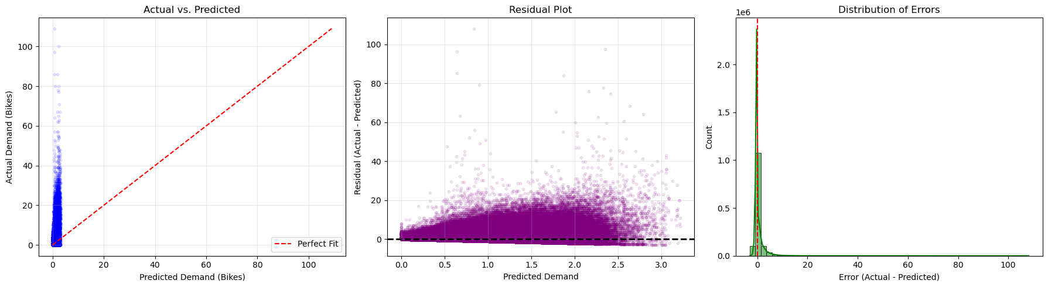

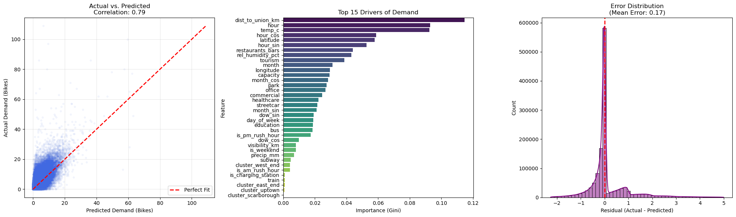

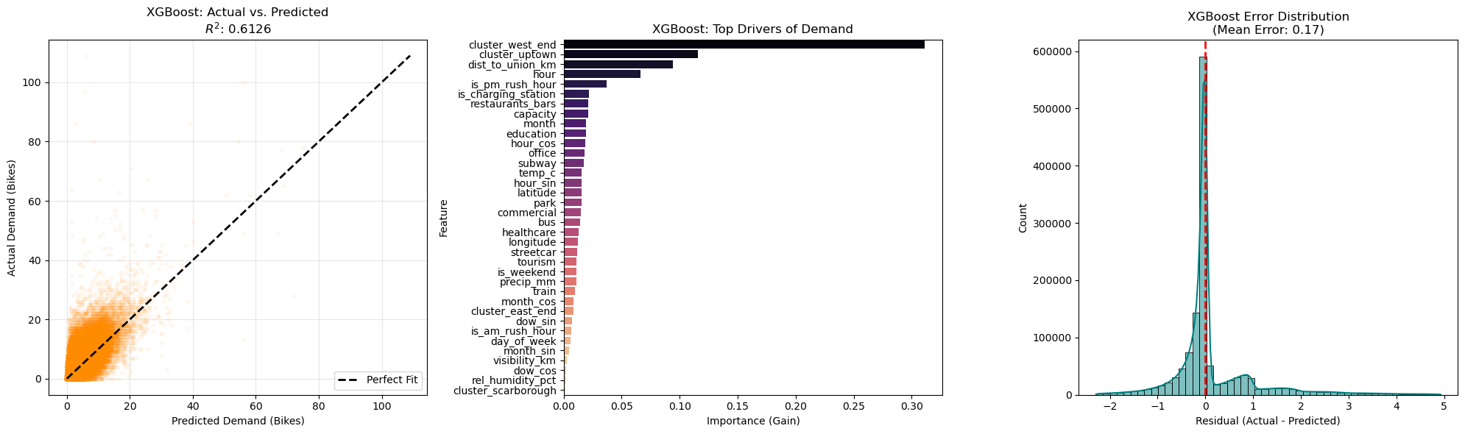

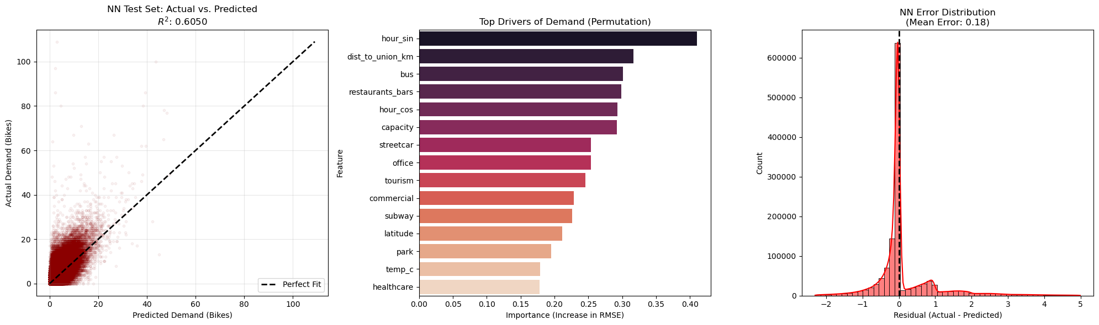

Looking at the features though, some clear trends show up. For all three non-linear models, time was consistently one of the primary drivers for demand. This was regardless of whether the feature was cyclically encoded or not. Similarly, spatial features, especially the distance to Union Station were critical in predicting trends. Since some of the busiest stations are located closest to Union, this is a promising trend to have been identified by the models and both should continue to be incorporated in future models. Among the other features, weather contributed inconsistently, but restaurants and bars were surprisingly strong predictors. This suggests that bike station planners could potentially look at concentrations of restaurants as good potential locations for new bike stations and any new bike stations planned around bars should expect higher demand. Lastly, the transit features tend to be solid contributors but interestingly it is rarely the same one that rises to the top. More research will be required into this. A more interesting variable to look at in the future could be distance to nearest subway, bus, or streetcar station.

6 – Conclusion and Future Work
This study successfully trained and evaluated several machine learning models to solve the problem of per-station, hourly demand prediction for new or future bike stations in Toronto. By focusing on temporal, spatial, and POI features available before a station is built, the models provide BSS planners with a novel tool for new bike share station capacity planning and assessing the expected ROI for new bike station infrastructure. When comparing the Multivariate Linear Regression model, Random Forest model, XGBoost model, and Artificial Neural Network model, the XGBoost model came out on top. Feature importance analysis on models identified time of day and distance to the city center to be two of the biggest drivers for predicting demand. Furthermore, Points-of-Interest (POI) related to restaurants and bars were surprisingly high, which suggests that these areas are strong indicators for new potential station locations. Overall, this study establishes a strong benchmark performance for station prediction models targeted at new BSSs, validating the use of publicly available data for effective demand forecasting.
While the models demonstrated strong stability and performance on the test set, all models struggled with under-predicting during peak demand hours. This limitation likely resulted from the zero-inflated nature of the hourly dataset. Future work should explore methodologies to address this balance. One promising approach is a two-stage modeling process. A classification model would be used to predict whether a station will be active during a given hour. A regression model can then predict the magnitude of that demand, working only with data from active stations.
Exploring the usage of Graph Convolutional Networks (GCNs) is recommended. While traditionally used for flow prediction between existing stations, GCNs could be adapted to model the potential influence of surrounding stations on a proposed new site, helping to forecast demand in balance with the existing network and predict potential effects on neighboring BSS locations.

References
Allen, J. (2024, August). Bike Share Toronto Growth. Bike Share Toronto Growth | School of Cities. https://schoolofcities.github.io/bike-share-toronto/growth
City of Toronto. (2025, October 21). Open data dataset. City of Toronto Open Data Portal. https://open.toronto.ca/dataset/bike-share-toronto-ridership-data/
El-Assi, W., Salah Mahmoud, M., & Nurul Habib, K. (2015). Effects of built environment and weather on bike sharing demand: A station level analysis of Commercial Bike Sharing in Toronto. Transportation, 44(3), 589–613. https://doi.org/10.1007/s11116-015-9669-z
El-Geneidy, A., Grimsrud, M., Wasfi, R., Tétreault, P., & Surprenant-Legault, J. (2013). New evidence on walking distances to transit stops: Identifying redundancies and gaps using variable service areas. Transportation, 41(1), 193–210. https://doi.org/10.1007/s11116-013-9508-z
Eren, E., & Uz, V. E. (2020). A review on bike-sharing: The factors affecting bike-sharing demand. Sustainable Cities and Society, 54, 101882. https://doi.org/10.1016/j.scs.2019.101882
Government of Canada. (2025, October 15). Hourly Data Report for January 01, 2024. Government of Canada. https://climate.weather.gc.ca/climate_data/hourly_data_e.html?hlyRange=2009-12-10%7C2025-09-24&dlyRange=2010-02-02%7C2025-09-24&mlyRange=%7C&StationID=48549&Prov=ON&urlExtension=_e.html&searchType=stnProx&optLimit=specDate&Month=1&Day=1&StartYear=1840&EndYear=2016&Year=2024&selRowPerPage=25&Line=1&txtRadius=25&optProxType=navLink&txtLatDecDeg=43.666666666667&txtLongDecDeg=-79.4&timeframe=1
Hanna, J. (2024, November 29). Bike share toronto 2024 Business Review. Toronto Parking Authority. https://www.toronto.ca/legdocs/mmis/2024/pa/bgrd/backgroundfile-251202.pdf
Lainjo, B. (2022). Application of machine learning in predicting the number of bike share riders. International Journal of Business, Management and Economics, 3(4), 339–370. https://doi.org/10.47747/ijbme.v3i4.865
Mohseni, G., Nourinejad, M., & Park, P. Y. (2026). Bike-sharing ridership prediction for network expansion using Graph Neural Networks. Transportation Research Part A: Policy and Practice, 203, 104701. https://doi.org/10.1016/j.tra.2025.104701
Places API - points of Interest Data & Location Search. Geoapify. (2025, March 18). https://www.geoapify.com/places-api/
Wang, X., Cheng, Z., Trépanier, M., & Sun, L. (2021). Modeling bike-sharing demand using a regression model with spatially varying coefficients. Journal of Transport Geography, 93, 103059. https://doi.org/10.1016/j.jtrangeo.2021.103059

