1. Introduction
Over the past decade, bike-share systems (BSS) have grown increasingly popular in major cities across the globe, with incredible effects on urban transportation. For example, Toronto's bike-share ridership has increased by more than 1 million trips each year, for the past 4 years in a row. Additionally, there are now 1000+ active bike stations in 2025, compared to the 773 stations that were active at the start of 2024 (source).
The problem for users and owners of BBSs is that especially during peak hours, it can be challenging to either find bikes or find open ports to park your bike, resulting in a longer trip than necessary if any trip at all. This is due to the nature of urban transportation where in 2024, a Toronto bike share report found that more than 80% of trips at peak hours tend to go in the same direction, towards the city center (source).
Current rebalancing methods include using predictive models trained on past data to choose how to manually reallocate bikes, while also using point systems to incentivize users to bring bikes to stations that require more bikes, thus balancing the load. Nonetheless, this is still one of the major challenges experienced by BSS across many cities, which is why much of the current literature surrounding BSS, focuses on tackling the challenge of BSS demand prediction using various models and features.
This study will aim to apply key learnings regarding spatial-temporal features for BSS demand predictions from other papers, in the context of Toronto's BSS, on a per-station, hourly basis. We'll be comparing various machine-learning models, using Multivariate Linear-Regressions as a baseline. The results of this analysis are intended to assist system operators in optimizing rebalancing logistics and city planners in identifying high-demand zones for infrastructure expansion. The rest of this paper is structured as follows: Section 2 reviews related literature. Section 3 describes our methodology and dataset preprocessing. Section 4 presents the experimental results. Section 5 discusses implications and limitations, and Section 6 concludes.

2. Related Work
2.1 Bike-Share Demand Modeling Across Cities
Many existing studies focus on the BSSs of cities like New York, Seoul, Montreal, or Washington D.C. Their works have identified import predictors for predicting demand across an entire BSS such as temperature, wind-speed, and date/time-based features (source). They've also discovered indicators for station specific demand such as distance from Points of Interest (POI) and the socioeconomic level of surrounding neighbourhoods (source).
However, cross-city results are not always easily applicable as bike-share users' behaviours can be highly local. A literature review on existing BSS research in 2019, found that users across different systems reacted wildly differently to the same temperatures (source). This highlights the need for city-specific models, trained on local data rather than generalizing across systems.

2.2 Prior Work on Toronto's Bike-Share System
Several papers attempt to tackle the challenge of bike-share prediction using data from Toronto's Open Data Portal. Many of these papers are exploratory in nature or only predict system-wide ridership, rather than station level demand (source). This makes the results from these studies unsuitable for application to real operations.
One study does take an in-depth look into the Toronto BSS, utilizing Graph Convolutional Networks to predict flow on a per-station basis (source). It considers station specific features like distance between stations, points of interest, socioeconomic levels, age, and more. We will attempt to incorporate some of these features in our models.

2.3 Gaps in Existing Research
In the extensive literature on BSSs, there is a small gap I aim to fill. First, there's a lack of Toronto-specific prediction models to handle the unique differences of Toronto compared to other major cities. Second, there is a lack of station-level forecasting. While some papers make predictive models, it's on a system wide basis. Lastly, most research is using old data. Between the start of 2022 and the end of 2024, there has been an increase of more than 250 stations in Toronto (source). There have also been improvements to the bike path network which has been shown to increase ridership of stations. Thus, this study will look to provide, Toronto-specific, station-level hourly demand (trip starts) forecasting, using only the most recent data from 2023-2024.

3. Method
Dataset Description and Data Cleaning/Pre-processsing
- Toronto Bike Share
  - Source: Toronto’s Open Data Portal (source)
  - Key features:
    - Trip Id
    - Start Station Id
    - Start Time
    - Start Station Name
    - End Station Id
    - End Time
    - End Station Name
    - Bike Id
    - User Type [Casual, Annual]
    - Trip Duration
  - This is the source of our target variable which will be a summation of the number of trips per-station on a hourly basis.
  - Limitations/Potential Biases
    - This only shows the stations, and hours that have trips occurring. There is no representation of the majority of hours where there are no trips occurring for many stations.
    - To adjust for this I made a “time skeleton” of all the hours from the beginning (2023-01-01) to the end (2024-09-30) of our dataset.
    - There is a bias towards zero because of this.
    - We don’t have more recent data past 2024-09-30.
  - Data Quality Issues and cleaning done
    - Missing start and end station IDs. – station names were mapped to IDs based on the stations dataset and the rest were removed
    - Missing station names – stations ids were mapped to station names based on the stations dataset and the rest were removed
    - 8.11% of trips involved Station IDs that did not exist in the official Stations master list (86 unique missing stations).
    - Trips that lasted less than 30 seconds were considered user mistakes and not representative of real usage so were removed
    - Based on a distribution, trips that lasted longer than 2 hours were considered outliers or mistakes where bikes were left at locations and thus were removed
    - Stations present in trips data but not 2025 bike stations data, but with addresses. Used the addresses to manually find the longitude/latitude locations and used median values to fill in other features.
- Bike Share Station Data
  - Source: Toronto’s Public Bike System Feed (GBFS) (source)
  - Key features:
    - station_id
    - Name
    - Lat
    - Lon
    - Capacity
    - Address
    - is_charging_station
    - nearby_distance
  - Limitations/Potential Biases
    - Station locations and IDs change. We only have the most recent 2025 station data, while our trip data is for 2023-2024. This means that we are missing data for many stations from 2023-2024 or have no trip data on many of today’s new stations.
  - Data Quality Issues
    - Mostly complete, just the issues mentioned above regarding bike trip stations vs bike stations data from 2025.
- Weather Data
  - Source: Government of Canada weather service (source)
    - From the weather station located at Billy Bishop Airport
  - Key features:
    - Temperature (C)
    - Humidity (%)
    - Precipitation (mm)
    - Wind Speed (km/h)
    - Visibility (km)
  - Limitations/potential biases
    - A lot of the weather stats are skewed towards 0 (right-skew)
    - This is weather focused on the downtown core of Toronto so may not be representative for areas further from the core.
  - Data Quality Issues
    - Lots of redundant data
    - Timezone issues. The data was in LST but had to adjust for Toronto’s Daylight Savings Time
    - Wind Chill, Hmdx, Weather, and Precipitation contained nulls:
      - Linear Interpolation: Used linear interpolation to fill gaps in time-series data for Temp, Dew Point, Rel Hum, Stn Press, Visibility, and Wind Spd.
      - Zero-Filling: Assumed missing values for Precip. Amount (mm) represented no rain and filled them with 0.
- Point-of-Interest Data
  - Source: Geoapify Places API (source)
  - Key features (that we searched for):
    - Educational buildings
    - Healthcare buildings
    - Offices
    - Restaurants/bars
    - Bus stations
    - Subway stations
    - Streetcar stations
    - Train stations
    - Parks
    - Tourism locations
    - Commercial buildings
  - Limitations/potential biases
    - Relies on the completeness of the API data
    - Only searched for a 400m radius around each station based on urban planning best practices (source)
  - Data quality issues:
    - No issues with data quality. Just had to query for the requests points of interest for every single one of the bike stations
- Issues faced while joining the data sources
  - Syncing up timezones
  - With more than 15 million rows in the initial dataset, the file size was huge at more than 8GB. Data types needed to be adjusted to be more efficient
  - Created the time skeleton
Feature Engineering and Data Preprocessing
- Aggregated raw individual trips into hourly demand counts by station
- Extracted temporal features: hour, day of week, month, year
  - Created cyclical sin/cos encodings of each of the temporal features to maintain cyclic nature
- Boolean flags: is_weekend, is_am_rush_hour, is_pm_rush_hour
- Applied log1p (log + 1) transformation to skewed features since there was a heavy bias towards zero for some
  - Target: trips_started
  - Weather: precip_mm
  - Spatial: dist_to_union_km
  - POIs: tourism, office, park, healthcare, education, restaurants_bars, commercial
- Used latitude and longitude station data as a basis for finding POI data using the GeoApify API
  - Mapped raw Geoapify categories to 12 distinct feature counts within a 400m radius:
  - Transportation: bus, subway, streetcar, train, public_transport_total.
  - Amenities: tourism, office, park, healthcare, education, restaurants_bars, commercial.
- Grouped stations together into meaningful geographic neighbourhoods using K-means clustering and applied it to longitude and latitude.
  - Selected K=5 as the optimal number of clusters and assigned semantically meaningful names based on location:
    - downtown (Dominant cluster, 510 stations)
    - east_end
    - west_end
    - uptown
    - scarborough
  - Applied one-hot encoding with dropping the first level to serve as a reference category
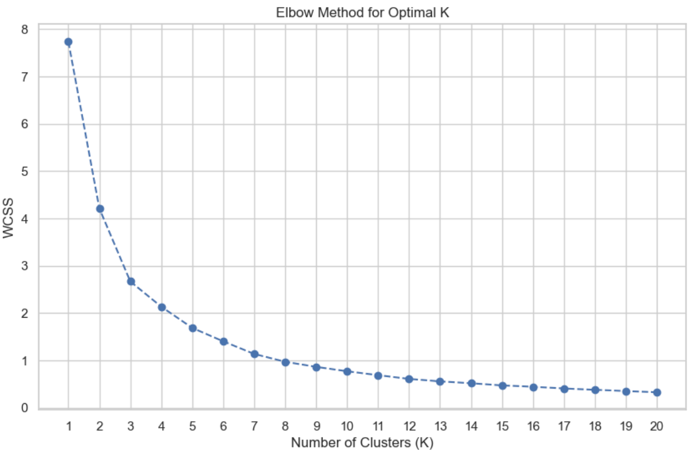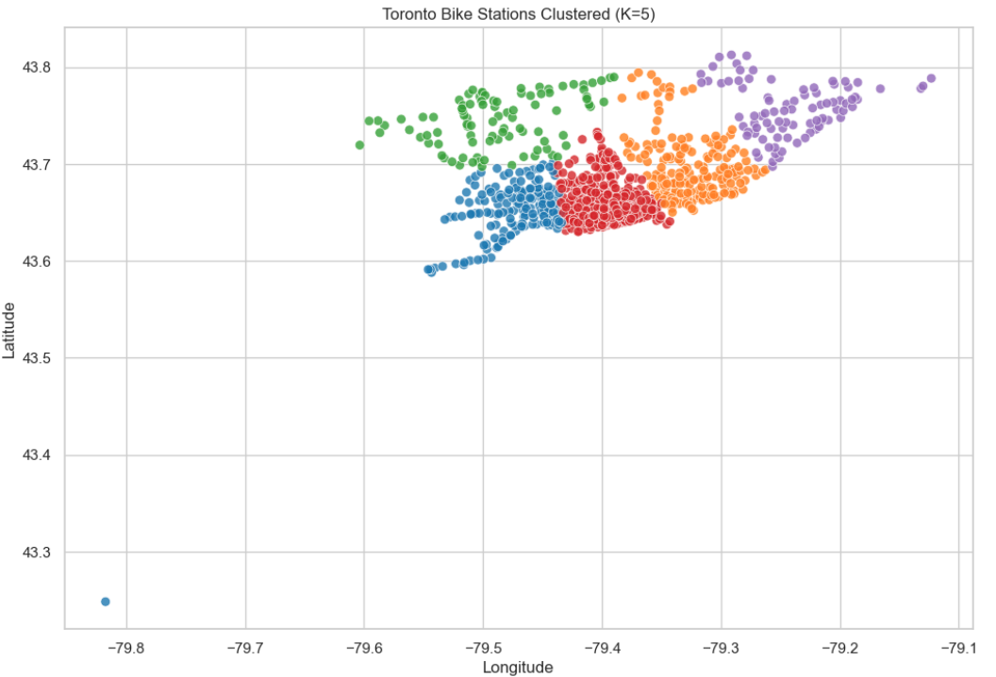
- Calculated the Geodesic distance in km from each station to the city center (Toronto Union Station) to capture centrality. Used the Haversine formula.

Exploratory Data Analysis and Feature Selection
Visualizations – Trip data
- Over 10.9 million trips analyzed form Jan 2023-Sept 2024
- Seasonal Pattern: Strong seasonal demand with peaks in summer months (June-August) reaching ~900k trips/month, and significant drops in winter (Jan-Feb) to ~200k trips/month.
- Rush Hour: Clear bimodal peaks at 8 AM and 5 PM (17:00), indicating heavy commuter usage. The afternoon peak is much higher than the morning peak.
- Most trips average under 20 minutes (makes sense given the limit is 30 minutes
  - This drops significantly during the winter months
- Station activity:
  - There is a lot of variance in the most and least busy stations
  - The top 10 busiest stations are the busiest Monday through Thursday with a sharp drop off on Friday, indicating heavy usage by users who work in office and then maybe work from home on Fridays
  - The 10 least busy stations show a more erratic pattern, with greater ridership on weekends, which might indicate that less busy stations are ones that are used more often for leisure. This makes sense since office locations often don’t overlap with parks and recreational areas.
- Despite the growth in more than 1 million trips between 2023 and 2024, the average trips per station stayed relatively similar, indicating that more stations are going up splitting the demand, but also that demand is increasing based on new station availability. Could be an example of induced demand
Visualizations – Weather data
- Temperature: Positive correlation. Ridership increases as temperature rises, peaking around 20°C - 25°C, then slightly plateauing or dipping in extreme heat.
- Precipitation: Strong negative impact. Ridership drops sharply even with light rain (> 0mm), and is near zero during heavy rainfall.
- Humidity: Moderate negative trend. High humidity (often associated with rain or uncomfortable heat) correlates with fewer trips.
- Wind Speed: Negative correlation. Higher wind speeds (> 30 km/h) visibly reduce ridership.
- Visibility: Positive correlation. Clearer days see more rides, while low visibility (fog/heavy rain) suppresses demand.
Distributions
- Right-Skewed Features: Many features follow a right-skewed distribution (long tail to the right), justifying the need for the log-transformations applied in the final dataset:
  - precip_mm (mostly 0)
  - wind_speed_kmh
  - dist_to_union_km
  - POI counts (restaurants_bars, commercial, office)
  - Target Variable (trips_started)
- Pearson Correlation Matrix
  - Took a small sample of the training set (just ~500,000 rows) because the whole dataset would be too huge for the matrix
  - Positive Correlations: POI features like tourism, restaurants_bars, office, park, and healthcare showed moderate positive correlation (~0.25 - 0.30). Weather (temp_c) and time (hour) also positively correlated.
  - Negative Correlations: Spatial features like dist_to_union_km (-0.37) and cluster indicators (e.g., cluster_scarborough) showed negative correlation, confirming that demand drops as stations move away from the city center.
  - High collinearity in some features:
    - Dew_point_c and temp_c – dropped dew_point_c
    - The raw temporal features and the cyclic encoding of the raw temporal features – dropped the raw temporal features for the linear models and neural network. Kept it for the tree models.
  - Some collinearity in POI features which makes sense, but decided to keep them in
- Lasso Regression (L1 Regularization)
  - Objective: Used Lasso as an embedded feature selection method because it shrinks coefficients of irrelevant features to absolute zero.
  - Preprocessing: Standardized all features using StandardScaler to ensure coefficients were comparable.
  - Hyperparameter Tuning: Ran LassoCV to find the optimal alpha (regularization strength)
    - Using the manual alpha ended up keeping all the variables
    - Ended up manually tested alpha = [0.0001, 0.001, 0.01] to observe the shrinkage path.
  - Prioritized features that "survived" (non-zero coefficients) at higher alpha values.
    - Dropped features that consistently shrank to zero or were redundant (e.g., day_of_week, month, year, public_transport_total, dew_point_c).
  - Many features were kept despite the indication of Lasso because from our EDA, we knew that the target variable was likely not linear
- Final feature set: two distinct feature sets were defined for subsequent modeling
  - Linear Feature Set (33 features): For linear models and neural networks. Includes cyclical time features (_sin, _cos), spatial metrics, weather, and specific POI counts.
    - linear_feature_set = [
    - 'hour_sin', 'hour_cos', 'dow_sin', 'dow_cos', 'month_sin', 'month_cos',
    - 'is_weekend', 'is_am_rush_hour', 'is_pm_rush_hour',
    - 'latitude', 'longitude', 'dist_to_union_km',
    - 'cluster_east_end', 'cluster_west_end', 'cluster_uptown', 'cluster_scarborough',
    - 'temp_c', 'precip_mm', 'rel_humidity_pct', 'visibility_km',
    - 'capacity', 'is_charging_station',
    - 'bus', 'subway', 'streetcar', 'train',
    - 'restaurants_bars', 'education', 'park', 'tourism', 'office', 'commercial', 'healthcare'
    - ]
  - Tree Feature Set (35 features): For Random Forest/XGBoost. Similar to the linear set but retains raw categorical integers (hour, month, day_of_week) as tree-based models can handle non-linear relationships without cyclical encoding.
    - tree_feature_set = [
    - 'hour_sin', 'hour_cos', 'dow_sin', 'dow_cos', 'month_sin', 'month_cos',
    - 'hour', 'day_of_week', 'month',
    - 'is_weekend', 'is_am_rush_hour', 'is_pm_rush_hour',
    - 'latitude', 'longitude', 'dist_to_union_km',
    - 'cluster_east_end', 'cluster_west_end', 'cluster_uptown', 'cluster_scarborough',
    - 'temp_c', 'precip_mm', 'rel_humidity_pct', 'visibility_km',
    - 'capacity', 'is_charging_station',
    - 'bus', 'subway', 'streetcar', 'train',
    - 'restaurants_bars', 'education', 'park', 'tourism', 'office', 'commercial', 'healthcare'
    - ]
- Also based on the distributions + regressions and EDA I saw that there was some patterns that could potentially be modeled with a linear regression like temperature, but that likely wouldn’t explain everything.
  - Decided on modeling ensemble tree models like random forest, XGBoost, as well as neural networks to capture non-linear trends.
Train-Test Split
- Final strategy:
  - Test Set (10%): Days where day_of_year % 10 == 0
  - Validation Set (10%): Days where day_of_year % 10 == 1
  - Training Set (80%): All remaining days (day_of_year % 10 > 1)
- Preserving Temporal Integrity: Bike share demand is a time-series problem where hourly patterns are critical. Randomly splitting rows would break the continuity of hourly data within a single day.
- Avoiding Leakage: By splitting entire days into sets, the model cannot "peek" at adjacent hours (e.g., training on 8 AM and testing on 9 AM of the same day), which would artificially inflate performance.
- Representing Seasonality: This modulo approach ensures that all seasons (winter, summer, shoulder months) are equally represented in Train, Validation, and Test sets, rather than cutting off the last 20% of dates (which would make the test set purely "future" data, potentially biased by specific seasonal trends of late 2024).
- Because of the zero biased nature of the data, I attempted to apply some negative downsampling. The ratio of zero rows to positive rows was about 2:1 though so I didn’t want to too heavily impact my results.
Modeling

