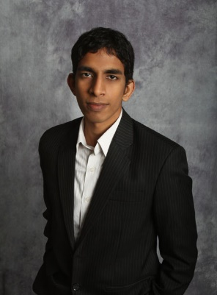CV

Dhanish is an Analyst at Deloitte working within the Technology Advisory service area.

Dhanish Semar

Dhanish is an Analyst with Deloitte based in Auckland, New Zealand.

Dhanish joined Deloitte after completing a degree in Software Engineering and has experience programming in Java, Scala, Python and more.

Prior to joining Deloitte, Dhanish co-founded and ran a gaming network serving over 50 million views over a 2 year span and also worked as a web consultant for the University of Auckland.

Education

* University of Auckland
  + Bachelor of Engineering in Software Engineering (Hons) at the University of Auckland

Achievements

* Featured as a headline interview on Forbes Technology
* Paper published at the Australasian Software Engineering Conference (ASWEC 2015) - “*Automating Smartphone Automation- Enhancing User Experience with Behaviour Learning*”
* 3rd place at the Asia Pacific IET “Present Around the World 2015” competition (representing New Zealand as the national champion)
* 2nd place at the University of Auckland Software Design Challenge
* Other achievements:
  + 2nd best speaker at the Russell McVeagh Regional Debating Tournament
  + Scholarship in NCEA Level 3 Statistics & Modelling
  + Auckland Regional Spelling Bee champion

Client portfolio

* AMP
* Rio Tinto
* The University of Auckland
* Deloitte

Experience

**AMP: UX for Web**

The client, a leading financial services provider in New Zealand, was looking to fast follow their Australian counterparts that had recently re-built their public website from the ground up. Leveraging existing design assets and frameworks, I played a key part in developing the UX. The starting focus was to define a new set of UX assets (personas, etc.,) that were relevant to the NZ market. These assets were then used to help to develop the proposed Information Architecture for the NZ site. Deloitte also lead the development of the content strategy and development process for the project.

**Rio Tinto: Global HR Operating Model Transformation**

The client, a multinational mining company, was transforming their global HR operating model with the help of Deloitte. As part of this, a new HR management system was being implemented. I provided support in testing the validity of the system integration and the reconciliation of data with the old system. This proofing was then used to identify and resolve critical issues in the system to meet the go-live date without delays. Deloitte are also supporting the wider global transformation.

**Deloitte: Financial Reporting Processes**

The client, a leading professional services provider, was looking to improve the efficiency of their financial reporting processes. Seconded internally for six months, I played a key part in several initiatives to link various data sources to improve reporting time and worked on several visualisations to enable more insight from the data. These developments were then used to speed up the time taken to deliver reports and increase the impact of the data.

**The University of Auckland: Web Manager**

The client, a leading educational institution, was seeking a new website for the Robotics department and guidance on redesigning their public-facing website. As a contractor, I assessed the architecture and layout of content and design elements and proposed a set of recommendations which were then implemented in the public UoA website. Additionally, I consulted with the Head of Robotics to develop a website purpose-built for the robotics team which is now being used by the Robotics Research Group at the University of Auckland..