**Business Case Assignment: Part 1**

Dear Mr. Stanton

I am submitting the following proposal for your consideration.

After surveying over 10,000 randomly selected people across Auckland, it is clear that Circus Café’s venu size is hidering our growth, as customers are reluctant to dine at Circus because they think our venu is too crowded.

We have a proud history serving ‘Auckland’s best coffee’ (as voted by Coffee lovers NZ) since 1986. This claim is validiated with the phenomenal numbers of coustomers visiting our Café, with an average of 1000 customers per day and peeking to 2000 when there are events happening around Mt Eden. This averages to $10,000 profit a day on non event days.

The company behiend us has offered to sell us their section for $1.5 mil, this is perfect for Circus Café as it will effectively double our venu size allowing us to reach an estimated 1900 customers per day and most importantly will take us one step closer to Circus’s vision of becoming an iconic land mark for tourists. There will also be reconstruction and redesign costs which our construction agent has estimated to be $500,000.

I am requesting a loan of 500,000 dollars from you, as this loan and our own investment will cover both the land acquisition plus the reconstruction costs. Once our finances are met our buiding agents have approximated that the construction will take about two months to complete and in the worst case will only be completed at the end of this year, thus taking the worse case senario of opening our cafe from January 2018, our board has predicted that with our new estimated profits of approxmiatly $20,000 a day, that we would be able to repay your loan of 500,000 in two years.

Thank you for your consideration of my request.

Sincerely,

Joel Jeevan

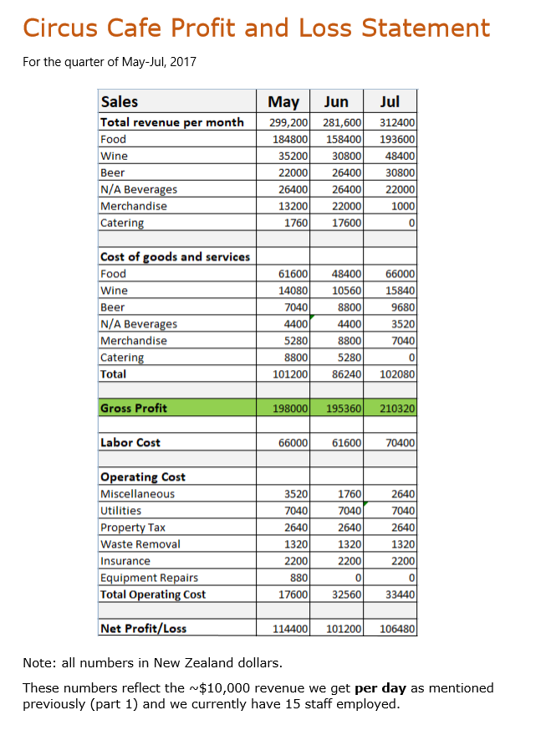**Business Case Assignment: Part 2**

**Circus Cafe**

|  |  |
| --- | --- |
| **Company profile** Image result for circus cafe logo 29 Mt Eden Rd, Auckland  0800 777 7777  www.circuscafe.com  **Industry** Hospitality Café/restaurant  **Development stage** Profitable  **Year founded** 1984  **Number of Employees**  15  **Funding Opportunity** $500,000  **Use of Fund** 25% Expansion of infrastructure 60% land acquisition 5% Operation/Inventory 10% Legal/Other  **Current Monthly Burn Rate** $110,000  **Current Monthly Revenue** $300,000  **Existing Debt** $0  **Existing Investors** Hugh Cullman, David S. Rose, Ross Theodore Technology partners, NER  **Advisors**  Lawyer: Tim Fouler  Accountant: Tracy Bra  **Investors**  Flade Clide insurance  M&B Co | **BUISNESS SUMMARY**  Launching in 1984 Circus Café has built a reputable name for its self from fellow Aucklanders, selling on average 200 cups per day of our world famous coffee. We are fast expanding and our goal is to branch out nationwide.  **PROBLEM/OPPORTUNITY**  As our revenue as been on a sharp increase over the past decade, we do not have the funds to expand our infrastructure to the scale we see appropriate.  **SOLUTION/PRODUCT**  The Arts gallery directly behind us is willing to sell the entitlement deed to us; with the acquisition of the new land our companies’ physical size will be effectively five times larger.  **POTENTIAL RETURN/REVENUE MODEL**  Once we do accrue the land behind our store and finish reconstruction in late Jan of 2018 (as predicted by the our building Agents), our Analysts using the data from surveys and studying our rate of revenue growth have estimated that our revenue to increase two fold with this new venture taking is to approximately $20,000 per day.  **COMPETITION**  We do seem to have some small scale competition at the moment as the ‘Angel Cakes and Wine’ bakery a few blocks down the street have also begun selling coffee and started attracting a moderate size of customers  **POTENTIAL RISKS**  The civil engineers discovered damage to the internal wall at the back of our store due to a pipe leak, they were quick to say that might affect the time taken to construct our larger building and can concur additional costs to the expansion costs.  A few customers surveyed say they like Circus café due to its size and reconstructing our café effectively into the size of a large restaurant might possibly decrease our revenue in the short term.  **EXECUTION / RISK MITIGATION STRATEGY**  Do deal with Angel Cakes and wine and other potential competitors we will be partnering with ‘Baker Caker’ a well established cake restaurant that have had a very stable growth over the past decade. Since ‘Angel Cake’ sells cakes and coffee, we predict that if we were to invest in Baker Caker it will help them have a monopoly on the Cake market and customers would prefer to dine at a restaurant that specializes in the food they want rather, hence visiting our restaurant instead of ‘Angel Cakes’.  As for the damaged walls, we have the support of another investor ‘Flade Clide insurance’ that has agreed to support us if there are any extra costs involved in the construction process, and with the net profit of their company being $4.5 billion last year we feel quire assured the walls do not cause a problem to our growth.  **MANAGEMENT TEAM**  Phillis O’reily our chair analyst and financial advisor for over the last 13 year, her analyses and input have contributed to our sharp increase in revenue over the past 4 years.  Amanda Cummolt, our marketing manager with experience in 24 different countries and 39 different companies has lead to the unique design or circus café loved so much by our customers.  Joel Jeevan, CEO, whose decisions over the past years have lead to the successful growth of Circus café since 1984. |

Providing Aucklanders with our world famous in New Zealand coffee since 1984

