Criticality Safety Evaluation: Cascade Cylinder Array

Safe-by-Design Demonstration
Document Information
Document Number | CSE-2026-001
Revision | 0
Date | 2026-02-13
Status | DRAFT - FOR REVIEW

Prepared By | Reviewed By | Approved By
Date: | Date: | Date:

Executive Summary
Finding: The cascade cylinder array is safe by design. Criticality is not credible given operating conditions and equipment design.

Why UO2F2 Cannot Cause Criticality
 | Critical Threshold | Max Accumulation | Margin
Fill fraction | 2.5% | 0.29% | 8.6×
Mass per cylinder | 2.5 kg | 283 g | 8.8×
- The critical threshold (2.5% fill) represents the minimum amount of material needed for criticality
- Maximum accumulation (0.29% fill) assumes worst case: 100% humidity, 100% water deposition, 100% reaction to UO2F2 at peak moderation (H/U=25), over entire 10-year equipment lifetime
- Even under these extreme assumptions, accumulation reaches only 1/9th of the critical threshold

Why UF6 Cannot Cause Criticality
 | Critical Threshold | Operating Limit | Margin
Mass per cylinder | 5.2 kg | 5 g | 1,040×
- The critical threshold (5.2 kg solid UF6) is 1,000× higher than the operating limit (5 g)
- UF6 would need to solidify and continuously accumulate to reach criticality — this is not credible given process conditions

Conclusion
No additional criticality controls are required. Safety is ensured by physical limits on material accumulation, not administrative controls.

Table of Contents
- References
- Purpose
- Inputs
- Modeling Assumptions
- Methodology
- Results
- Accumulation Analysis
- Safety Margin
- Conclusions
Appendices - A: Geometry Validation - B: Density Calculations - C: Accumulation Calculation - D: Complete Results Data

1. References
Reference | Title
OpenMC | Monte Carlo Particle Transport Code, Version 0.15.x
ENDF/B-VIII.0 | Evaluated Nuclear Data File, Release VIII.0

2. Purpose
This analysis evaluates criticality safety for the cascade cylinder array by determining:
- Critical threshold — What fill fraction causes criticality? (Sections 5–6)
- Maximum accumulation — What is the maximum credible material buildup? (Section 7)
- Safety margin — Is the margin sufficient for safe-by-design? (Section 8)
Three material scenarios representing upset conditions in a cascade are evaluated:
Scenario | Material | Scenario
UF6 Dry | Solid UF6 | Direct UF6 is deposited in maker
UO2F2 Dry | Dry UO2F2 (H/U=0) | UO2F2 is deposited in maker
UO2F2 Wet | Wet UO2F2 (H/U=25) | Bounding case of UO2F2 with peak moderation

3. Inputs

3.1 Array Configuration
Parameter | Value | Basis
Array | 3 × 4 × 5 | Unit cell (rows × cols × layers)
Boundary | Reflective | Models infinite array
Enrichment | 21 wt% U-235 | HALEU is 20% so we add additional 1% enrichment

3.2 Geometry
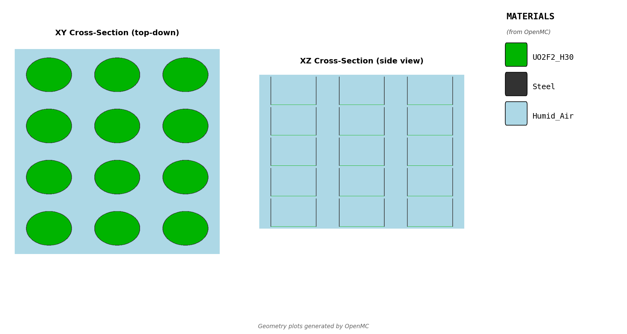
Geometry Cross-Sections
Figure 3.1: Unit cell geometry. Left: XY plane (top view). Right: XZ plane (side view). Note top and bottom caps are not shown because of pixel fidelity but they are there

3.3 Cylinder Dimensions
Parameter | Value | Units
Inner diameter | 25.4 | cm
Internal height | 100.0 | cm
Wall thickness | 0.3175 | cm
Horizontal gap | 12.7 | cm
Vertical gap | 7.62 | cm
Internal volume | 50,671 | cm³

3.4 Material Properties
Material | Density (g/cc)
UF6 (solid) | 5.09
UO2F2 (dry) | 6.37
UO2F2 (H/U=25) | 1.95
Note: UF6, UO2F2 (dry) densities reported from Wikipedia. UO2F2 wet density calculated from ideal mixing (see Appendix B).

4. Modeling Assumptions
We setup an infinite array of casettes and make several conservative modeling assumptions to assess criticality.

4.1 Conservative Assumptions
# | Assumption | Justification
1 | Infinite array (reflective BC) | Bounds any finite array configuration
2 | 21 wt% enrichment | Maximum credible HALEU for this process
4 | H/U = 25 for wet UO2F2 | Peak moderation ratio (Section 6.2)
5 | All water ingress reacts to UO2F2 and deposits in machine | Bounds water ingress and UO2F2 formation
6 | 10-year equipment lifetime | Full design life
7 | All machines accumulate uniformly | In practice, only failed seals leak and accumulate fissile material significantly.

5. Methodology

5.1 Approach
- Run Monte Carlo simulations sweeping fill fraction (α) for each material
- Identify critical threshold: fill fraction where k-eff + 2σ ≥ 0.95
- Convert threshold to mass (kg)
- Compare to maximum credible accumulation
- Calculate safety margin

5.2 Monte Carlo Parameters
Parameter | Value
Code | OpenMC v0.15.x
Nuclear data | ENDF/B-VIII.0
Particles per batch | 10,000
Total batches | 150 (50 inactive)
Safety Classification: - SAFE: k-eff + 2σ < 0.95 - MARGINAL: 0.95 ≤ k-eff + 2σ < 1.00 - CRITICAL: k-eff + 2σ ≥ 1.00

5.3 Fill Fraction (α)
Fill fraction α is the fraction of cylinder volume occupied by fissile material:
$$α=\frac{V_{fissile}}{V_{cylinder}}$$
At fill fraction α, the fissile mass per cylinder is:
$$m=α×V_{cylinder}×ρ$$

6. Results

6.1 k-effective vs Fill Fraction

UF6 Dry
fill (%) | k-eff + 2σ | Status
1% | 0.772 | SAFE
2% | 0.960 | MARGINAL
5% | 1.139 | CRITICAL
10% | 1.220 | CRITICAL
20% | 1.266 | CRITICAL

UO2F2 Dry (H/U = 0)
fill (%) | k-eff + 2σ | Status
1% | 0.885 | SAFE
2% | 1.062 | CRITICAL
5% | 1.223 | CRITICAL
10% | 1.296 | CRITICAL
20% | 1.341 | CRITICAL

UO2F2 Wet (H/U = 25, Bounding)
fill (%) | k-eff + 2σ | Status
2.0% | 0.846 | SAFE
2.5% | 0.953 | MARGINAL
3.0% | 1.037 | CRITICAL

6.2 H/U Ratio Optimization
Peak reactivity occurs at H/U = 25 (k-eff = 1.650 at 100% fill). This ratio is used for the bounding wet UO2F2 analysis.
H/U | k-eff + 2σ
0 | 1.387
20 | 1.649
25 | 1.652
30 | 1.649
50 | 1.605

6.3 Combined Results
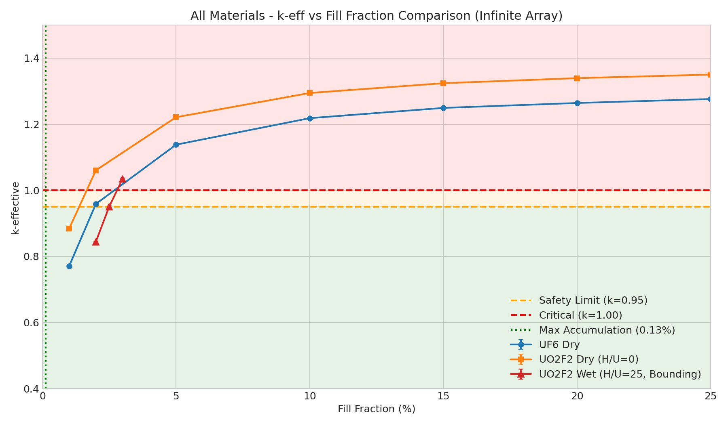
Combined Fill Sweep
Figure 6.1: k-effective + 2σ vs fill fraction for all three material scenarios. Horizontal lines show safety limit (0.95) and critical (1.00). Vertical line shows maximum credible accumulation (0.29%).

6.4 Critical Thresholds
Material | Critical α | Mass per Cylinder
UF6 Dry | ~2% | 5.2 kg UF6
UO2F2 Dry | ~1.5% | 4.8 kg UO2F2
UO2F2 Wet (H/U=25) | ~2.5% | 2.5 kg mixture

7. Accumulation Analysis

7.1 Mechanism
UO2F2 forms when humid air leaks into UF6-containing equipment:
$${\text{UF}}_{6}+2{\text{H}}_{2}\text{O}→{\text{UO}}_{2}{\text{F}}_{2}+4\text{HF}$$

7.2 Input Parameters
Parameter | Value | Basis
Leak rate | 0.01 torr/min | Conservative differential pressure (provided by Riane and Wisher)
Humidity | 100% relative humidity | Bounding
Temperature | 25°C | Ambient
Equipment volume | 12 L | Equipment spec
Lifetime | 10 years | Design life

7.3 Result
Parameter | Value
UO2F2 accumulated per machine | 163.6 g
Water associated (H/U=25) | 119.6 g
Total wet mixture mass | 283.2 g
Mixture volume (at 1.95 g/cc) | 145.2 cc
Fill fraction | 0.29%
See Appendix C for full calculation.

7.4 UF6 Accumulation
Per process engineering, the maximum UF6 holdup at any given time is conservatively 5 g per machine.
Parameter | Value
UF6 max per machine | 5 g
Fill fraction | 0.002%

8. Safety Margin
Material | Critical Threshold | Max Accumulation | Margin
UF6 Dry | 2% (5.2 kg) | 5 g | 1,040×
UO2F2 Wet | 2.5% (2.5 kg) | 283 g (0.29%) | 8.6×
Bounding Case: UO2F2 wet at H/U=25 with 8.6× safety margin. UF6 has an even larger margin (1,040×) but UO2F2 wet is the limiting scenario.

9. Conclusions
The cascade cylinder array is safe by design. (See Executive Summary)
Scenario | Critical Threshold | Max Accumulation | Margin
UF6 Dry | 5.2 kg | 5 g (operating limit) | 1,040×
UO2F2 Wet | 2.5 kg | 283 g (lifetime accumulation) | 8.6×
Key points: - UO2F2: Even if all water deposits and reacts over 10 years at peak moderation (H/U=25), accumulation is 8.6× below critical - UF6: Operating limit is 1,000× below critical, and would require solidification and continuous accumulation
Recommendations: 1. No additional criticality controls required 2. Maintain existing leak-tightness verification program 3. Obtain chemistry SME validation of material properties (Section 4.2)

Appendix A: Geometry Validation
Location: _validation/ and summary_plots/
File | Description
geometry.png | XY and XZ cross-sections
geometry_thick_wall.png | Enhanced view with visible caps

Appendix B: Density Calculations

B.1 UO2F2 Wet Density (Ideal Mixing)
When UO2F2 is hydrated, the mixture density is:
$$ρ_{mixture}=\frac{M_{UO_{2}F_{2}}+n_{H_{2}O}×M_{H_{2}O}}{V_{UO_{2}F_{2}}+n_{H_{2}O}×V_{H_{2}O}}$$
Where: - $n_{H_{2}O}=\frac{H/U}{2}$ (moles water per mole UO2F2) - $M_{UO_{2}F_{2}}=308.03$ g/mol - $M_{H_{2}O}=18.02$ g/mol - $V_{UO_{2}F_{2}}=\frac{308.03}{6.37}=48.35$ cc/mol - $V_{H_{2}O}=\frac{18.02}{1.00}=18.02$ cc/mol

B.2 Calculated Densities
H/U | n_H2O | Mass (g) | Volume (cc) | ρ (g/cc)
0 | 0 | 308.03 | 48.35 | 6.37
10 | 5.0 | 398.13 | 138.45 | 2.88
20 | 10.0 | 488.23 | 228.55 | 2.14
25 | 12.5 | 533.28 | 273.60 | 1.95
30 | 15.0 | 578.33 | 318.65 | 1.82

B.3 Mass Conversion
Fissile mass at fill fraction α:
$$m=α×50,671{\text{ cm}}^{3}×ρ$$
Material | ρ (g/cc) | Mass at 1% fill
UF6 | 5.09 | 2.58 kg
UO2F2 dry | 6.37 | 3.23 kg
UO2F2 wet (H/U=25) | 1.95 | 0.99 kg

Appendix C: Accumulation Calculation

C.1 Water Ingress Rate
Water mole fraction in saturated air:
$$f_{H_{2}O}=\frac{RH×P_{sat}}{P_{atm}}=\frac{1.0×23.8}{760}=0.0313$$
Water partial pressure rise rate:
$$\frac{dP_{H_{2}O}}{dt}=0.0313×0.01=3.13×{10}^{−4}\text{ torr/min}$$

C.2 Lifetime Accumulation
Lifetime in minutes:
$$t=10×365×24×60=5,256,000\text{ min}$$
Total water pressure:
$$ΔP_{H_{2}O}=3.13×{10}^{−4}×5,256,000=1,646\text{ torr}=2.17\text{ atm}$$
Moles of water (ideal gas law):
$$n_{H_{2}O}=\frac{2.17×12}{0.0821×298.15}=1.06\text{ mol}$$

C.3 UO2F2 Formation
From stoichiometry (UF6 + 2H2O → UO2F2 + 4HF):
$$n_{UO_{2}F_{2}}=\frac{1.06}{2}=0.531\text{ mol}$$
$$m_{UO_{2}F_{2}}=0.531×308.03=163.6\text{ g}$$

C.4 Wet Mixture at H/U=25
At peak moderation (H/U=25), each mole of UO2F2 is associated with 12.5 moles of water:
$$m_{H_{2}O}=0.531×12.5×18.015=119.6\text{ g}$$
Total wet mixture mass:
$$m_{mixture}=163.6+119.6=283.2\text{ g}$$

C.5 Fill Fraction
Using wet UO2F2 density at H/U=25 (from ideal mixing, see Section 4.2):
$$ρ_{H/U=25}=1.95\text{ g/cc}$$
$$V_{mixture}=\frac{283.2}{1.95}=145.2\text{ cc}$$
$$α=\frac{145.2}{50,671}=0.00287=0.29\%$$

Appendix D: Complete Results Data
Location: runs/*/latest/results.csv
Run | Description | Cases
uf6_dry_low_fill | UF6 at 1-20% fill | 6
uo2f2_dry_low_fill | UO2F2 dry at 1-20% fill | 6
uo2f2_hu_sweep | H/U sweep at 100% fill | 11
uo2f2_wet_peak | UO2F2 H/U=25 at 2-3% fill | 3

End of Document

