Criticality Safety Analysis

HALEU Parallel Pipes Configuration
Calculation Number: [To Be Assigned]
Revision: 0
Date: 2026-02-09
Role | Name | Date
Prepared by
Reviewed by
Approved by

1. References
- ANSI/ANS-8.1-2014, "Nuclear Criticality Safety in Operations with Fissionable Materials Outside Reactors"
- 10 CFR 70.24, "Criticality Accident Requirements"
- NUREG/CR-6698, "Guide for Validation of Nuclear Criticality Safety Calculational Methodology"
- OpenMC Monte Carlo Code (open-source particle transport)
- ENDF/B-VIII.0 Nuclear Data Library

2. Purpose
This analysis determines the criticality safety of parallel cascade piping configurations containing high-assay low-enriched uranium (HALEU) in the form of solid UF6. The study evaluates a configuration of three parallel horizontal pipes arranged in a row, as would be found in cascade header piping or process manifolds.
The analysis addresses the following criticality safety questions:
- What is the maximum reactivity for 3 parallel pipes at HALEU enrichments (20-24%)?
- How does pipe diameter (NPS 3" to 6") affect criticality safety?
- What pipe spacing (edge-to-edge gap) is required for adequate subcriticality?
This parametric study sweeps enrichment levels from 20% to 24% (HALEU range), pipe sizes from NPS 3" to NPS 6", and gap distances from 2 cm to 6 cm to map the safety envelope for these configurations.

3. Inputs

3.1 Geometry Visualization
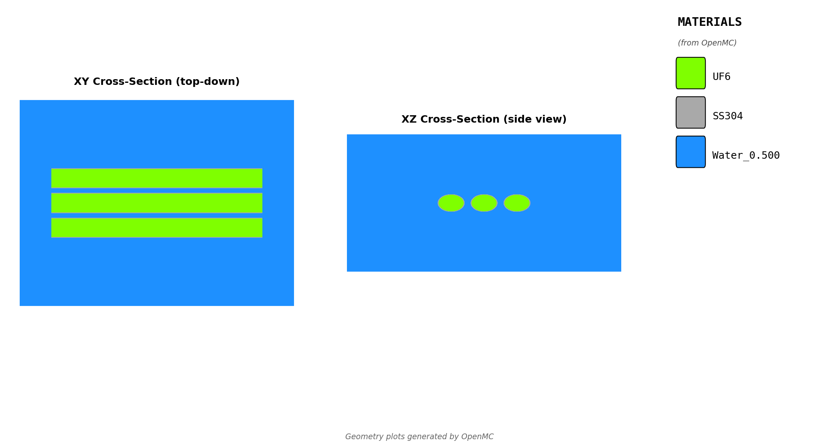
Figure: Geometry Cross-Section
Figure: XY cross-section showing three parallel pipes with UF6 (yellow), stainless steel walls (gray), and water moderator/reflector (blue).

3.2 Pipe Configuration
Parameter | Value | Units
Number of pipes | 3 | -
Pipe arrangement | Horizontal, parallel | -
Pipe orientation | Horizontal (along X-axis) | -
Pipe length | 200 | cm

3.3 Pipe Geometry (per NPS)
Standard schedule 40 pipe dimensions:
NPS | Outer Diameter | Wall Thickness | Inner Diameter
3" | 8.89 cm | 0.549 cm | 7.79 cm
4" | 11.43 cm | 0.602 cm | 10.23 cm
5" | 14.13 cm | 0.655 cm | 12.82 cm
6" | 16.83 cm | 0.711 cm | 15.41 cm

3.4 Materials
Material | Composition | Density (g/cc)
UF6 | Solid uranium hexafluoride | 5.09
Pipe wall | Stainless steel 304 | 8.0
Moderator/Reflector | Water | 0.5 (worst-case)

Note: Water at 0.5 g/cc represents worst-case moderation conditions (mist, fog, or partial flooding). This density produces peak reactivity for multi-unit arrays.

3.5 Parameter Ranges Analyzed
Parameter | Values | Units
Enrichment | 20, 24 | wt% U-235
Pipe size (NPS) | 3, 4, 5, 6 | inches
Edge-to-edge gap | 2, 4, 6 | cm
Water density | 0.5 | g/cc
Water reflector thickness | 30 | cm

Total cases analyzed: 2 enrichments × 4 pipe sizes × 3 gaps = 24 cases

4. Assumptions

4.1 Worst-Case Moderation
For multi-unit configurations, the most reactive water density is NOT fully flooded (1.0 g/cc). Instead, intermediate densities (~0.5 g/cc) can produce higher k-eff values due to the balance between:
- Moderation benefit: Water thermalizes neutrons, increasing fission probability
- Absorption penalty: More water = more neutron absorption between units
A preliminary moderation sweep identified ~0.5 g/cc as peak reactivity, representing conditions such as:
- Water mist/fog accumulation
- Partial flooding scenarios
- Fire suppression spray conditions

4.2 Conservative Assumptions Summary
Assumption | Value Used | Justification
UF6 form | Pure solid | Bounds actual chemistry (complexes reduce reactivity)
UF6 density | 5.09 g/cc | Maximum solid density
Fill level | 100% | Assumes fully loaded pipes
Temperature | Room temperature | Most reactive condition
Enrichment | Up to 24% | Bounds HALEU operations
Water density | 0.5 g/cc | Peak reactivity from moderation sweep
Reflection | 30 cm water | Full reflection on all sides
Pipe wall | SS304 | Realistic for process piping

5. Analytical Methods and Computations

5.1 Monte Carlo Code
- Code: OpenMC (open-source Monte Carlo particle transport)
- Nuclear data: ENDF/B-VIII.0 continuous-energy cross sections
- Thermal scattering: S(α,β) treatment for hydrogen in water

5.2 Simulation Parameters
Parameter | Value
Particles per batch | 10,000
Total batches | 150
Inactive batches | 50
Active batches | 100
Total histories | 1,000,000

5.3 Geometry Model
- 3D explicit geometry: Three horizontal cylinders modeled individually
- Pipe components: UF6 core, stainless steel wall
- Water: Surrounds all pipes and fills gaps between them
- Boundary conditions: Vacuum at outer boundaries

5.4 Statistical Uncertainty
- Expected 1σ uncertainty: ~80-100 pcm
- Safety margin: k-eff + 2σ used for all safety determinations
- Status classification:
- SAFE: k-eff + 2σ < 0.95
- MARGINAL: 0.95 ≤ k-eff + 2σ < 1.0
- CRITICAL: k-eff + 2σ ≥ 1.0

6. Results

6.1 Summary Statistics
Metric | Value
Total cases analyzed | 24
Cases SAFE | 24
Cases MARGINAL | 0
Cases CRITICAL | 0
k-eff range | 0.4985 - 0.6936

6.2 k-effective Results
k-eff by Enrichment and Pipe Size (Gap = 2 cm)
Enrichment | NPS 3" | NPS 4" | NPS 5" | NPS 6"
20% | 0.5015 | 0.5690 | 0.6200 | 0.6711
24% | 0.5158 | 0.5855 | 0.6415 | 0.6922

k-eff by Enrichment and Pipe Size (Gap = 4 cm)
Enrichment | NPS 3" | NPS 4" | NPS 5" | NPS 6"
20% | 0.5072 | 0.5756 | 0.6257 | 0.6750
24% | 0.5207 | 0.5898 | 0.6442 | 0.6936

k-eff by Enrichment and Pipe Size (Gap = 6 cm)
Enrichment | NPS 3" | NPS 4" | NPS 5" | NPS 6"
20% | 0.4985 | 0.5643 | 0.6127 | 0.6649
24% | 0.5126 | 0.5803 | 0.6326 | 0.6834

6.3 Effect of Pipe Size
Larger pipe sizes result in higher k-effective values due to increased fissile mass:
- At 20% enrichment: NPS 3" to NPS 6" increases k-eff by Δk = 0.168
- At 24% enrichment: NPS 3" to NPS 6" increases k-eff by Δk = 0.173

6.4 Effect of Gap Distance
The effect of edge-to-edge gap on k-effective is minimal for these configurations:
- At 20% enrichment, NPS 6": Gap 2 cm to 6 cm changes k-eff by Δk = -0.0062
- At 24% enrichment, NPS 6": Gap 2 cm to 6 cm changes k-eff by Δk = -0.0088
The negligible gap sensitivity indicates that pipe spacing has minimal impact on criticality for these far-subcritical configurations.

6.5 Visualization
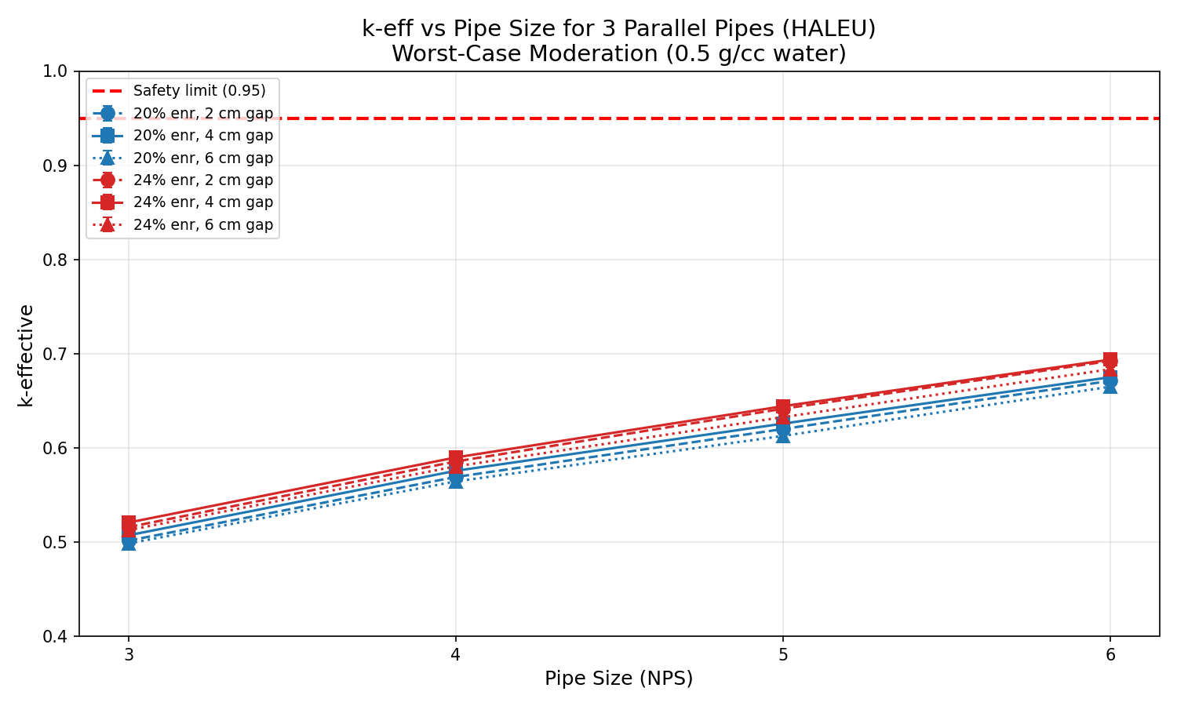
Figure: k-eff vs Pipe Size
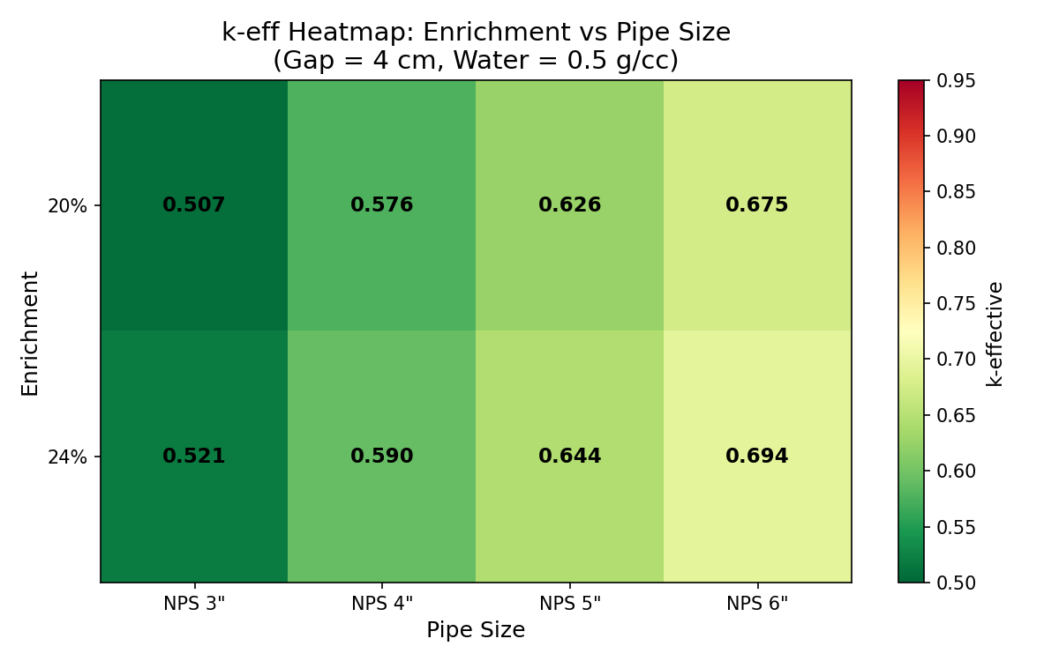
Figure: k-eff Heatmap

7. Conclusions

7.1 Safety Status
All 24 analyzed cases are SAFE (k-eff + 2σ < 0.95).
The maximum k-effective observed was 0.694 (at 24% enrichment, NPS 6", 4 cm gap), which provides a substantial safety margin below the 0.95 acceptance criterion.

7.2 Maximum k-eff by Configuration
Enrichment | Pipe Size | Max k-eff | Safety Margin to 0.95
20% | NPS 6" | 0.6750 | 0.2750
24% | NPS 6" | 0.6936 | 0.2564

7.3 Key Findings
- Three parallel pipes are inherently safe for HALEU enrichments up to 24% in pipes up to NPS 6", even at worst-case moderation conditions.
- No spacing restrictions required: All analyzed gap distances (2-6 cm) are safe. Even touching pipes (gap = 0) would likely remain subcritical given the large safety margins observed.
- Pipe diameter is the dominant parameter: Increasing pipe size from NPS 3" to NPS 6" increases k-eff by approximately 0.17, compared to negligible (<0.01) changes from gap distance.
- Conservative bounding analysis: These results use worst-case moderation (0.5 g/cc water) and maximum solid UF6 density (5.09 g/cc). Actual operating conditions would produce lower reactivity.

7.4 Operational Recommendations
Based on this analysis, the following operational guidance is provided:
- No minimum spacing required between parallel pipes up to NPS 6" at enrichments up to 24%
- No administrative controls needed for 3-pipe configurations in this size range
- Standard pipe installation practices are acceptable from a criticality safety standpoint

8. Attachments
- Attachment A: Geometry validation plots (XY, XZ cross-sections)
- Attachment B: Full results CSV file
- Attachment C: Input YAML configuration file
- Attachment D: OpenMC input files (sample case)

Report generated by Crit-Buddy

