CPI predication app based on kivy

1. kivy

CPI predication app is developed on kivy platform. Kivy is a [free](https://en.wikipedia.org/wiki/Free_Software" \o "Free Software) and [open source](https://en.wikipedia.org/wiki/Open_Source_Software" \o "Open Source Software) [Python](https://en.wikipedia.org/wiki/Python_(programming_language)" \o "Python (programming language)) library for developing [mobile apps](https://en.wikipedia.org/wiki/Mobile_app" \o "Mobile app) and other [multitouch](https://en.wikipedia.org/wiki/Multitouch" \o "Multitouch) [application software](https://en.wikipedia.org/wiki/Application_software" \o "Application software) with a [natural user interface (NUI)](https://en.wikipedia.org/wiki/Natural_User_Interface" \o "Natural User Interface). It is distributed under the terms of the [MIT License](https://en.wikipedia.org/wiki/MIT_License" \o "MIT License), and can run on [Android](https://en.wikipedia.org/wiki/Android_(operating_system)" \o "Android (operating system)), [iOS](https://en.wikipedia.org/wiki/IOS" \o "IOS), [GNU](https://en.wikipedia.org/wiki/GNU" \o "GNU)/[Linux](https://en.wikipedia.org/wiki/Linux" \o "Linux), [OS X](https://en.wikipedia.org/wiki/OS_X" \o "OS X), and [Windows](https://en.wikipedia.org/wiki/Microsoft_Windows" \o "Microsoft Windows).

1. Dataset

The data set is crawed and cleaned by python named clean_cpi.csv.

1. Model

The target variable we are going to predict is CPI. Therefore, we apply linear regression algorithm to predict the CPI. The model is well trained using by the data set.

1. GUI of app

This interface has 2 input boxes(country code and date), and one output box(predicated CPI). The user could input the country code and date to predicated the respective CPI.

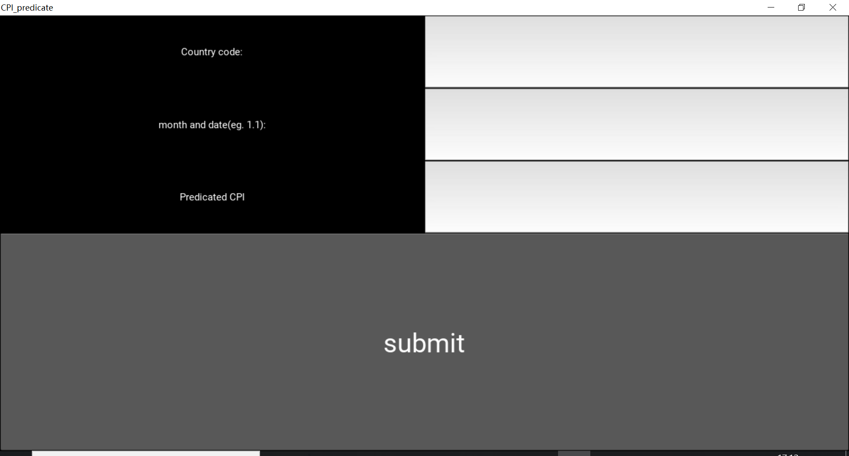

The predicated value:

