Oregon State University
Avoiding Flight Delays
ST 599 – Big Data & Statistical Computing
Project 2

Sarah Guermond
Andy Olstad
Jasmine Pahukula
Tim Skalland

May 12, 2014

Overview
The Bureau of Transportation Statistics (BTS) collects, manages and shares transportation related statistical data. This data analysis focused on major commercial airlines’ on-time performance. The data analysis will include a population-based answer as well as a sample-based answer.

Question of Interest: What time of the day and day of the week is best for avoiding flight delays?

There are 25 years of data available to use as the population, however, we redefined the population to include only the last 3 years (2011-2013). We also chose to consider arrival delay, as our variable of interest. Lastly, we forced negative arrival times to be taken as zero delay. See obstacles/solutions section for a discussion on these choices.

Findings
Population-based Approach
Overall, each day of the week followed a similar trend, as shown in Figure 1. There is a peak average delay around 3:00 am, a low average delay around 5:00 am and then the average delay increases until about 8:00 pm, tapering off again. Flights departing on Wednesday at 6:00 am had the shortest average delay time of about 5.5 minutes while flights departing on Saturday at 3:00 am had the longest average delay time of about 21.5 minutes. Flights departing on Wednesday at 5:00 pm have the smallest proportion of delays at about 23% while flights on Thursday at 8:00 pm have the highest proportion of delays at about 51%. (Note: Time 0 is Midnight)
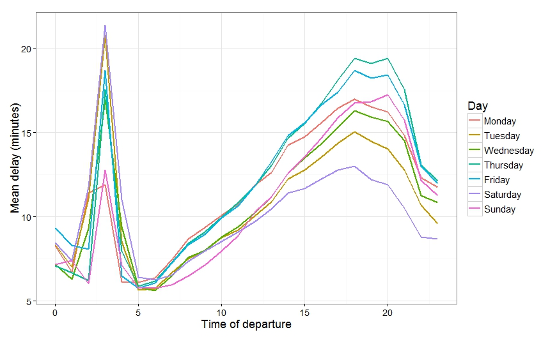
Figure 1: Average Arrival Delay Experienced by Time of Day and Day of Week for the Population

Sample-based Approach
We considered several sampling designs and decided to stratify by day of week and hour of day. Our initial simple random sample gave small subsamples for late evening/early morning flights, and omitted some hours entirely on some days. By stratifying, we ensured we could estimate a value for all 168 (24 hours * 7 days) times. We sampled roughly 2000 flights in each stratum, or the whole population if that was smaller. Our sample data was consistent with the population data:
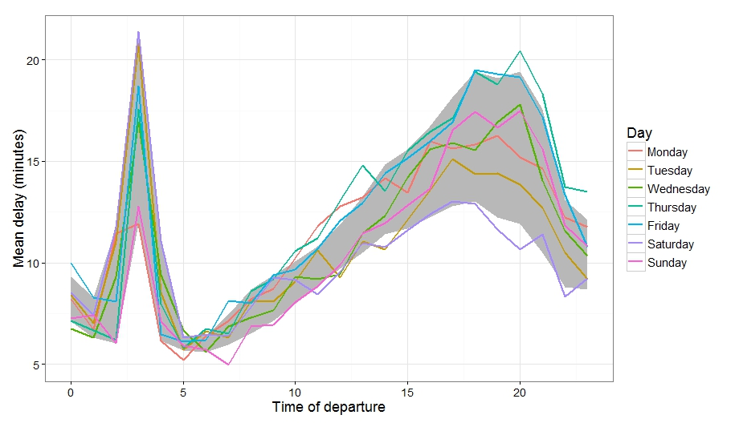
Figure 2: Average Arrival Delay Experienced by Time of Day and Day of Week for the Sample. The grey band represents the minimum and maximum average delay for each time of day from our population.

The sample data was able to show statistically significant differences between days for nearly all the daytime hours (p-values were inconclusive between 1 and 6 am) using ANOVA tests. The margin of error for each of the 168 confidence intervals, without any multiple comparisons correction, ranged from 1 to 10 minutes (2 minute average ME).
We note that Sundays at 7am showed the lowest mean arrival delay within our sample data (although the confidence intervals for these early times overlap across days). Saturdays at 3am still had the highest mean arrival delay and Thursday evenings had the highest proportion of delayed flights.

Obstacles and Solutions
A big obstacle throughout this project was deciding on the population of interest and how to define our variable of interest (delay). We had 25 years of data and 3 measures of delay (departure delay, arrival delay and proportion of delayed flights). We first decided to consider only the last 3 years of data. Airline operations have changed a great deal since 1992 due to mergers, security behaviors after terrorist attacks, and possible increased padding of flight schedules, we felt the use of older data to identify the best day and time to avoid flight delays today was irrelevant. We also had to consider which delay was worse: arrival delay or departure delay. Since we really didn’t care if we took off late as long as we got to our destination on-time, we decided that arrival delay was worse and thus was a more informative variable of interest.
Our next issue was that time of day was a date/time variable in the database and was not indexed. Charlotte created an index on truncated 24h time.
Of course we had issues with the size of the data set, even when considering only 3 years. We had to be very careful on our coding, using the indexes as best we could, calling the smallest number possible of columns and summarizing over the times of day before collecting from the database. This allowed us to run our code very efficiently and avoid earlier issues such as running out of memory and long run times to get summaries.

