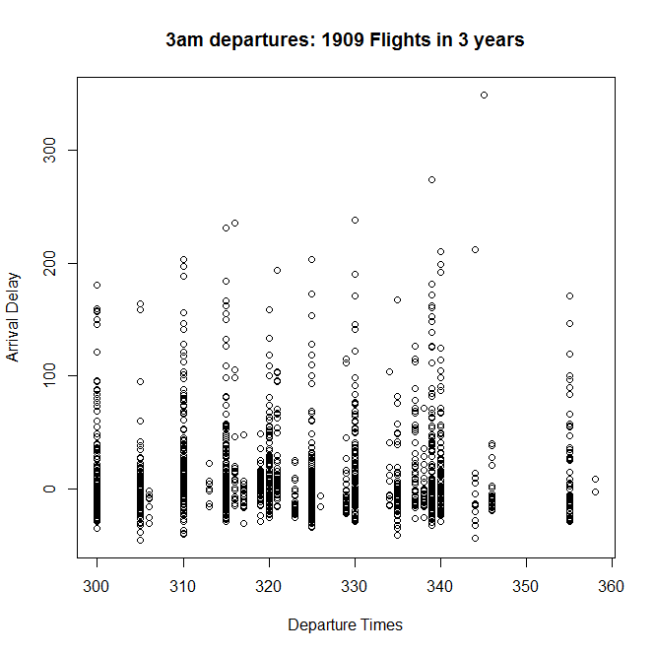
Summary of 3am arrival delays:

Min. 1st Qu. Median Mean 3rd Qu. Max. NA's
-45.00 -13.00 -2.00 10.43 16.00 349.00 33

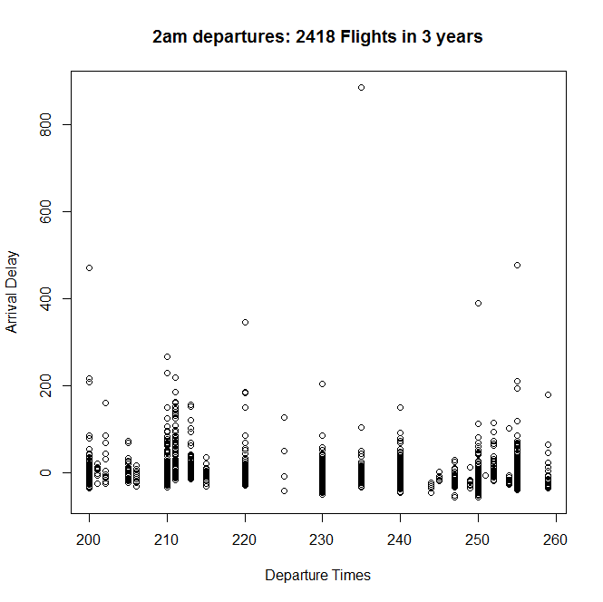
Summary of 2am arrival delays:
Min. 1st Qu. Median Mean 3rd Qu. Max. NA's
-55.0000 -17.0000 -7.0000 -0.7358 4.0000 884.0000 30

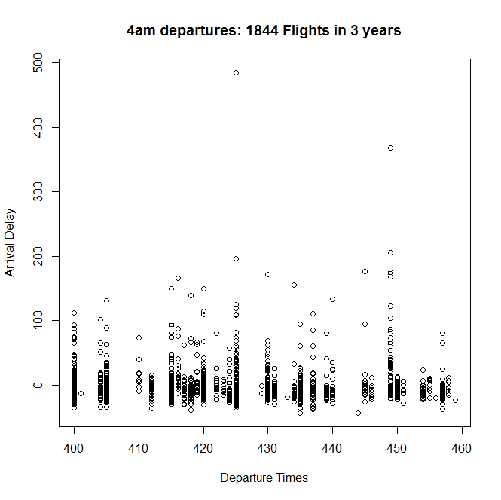

Summary of 4am arrival delays:
Min. 1st Qu. Median Mean 3rd Qu. Max. NA's
-43.000 -15.000 -7.000 -0.661 4.000 485.000 27

