Robert Rash

Dr. Çankaya

CSE5343

21 July 2017

**Semester Project**

**Part 1**

Processes are represented by the PCB class. These are basic class representations of actual PCBs from a real operating system. There is no real functionality in a PCB object itself aside from storing data.

The main queue data structure is implemented using a doubly-linked list of my own creation. Basic additions and deletions can be accomplished using the push_back()/push_front() methods and the pop_back()/pop_front() methods, respectively. Additionally, there are insert() and delete(). insert() puts a value in the list at a given index location in the list, and delete() deletes a given value in a greedy fashion (that is, the first value in the list that matches the given value is deleted).

**Part 2**

As per the requirements for CSE5343 students, I implemented Shortest-Job-First (SJF) scheduling as well as Non-Preemptive Priority (NPP) scheduling. Source code for these algorithms can be found in the provided src/ directory.

Screenshots

Sample of tabular output using Shortest Job First (SJF)

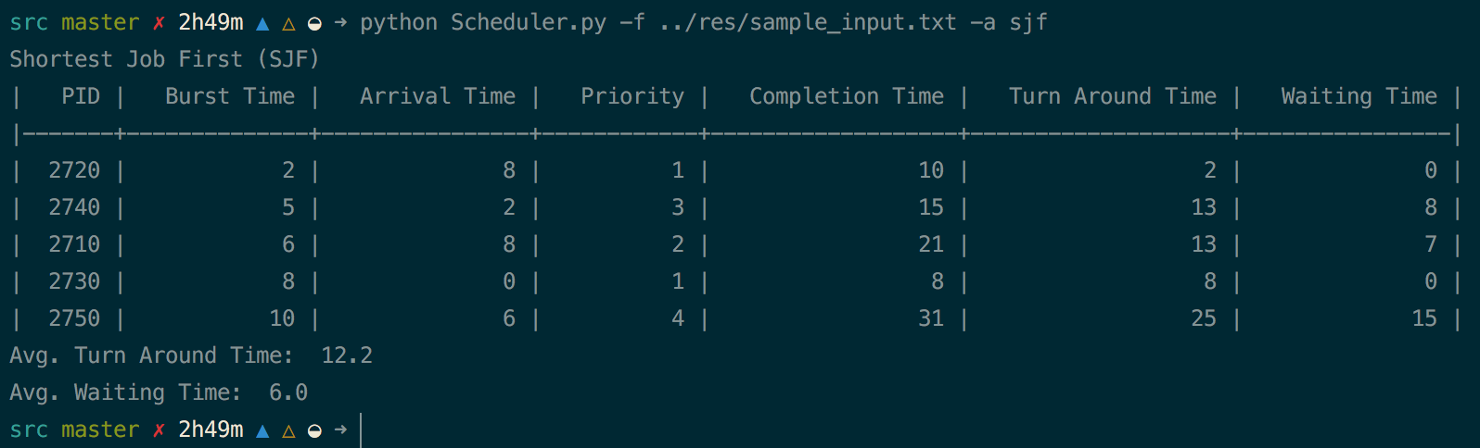

Sample of tabular output using Non-Preemptive Priority (NPP)

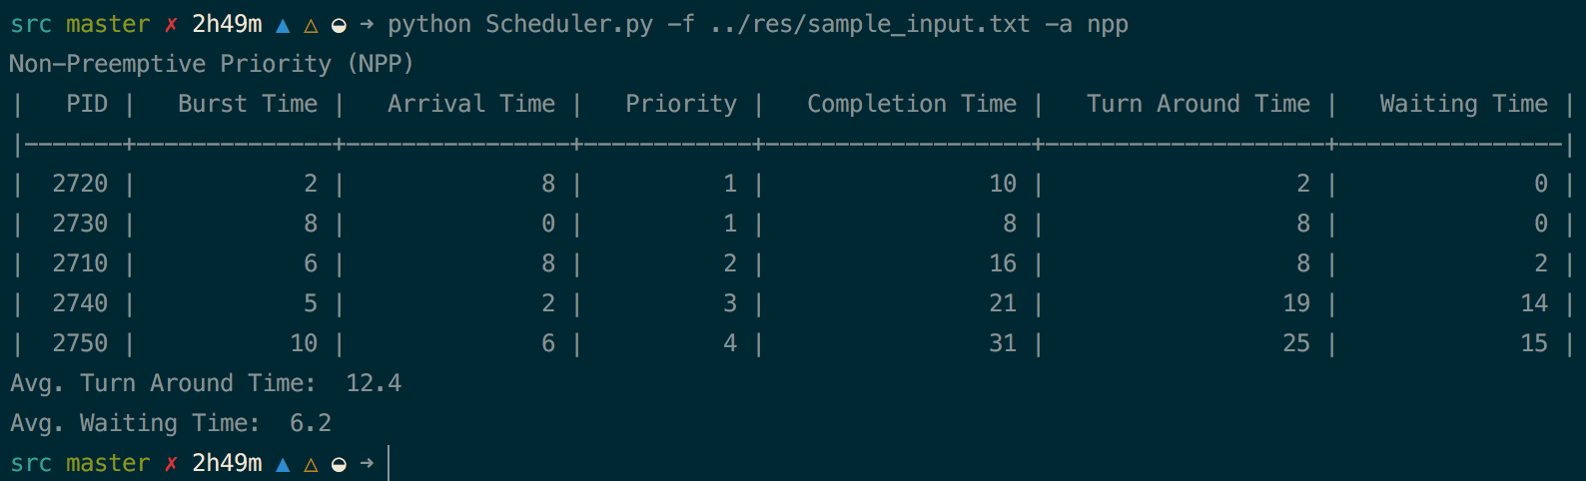

Execution trace for Shortest Job First (SJF)

* Numbers on left indicate “system time”
* Item on right is a representation of a PCB with a given PID and state

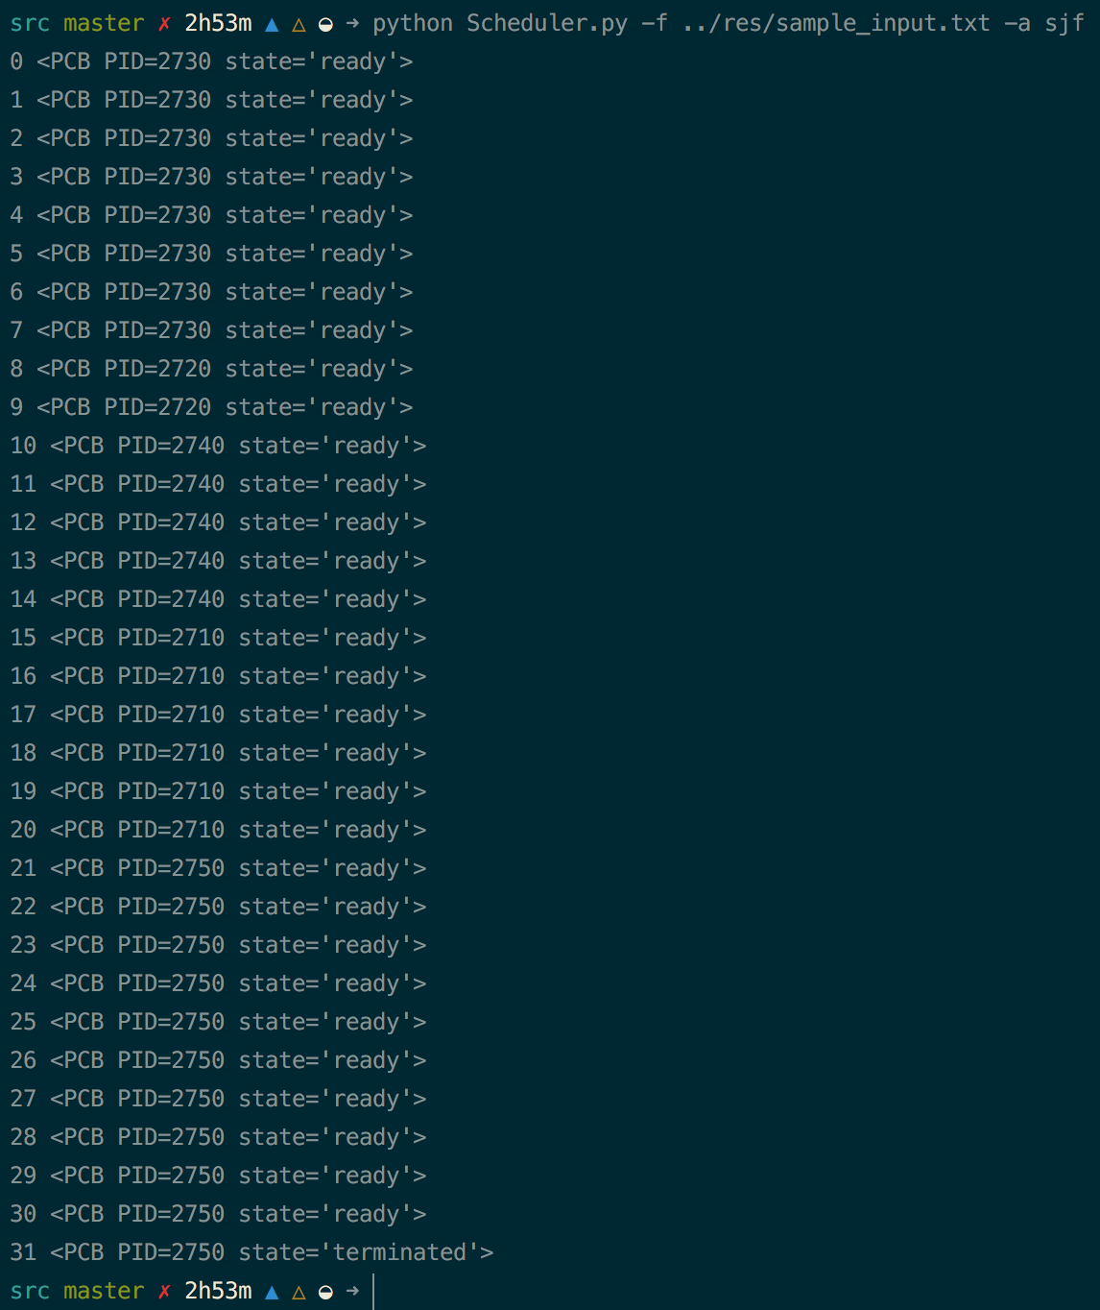

Execution trace for Non-Preemptive Priority (NPP)

* Numbers on left indicate “system time”
* Item on right is a representation of a PCB with a given PID and state

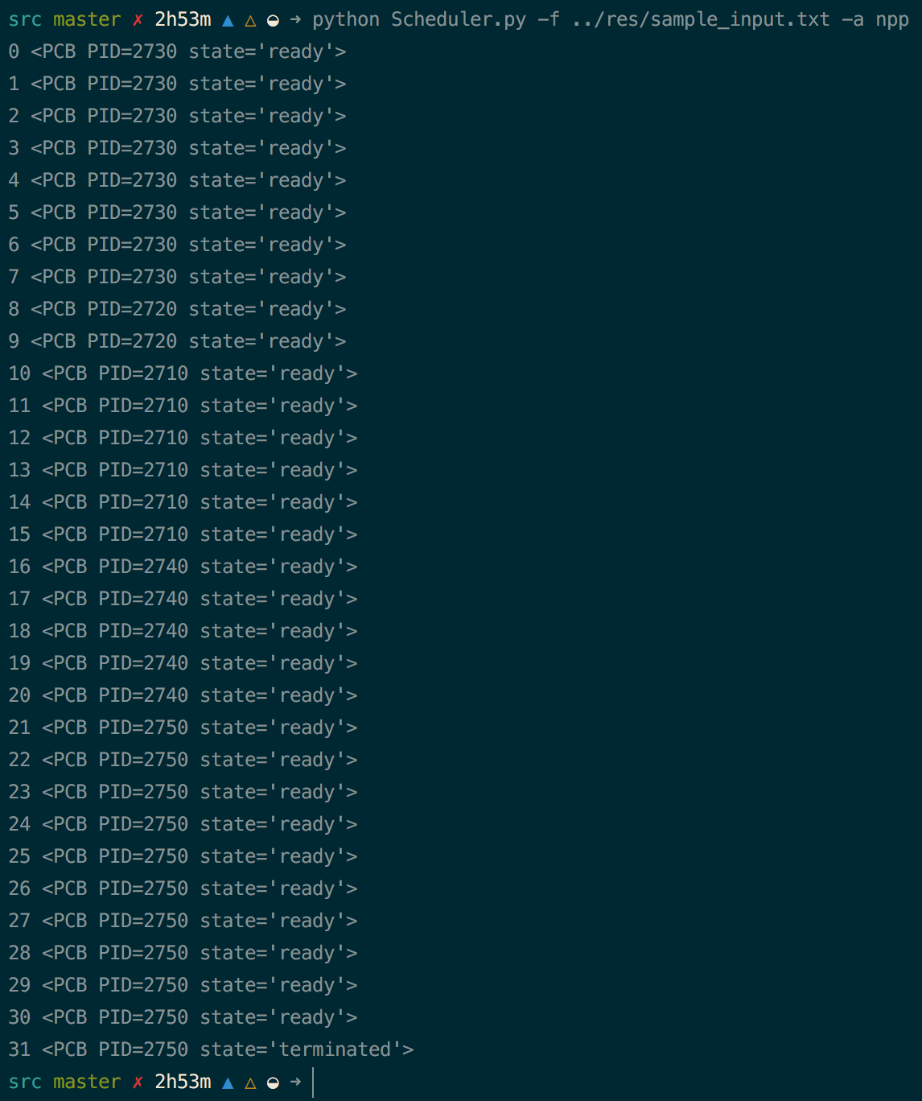

**Programming Environment**

My main machine is a MacBook Pro running macOS Sierra. My text editor of choice is vim.

Source code can be found attached to this project or on GitHub (request access at <https://github.com/andy-rash>).

This program is written in Python 2.7. I used a virtualenv in order to neatly encapsulate program requirements. In order to install the required components, install virtualenv, create a virtualenv, and run `pip install –r requirements.txt` from the root folder.