**Problem1**

|  |  |  |  |  |
| --- | --- | --- | --- | --- |
|  | a | b | c | ε |
| Q0 | Q0, Q1 | ∅ | Q4 | Q2,Q3 |
| Q1 | ∅ | Q2 | ∅ | ∅ |
| Q2 | ∅ | Q1 | Q3 | ∅ |
| Q3 | ∅ | Q4 | ∅ | Q0 |
| Q4 | ∅ | ∅ | Q0 | ∅ |

ε-closure(Q0) = {Q0, Q2, Q3}

ε-closure(Q1) = {Q1}

ε-closure(Q2) = {Q2}

ε-closure(Q3) = {Q0, Q2, Q3}

ε-closure(Q4) = {Q4}

ε-closure(0) = {Q0,Q2,Q3} = A

ε-closure(move(A,a)) = ε-closure({Q0,Q1}) = {Q0,Q1,Q2,Q3} = B

ε-closure(move(A,b)) = ε-closure({Q1,Q4}) = {Q1,Q4} = C

ε-closure(move(A,c)) = ε-closure({Q3,Q4}) = {Q0,Q2,Q3,Q4} = D

ε-closure(move(B,a)) = ε-closure({Q0,Q1}) = {Q0,Q1,Q2,Q3} = B

ε-closure(move(B,b)) = ε-closure({Q1,Q2,Q4}) = {Q1,Q2,Q4} = E

ε-closure(move(B,c)) = ε-closure({Q3,Q4}) = {Q0,Q2,Q3,Q4} = D

ε-closure(move(C,b)) = ε-closure({Q2}) = {Q2} = F

ε-closure(move(C,c)) = ε-closure({Q0}) = {Q0,Q2,Q3} = A

ε-closure(move(D,a)) = ε-closure({Q0,Q1}) = {Q0,Q1,Q2,Q3} = B

ε-closure(move(D,b)) = ε-closure({Q1,Q4}) = {Q1,Q4} = C

ε-closure(move(D,c)) = ε-closure({Q0,Q3,Q4}) = {Q0,Q2,Q3,Q4} = D

ε-closure(move(E,b)) = ε-closure({Q1,Q2}) = {Q1,Q2} = G

ε-closure(move(E,c)) = ε-closure({Q0,Q3}) = {Q0,Q2,Q3} = A

ε-closure(move(F,b)) = ε-closure({Q1}) = {Q1} = H

ε-closure(move(F,c)) = ε-closure({Q3}) = {Q0,Q2,Q3} = A

ε-closure(move(G,b)) = ε-closure({Q1,Q2}) = {Q1,Q2} = G

ε-closure(move(G,c)) = ε-closure({Q3}) = {Q0,Q2,Q3 } = A

ε-closure(move(H,b)) = ε-closure({Q2}) = {Q2} = F

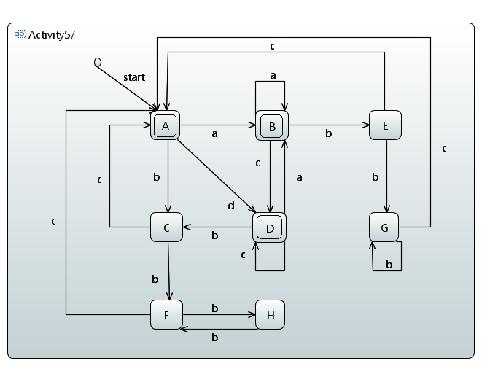

Exp: a*c*|a+b+c

|  |  |  |  |  |
| --- | --- | --- | --- | --- |
|  | a | b | c | ε |
| Q0 | ∅ | ∅ | Q1,Q5 | ∅ |
| Q1 | Q2 | Q3 | ∅ | Q5 |
| Q2 | Q4 | ∅ | Q5 | ∅ |
| Q3 | ∅ | Q4 | Q5 | ∅ |
| Q4 | Q1 | Q1 | ∅ | ∅ |
| Q5 | ∅ | ∅ | ∅ | Q0 |

ε-closure(Q0) = {Q0}

ε-closure(Q1) = {Q0, Q1, Q5}

ε-closure(Q2) = {Q2}

ε-closure(Q3) = {Q3}

ε-closure(Q4) = {Q4}

ε-closure(Q5) = {Q0, Q5}

ε-closure(0) = {Q0} = A

ε-closure(move(A,c)) = ε-closure({Q1,Q5}) = {Q0,Q1,Q5} = B

ε-closure(move(B,a)) = ε-closure({Q2}) = {Q2} = C

ε-closure(move(B,b)) = ε-closure({Q3}) = {Q3} = D

ε-closure(move(B,c)) = ε-closure({Q1,Q5}) = {Q0,Q1,Q5} = B

ε-closure(move(C,a)) = ε-closure({Q4}) = {Q4} = E

ε-closure(move(C,c)) = ε-closure({Q5}) = {Q0,Q5} = F

ε-closure(move(D,b)) = ε-closure({Q4}) = {Q4} = E

ε-closure(move(D,c)) = ε-closure({Q5}) = {Q0,Q5} = F

ε-closure(move(E,a)) = ε-closure({Q1}) = {Q0,Q1,Q5} = B

ε-closure(move(E,b)) = ε-closure({Q1}) = {Q0,Q1,Q5} = B

ε-closure(move(F,c)) = ε-closure({Q1,Q5}) = {Q0,Q1,Q5} = B

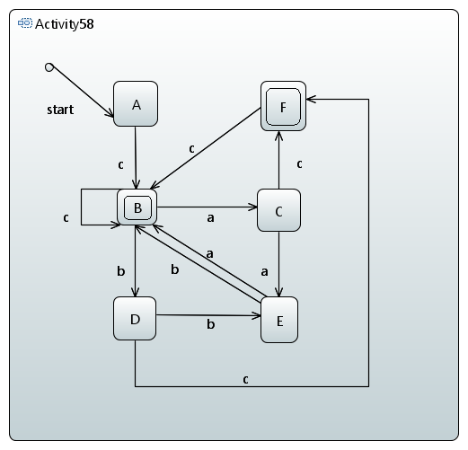

Exp: c(b+a*|a+b*)c{0,1}

**Problem2**

1. ^(aa)*|$(aa)*(bbbcc|bcbbc|bcbcb|bccbb|bbcbc|bbccb|ccbbb|cbcbb|cbbcb|cbbbc)+
2. [ab|ac|bc|aa|bb|cc|ba|bc|ca|cb]*a[ab|ac|bc|aa|bb|cc|ba|bc|ca|cb]+a[ab|ac|bc|aa|bb|cc|ba|bc|ca|cb]*

**Problem3**

1. Assume (ab)n(ba)m is a regular language, so there must be a const x>0 make that

(ab)n(ab)x-m-n(ba)m  x-m-n>=1

Let k>=0

(ab)n(ab)k(x-m-n)(ba)m

Now the const is n+k(x-m-n)+m

= n+kx-km-kn+m

= kx + (m+n)(1-k)

The actual const is x+k(x-m-n)

= (1+k)x - k(m+n)

These two const will never be the same, so the language is not regular.

1. Assume c2kab2c2n is a regular language.

= cxcyc2k-x-yab2c2n  y>=1

Let j>=0

cxcyjc2k-x-yab2c2n

x+yj+2k-x-y

= yj+2k-y

= 2k + (j-1)

These two const will never be the same, so the language is not regular.

**Problem5**

If L2 is regular language, then

S -> f*(w)B

S -> f*(w)

S and B belongs to VN, f*(w) belongs to VT

So

1. w = ε, f*(w) = ε
2. w = ε, f*(w) != ε
3. w != ε, f*(w) = ε
4. w != ε, f*(w) != ε

S -> wB

S -> w

S and B belongs to VN, w belongs to VT

So

F(f*(wB)) = wB

F(f*(w) = w

So it is also a regular language.