**Azure Service Integration**

Steps for creating and deploying Translator web app services with Azure:

**Create Cognitive Services -**

1. Login to Azure - <https://azure.microsoft.com/en-gb/>

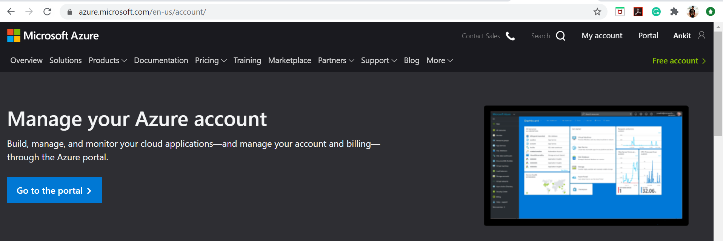

1. Go to Portal - <https://portal.azure.com/#home>

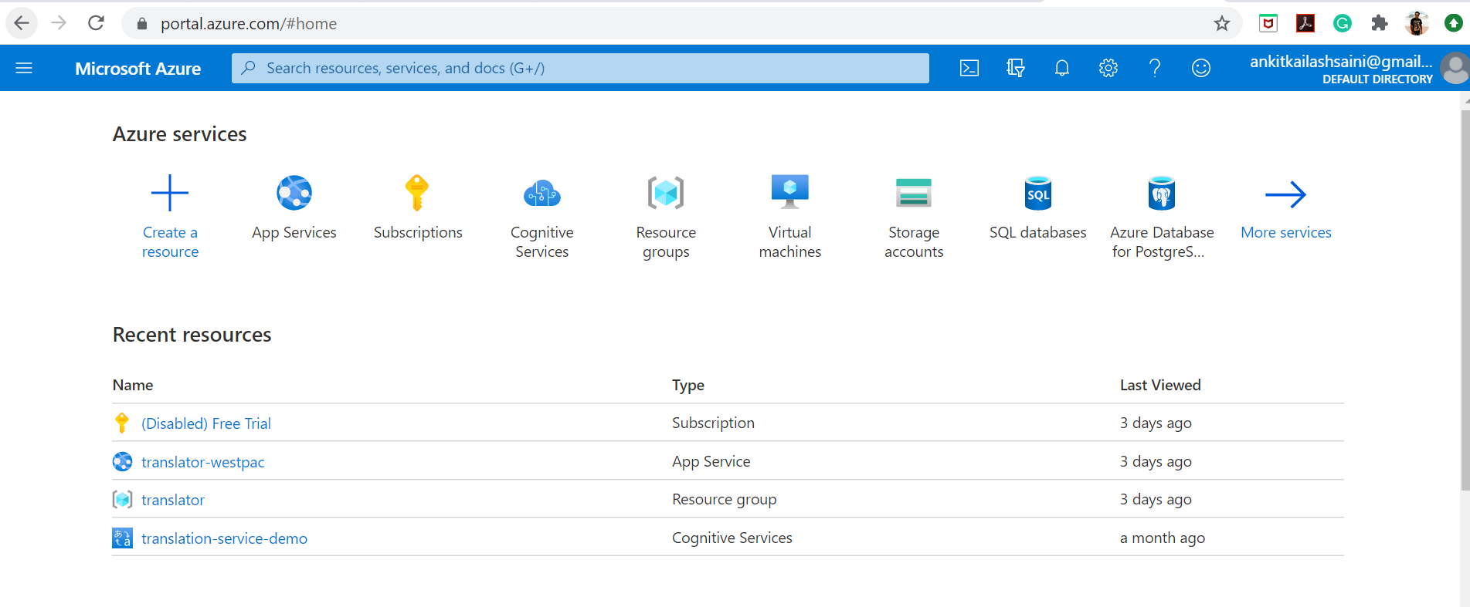

1. Create a Resource Group - <https://portal.azure.com/#create/Microsoft.ResourceGroup>
2. By clicking on Add, user can create a new group

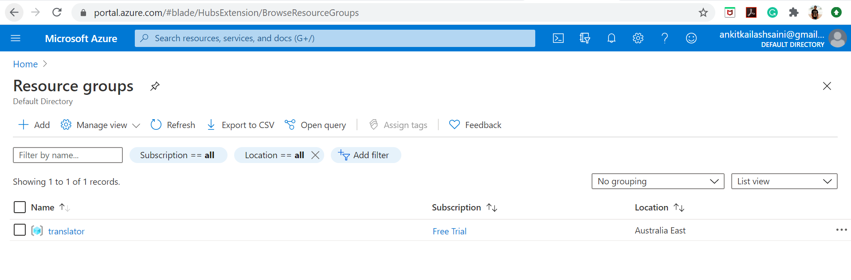

Existing translator configuration –

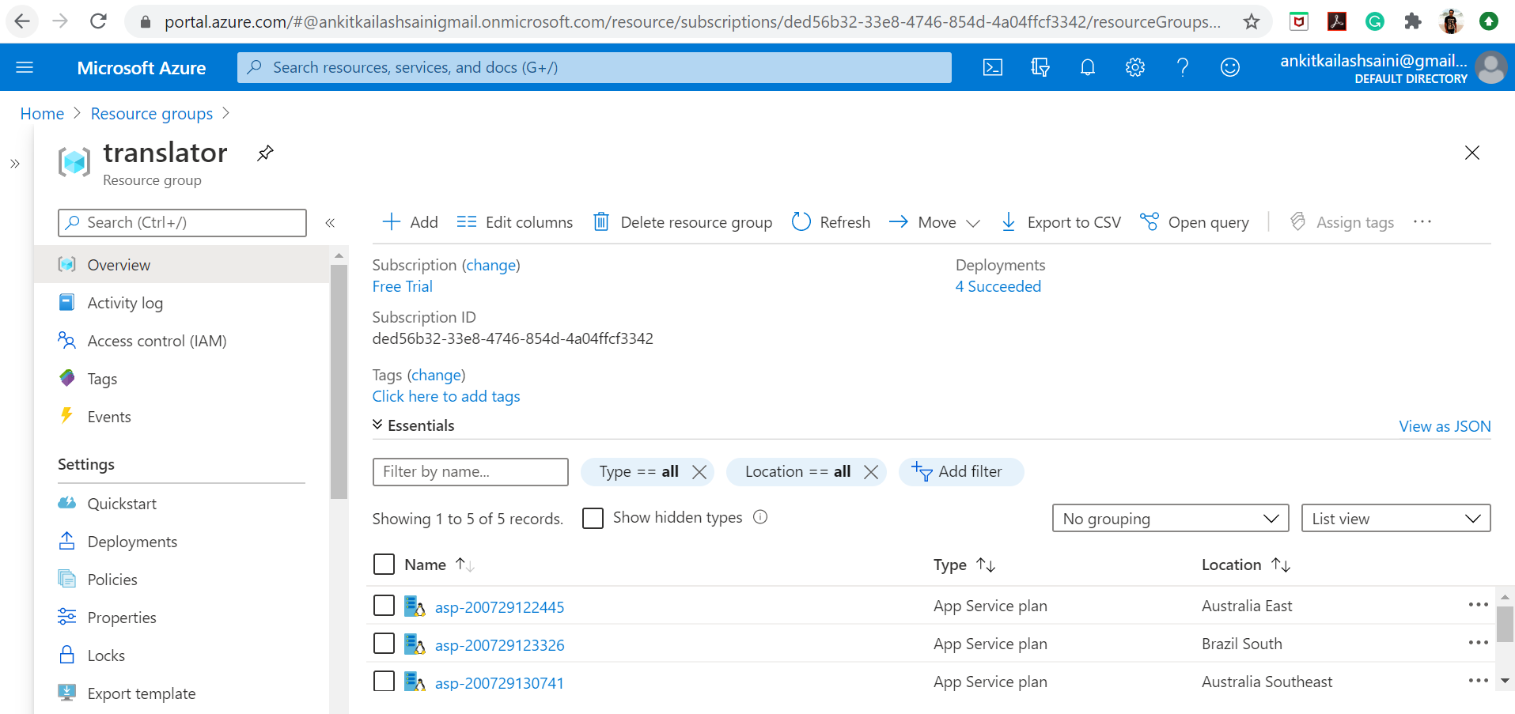

1. Go back to Portal Home –

Select Cognitive Services

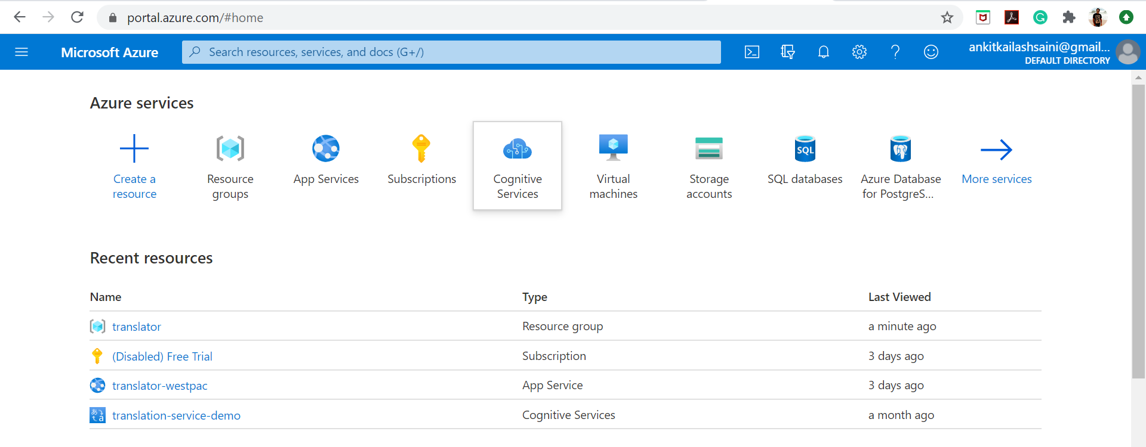

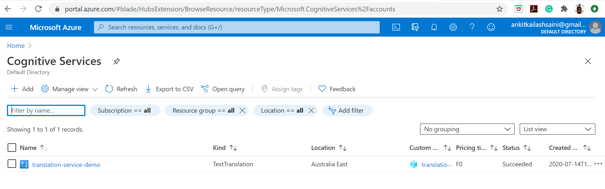

1. Click on Add to create a new service, here user needs to select a service. In our case we need to search for Translator

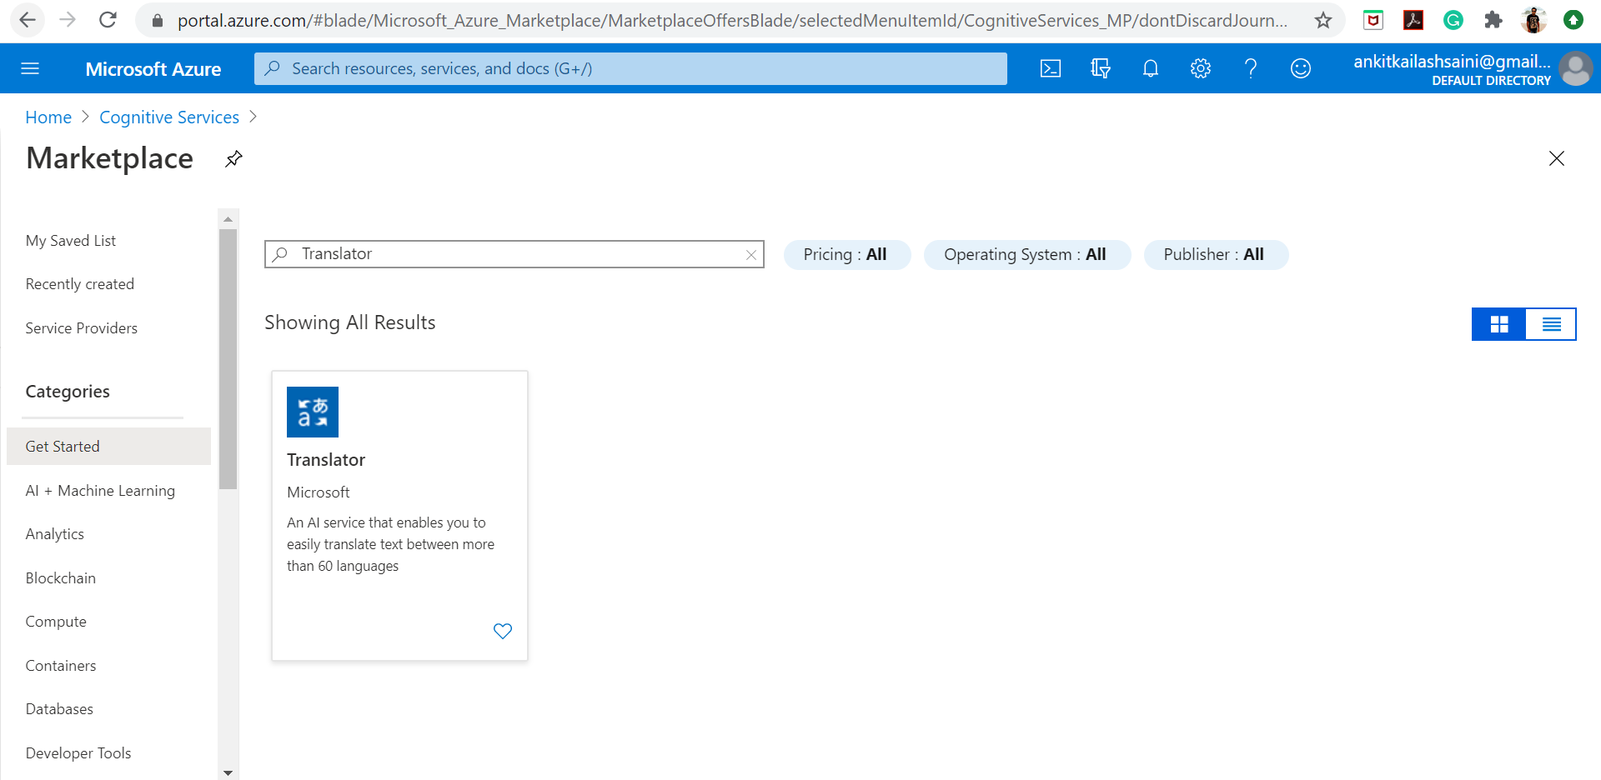

1. Click on translator tab, it will navigate you below page –

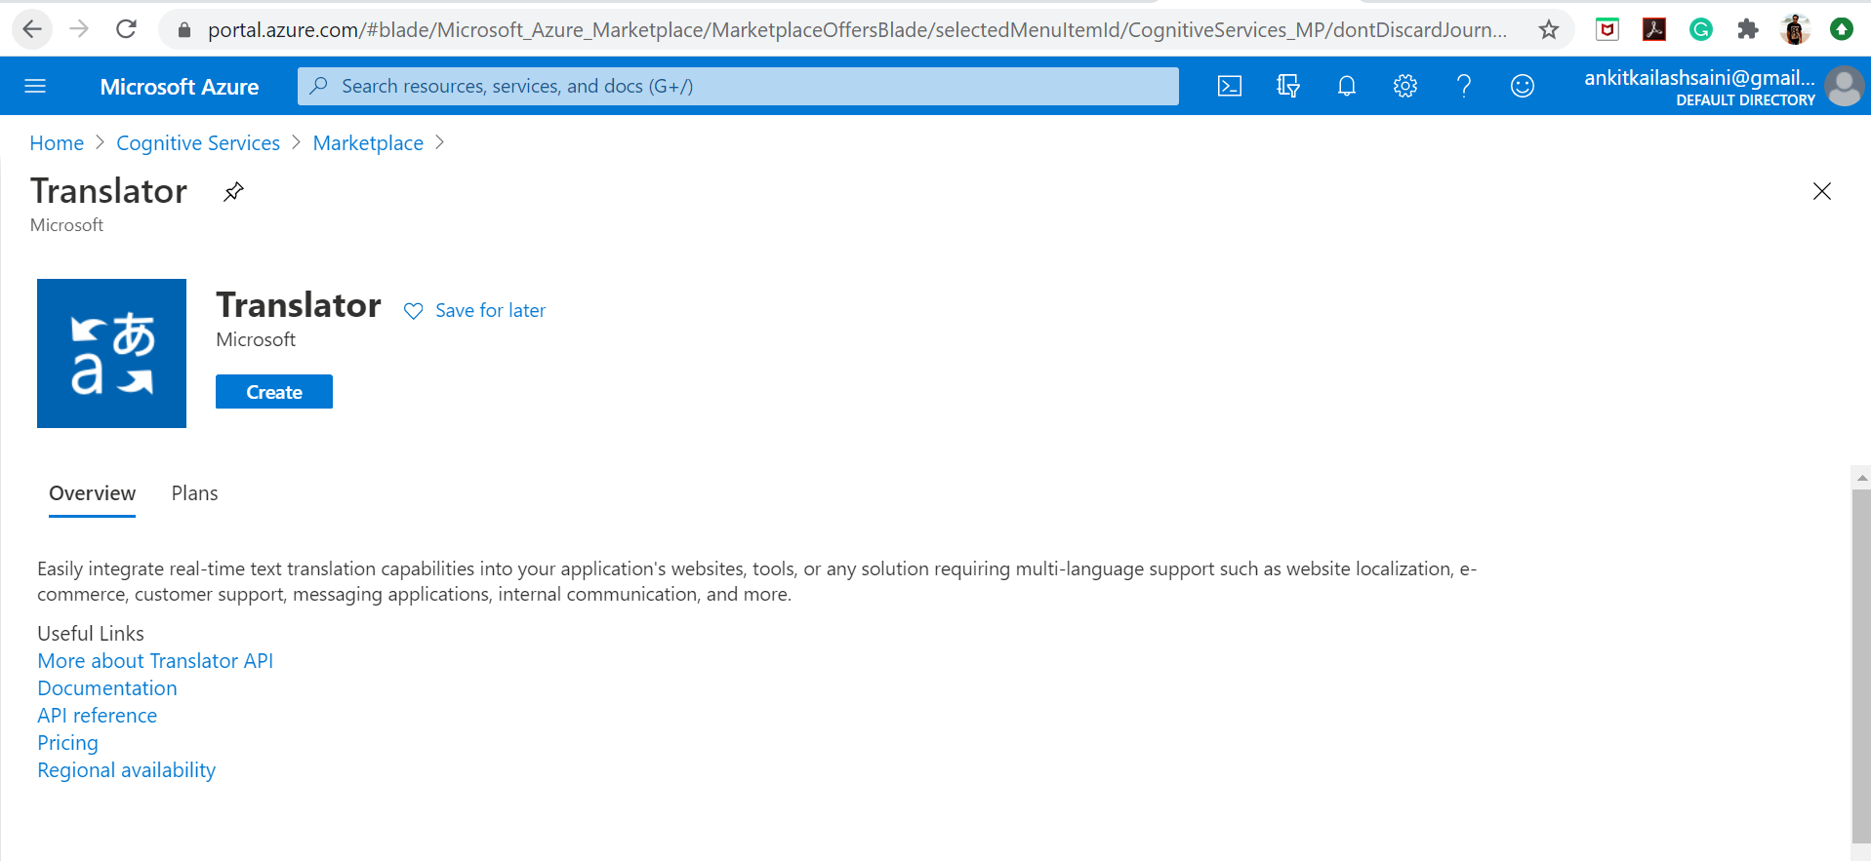

1. Click on Create button –

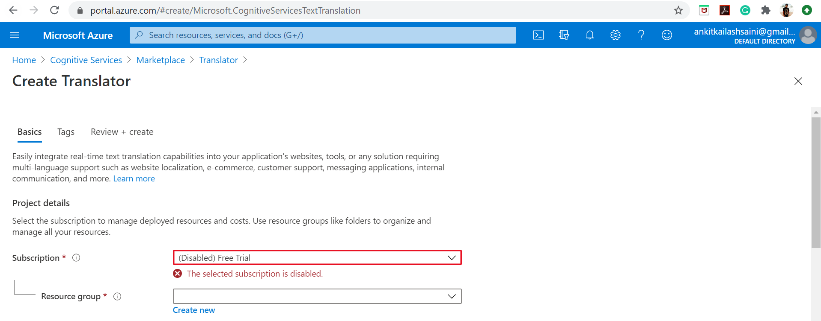

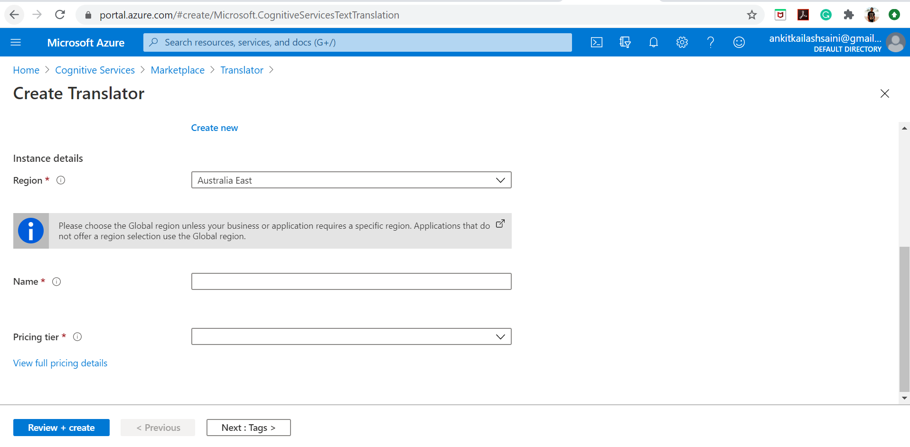

1. Select created resource group and region would be Australia East, after that Review and create.

Go to Home screen –

It will show created resource, in our case it’s translation-service-demo

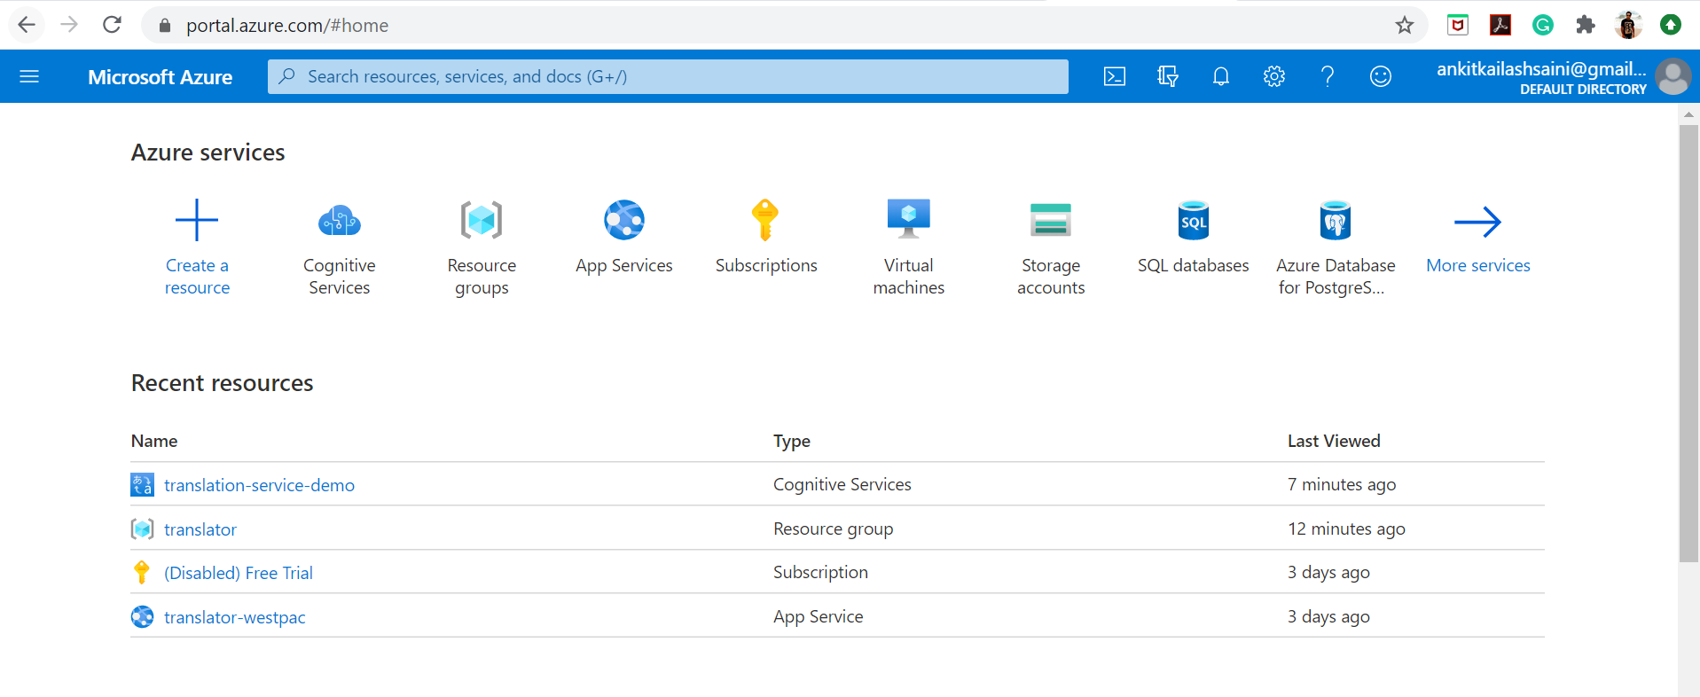

Click on translation-service-demo –

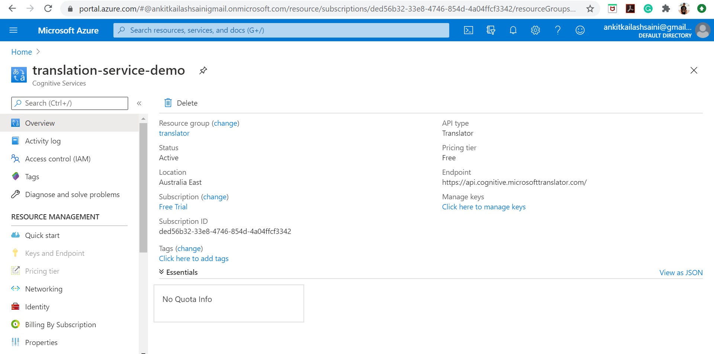

It shows – Overview and other properties

Under Quick start it shows, how we can use this service.

By following Quick start – We have created a translator project - <https://github.com/andy000087/trans-final>

**Create Web App Services -**

If we want to deploy this project to Azure app service then we need to follow below steps –

1. Go to - <https://portal.azure.com/#home>
2. Select App Services to deploy project

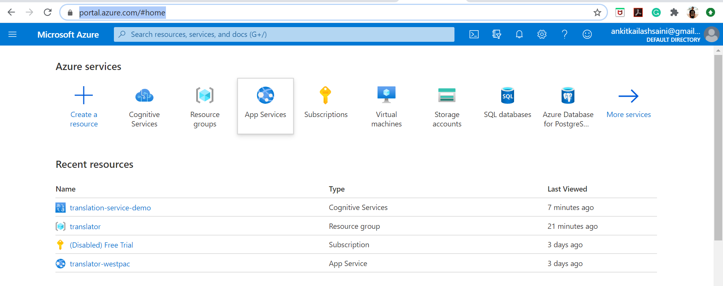

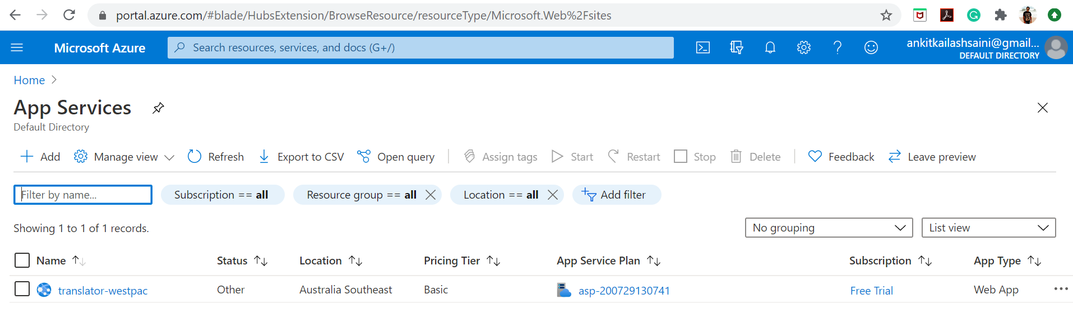

1. Click on Add to create a new resource

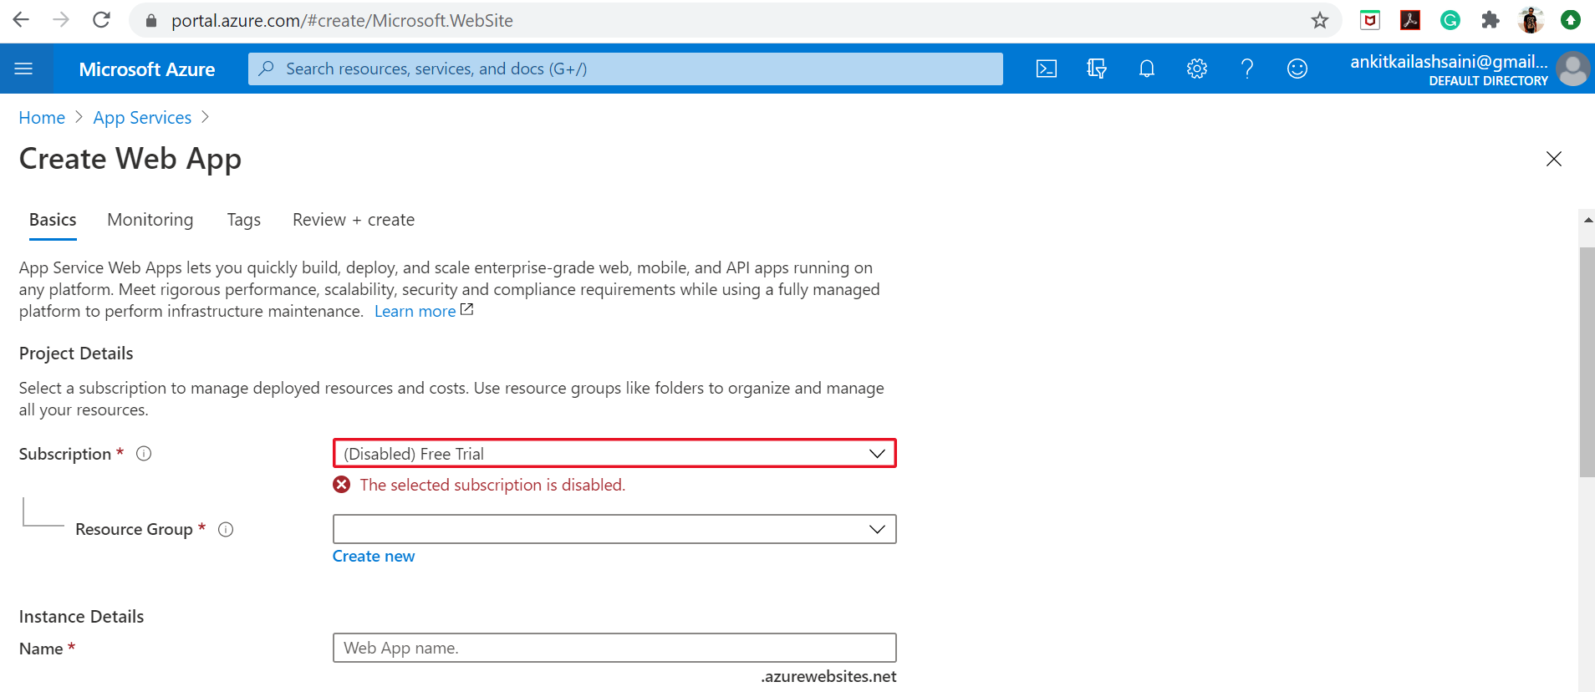

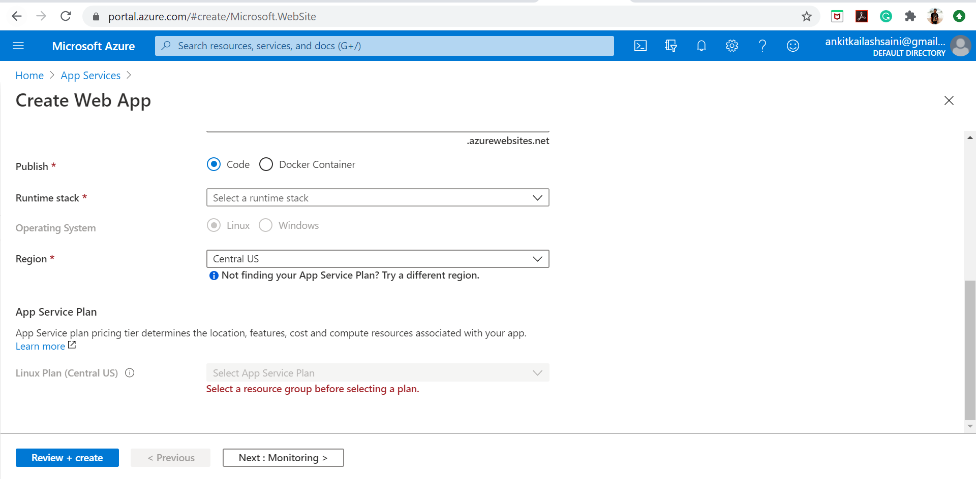

1. After entering details click on Review and create button, it will create another resource for hosting web app, existing configuration are given below

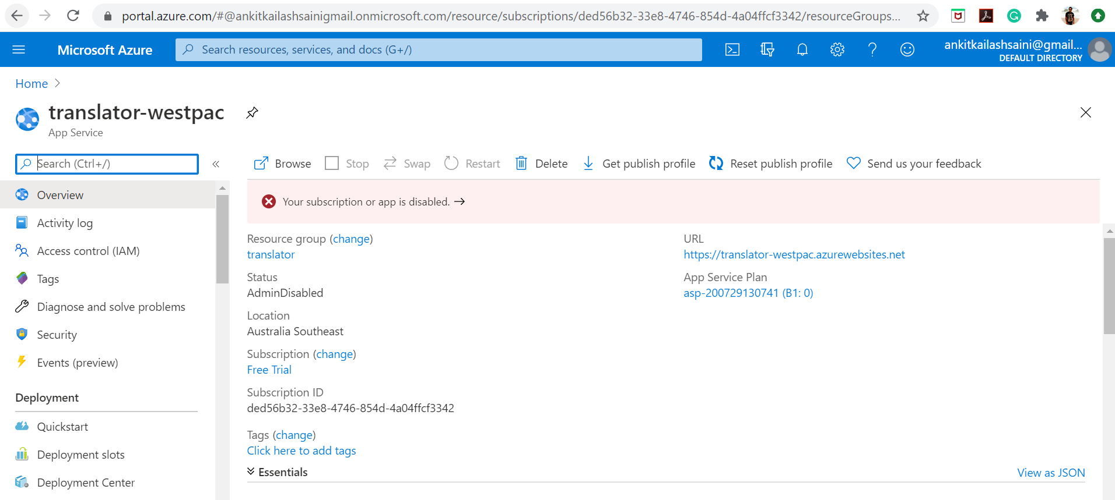

1. Left hand side tabs showing properties, deployment configuration, settings and QuickStart. With QuickStart user can do configuration to deploy web app as per need.

