Lab 04
Name: | 江承恩
Student ID: | B09611004
Total Score:
Note:
Most of the explanations in this lab is optional. However, giving reasonable explanations to your answer or programs will earn you partial credits when your answer is incorrect.
- Multiple Choice (10 points, 5 points each question)
# | Answer | Explanation (Optional) | Score
1 | D
2 | C
- A Piece of Cake (28 points, 4 points each question)
# | Explanation (Optional) | Score
1
2
- Programming Exercise (30 points, 6 points each question)
# | Explanation (Optional) | Score
1
2
3
4
5
- Markov Chains (32 points, 6 / 6 / 4 / 2 / 4 / 6 / 4)
# | Explanation (Optional for questions 1, 2, and 5) | Score
1
2
3 | Which state has the highest probability in step 8?  State 0  What is the probability to reach the final state ($i=9$) in step 8?  0  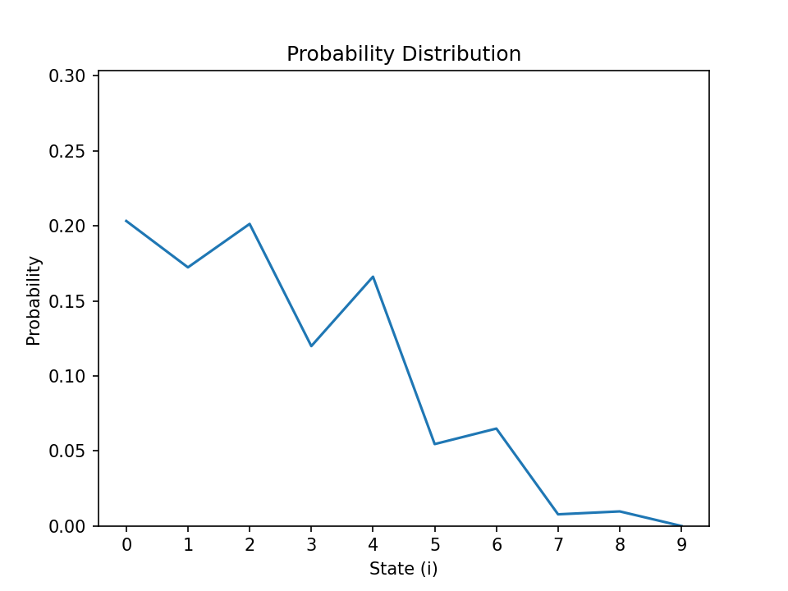
4 | How many steps does it take for the probability of being in the final state (i=9) to be at least 1%?  11 steps
5 | Try initialing x0 with random numbers and keep $sum\left(x^{\left(0\right)}\right)=1$, will the probability distribution be different? Give an explanation.  With k being larger, the random numbers of x0 will be totally the same as x0 with state 0’s probability is 1. We say the result will always be convergent.
6
7 | Which state has the highest probability in step 8?  State 1  What do you observe from the two figures? Does the result meet your expectation?  They both decrease with states increasing comprehensively, but every state jumps up and down like my expectation.  