Lab 08
Name: | 江承恩
Student ID: | B09611004
Total Score:
Note:
Most of the explanations in this lab is mandatory, However, giving reasonable explanations to your answer or programs will earn you partial credits when your answer is incorrect.
- Multiple Choice (10 points)
# | Answer | Explanation (Optional) | Score
1 | B
- Filters and Convolution (25 points, 5 points each question)
Original image:
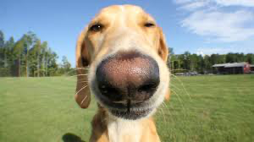
# | Description | Score
a |   This filter extracts horizontal features of image.
b |   This filter extracts diagonal feature of image.
c |   This filter enhances the edge of the image.
d | 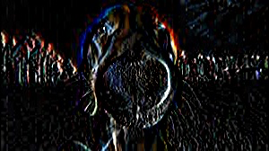  This filter enhance the vertical features of the image.
e |   This filter finds slight contours of the image.
- Denoising a Picture (20 points)
# | Description | Score
- | Be sure to show all your experiment result (e.g., image processing steps and output images) here.  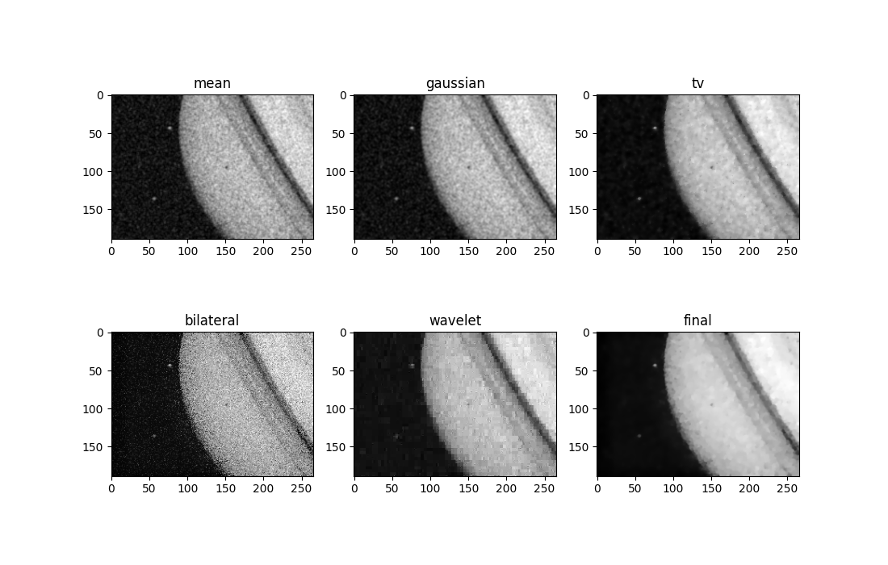  Final:bilateral first, and then gaussianblur, finally total variation.
- Image Enhancement (15 points)
# | Description | Score
- | Paste your result from (a) to (g) here.  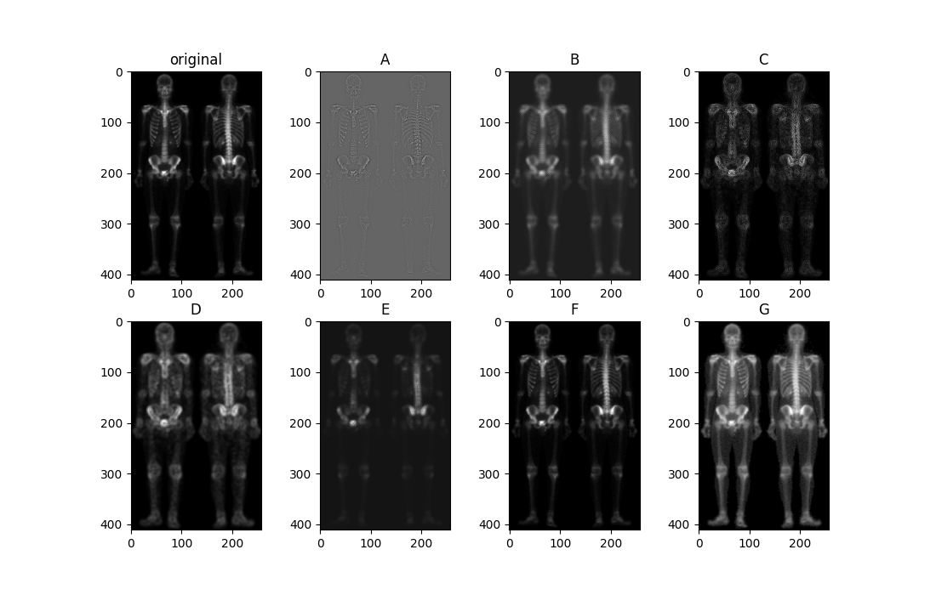
- Fingerprint Analysis (30 points)
# | Description | Score
- | Paste your result here and briefly describe your image processing procedure and approach. How do you think your results are?  First, I enhance the fingerprint image by using gaussian, binarization, binary erosion and dilation, remove small holes and objects in sequence. And then I thin the processed image. Next, in order to find the features of thinned image , I use Crossing number theory as known as CN; after that I make a mask to filter the features which are on the edge of fingerprint.  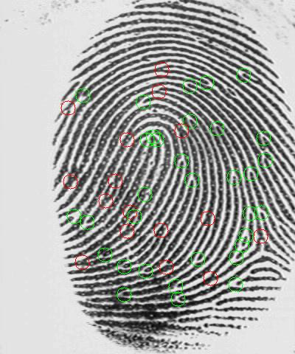
- Fingerprint Analysis (30 points)
# | Description | Score
1
2

