Software Design Specification

LONI Brain Puzzle

Bilal Bhakhrani
Emily Li
Tianyuan Qin
Ding Zhao
Mengyi Zhu

Revisions
Revision Date | Draft Number | Authorization
November 22, 2012 | 1 | Bhakhrani, Li, Qin
December 7, 2012 | 2 | Bhakhrani, Li, Qin, Zhao, Zhu

Table of Contents
1. Introduction 5
1.1. Project Overview 5
1.2. Project Scope 5
1.3. Document Preview 5
1.4. Glossary 6
1.5. References 6
2. Architectural Design 7
2.1. Overview 7
2.2. General Constraints 7
2.3. Data Design 7
2.4. Program Structure 7
2.5. Alternatives Considered 9
3. Detailed Design 9
3.1. Section Overview 9
3.2 Dragging Brain Piece and Rotate the Scene 9
3.2.1. Description 9
3.2.2. Implementation Design 9
3.3 Display/Hide Hints 11
3.3.1 Description 12
3.3.2 Methods 12
3.4 Changing Color and Opacity, Showing/Hiding a Piece 12
3.4.1 Description 13
3.4.2 Methods 13
3.5 Selecting Level 13
3.5.1 Description 14
3.5.2 Method 14
3.6 Ending the Game 14
3.6.1 Description 14
3.6.2 Method 15
4. User Interface Design 15
4.1. Section Overview 15
4.2. Interface Design Rule 16
4.3. GUI Components 16
4.4. Detailed Description 16
5. Conclusion 18

1. Introduction

1.1. Project Overview

This software is a fun, interactive and educational puzzle game to help people learn neuroanatomy. This interactive tool will allow users to study and learn about the different parts of the human brain in an online three-dimensional space. It is a component of the LONI PIPELINE project based on a web application called the Brain Viewer. Our goal is to implement the game portion, the Brain Puzzle, including allowing a player to click on a brain piece and move them in order to assemble the brain.

1.2. Project Scope

The game will have three levels: easy, hard, and custom. Each level is based on the number of brain pieces shown or is user-defined in the custom case. The custom level allows the user (player) to enter the desired number and type of brain pieces into the game as URLs to the brain piece files. In the game, the user will click and move the pieces in 3D space in order to assemble a complete brain. Two types of hints are available as well: visual and textual. The visual hint gives the user a transparent picture of the entire brain, while textual hints show the name of the brain piece if the mouse is moved over the piece. At the end of the game, a score will be given based on the amount of time and types of hints, if any, used.

This product adds features to an existing project, with the following constraints:
• It can only be accessed with the Mozilla Firefox or Google Chrome web browser with WebGL support.
• The additions must follow the original’s formatting and structure, including but limited to any internal packages used. The project is in JavaScript and uses the XTK library
• As this is a course project with a rigid overall deadline, there may not be enough time to do much beyond satisfying the requirements.

1.3. Document Preview

This document is intended to provide a general overview of the project and the additions made. These additions include all the features we have added, including the game levels, the scoring, and such. The document contains designs that viewers may use to understand the functions of each feature.

1.4. Glossary

Terms that are used during the document
Term | Definition
LONI | Laboratory of Neuro Imaging Collaboration Platform
XTK library | A WebGL framework providing an easy-to-use API to visualize scientific data on the web
Brain Viewer | A web application uses the XTK library to render 3D brain images
User | The player of the game

1.5. References
References used in the design of this project
LONI PIPELINE: 2012 Student Project | http://www.loni.ucla.edu/twiki/bin/view/LONI/Pipeline2012_StudentProjects
XTK Library | http://api.goxtk.com/
Brain Viewer Project | http://users.loni.ucla.edu/~zliu/viewer/
Slicedrop | http://slicedrop.com/
LONI2 Project Repository | https://github.com/andy0727/LONL2

2. Architectural Design
This section provides an overview and rationale for the program's data and architectural design decisions.

2.1. Overview

The program is an expansion of the LONI Viewer Project, so it inherits most of the original architecture. The program consists of two major components: a 3D rendering component and a user interface component. The 3D rendering component is supported by the XTK library, which provides an interface to manipulate object in 3D spaces. The user interface component includes display and game interaction such as selecting a level. The two components communicate with each other through multiple events triggered by the user.

2.2. General Constraints

The 3D rendering part of the program is mainly based on the XTK library, so the expansion has to adhere to the library in order to keep the original project’s functionality. However, modification to the library is allowed, and it is inevitable due to the requirement of the project. The use of this library also requires a browser with WebGL enabled as the library uses WebGL to render the brain pieces. To reduce complexity, modification is kept to a minimum.

2.3. Data Design

The only external files needed for the program are the mesh files representing each brain piece. For the simple and hard levels, the mesh files in .fsm format are stored on the server under the /data directory. For the custom level, the mesh files are uploaded by the user during runtime, and the program accepts mesh file in the following format: STL, VTK, FSM, SMOOTHWM, INFLATED, SPHERE, PIAL, ORIG, DX. Since the data size is relatively small, there is no need to maintain a database.

2.4. Program Structure

Below is a pictorial representation of our project architecture. The Brain Viewer project is comprised of four parts. The additions made in this design specification are under the puzzle part of the viewer. The puzzle components involve the five things as shown.

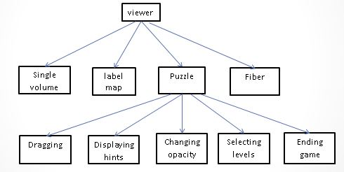
Figure 1.1: Project Architecture

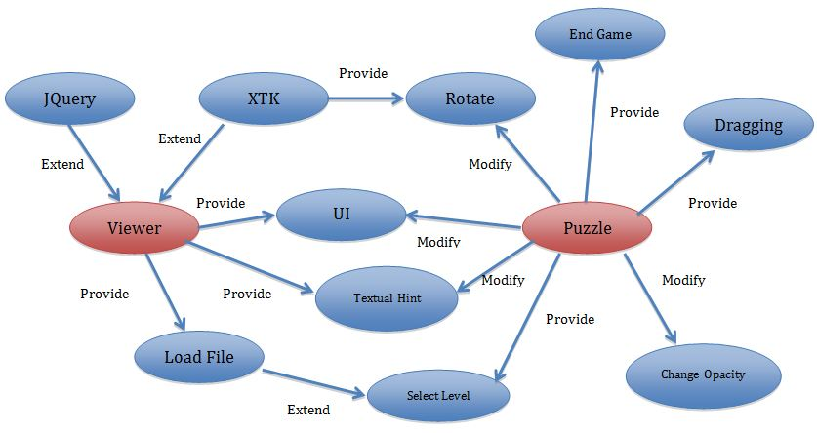
Figure 1.2: Project UML

Figure 1.2 shows the relationships between the existing Brain Viewer project and the Brain Puzzle extension. It displays what functions are added under our puzzle components and how they interact with the viewer components.

2.5. Alternatives Considered

This architecture was the most practical for our purposes because we are simply adding feature to the existing LONI Brain Viewer project. We could have made our own page which simply used parts of the Brain Viewer project, but was not connected to it. This design, however, would not have met the needs of the client, as they required it to be under the Brain Viewer project. Overall, we were quite restricted in terms of architectural design as the client had very specific expectations for the design.

3. Detailed Design

3.1. Section Overview

This section provides a detail design of the program, including functions modified and features added to the existing project. Each component’s functionality and overall implementation methods are described.

3.2 Dragging Brain Piece and Rotate the Scene

3.2.1. Description

By clicking and dragging the mouse, the user can either drag a brain piece or rotate the scene. This is done by checking and un-checking the “drag” box on the side menu. Once the box is checked, the user can select a brain piece and move it freely in the 3D space. The rotation of the scene is already implemented in the original project, so this program adds the new function to drag a brain piece and the ability to toggle back and forth between the two options.

3.2.2. Implementation Design
Dragging is handled by two event handlers: onMouseDown, onMouseMove. These event handlers are all built into the XTK library. They are member functions of the 3DInteractor object. The program overrides these member functions.

3.2.2.1. OnMouseDown
This function checks whether there is a brain piece to be selected under the mouse cursor. The XTK library function pick() is used here to accomplish this task. If there is a brain piece, the id of that mesh is returned. Then, the function changes the color and opacity of the mesh to indicate which piece is selected. It also records the current mouse position for later use.

3.2.2.2. OnMouseMove
Once the mouse moves, the color of the selected piece changes back to the original, a new mouse position is recorded. Using the new mouse position, the old position, and the camera view matrix, this function calculates the translation vector which indicates the distance and direction that the selected brain should move in 3D space. Using the original transform matrix of the brain piece and the translation vector, a new transform matrix is calculated and the 3D renderer updates the scene with the new position of the brain piece. More details will be given in the following section.

3.2.2.3 Dragging Algorithm
When the user selects the drag option and starts to move the piece, the piece is always moving in a 2D plane in the user’s view. However, the representation of this action must be converted into a transformation matrix, which is measure in a 3D coordinate system. Therefore, we must divide the dragging algorithm into two parts: unit matching and 3D mapping.

First, when the user clicks on a brain piece and moves it, the positions of the mouse are recorded in pixels with only horizontal and vertical components (Px and Py). However, the unit in the 3D coordinate system is not measured in these pixels. It has its own “secret” unit. Since the conversion from pixels to the coordinate system unit is not specified in the project and related libraries given, an approximation ratio is measured. By using this approximation as a magic number in the code, the unit problem can be roughly solved. So the calculated difference between the two mouse positions in pixels is then converted into the 3D coordinate units. These are represented in a vector form as [ΔX, ΔY, 0].

The procedure of translating the above vector into a 3D transformation matrix is the 3D mapping. According to the XTK library, the view of the brain is based on the camera’s position, focus, and zoom. When the renderer is initialized, it translates the camera’s information into a 4x4 matrix as shown below in Figure 2.

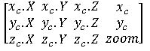
Figure 2: Matrix of camera location and other information

After initialization, every time the camera is rotated or zoomed, the renderer only needs to update this matrix, as Figure 2 shows, the first three elements of the first row in the matrix represent the normalized component of the camera’s x-axis in relation to the real 3D coordinates. In other words, moving a unit along the camera’s x-axis is the same as moving the x.x unit along the x-axis, the x.y unit along the y-axis, and the x.z unit along the z-axis of the real 3D coordinates. Similarly, one can conclude that the same can be done for the camera’s y and z components. In addition, since the camera’s view is always orthogonal to the plane that the user is viewing, the difference vector obtained above actually represents the x and y components moving along the camera’s axes. Therefore, a matrix multiplication as shown in Figure 3 below can be used to sum up the actual moving distance along the axes of the real 3D coordinates.

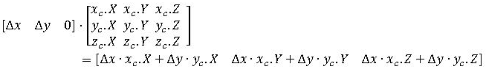
Figure 3: Matrix multiplication

Once the new transformation matrix is obtained by this multiplication, it should be multiplied again by the existing transformation matrix of the selected brain piece to update its new position.

3.2.2.4 Enable/Disable Rotation
The rotation function is a built-in feature provided by the XTK library. In order to make it an optional functionality as required for the project, some modifications had been made to the XTK library, recompiling it as needed. The modifications occur in the visualization/camera.js class. A new private variable, rotationable, and its setting and accessing functions were added. In addition, the rotate function was modified so that it would only rotate the view when rotationable was true. This way, one only needs to toggle the rotationable variable to enable or disable the rotation functionality.

3.3 Display/Hide Hints

3.3.1 Description
The game has two types of hints: textual hints and visual hints. Textual hints are labels indicating the name of a brain piece. It will show when the mouse is over the piece. Textual hints are already implemented, but currently remain on throughout the game. The program adds functionality to turn the textual hints on and off. Visual hints show the complete brain as a guide. To distinguish the hint from the rest of the brain pieces, it is displayed in gray with some transparency.

3.3.2 Methods

3.3.2.1. Enable/Disable Hints
Both hints have a check box on the side menu to turn the hints on and off. There are two check boxes, one for visual and one for textual hints. Enabling hints will allow the hints to appear to the user. Checking visual hints will show the complete brain, while checking textual hints will allow the user to see the brain piece’s name if moused over.

3.3.2.2. Displaying Visual Hint
Upon loading, the original transform matrix of each brain piece is saved. Once the visual hint box is checked, the hint, using the original transform matrix, is rendered in the center of the scene. The hint is not selectable, thus, the user can not drag the hint piece or change its color and opacity. The visual hint will stay on as long as the visual hint option box is selected. However, the time duration the hint is on will be recorded as a consideration for when the score is calculated.

3.3.2.3 Displaying Textual Hints
Upon loading, the name of each brain piece is saved into an array. Once the textual hint option box is selected, the names are loaded into the caption field of each object. This caption field enables the textual hints, so that when the user moves the mouse over any piece, the name of that brain piece will be displayed. When this hint box is deselected, all the names will be cleared from the caption fields and no name will be displayed when the user’s mouse hovers over any brain piece.

3.4 Changing Color and Opacity, Showing/Hiding a Piece

3.4.1 Description

When a user left clicks on a piece, its color can be changed by clicking on the color panel on the side menu and selecting a color and its opacity can be changed by dragging the slider bar on the side menu. The color panel and slider bar already exist in the original project. However, these two functionalities only worked for the last rendered brain piece. Thus, we had to add the ability to mark a piece as selected when left-clicked that allows the user to change these two qualities for that specific piece.

3.4.2 Methods

3.4.2.1. Selecting a Piece
Once a user left clicks a brain piece, whether to drag/rotate or not, the program saves the ID of the piece so it can recognize it as the last piece selected.

3.4.2.2. Change Color
The color panel on the side menu is used to change the color or the selected piece. If the panel is clicked on, a range of colors appear and the user can select any one of them for the specific brain piece.

3.4.2.3. Change Opacity
The opacity of the selected brain piece can be adjusted by the slider on the side menu. The opacity ranges from zero percent to one-hundred percent. It is at zero percent if the slider is on the left most side, and at one-hundred percent if the slider is on the right most side.

3.4.2.3. Show/Hide a piece
There is a button on the menu to show or hide the selected brain piece. It works similarly to the change of color. After a user selects a piece, he or she can further hide or show the piece by click that button.

3.5 Selecting Level

3.5.1 Description

Before the game start, a menu, another HTML page, pops up to show the different levels of the game a user can select from. There are three possible levels based on the number of pieces: easy, hard and custom. When the level is selected and the game has started, all the pieces are scattered randomly throughout the scene and the camera will be set to a position where all the pieces are visible.

3.5.2 Method

3.5.2.1. Selecting Easy/Hard Level
The easy level has 13 pieces, and the hard level has 56 pieces. The XTK library is used to render these objects from the brain .fsm files on the server.

3.5.2.2. Showing Answers for Each Level
For each level, there is an option to show the answers, which is a brain image with all the pieces combined together. However, all game options, such as dragging pieces and clicking on the “end-game” button, are still operational.

3.5.2.3. User Specified Level
If the user selects the custom level, a text box is available for the user to enter the URL of each brain piece. Each brain piece mesh is indicated by a single URL, and URLs are separated by a newline. Thus, the total number of brain pieces is equal to the number of URLs given. The program only checks if the URL starts with “http://” and does not perform any other validation. If the URL does not link to a valid mesh file, the game will not be able to start.

3.6 Ending the Game

3.6.1 Description

There is two ways to end the game: correctly combining all the pieces together or clicking the “End Game” button on the menu. Once the game ends, the program will calculate the score based on the correctness of connected pieces, whether or not any hints were used, and speed of the user. The score will then be displayed to the user in a pop-up window.

3.6.2 Method

3.6.2.1 Combining Pieces
When the user moves a piece to a new location, the program calculates the distance of that piece with respect to the other pieces. Then the program compares these distances with the “correct” distances, which are the distances when the pieces are connected correctly. If the difference is small enough, the program considers the pieces as correctly connected, and it will inform the user by changing the connecting pieces into the same color and outputting a message in the console. If all the pieces are connected, the game will terminate and the score will be calculated automatically.

3.6.2.2. Calculate Score
The score is calculated using three parameters: time spent, pieces connected, hints used. The score has two parts: time score and combo score. The full score of both parts are set to 100. Suppose the total number of pieces are N, and the number of pieces that are not connected is n, the user will be deducted (n/N) * 100 points from the combo score. Also, for every five seconds a hint, including both visual and textual hints, is “on”, one point is deducted from the combo score. For the time score, if the user ends the game within half an hour, there is no penalty. Between half an hour and two hours, the program deducts points gradually. If the user passes over two hours, the user gets 0 points for the time score. The total score is the average of the time and the combo scores, namely time score plus combo score then divide by two.

4. User Interface Design

4.1. Section Overview

This section describes the user interface design of the program. It will start off with a description of the design rules which are conventions and standards used in designing the interface. Following that, it will then discuss the GUI components followed by a detailed description of the design. Section 4.2 describes design rules, which are conventions and standards used in designing the interface. Section 4.3 lists the GUI components used. Section 4.4 is a detailed description of each component.

4.2. Interface Design Rule

The interface chosen is adapted from the Brain Viewer project. Thus, the program should follow the general design of the original project. The user interface should be relatively simple to understand, meaning the user should be able to begin playing mere moments after viewing the UI. The user should not need to read any instruction to learn how to play the game.

4.3. GUI Components

There will be two parts to the GUI: the initial interface to setup the game and the interface while the game is in progress. The initial interface is handled by a HTML web page, so all the user interface components in this part are HTML elements. When the game is in progress, brain viewer provides interface to interact with the scene. The side menu is handled by the JQuery sidebar. A complete list of user interface is the following:

API | Usage
HTML radio button | Select game level
HTML text box | Input URLs in custom level
HTML check-box | Enable/Disable hints, dragging
JQuery sidebar | Side menu displayed when game is in progress
JQuery icon | Change color of a piece, show and hide a piece
JQuery slider | Change opacity of a piece
HTML button | End game

4.4. Detailed Description

The start page is a HTML web page. Since the user only sees this page at the beginning of the game, its design is clean and simple. Here is an example how this page looks like:
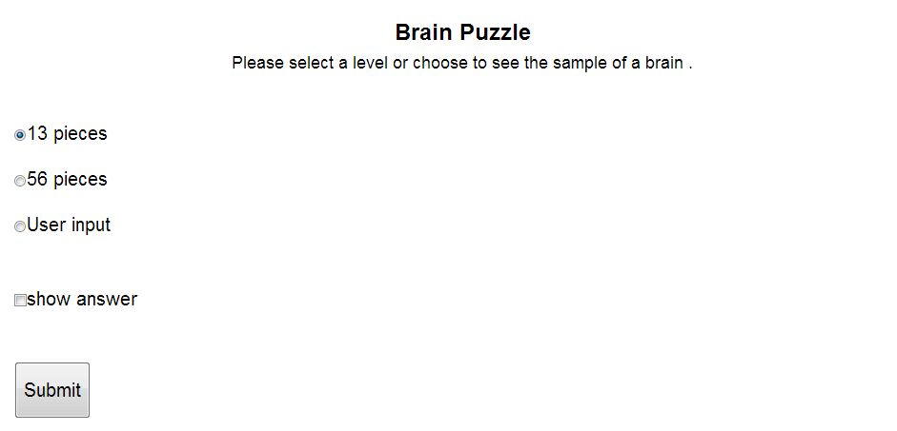
Figure 4: HTML level selection page

The other component that the program modified is the game menu, which is a side bar displayed on the left side of the screen.

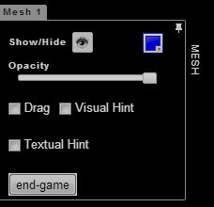
Figure 5: Game menu sidebar with options

The program removes the irrelevant components that are on the original project. The icons, boxes and buttons should be lined up and displayed in a nice way. Spaces between each line should be kept the same. The menu is put on a separate space from the viewer so that the menu does not interrupt the game scene.

Upon loading, the Show/Hide icon is set to “show”; color icon shows the color of the last loaded piece; opacity is set to 1 (100%); the drag and visual hint boxes are unchecked.

Each component’s format is set up in its corresponding CSS file, which gives a lot of convenience to adjust and modify.

5. Conclusion
All features are added by modifying the original code. Thus, the implementation should be incremental and tested frequently so that the original project’s functionality is not corrupted. Since the program requires modification to the XTK library, these modifications should be well documented so that others who use this XTK library are aware of the change. Also, this design specification is not final. Further progress into the project may cause changes to this file.

