Neural Network and Stack Up Models for Diamond Price Prediction
MSDS 458 Assignment 1 Research Report

Andy Chen
Northwestern University
MSDS 458 Artificial Intelligence and Deep Learning
October 12 2026

Abstract
This study evaluated fully connected neural networks for predicting diamond sale prices from physical measurements and categorical quality grades. The analysis used the 53,940 row Diamonds dataset and retained 53,771 observations after removing impossible dimensions, extreme geometric values, and exact duplicate records. Numerical predictors were standardized, categorical predictors were one hot encoded, and the resulting 23 features were divided into training, validation, and test sets. Twelve modeling experiments compared single hidden layer networks, deeper networks, raw and log transformed targets, dropout regularization, and two stack up strategies. The best model under the prespecified validation MAPE criterion was a 256 128 64 network trained on log price with 15 percent dropout. On 10,755 test observations, it produced a mean absolute error of $282.08, root mean squared error of $557.60, MAPE of 6.91 percent, and R squared of 0.9800. A total of 95.57 percent of predictions were within 20 percent of actual price, with a 95 percent Wilson interval of 95.17 to 95.95 percent. The model therefore met the coverage requirement but missed the 5 percent average MAPE target. The results show that transforming the skewed target improved percentage accuracy more than increasing depth alone. The model is suitable for expert assisted pricing, but the remaining systematic error does not support fully automated deployment.
Keywords diamond pricing, neural networks, regression, stack up models, MAPE, t SNE

Introduction
Diamond valuation combines measurable physical characteristics with graded quality attributes. The Gemological Institute of America organizes the most widely recognized quality framework around carat weight, color, clarity, and cut. Two diamonds with similar weight can command different prices because the other quality dimensions change rarity and appearance (Gemological Institute of America, 2014). A seller must integrate these attributes consistently while also accounting for nonlinear interactions. Manual appraisal provides domain judgment, but it requires time and can vary across evaluators. A predictive model can supply a repeatable initial estimate for expert review.
The management problem in this study was to estimate the sale price of a new diamond from carat, depth, table, length, width, height, cut, color, and clarity. Management established two performance requirements. First, average test MAPE had to be no greater than 5 percent. Second, at least 95 percent of individual test predictions had to have an absolute percentage error below 20 percent. These requirements emphasize relative accuracy across the price distribution rather than fit alone. A model can explain most price variance and still fail the business target if a material group of inexpensive or unusually expensive diamonds receives poor estimates.
The analysis addressed four questions. The first was whether networks with multiple hidden layers improved performance over single hidden layer networks. The second was whether training on log transformed price reduced the effect of the strongly skewed response. The third was whether a two stage stack up design, consisting of a price tier classifier and tier specific regressors, outperformed a single global model. The fourth was whether the final hidden layer organized diamonds by price more clearly than the observed input features.
The experiment produced a clear operational conclusion. Neural networks modeled the pricing relationship well in terms of explained variance, but the strongest improvement came from changing the target representation rather than adding layers. The selected log price network met the coverage requirement with a small margin and failed the average MAPE target by 1.91 percentage points. This report therefore recommends controlled use as a pricing aid with expert review and continued model development before automated pricing.

Literature Review
The Diamonds dataset distributed with ggplot2 contains prices and nine descriptive attributes for more than 50,000 round cut diamonds (Wickham, 2016). Its fields align closely with the commercial grading framework. Carat measures weight, while cut, color, and clarity represent ordered quality categories. Length, width, height, depth, and table capture geometry. The combination creates a useful tabular regression problem because the predictors include continuous measurements, ordered categories, substantial collinearity, and nonlinear price effects.
Previous analyses of this dataset show that model choice and preprocessing materially change conclusions. Panwala (2019) compared several regression methods and reported that a decision tree performed best in that implementation, followed by neural networks and polynomial regression. Crépin (n.d.) likewise treated diamond pricing as a supervised learning problem with data exploration and model comparison. These course supplied examples establish a useful baseline but do not answer whether a deeper network, a transformed target, or a mixture of classification and regression can satisfy explicit percentage error thresholds.
Peer reviewed studies reach a similar conclusion about the nonlinear nature of diamond pricing. Kigo, Omondi, and Omolo (2023) compared regression and classification algorithms and identified strong performance from random forest models. Their study emphasized that carat, cut, clarity, table, and depth combine nonlinearly, which limits simpler linear specifications. Xiao (2024) compared random forest, k nearest neighbors, XGBoost, and multilayer perceptron models on the same 53,940 row dataset. XGBoost achieved the strongest results in that comparison, with test R squared near 0.982. These findings suggest that high fit is attainable, but they also show that no single algorithm dominates every objective. The present study narrows the question to fully connected neural networks and evaluates them against business thresholds based on MAPE and tail coverage.
The neural network design follows established approximation and optimization results. Hornik, Stinchcombe, and White (1989) showed that feedforward networks with a sufficiently large hidden layer can approximate broad classes of functions. Additional depth may represent interactions more compactly, but the theorem does not imply that deeper networks will generalize better on a particular dataset. The experiments therefore compare width and depth empirically rather than assuming that a larger model must win.
All networks were optimized with Adam, which uses adaptive estimates of gradient moments to update parameters efficiently (Kingma & Ba, 2015). One experiment added dropout. Dropout randomly removes units during training to limit coadaptation and approximate an ensemble of thinner networks, which can reduce overfitting in large networks (Srivastava et al., 2014). The selected model combined dropout with a log transformed response. This transformation is especially relevant because raw diamond prices are right skewed and MAPE gives equal proportional importance to inexpensive and expensive observations.
The hidden representation was evaluated with t distributed stochastic neighbor embedding. t SNE maps high dimensional observations into two dimensions while seeking to preserve local neighborhoods (van der Maaten & Hinton, 2008). The method is appropriate for qualitative comparison of the encoded inputs and the final hidden layer, but distances between remote clusters should not be interpreted as a formal measure of separation. In this study, t SNE serves as visual evidence of what the network learned, not as a model selection metric.

Methods

Dataset and Variables
The response variable was price in US dollars. Six numerical predictors were used: carat, depth, table, x, y, and z. Three categorical predictors represented cut, color, and clarity. The raw dataset contained 53,940 observations, ten columns, and no missing values. Price ranged from $326 to $18,823, with a median of $2,401 and a mean of $3,932.80. The large difference between the mean and median, together with the long upper tail, motivated explicit comparison of raw and log transformed targets.
Table 1
Analysis dataset and partition sizes
Component | Observations | Share | Purpose
Raw data | 53,940 | 100.0% | Initial exploration and cleaning
Clean data | 53,771 | 99.7% | Modeling population
Training | 34,412 | 64.0% | Parameter estimation
Validation | 8,604 | 16.0% | Early stopping and model selection
Test | 10,755 | 20.0% | Final performance assessment

Data Cleaning and Partitioning
Cleaning removed rows with nonpositive x, y, or z dimensions, y or z values above 20 millimeters, and table values of 80 or greater. Exact duplicate rows were also removed. The combined rules removed 169 observations, or 0.31 percent of the original data. Because the dataset does not include unique diamond identifiers, removing exact duplicates assumes that repeated rows represent duplicate records rather than distinct diamonds with identical recorded attributes. This assumption is revisited as a limitation.
The clean data were divided with random seed 42. Twenty percent was reserved for the final test set. The remaining observations were split into training and validation samples, producing an overall 64 16 20 allocation. The test set remained separate during network fitting and early stopping. Model selection used validation MAPE, which matched the primary business objective and avoided selecting a model solely because it performed favorably on the test sample.

Preprocessing
The preprocessing transformer was fitted on the training data. Numerical variables were standardized to zero mean and unit variance. Cut, color, and clarity were one hot encoded with one reference category removed from each feature. The procedure generated 23 model inputs. The fitted transformer was then applied without refitting to the validation and test observations. This sequence prevented information from the validation or test distributions from influencing the learned scaling parameters.
Each response representation was standardized using the training response. Raw target experiments standardized price directly. Log target experiments applied log one plus price before standardization and converted predictions back to dollars with the inverse transformation. The log transformation compressed the long upper tail and changed squared error optimization from emphasizing large dollar deviations toward a more proportional treatment of price differences.

Neural Network Experiments
Ten global neural network experiments and two stack up experiments were completed. The single hidden layer group used 16, 32, 64, or 128 ReLU units. The raw price deep network group used 64 32, 128 64, and 128 64 32 architectures. Three log target experiments evaluated a 128 64 32 model, a lower learning rate version of that model, and a wider 256 128 64 model with 15 percent dropout and small L2 weight decay. All models used a linear output node, mean squared error loss on the standardized target, mini batches, Adam optimization, and early stopping with restoration of the best validation weights.
The architecture tests were intentionally structured rather than treated as an unrestricted search. The single layer runs measured the effect of width. The raw deep runs measured the effect of adding hidden layers. The log target comparison isolated the effect of transforming the response. The lower learning rate run tested optimization sensitivity, and the dropout run examined whether regularization helped a wider model generalize. Appendix B lists the full configuration and outcomes for all twelve experiments.

Stack Up Modeling
Price tiers were defined from the training response using the 33rd and 67th percentiles. The resulting boundaries were approximately $1,235 and $4,285, producing 11,486 low, 11,455 medium, and 11,471 high training observations. A 128 64 32 classifier with 10 percent dropout predicted the tier from the same 23 encoded inputs. Three separate 128 64 32 log price regressors were trained using observations from their assigned tiers.
Two combination rules were evaluated. Hard routing selected the regression output associated with the classifier's most probable tier. Soft weighting generated a prediction from each tier regressor and averaged those predictions using the classifier probabilities. Soft weighting was expected to reduce discontinuities around tier boundaries because an observation near a cutoff could receive information from both adjacent regression models.

Model Evaluation
Performance was summarized with mean absolute error, root mean squared error, MAPE, R squared, the 95th percentile of individual absolute percentage error, and the percentage of predictions below 20 percent error. MAPE was computed as MAPE = (100 divided by n) times the sum of the absolute value of actual price minus predicted price divided by actual price. The coverage requirement used the indicator that individual absolute percentage error was below 20 percent. A 95 percent Wilson interval was calculated for the selected model's observed coverage proportion.
The primary selection criterion was validation MAPE because management specified an average percentage error target. Test performance was reported only after selection. The analysis also retained MAE, RMSE, and R squared because a model selected on relative error may not minimize dollar error or large residuals. This distinction proved important when comparing the selected global DNN with the soft stack up model.

Results

Data Patterns
Diamond prices were not evenly spread. Most were below $5,000, while a small number were above $18,000. Carat had the strongest relationship with price, with a correlation of 0.92. The x, y, and z measurements were also closely related because they all describe diamond size. The category plots were affected by differences in carat, so they should not be read as proof that a lower quality grade causes a higher price. Taking the log of price made the values more balanced for the models. The supporting plots are in Appendix A.

Model Comparison
The models trained on regular price had test MAPE values from 9.13 to 9.86 percent. Adding more nodes or layers did not help very much. The main improvement came from training on log price. E10, a three-layer model with dropout, had the lowest validation MAPE at 6.77 percent and was selected as the final model. On the test data, E10 had MAPE of 6.91 percent, MAE of $282.08, RMSE of $557.60, and R squared of 0.9800. E08 was slightly better on a few test measures, but E10 remained the correct choice because the model was selected using validation results.
Table 2
Performance of the principal comparison models
Model | Test MAPE | Within 20% | MAE | RMSE | R squared
E07 raw DNN | 9.13% | 90.79% | $301.62 | $553.96 | 0.9803
E08 log DNN | 6.98% | 95.83% | $279.56 | $531.80 | 0.9818
E10 log DNN dropout | 6.91% | 95.57% | $282.08 | $557.60 | 0.9800
E11 hard stack up | 7.11% | 95.01% | $279.32 | $537.48 | 0.9815
E12 soft stack up | 6.94% | 95.47% | $274.75 | $534.00 | 0.9817

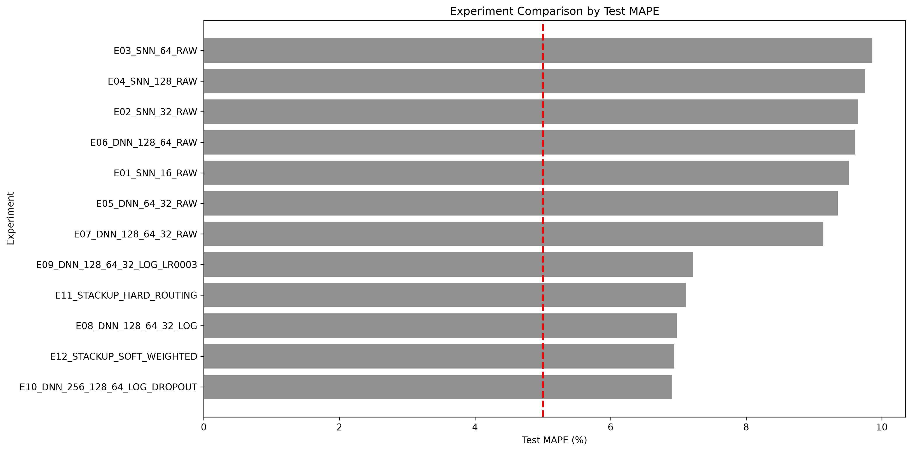
Figure 1 Test MAPE for all neural network and stack up experiments
Source Author analysis of the Seaborn Diamonds data

Stack Up Model
The stack-up method first placed each diamond into a low, medium, or high price group. The classifier was correct on 95.43 percent of the test cases, and all mistakes were between neighboring groups. Soft weighting performed better than hard routing. It reached MAPE of 6.94 percent and the lowest MAE of $274.75, but its validation MAPE was still slightly worse than E10. For this reason, E10 stayed as the final model.

Business Requirements
E10 did not meet the 5 percent MAPE goal because its test MAPE was 6.91 percent. However, it met the second goal. A total of 10,279 of 10,755 predictions, or 95.57 percent, were within 20 percent of the actual price. The 95 percent confidence interval was 95.17 to 95.95 percent, which also stayed above the required 95 percent level.
Table 3
Selected model evaluation against management requirements
Requirement | Target | Observed | Decision
Average percentage error | MAPE no greater than 5% | 6.91% | Not met
Individual error coverage | At least 95% below 20% error | 95.57% | Met
Coverage confidence interval | Lower bound at least 95% | 95.17% to 95.95% | Met
Tail percentage error | 95th percentile below 20% | 18.88% | Met

Error Patterns
The dollar errors became larger for expensive diamonds, and some high-price stones were predicted too low. The medium price group was the hardest group. Its MAPE was 7.18 percent, and only 93.86 percent of its predictions were within 20 percent of the true price. The low and high groups performed better. More model work should focus on the medium group and expensive outliers.

What the Network Learned
t-SNE is a tool that places complex data on a two-dimensional graph. In the input graph, low- and high-price diamonds were mixed together. In the hidden-layer graph, the prices followed a clearer pattern. This suggests that the network learned useful price information from the inputs. The graph is only a visual check and was not used to select the model. The comparison appears in Appendix C.

Limitations
The data do not include the sale date, seller, location, certification laboratory, fluorescence, or current market conditions. Removing duplicates may also have removed real diamonds. I used one data split and mainly tested neural networks. Future work should test repeated splits and other models.

Conclusions
Log price helped more than adding extra layers. E10 explained about 98 percent of the variation in test prices and had an MAE of $282.08. It met the individual prediction goal but missed the 5 percent MAPE goal. It should only give an initial estimate with human review until more testing improves accuracy.

References
Crépin, M. (n.d.). Machine learning diamond price prediction. RPubs. https://rpubs.com/M4thysu/Diamond
Gemological Institute of America. (2014, February 4). Understanding the 4Cs of diamond quality. https://4cs.gia.edu/en-us/blog/understanding-4cs-diamond-quality/
Hornik, K., Stinchcombe, M., & White, H. (1989). Multilayer feedforward networks are universal approximators. Neural Networks, 2(5), 359-366. https://doi.org/10.1016/0893-6080(89)90020-8
Kigo, S. N., Omondi, E. O., & Omolo, B. O. (2023). Assessing predictive performance of supervised machine learning algorithms for a diamond pricing model. Scientific Reports, 13, 17315. https://doi.org/10.1038/s41598-023-44326-w
Kingma, D. P., & Ba, J. (2015). Adam A method for stochastic optimization. International Conference on Learning Representations. https://arxiv.org/abs/1412.6980
Panwala, S. (2019, November 3). Regression based machine learning approaches for diamond price prediction. Medium. https://sp7091.medium.com/regression-approaches-to-predict-diamond-price-258478a485c9
Srivastava, N., Hinton, G., Krizhevsky, A., Sutskever, I., & Salakhutdinov, R. (2014). Dropout A simple way to prevent neural networks from overfitting. Journal of Machine Learning Research, 15, 1929-1958. https://www.jmlr.org/papers/v15/srivastava14a.html
van der Maaten, L., & Hinton, G. (2008). Visualizing data using t SNE. Journal of Machine Learning Research, 9, 2579-2605. https://www.jmlr.org/papers/v9/vandermaaten08a.html
Wickham, H. (2016). ggplot2 Elegant graphics for data analysis. Springer. https://ggplot2.tidyverse.org/reference/diamonds.html
Xiao, M. (2024). Diamond price prediction based on regression algorithms Analyzing key factors and model performance. Proceedings of the 3rd International Conference on Financial Technology and Business Analysis, 139, 196-205. https://doi.org/10.54254/2754-1169/139/2024.19476

Appendix A Exploratory Data Analysis
Appendix A contains supporting distributions used to assess categorical predictors and cleaning decisions. The plots display unadjusted prices and should be interpreted jointly with carat and the other predictors.
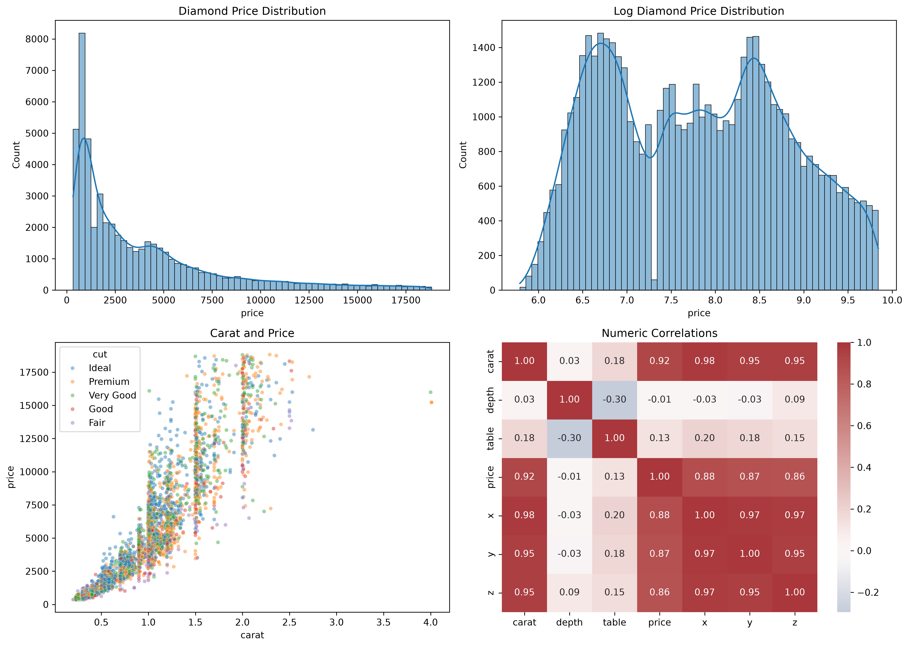
Figure A1 Price distribution carat relationship and numerical correlations
Source Author analysis of the Seaborn Diamonds data
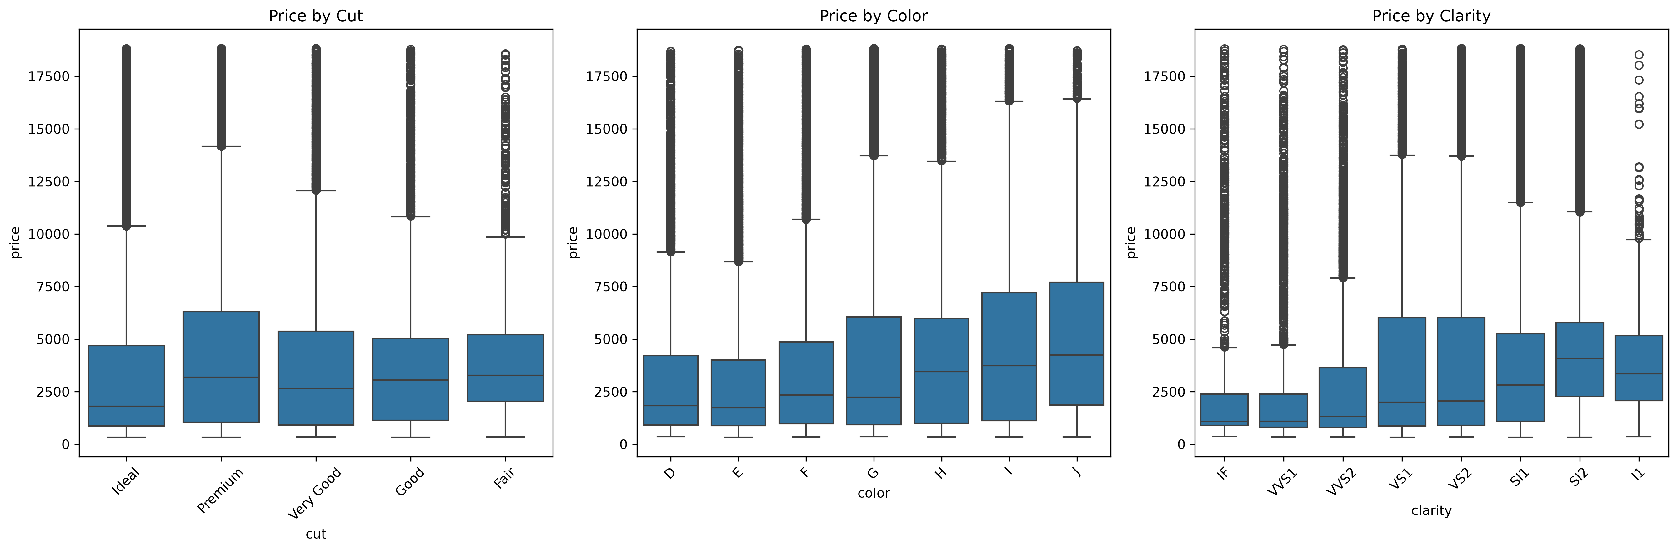
Figure A2 Unadjusted price distributions by cut color and clarity
Source Author analysis of the Seaborn Diamonds data
Table A1
Data cleaning rules
Cleaning rule | Rationale | Effect
x y and z greater than zero | Removes physically impossible dimensions | Part of 169 total removals
y and z below 20 | Removes extreme geometric values | Part of 169 total removals
table below 80 | Removes extreme table value | Part of 169 total removals
Exact duplicate row | Avoids overweighting identical records | 146 duplicate rows identified

Appendix B Model Experiments
Table B1
Neural network and stack up configurations
Experiment | Hidden layers | Target | LR | Batch | Dropout | Best epoch
E01 SNN 16 RAW | 16 | raw | 0.0010 | 256 | 0.00 | 73
E02 SNN 32 RAW | 32 | raw | 0.0010 | 256 | 0.00 | 76
E03 SNN 64 RAW | 64 | raw | 0.0010 | 256 | 0.00 | 50
E04 SNN 128 RAW | 128 | raw | 0.0010 | 256 | 0.00 | 62
E05 DNN 64 32 RAW | 64 32 | raw | 0.0010 | 256 | 0.00 | 37
E06 DNN 128 64 RAW | 128 64 | raw | 0.0010 | 256 | 0.00 | 39
E07 DNN 128 64 32 RAW | 128 64 32 | raw | 0.0010 | 256 | 0.00 | 17
E08 DNN 128 64 32 LOG | 128 64 32 | log | 0.0010 | 256 | 0.00 | 61
E09 DNN 128 64 32 LOG LR0003 | 128 64 32 | log | 0.0003 | 256 | 0.00 | 79
E10 DNN 256 128 64 LOG DROPOUT | 256 128 64 | log | 0.0010 | 256 | 0.15 | 59
E11 STACKUP HARD ROUTING | Classifier and three regressors | log | 0.0010 | 256 | 0.10 | 39
E12 STACKUP SOFT WEIGHTED | Classifier and three regressors | log | 0.0010 | 256 | 0.10 | 39

Table B2
Complete test performance by experiment
Experiment | MAE | RMSE | MAPE | R squared | P95 APE | Within 20%
E10 DNN 256 128 64 LOG DROPOUT | 282.08 | 557.60 | 6.91% | 0.9800 | 18.88% | 95.57%
E12 STACKUP SOFT WEIGHTED | 274.75 | 534.00 | 6.94% | 0.9817 | 19.19% | 95.47%
E08 DNN 128 64 32 LOG | 279.56 | 531.80 | 6.98% | 0.9818 | 18.71% | 95.83%
E11 STACKUP HARD ROUTING | 279.32 | 537.48 | 7.11% | 0.9815 | 19.99% | 95.01%
E09 DNN 128 64 32 LOG LR0003 | 282.16 | 536.01 | 7.22% | 0.9816 | 19.35% | 95.47%
E07 DNN 128 64 32 RAW | 301.62 | 553.96 | 9.13% | 0.9803 | 24.42% | 90.79%
E05 DNN 64 32 RAW | 293.52 | 535.20 | 9.35% | 0.9816 | 25.99% | 89.69%
E01 SNN 16 RAW | 308.70 | 565.69 | 9.51% | 0.9795 | 25.89% | 89.27%
E06 DNN 128 64 RAW | 293.84 | 537.28 | 9.61% | 0.9815 | 27.60% | 87.36%
E02 SNN 32 RAW | 303.39 | 546.32 | 9.64% | 0.9808 | 25.84% | 89.26%
E04 SNN 128 RAW | 304.84 | 544.98 | 9.75% | 0.9809 | 28.19% | 88.07%
E03 SNN 64 RAW | 304.01 | 548.93 | 9.86% | 0.9807 | 28.92% | 87.45%

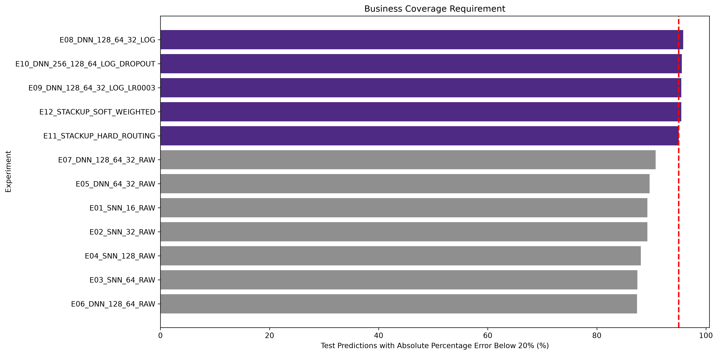
Figure B1 Percentage of test predictions below 20 percent absolute error
Source Author analysis of the Seaborn Diamonds data

Appendix C Best Model Diagnostics
The selected E10 model stopped at epoch 59. The validation curve remained stable while the training curve was higher because dropout was active during training and disabled during evaluation. Residual dispersion increased with price, and a small number of observations produced large dollar errors.
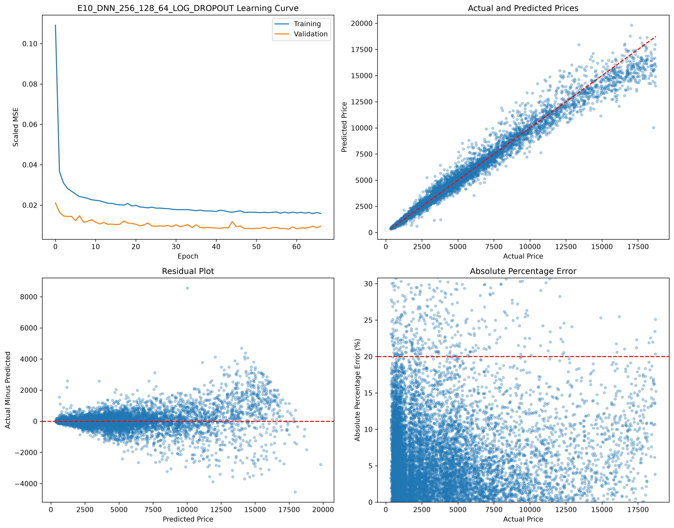
Figure C1 Learning curve prediction fit residuals and percentage errors for E10
Source Author analysis of the Seaborn Diamonds data
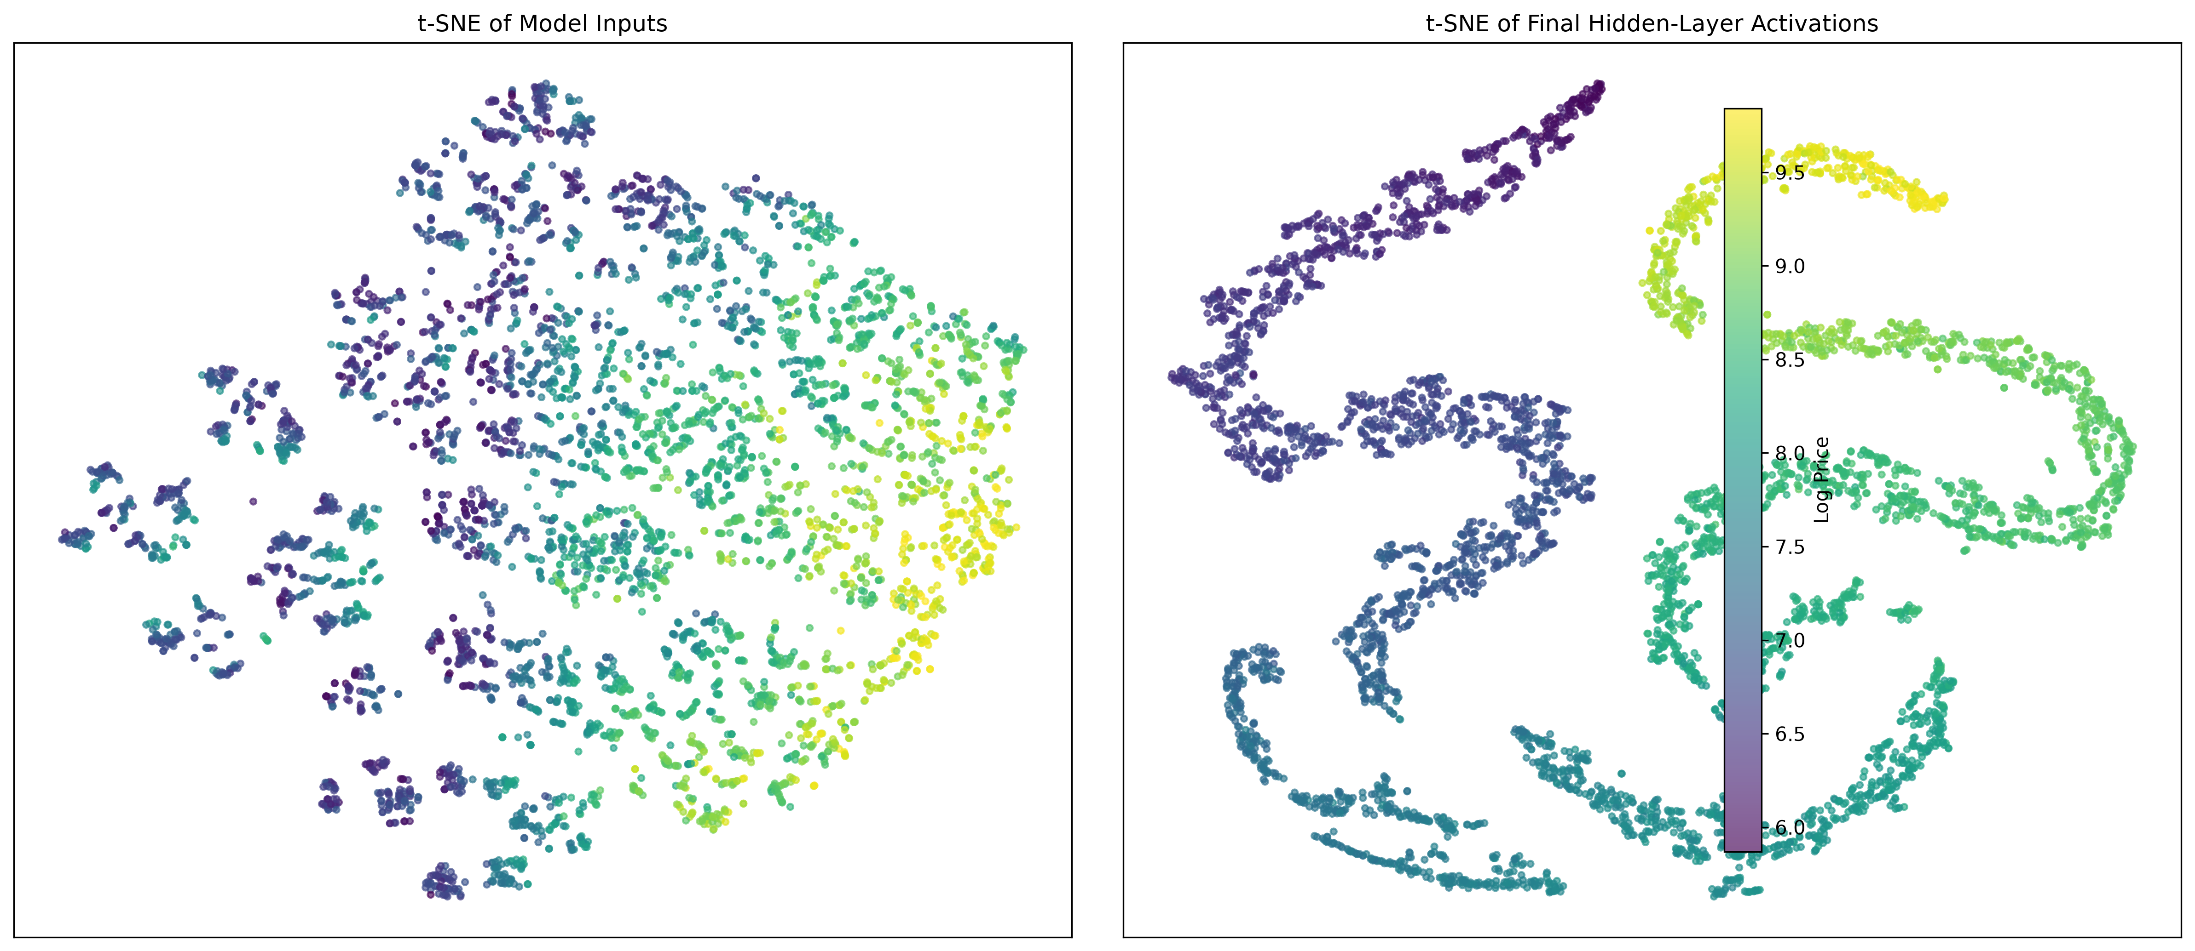
Figure C2 t SNE comparison of encoded inputs and final hidden layer activations
Source Author analysis of the Seaborn Diamonds data

Appendix D Stack Up Model
The classifier separated the balanced low medium and high tiers with 95.43 percent test accuracy. All classification mistakes occurred between adjacent tiers.
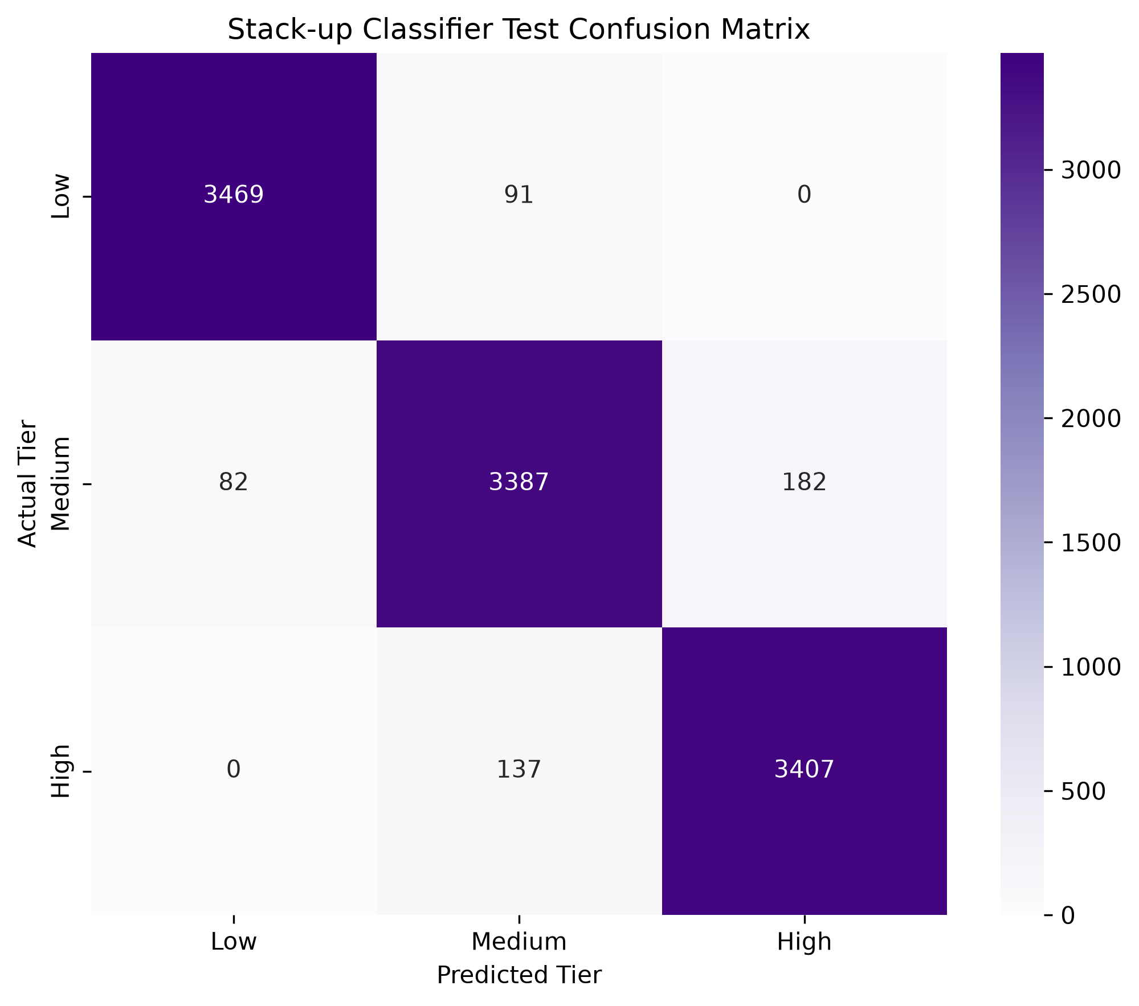
Figure D1 Test confusion matrix for the price tier classifier
Source Author analysis of the Seaborn Diamonds data
Table D1
Tier performance for the selected global model and stack up models
Model | Price tier | MAE | MAPE | Within 20%
E10 log DNN | Low | $50.67 | 6.56% | 97.58%
E10 log DNN | Medium | $187.52 | 7.18% | 93.86%
E10 log DNN | High | $611.94 | 6.97% | 95.32%
E11 hard stack up | Low | $53.61 | 6.87% | 96.35%
E11 hard stack up | Medium | $197.39 | 7.48% | 93.89%
E11 hard stack up | High | $590.47 | 6.97% | 94.81%
E12 soft stack up | Low | $51.57 | 6.71% | 96.80%
E12 soft stack up | Medium | $189.68 | 7.25% | 94.55%
E12 soft stack up | High | $586.56 | 6.86% | 95.09%

Appendix E Reproducibility
The analysis used random seed 42 and executed on Apple Metal Performance Shaders. All 21 notebook cells completed without errors. The notebook produced the model weights, validation and test predictions, experiment tables, and figures used in this report.
Table E1
Software and execution settings
Item | Value
Python | 3.14.4
PyTorch | 2.14.1
NumPy | 2.5.3
pandas | 3.0.6
scikit learn | 1.9.1
seaborn | 0.13.2
Random seed | 42
Execution device | Apple MPS
Encoded features | 23
Maximum epochs | 80 for global models and 100 for tier regressors
Early stopping | Validation loss with restored best weights

The executed notebook is submitted separately in HTML format. The main output files include experiment_results.csv, results_by_price_tier.csv, test_predictions.csv, validation_predictions.csv, best_base_model.pt, and stackup_models.pt.

