COFFEE SALES
ANALYTICS REPORT
─────────────────────────────────────
Sales Performance, Customer Insights & Market Analysis
Reporting Period: January 2019 – August 2022
Data Source: Coffee Orders Transactional Database (1,000 records)
Analyst: Vu Tran Hai Long | Tools: Microsoft Excel (Pivot Tables, XLOOKUP, INDEX/MATCH)

1. EXECUTIVE SUMMARY
This report presents a comprehensive analysis of coffee sales performance across three markets — the United States, Ireland, and the United Kingdom — spanning a 44-month period from January 2019 to August 2022. The dataset encompasses 1,000 transaction records across four coffee varieties (Arabica, Excelsa, Liberica, and Robusta), three roast profiles, and four package sizes. All data was processed, enriched, and visualized using Microsoft Excel.

$45,134  TOTAL REVENUE  Jan 2019 – Aug 2022 |  | 957  TOTAL ORDERS  Unique order IDs |  | 913  UNIQUE CUSTOMERS  Across 3 markets |  | $47.16  AVG ORDER VALUE  Per transaction

Key Highlights
▸ The United States dominates revenue contribution at 79.0% ($35,639), with Ireland (14.8%) and the UK (6.2%) as secondary markets.
▸ Excelsa is the top-grossing coffee variety at $12,306 (27.3%), narrowly ahead of Liberica ($12,054) and Arabica ($11,768).
▸ FY2021 was the strongest full year on record with $13,766 in revenue — a 13.6% increase over FY2020.
▸ The 2.5 kg package size accounts for 52.7% of all revenue, indicating strong preference for bulk purchasing.
▸ Light roast leads category revenue at 38.5% ($17,354), followed by Medium (32.3%) and Dark (29.2%).

2. DATA PROCESSING & METHODOLOGY
The raw transactional dataset contained 1,000 order line records with incomplete fields. A structured data enrichment pipeline was developed entirely within Microsoft Excel, leveraging advanced lookup and conditional functions to transform the raw data into a fully analysis-ready dataset.

2.1 Data Enrichment — Orders Table

Field Added | Method | Description
Customer Name | XLOOKUP | Matched Customer ID to customers table to retrieve full name
Email | XLOOKUP | Retrieved email from customers table; blank cells returned for customers with no email on record
Country | XLOOKUP | Populated market/country from the customers reference table
Coffee Type | INDEX / MATCH | Looked up coffee type code from products table using Product ID
Roast Type | INDEX / MATCH | Retrieved roast type identifier (L / M / D) from products table
Size (kg) | INDEX / MATCH | Pulled package size (0.2 / 0.5 / 1.0 / 2.5 kg) from products table
Unit Price | INDEX / MATCH | Retrieved unit selling price from products catalog (48 SKUs)
Sales | Formula | Calculated as Unit Price × Quantity ordered
Coffee Type Name | Nested IF | Converted code (Ara/Exc/Lib/Rob) to full descriptive name
Roast Type Name | Nested IF | Converted code (L/M/D) to Light / Medium / Dark
Loyalty Card | XLOOKUP | Flagged whether the customer holds an active loyalty card (Yes / No)

2.2 Data Formatting & Quality Controls

▸ Order Date formatted as dd-mmm-yyyy (e.g., 05-Sep-2019) for visual clarity and consistent temporal sorting.
▸ Size column formatted with "0.0 kg" number format to make package weight explicit to end users.
▸ Unit Price and Sales columns formatted with the "$" prefix, ensuring financial readability.
▸ Duplicate check performed across the entire Orders table — 31 Order IDs contain multiple line items (multi-product orders), which is expected behaviour and not a data quality issue.
▸ 187 customer records had no email address on file; these were returned as blank cells rather than "0" using the concatenation method in the XLOOKUP formula.

2.3 Dashboard & Visualizations (Microsoft Excel)

▸ TotalSales Pivot Table — Order Date (rows: Year → Month), Coffee Type Name (columns), Sum of Sales (values). Linked to an interactive line chart with a Date Timeline slicer.
▸ CountryBarChart Pivot Table — Country (rows), Sum of Sales (values). Linked to a horizontal bar chart.
▸ Top5Customers Pivot Table — Customer Name (rows), Sum of Sales (values). Linked to a horizontal bar chart showing the five highest-value customers.
▸ Three interactive slicers applied: Roast Type Name, Loyalty Card status, and Package Size — allowing dynamic cross-filtering across all three charts simultaneously.

3. INTERACTIVE DASHBOARD
The Excel dashboard consolidates all key metrics into a single-pane view, enabling stakeholders to filter and explore data dynamically. The layout mirrors enterprise BI tool conventions, with a color-coded purple theme, responsive slicers, and cross-chart interactivity.

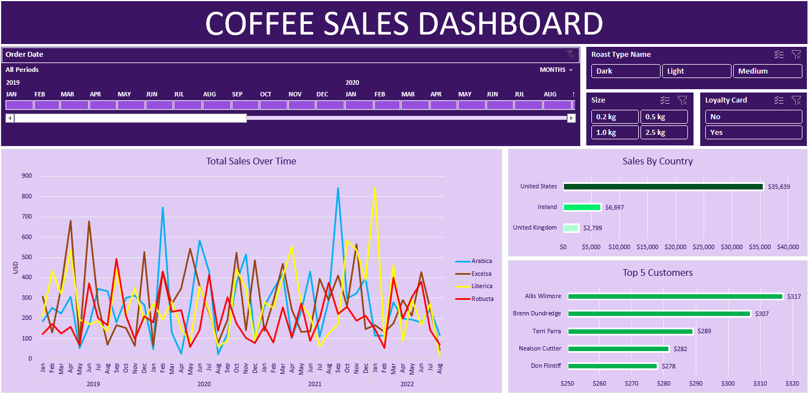
Figure 1: Coffee Sales Interactive Dashboard — Microsoft Excel (All Periods, All Filters)

4. SALES PERFORMANCE ANALYSIS
4.1 Revenue Trend (2019–2022)

Year | Revenue (USD) | YoY Growth | Notes
2019 | $12,187 | — | Baseline year; 12 full months
2020 | $12,118 | -0.6% | Near-flat; slight decline likely from COVID disruptions
2021 | $13,766 | +13.6% | Strongest full year — recovery & demand acceleration
2022 | $7,063 | — | Partial year (Jan–Aug only); annualized est. ~$10,595

Revenue remained broadly stable in 2019–2020, with a near-flat year-on-year change of -0.6% in FY2020. The business rebounded strongly in FY2021, recording $13,766 — a 13.6% growth rate driven by an uptick across all four coffee varieties. September 2021 was the single-month peak for Arabica sales ($841). The 2022 partial-year figure of $7,063 (8 months) projects to approximately $10,595 annualized, suggesting a deceleration that warrants further investigation beyond the reporting window.

4.2 Sales by Coffee Variety

Coffee Variety | Total Revenue | Revenue Share | Avg Unit Price
Excelsa | $12,306 | 27.3% | $14.29
Liberica | $12,054 | 26.7% | $14.59
Arabica | $11,768 | 26.1% | $12.28
Robusta | $9,005 | 20.0% | $10.46

Revenue distribution across the four varieties is remarkably balanced, with Excelsa (27.3%), Liberica (26.7%), and Arabica (26.1%) performing at near-parity. Robusta trails at 20.0%, which correlates with its lower average unit price ($10.46 vs. $14.59 for Liberica). This pricing gap suggests an opportunity to either reposition Robusta at a higher price point or focus marketing efforts on the higher-margin varieties.

4.3 Sales by Roast Profile & Package Size

Roast Type Revenue Share  Light $17,354 38.5%  Medium $14,600 32.3%  Dark $13,179 29.2% |  | Package Size Revenue Share  2.5 kg $23,786 52.7%  1.0 kg $11,011 24.4%  0.5 kg $7,030 15.6%  0.2 kg $3,308 7.3%

5. GEOGRAPHIC & CUSTOMER ANALYSIS
5.1 Sales by Country

Market | Total Revenue | Revenue Share | Assessment
United States | $35,639 | 79.0% | Primary market — highly concentrated revenue base
Ireland | $6,697 | 14.8% | Strong secondary market; growth opportunity
United Kingdom | $2,799 | 6.2% | Emerging market; significant upside potential

The revenue concentration in the United States (79.0%) indicates a strong domestic market but also significant geographic risk exposure. Ireland and the United Kingdom together account for 21.0% of revenue. Given that the UK customer base generates only $2,799 over the full period, there is a material opportunity to expand marketing and distribution efforts in the UK market, particularly for the Liberica and Excelsa varieties which command the highest average unit prices.

5.2 Top 5 Customers by Lifetime Value

Rank | Customer Name | Lifetime Revenue | Premium vs. Avg Order
#1 | Allis Wilmore | $317.07 | +572%
#2 | Brenn Dundredge | $307.05 | +550%
#3 | Terri Farra | $289.11 | +512%
#4 | Nealson Cuttler | $281.68 | +497%
#5 | Don Flintiff | $278.01 | +489%

The top 5 customers each contribute between $278 and $317 in lifetime value — approximately 5.9× to 6.7× the average order value of $47.16. While individual customer concentration is relatively low (the top customer represents only 0.7% of total revenue), this underscores a broadly diversified customer base with no single point of failure. A loyalty or VIP retention program targeting this cohort could yield disproportionate returns.

5.3 Loyalty Card Analysis

Loyalty Status | Total Revenue | Revenue Share | Customer Distribution
Card Holders (Yes) | $20,918 | 46.3% | 47.9% of transactions
Non-Card Holders (No) | $24,216 | 53.7% | 52.1% of transactions

Non-loyalty card holders account for a slightly larger share of both transactions (52.1%) and revenue (53.7%). The near-equal split suggests that the loyalty programme is not yet creating a strong enough differentiation in purchasing behaviour. Enhancing the loyalty reward structure could incentivize card enrollment and drive a shift in revenue toward higher-retention customers.

6. STRATEGIC INSIGHTS & RECOMMENDATIONS

Key Business Recommendations
▸ MARKET DIVERSIFICATION — Revenue is heavily concentrated in the US (79%). Targeted campaigns in the UK market, where only $2,799 in revenue was recorded, could significantly improve geographic resilience.
▸ ROBUSTA REPOSITIONING — As the lowest average unit price variety ($10.46), Robusta underperforms on revenue share. Consider bundle promotions or upsell pathways toward Excelsa and Liberica.
▸ BULK PURCHASING INCENTIVES — 52.7% of revenue already comes from 2.5 kg packages. Introducing tiered pricing or subscription models for bulk buyers could further concentrate high-value orders.
▸ LOYALTY PROGRAMME ENHANCEMENT — The near 50/50 split between card vs. non-card revenue indicates low programme impact. Redesigning the loyalty rewards structure could shift more revenue to a retained, higher-LTV customer base.
▸ EMAIL DATA COMPLETENESS — 187 customers (20.5%) have no email on record. Closing this gap would enable email retargeting, improving customer re-engagement rates at low incremental cost.
▸ SEASONALITY PLANNING — June ($4,843) and March ($4,796) are the highest monthly revenue periods across the reporting window. Aligning inventory, promotions, and staffing to these peaks can maximise conversion.

7. TECHNICAL APPENDIX
7.1 Tools & Technologies

▸ Microsoft Excel — Primary analysis environment: data enrichment, lookup functions, pivot tables, charts, slicers.
▸ XLOOKUP — Used for cross-table lookups (Customer Name, Email, Country, Loyalty Card) between the Orders and Customers tables.
▸ INDEX / MATCH — Used for multi-column product lookups (Coffee Type, Roast Type, Size, Unit Price) from the Products table (48 SKUs).
▸ Nested IF statements — Used for descriptive label mapping (Coffee Type Name, Roast Type Name).
▸ Pivot Tables × 3 — TotalSales, CountryBarChart, Top5Customers with cross-slicer interactivity.

7.2 Dataset Overview

Table | Records | Key Fields | Purpose
orders | 1,000 rows | Order ID, Date, Customer ID, Product ID, Qty | Primary fact table — all transactions
customers | 1,001 rows | Customer ID, Name, Email, Country, Loyalty Card | Customer dimension table
products | 48 rows | Product ID, Coffee/Roast Type, Size, Unit Price, Profit | Product dimension & pricing catalog

Prepared by: Vu Tran Hai Long
Tools: Microsoft Excel | Period: FY2019–FY2022 | Records Analyzed: 1,000
This report was produced as part of a data analytics portfolio project.

