SVKM’s NMIMS
Mukesh Patel School of Technology Management & Engineering
Computer Engineering Department
Program: BTech Integrated Sem VI

Course: Computer Graphics
2025-26

Experiment No.02
PART A
(PART A: TO BE REFFERED BY STUDENTS)
A.1 Aim
Computer Graphics includes a variety of graphics functions that enable the creation of a variety of visual objects. Students will be able to build pixels, lines, circles, rectangles, and ellipses, as well as learn how to plot objects using the graphics coordinate system.
Task 1: Install the Graphics package as given in the attached document
Task 2: Develop graphics programs using basic graphics functions defined in library of a programming language.
- Pixels
- Line
- Circles
- Rectangle
- Ellipse

Task 3. Using the above mentioned functions draw the following:
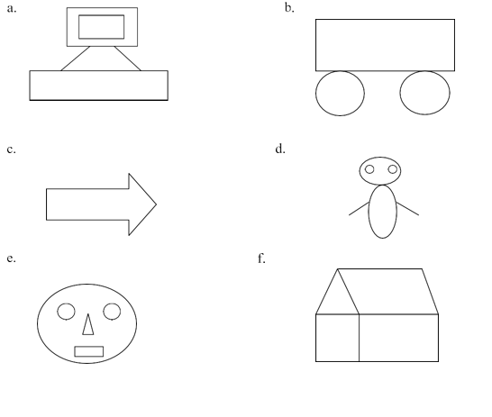

A.2 Pre requisite
The prerequisite of this laboratory exercise are Computer Programming I and Computer Programming II.
A.3 Outcome
After successful completion of this experiment students will be able to:
- Learn and manipulate visual and geometric properties of image.
- Implement graphics function for drawing 2D graphics.

A.4 Theory
In the graphic design of printed material are frequently produced on computers, as are the still and moving images seen in comic strips and animations. The realistic images viewed and manipulated in electronic games and computer simulations could not be created or supported without the enhanced capabilities of modern computer graphics. Computer graphics also are essential to scientific visualization, a discipline that uses images and colours to model complex phenomena such as air currents and electric fields, and to computer-aided engineering and design, in which objects are drawn and analyzed in computer programs. Even the windows based graphical user interface, now a common means of interacting with innumerable computer programs, is a product of computer graphics.
You have to import the graphics library.
// Graphics Library for C++
#include <graphics.h>
After this. you can start the methods/functions available in this graphics library.
Inside main() function before using the functions for all those objects you have to initialize the Graphics mode on your computer. This is necessary step, so that you can change your computer display mode to generate image.
// gm is Graphics mode, a computer display mode to
// generate image
// DETECT is a macro defined in "graphics.h" header file
int gd = DETECT, gm;

// initgraph initializes the graphics system by loading a
// graphics driver from disk, path can be empty
initgraph(&gd, &gm, "");
This completes your setup for using any of the methods listed in graphics library. Let’s draw a pixel first.
// putpixel(x,y,color): plots a pixel at location (x, y)
// of specified color
putpixel(50, 100, YELLOW);
line(int x1, int y1, int x2, inty2);
Line function is used to draw a line from point (x1,y1)- starting point to point (x2,y2)- ending point.
- circle(int x, int y, int radius);
Circle function is used to draw circle with center (x,y) and radius of circle.
- rectangle(int left, int top, int right, int bottom);
Rectangle function is used to draw rectangle with coordinates as left, right,top,bottom
- ellipse( int x, int y, start angle, end angle, int xradius, int yradius);
Ellipse function is used to draw ellipse with centre(x,y), starting angle, end angle, radius of x and y axis.
- outtextxy(int xy, int y, “text”);
Outtextxy function used to insert text at given position(x,y)
Sample C++ Code
#include <iostream>
// Graphics Library for C++
#include <graphics.h>
#include <conio.h>
#include <dos.h>
using namespace std;
int main()
{
int gd = DETECT, gm;
initgraph(&gd, &gm, "");

putpixel(50, 100, YELLOW);
outtextxy(35, 55, "PIXEL");

line(120, 90, 170, 170);
outtextxy(130, 55, "LINE");

circle(240, 120, 40);
outtextxy(215, 55, "CIRCLE");

rectangle(300, 90, 400, 140);
outtextxy(310, 55, "RECTANGLE");

ellipse(500, 120, 0, 360, 70, 35);
outtextxy(470, 55, "ELLIPSE");
getch();
closegraph();

return 0;
}
PART B
(PART B: TO BE COMPLETED BY STUDENTS)
(Students must submit the soft copy as per following segments within two hours of the practical. The soft copy must be uploaded or emailed to the concerned lab in charge faculties at the end of the practical.
Roll No.: C035 | Name: Arnav Deshpande
Program: BTI CE | Division: B
Batch:B2 | Date of Experiment:14/01/2026
Date of Submission: | Grade :

B.1 Code (Analyze the sample code given above and draw a drawing using it)
(Paste your Code here)
A:
Code:
#include <graphics.h>
using namespace std;
int main()
{

int gd = DETECT, gm;
initgraph(&gd, &gm, "");
rectangle(200, 20, 400, 120);//outer
rectangle(225, 35, 375, 105);//inner
line(250,120,150,150);//line left
line(350,120,450,150);//line right
rectangle(100,150,500,200);//rectangle bottom
outtextxy(225,225,"Arnav Deshpande C035");//Watermark
getch();
closegraph();
return 0;
}
Output:
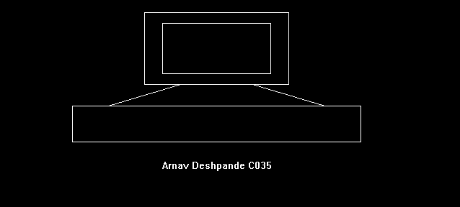
B:
Code:
#include <graphics.h>
using namespace std;
int main()
{

int gd = DETECT, gm;
initgraph(&gd, &gm, "");
rectangle(100, 20, 500, 120);//outer
circle(150,170,50);//left wheel
circle(450,170,50);//right wheel
outtextxy(225,225,"Arnav Deshpande C035");//Watermark
getch();
closegraph();
return 0;
}
Output:
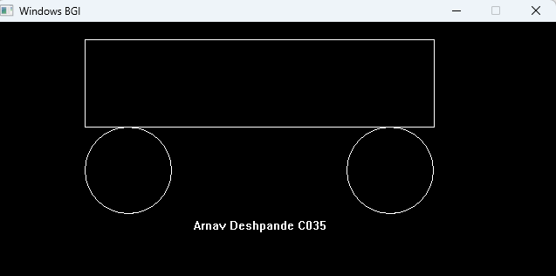
C:
Code:
#include <graphics.h>
using namespace std;
int main()
{

int gd = DETECT, gm;
initgraph(&gd, &gm, "");
line(100,50,100,70);
line(100,50,200,50);
line(200,50,200,30);
line(200,30,250,60);
line(100,70,200,70);
line(200,70,200,90);
line(200,90,250,60);
outtextxy(100,125,"Arnav Deshpande C035");//Watermark
getch();
closegraph();
return 0;
}

Output:
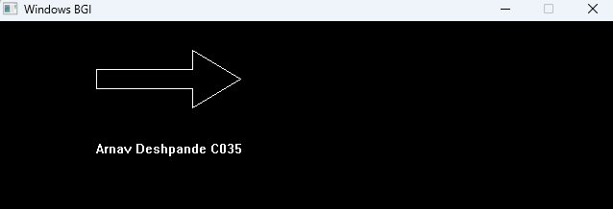
D:
Code:
// Graphics Library for C++
#include <graphics.h>
using namespace std;
int main()
{
int gd = DETECT, gm;
initgraph(&gd, &gm, "");
//D
// Head
ellipse(350, 130, 0, 360, 22, 20);
// Eyes
ellipse(340, 125, 0, 360, 3, 3);
ellipse(360, 125, 0, 360, 3, 3);
// Body
ellipse(350, 180, 0, 360, 16, 35);
// Arms
line(332, 175, 305, 190);
line(368, 175, 395, 190);
outtextxy(100,125,"Arnav Deshpande C035");//Watermark
getch();
closegraph();

return 0;
}
Output:
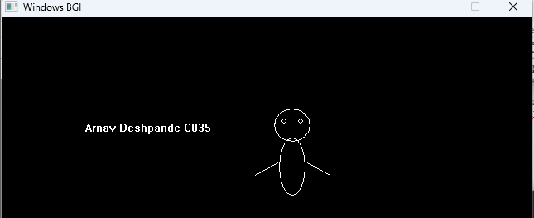
E:
Code:
// Graphics Library for C++
#include <graphics.h>
using namespace std;
int main()
{

int gd = DETECT, gm;
initgraph(&gd, &gm, "");
//E
// Face outline
ellipse(150, 350, 0, 360, 45, 35);

// Eyes
ellipse(135, 340, 0, 360, 6, 6);
ellipse(165, 340, 0, 360, 6, 6);

// Nose
line(150, 345, 145, 360);
line(145, 360, 155, 360);

// Mouth
rectangle(140, 370, 160, 380);
outtextxy(100,125,"Arnav Deshpande C035");
getch();
closegraph();

return 0;
}
Output:
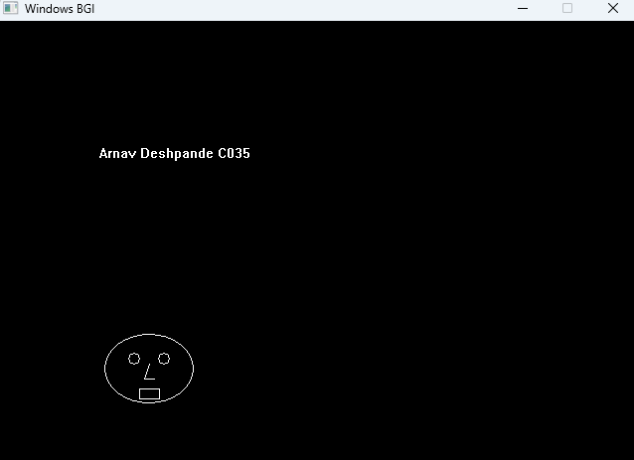
F:
Code:
// Graphics Library for C++
#include <graphics.h>
using namespace std;
int main()
{

int gd = DETECT, gm;
initgraph(&gd, &gm, "");
// Base rectangles
rectangle(150, 200, 300, 350); // Left rectangle
rectangle(300, 200, 500, 350); // Right rectangle

// Roof lines
line(150, 200, 225, 120); // Left slanted roof
line(225, 120, 400, 120); // Top horizontal roof
line(400, 120, 500, 200); // Right slanted roof

line(225, 120, 300, 200);
outtextxy(400,400,"Arnav Deshpande C035");
getch();
closegraph();

return 0;
}
Output:
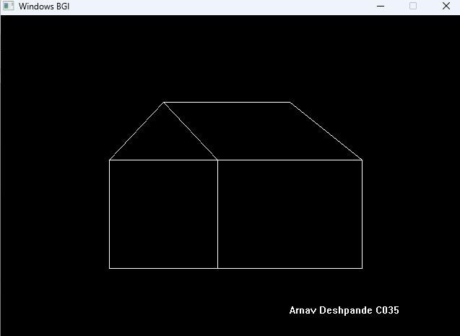
B.3 Observations and Learning:
(Students must write their observations and learnings as per the attainment of individual outcome listed above)

B.4 Conclusion
(Students must write the conclusion as per the attainment of individual outcome listed above)
B.5 Question of Curiosity
(To be answered by student based on the practical performed and learning/observations)
- Find the minimum and maximum coordinates of screen.
- What is graphics driver and graphics mode?
- Find error in following code
{
putpixel(20,20);
outtextxy(25,25, “Pixel”)
}

