演講題目:the development and application of bioimpedance technology
演講者:
Ohm,s Law
J=σE,where J is a vector from of current density,and E is a vector form of electric field intensity.
V=IR,where V is the voltage difference, I the current,and R the resistance.
Cardiac output(CO):CO=SV*HR where SV denotes stroke volume,and HR heart rate.
Methods:Oxygen Fick mehod,Indicator dilution method,etc.
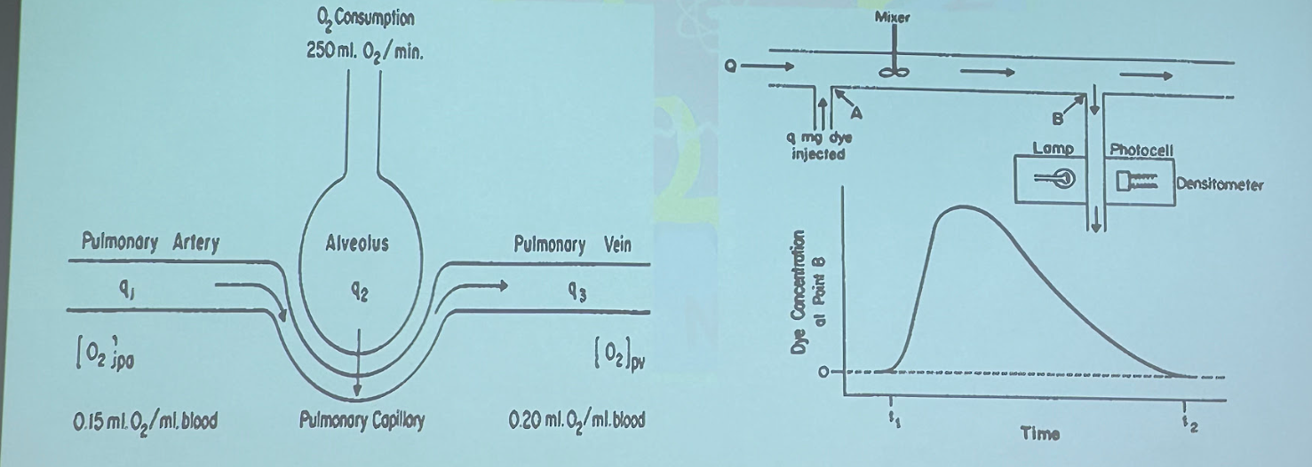
R=I/V=ρL/A
Z_{b}=ρ_{b}*L/ΔA
ΔZ=Z₀-( Z₀ Z_{b})/( Z₀+ Z_{b})
SV=(ρ_{b}*L²/ Z₀²)*LVET*(dZ/dt)_{max}
LVET:left Vevtricle Ejection Time
Since the discovery of X-rays in 1895, medical imaging has become an important tool for diagnosis.
Following the impedance camera designed by Henderson and Webster, Barber and Brown suggested the first electrical impedance tomography.
Electrical impedance tomography (EIT) is a newly developed imaging technique for revealing the conductivity as well as permittivity of biological tissues.
EIT is a non-invasive, radiation-free, real-time imaging system for a variety of medical applications, especially in ventilation as well as circulation.
Medical imaging modality | ct | us | mri | Eit
Basic principle | x-rays | High frequency sound | Radio waves | Impedance
Types of radiation | Lionizing radiation | Non- Lionizing radiation | Non- Lionizing radiation | Non-ionizing radiation
contrast | high | Low | high | Low
Scanning time | <20min | <30min | <40min | <10min
cost | moderate | low | Very high | Low
size | Non portable | portable | Non portable | portable
advantages | Bone and tumor imaging,anatomic imaging | Visualize muscles,rendon and internal organs | Morphological and functional imaging | Rapid tomographic inaging,low cost,noninvasive
disadvantages | High cost lionizing radiation | Operator dependency | Noisy,cost,low sensitivity | Not mature yet
Spatial resolution | 50-200μm | 50-500μm | 25-100μm | low

