## HW

### Hückel theory

* The molecular orbitals are linear combination of atomic orbitals
* Standard approximation of Hückel theory
  + , When
  + , Others
* Calculate the delocalize energy

#### Example 1,3-Butadiene

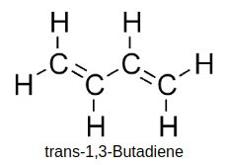 1. Linear combination of molecular orbitals

1. For solving the ith molecular orbital need to solve
2. By standard approximation of Hückel theory the matrix become
3. If c1,c2,c3,c4 is not trivial then the determinant is 0. E is the eigunvalue
4. Simplfy by divided by and then
5. Solve the equation
6. Derive the E1, E2, E3, E4
7. The electron configeration and shape(by HF/6-31G* ) 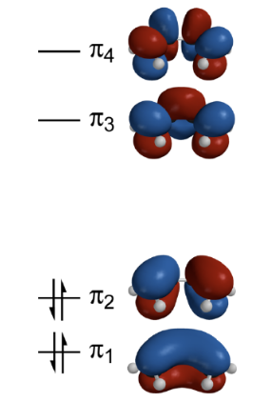
8. Calculate the energy of molecular orbitals
9. Compare the energy of butadiene with two ethylene

* The **delocalization energy** is about 0.48 = -35 kJ/mol
* 一張含有 文字, 白板 的圖片

  自動產生的描述The delocalization can stable the molecular

#### (b) The wavefunction of the π MOs () of benezne

#### (c) The Hamiltonian matrix for benezene

#### 一張含有 文字, 白板 的圖片 自動產生的描述(d)

E =

(e)

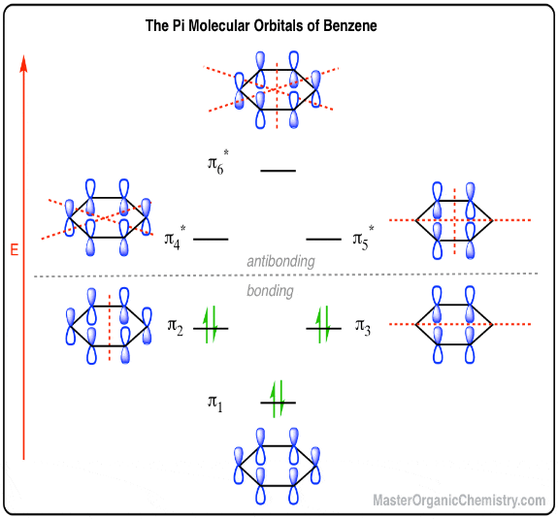

#### (f)

* 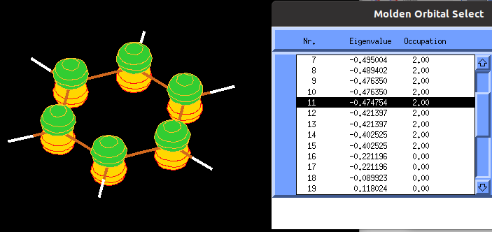
* 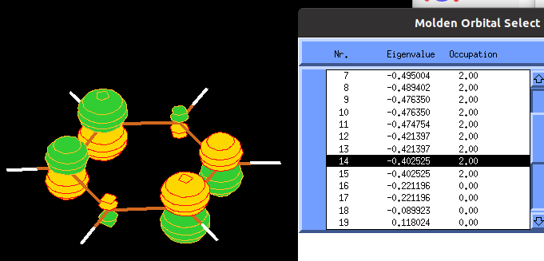
* 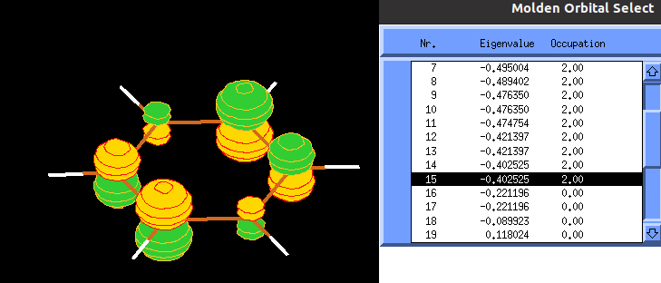
* * 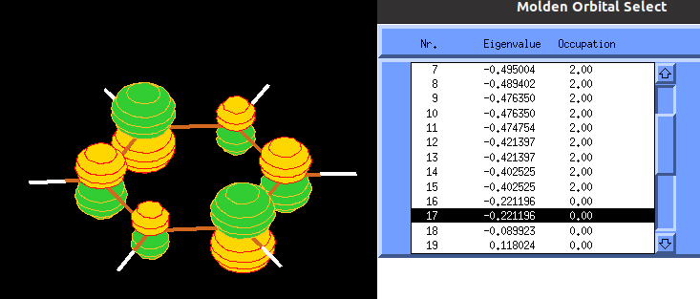
* * 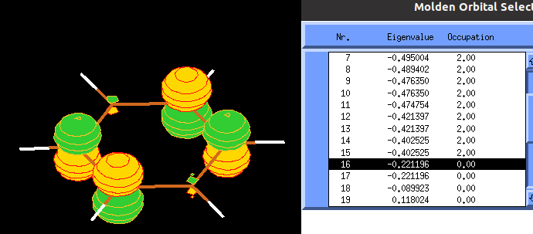
* * 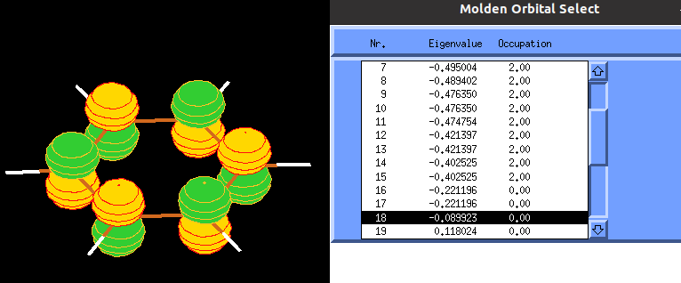
* E2-E1 ≠ E6-E5
  + E1 = -0.474754
  + E2 = -0.402525
  + E3 = -0.402525
  + E4 = -0.221196
  + E5 = -0.221196
  + E6 = -0.089923

#### 2.

#### generate files and directory

for dir in aN nN aA nN;do mkdir $dir ; cp naphthalene.xyz $dir;done

#### aA xtb

* parameter
  + charge: -1
  + unpair-electrons: 1
  + –opt
  + –molden
* command

xtb -c -1 -u 1 --opt --molden naphthalene.xyz > xtb.out

* Energy:
  + E = -25.638035481112 Eh
  + LUMO = -0.033169

#### nN xtb

* parameter
  + charge: 0
  + unpair-electrons: 0
  + –opt
  + –molden
* command

xtb -c 0 -u 0 --opt --molden xtbopt.xyz > xtb.out

* Energy:
  + E = -25.474386099963 Eh
  + LUMO = -0.257933

#### aN xtb

The aN is the anion with the ground state geometry - Use nN naphthalene_opt.xyz(ground state geometry) - parameter - charge: -1 - unpair-electrons: 1 - –molden - command

xtb -c -1 -u 1 --molden xtbopt.xyz > xtb.out

* Energy
  + E = -25.633869367054 Eh
  + LUMO = -0.035127

#### Conclude

|  |  |  |
| --- | --- | --- |
|  | E(hartree) | LUMO |
| nN | -25.474386099963 | -0.257933 |
| aA | -25.638035481112 | -0.033169 |
| aN | -25.633869367054 | -0.035127 |

* EAvertical = −0.1595 Eh = −4.3402183 eV
* EAadiabatic = −0.163649381 Eh = −4.45312877 eV
* EA(exp) = -0.200 ± 0.050 eV

1 Eh = 27.2114 eV

### HOMO, LUMO and their difference for oligothiophene

#### Structure bulid

1. Draw the structure by the following html http://www.cheminfo.org/flavor/malaria/Utilities/SMILES_generator___checker/index.html
2. Output the structure by SMILES
3. Use Avogadro to optimize the structure
4. Output with the file.xyz

#### HOMO,LUMO

* Search HOMO,LUMO

grep "Occu" -B 2 molden.input

|  |  |  |  |  |  |
| --- | --- | --- | --- | --- | --- |
| n | 1 | 2 | 3 | 4 | 5 |
| HOMO | -0.39302 | -0.370329 | -0.361751 | -0.357424 | -0.354870 |
| LUMO | -0.24234 | -0.272395 | -0.284796 | -0.291401 | -0.295524 |
| Gap | 0.15068 | 0.097933 | 0.076967 | 0.066022 | 0.05934 |

* The energy gap become narrow as the n inrease 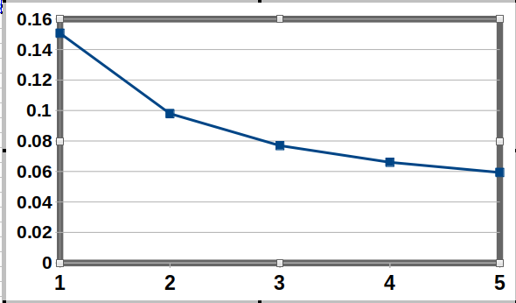
* The homo increase and lumo decrease as the n increase 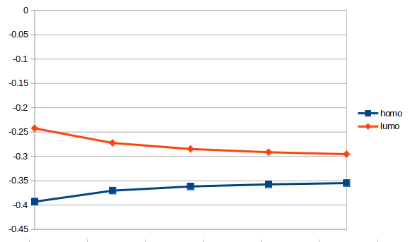

### MOs for VF5

#### Splitting field

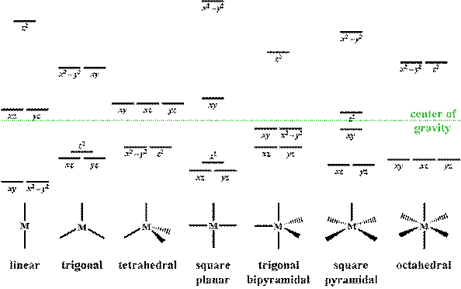

#### square pyramidal

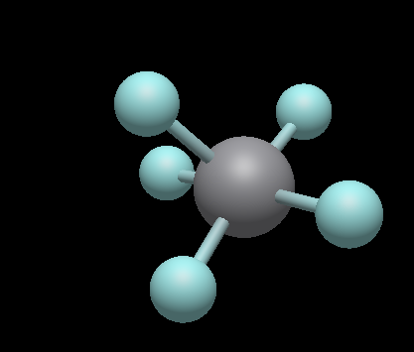

* Energy : -25.830963344050 Eh

##### bond length

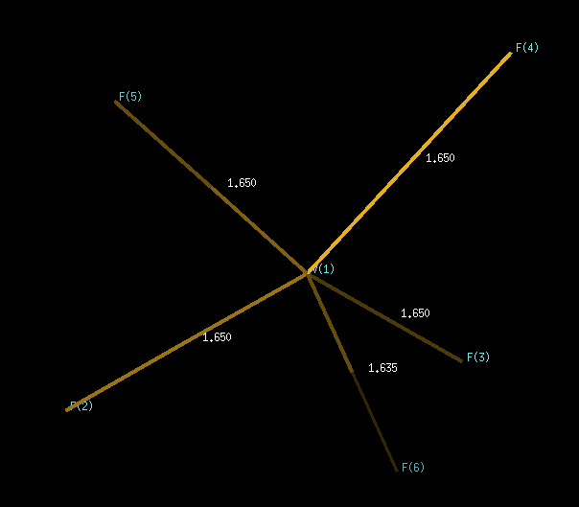

##### (c)

* 
* 24
* 
* 23dxy
* 
* 22dxz,21dyz
* 一張含有 汽球, 向量圖形, 交通號誌 的圖片

  自動產生的描述
* E :
* 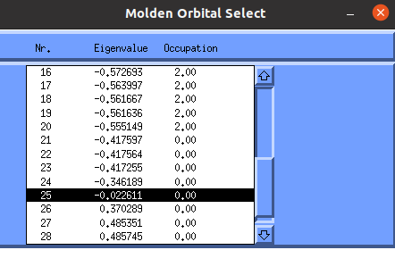

#### trigonal bipyramidal

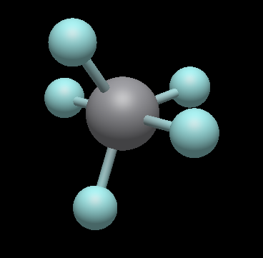

* Energy : -25.835167715651 Eh

##### bond length

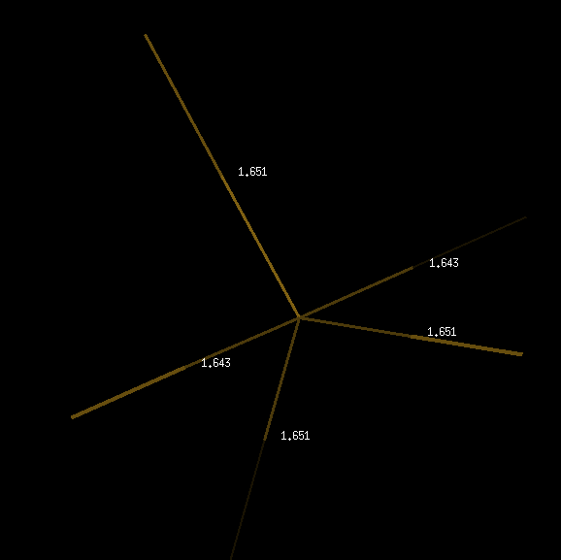

##### (c)

* 25
* 
* 24 dxy,23
*  
* 22 dxz, 21 dyz
*  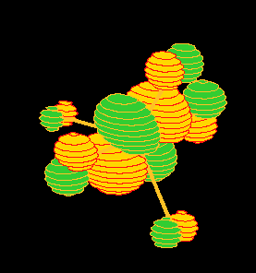
* E

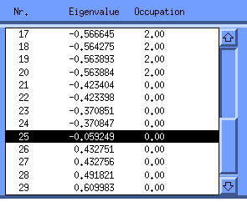

##### bond angle

#### (b)

* The sqare pyramidal is more stable

#### (d)

* Element V d-orbital E = -0.198747 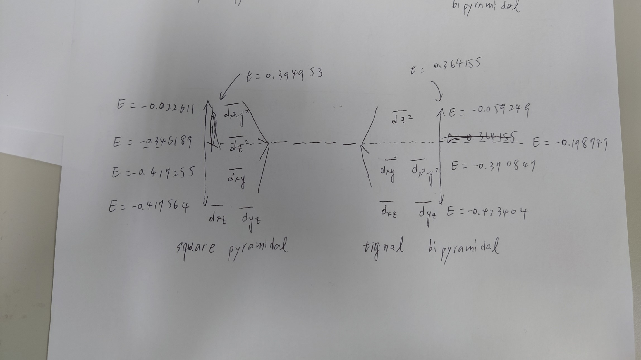

## Questions

1. The molecular orbitals have like d orbital but in low orbital
2. How to calculate the degenerate orbitals 

## repository

https://github.com/pumachu/2022-xTB-summer-school