銘傳大學 | JAVA應用程式設計
電腦與通訊工程學系 | JAVA應用程式設計
期中測驗
姓名：_______趙啟翔___________ 學號：________05050130__________
請將程式執行結果與相關的程式片段放入試卷中

- 選擇題，請至Moodle作答(60%)
- 設計一視窗應用程式，分別使用下列2種方式建立，並且具有相關layout。(30%)
- extends java.awt.Frame，使用Border Layout，置入4個Button，分別位於東、西、南、北
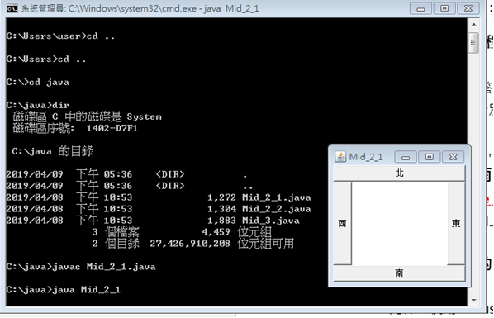

import java.awt.*;
import java.awt.event.*;

public class midtest1 extends java.awt.Frame {
public static void main(String[] args) {
new midtest1();
}
public midtest1() {
super("midtest1");

BorderLayout borderlayout = new BorderLayout();
setLayout(borderlayout);

Button button1 = new Button("東");
Button button2 = new Button("南");
Button button3 = new Button("西");
Button button4 = new Button("北");
add(button1, BorderLayout.EAST);
add(button2, BorderLayout.SOUTH);
add(button3, BorderLayout.WEST);
add(button4, BorderLayout.NORTH);

this.setSize(200,200);

Dimension screenSize = Toolkit.getDefaultToolkit().getScreenSize();
Dimension frameSize = this.getSize();
if (frameSize.height > screenSize.height)
frameSize.height = screenSize.height;
if (frameSize.width > screenSize.width)
frameSize.width = screenSize.width;
this.setLocation((screenSize.width - frameSize.width) / 2, (screenSize.height - frameSize.height) / 2);
this.setVisible(true);
this.addWindowListener(new WindowAdapter() {
public void windowClosing(WindowEvent e) {
System.exit(0);
}
});
}
}

- 直接以 java.awt.Frame建立，使用Flow Layout，置入5個Button，由左至右，由上而下

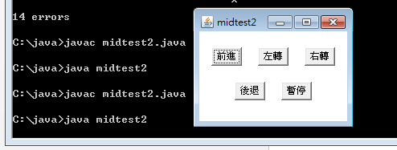
import java.awt.*;
import java.awt.event.*;

public class midtest2 extends java.awt.Frame {

public static void main(String args[]){
new midtest2();
}

public midtest2() {
super("midtest2");

FlowLayout flowlayout = new FlowLayout(FlowLayout.CENTER);
flowlayout.setHgap(20);
flowlayout.setVgap(20);
setLayout(flowlayout);

Button btn1 = new Button("前進");
Button btn2 = new Button("左轉");
Button btn3 = new Button("右轉");
Button btn4 = new Button("後退");
Button btn5 = new Button("暫停");
add(btn1);
add(btn2);
add(btn3);
add(btn4);
add(btn5);

this.setSize(200, 150);
Dimension screenSize = Toolkit.getDefaultToolkit().getScreenSize();
Dimension frameSize = this.getSize();
if (frameSize.height > screenSize.height)
frameSize.height = screenSize.height;
if (frameSize.width > screenSize.width)
frameSize.width = screenSize.width;
this.setLocation((screenSize.width - frameSize.width) / 2, (screenSize.height - frameSize.height) / 2);
this.setVisible(true);

this.addWindowListener(new WindowAdapter() {
public void windowClosing(WindowEvent e) {
System.exit(0);
}
});
}
}

- 試設計一具有事件監控的視窗應用程式，其功能與相關元件配置如下(30%)
- Label元件，使用Mouse Motion Listener監控，事件觸發時列印出相關訊息(只有這個Label有,其他區域都沒有)

- Button元件，使用Action Listener監控，事件觸發時列印出相關訊息(只有這個Button有,其他區域都沒有)

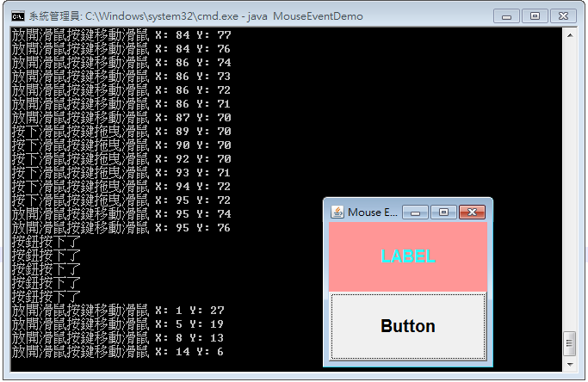

import java.awt.*;
import java.awt.event.*;
public class MouseEventDemo extends java.awt.Frame implements
MouseListener,
MouseMotionListener {
public static void main(String[] args) {
new MouseEventDemo();

}
public MouseEventDemo() {
super("Mouse Event Demo");
this.addMouseListener(this);
this.addMouseMotionListener(this);
setLayout(new GridLayout(2, 1));

java.awt.Label label;
label = new Label("LABEL");
label.setAlignment(Label.CENTER);
label.setFont(new Font("微軟正黑體", Font.BOLD, 20));
label.setForeground(new Color(41,255,255));
label.setBackground(new Color(255,150,150));
label.addMouseMotionListener(new MouseMotionListener(){
public void mouseMoved(MouseEvent e) {
System.out.println("放開滑鼠按鍵移動滑鼠" + " X: " + e.getX() + " Y: " + e.getY());}
public void mouseDragged(MouseEvent e) {
System.out.println("按下滑鼠按鍵拖曳滑鼠" + " X: " + e.getX() + " Y: " + e.getY());}

});

add(label);

java.awt.Button button;
button = new Button("Button");
button.setFont(new Font("", Font.BOLD, 20));
button.addActionListener(new ActionListener() {
public void actionPerformed(ActionEvent e) {
if (e.getSource().equals(button))
System.out.println("按鈕按下了");
}
});
add(button);
this.setSize(200, 200);
Dimension screenSize = Toolkit.getDefaultToolkit().getScreenSize();
Dimension frameSize = this.getSize();
if (frameSize.height > screenSize.height)
frameSize.height = screenSize.height;
if (frameSize.width > screenSize.width)
frameSize.width = screenSize.width;
this.setLocation((screenSize.width - frameSize.width) / 2, (screenSize.height - frameSize.height) / 2);
this.setVisible(true);
}
public void mouseClicked(MouseEvent e) {
System.out.println("按一下") ;
}
public void mouseEntered(MouseEvent e) {
System.out.println("進入") ;
}
public void mouseExited(MouseEvent e) {
System.out.println("離開") ;
}
public void mousePressed(MouseEvent e) {
System.out.println("一直按著");
}
public void mouseReleased(MouseEvent e) {
System.out.println("放開") ;
}
public void mouseDragged(MouseEvent e) {
System.out.println("按著移動") ;
}
public void mouseMoved(MouseEvent e) {
System.out.println("移動") ;
}
}

