電通二乙微處理器實驗 實驗結報

實驗名稱 | Lab08
組別 | 49 | 組員 | 趙啟翔

- 實驗目的
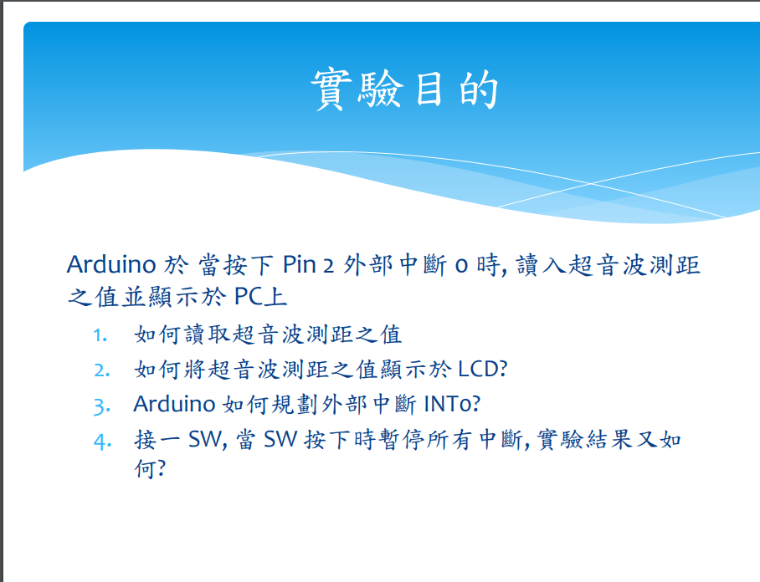
- 實驗步驟
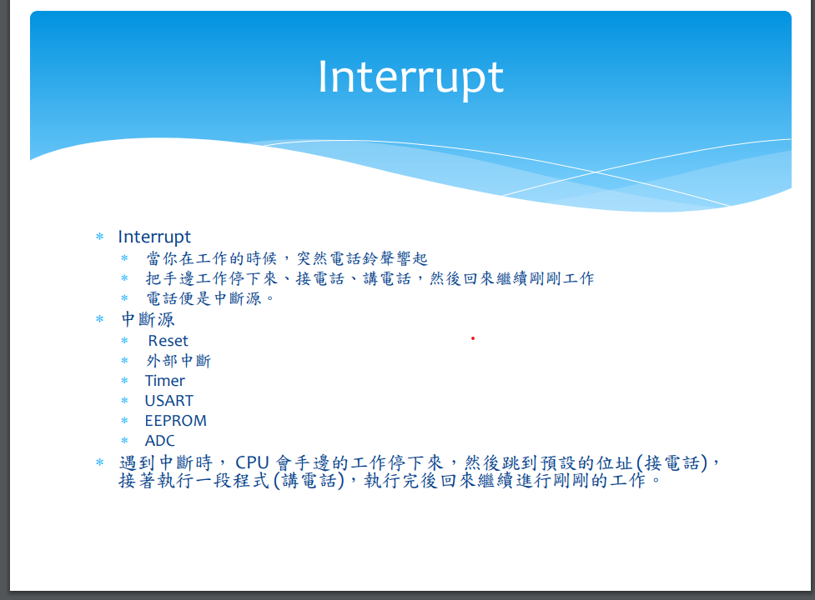
- 程式碼

#include "Arduino.h"
#include <Ultrasonic.h>
Ultrasonic ultrasonic(8,9);

const int led = 7; // USR LED pin is P7
const int usr_btn = 6; // USR BTN pin is P6
volatile boolean state=HIGH; //initial value of switch pin

void pin_change(void)
{
float cmMsec, inMsec;
state=!state; //reverse state

cmMsec = ultrasonic.read(CM);// 計算距離，單位: 公分
inMsec = ultrasonic.read(INC); // 計算距離，單位: 英吋

Serial.print("CM: "); Serial.print(cmMsec);
Serial.print(", IN: "); Serial.println(inMsec);
}

void setup() {
pinMode(led, OUTPUT);
pinMode(usr_btn, INPUT_PULLUP);
attachInterrupt(usr_btn, pin_change,FALLING);
digitalWrite(led, state);
Serial.begin(9600);

}

void loop() {
if (state) {digitalWrite(led, HIGH);//turn LED on
}
else{ digitalWrite(led, LOW); //turn LED off
}
}
- 實驗結果及分析
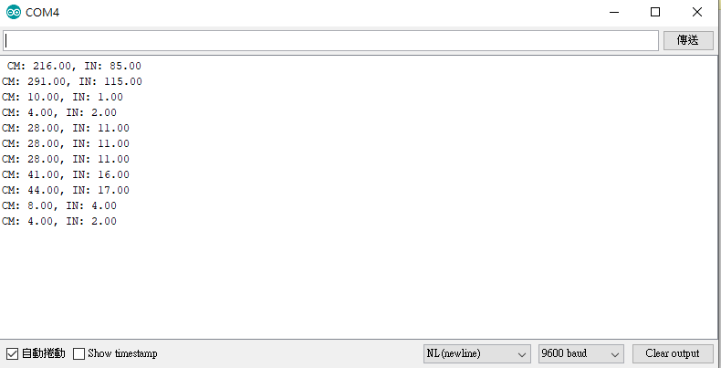
- 心得討論
今天寫中斷城市的過程很有趣，超音波實驗帶給我新知識

- 修正電路圖
- 修正程式碼

