電通二乙微處理器實驗 實驗結報

實驗名稱 | Lab11
組別 | 49 | 組員 | 趙啟翔

- 實驗目的
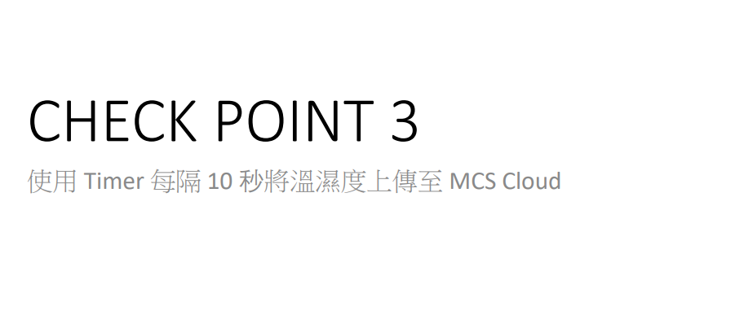
- 實驗步驟
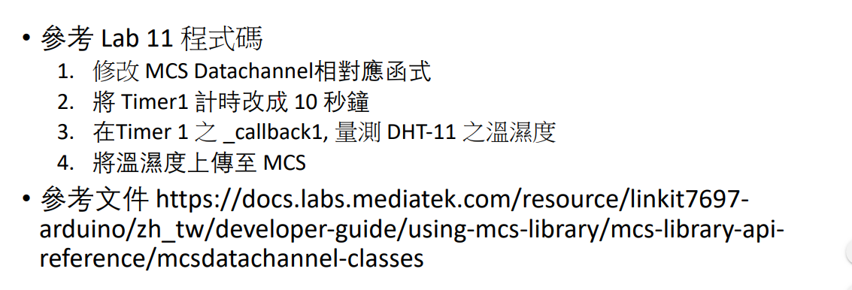
- 程式碼
#include <LWiFi.h>
#include <WiFiClient.h>
#include "MCS.h"
#include "DHT.h"
#define DHTPIN 2

// Assign AP ssid / password here
#define _SSID "AA202_2G"
#define _KEY "iteaa202"
#define DHTTYPE DHT11
// Assign device id / key of your test device
MCSDevice mcs("DypR0ItS", "er0MUjDl8Jbqw3gY");

// Assign channel id
// The test device should have 2 channel
// the first channel should be "Controller" - "On/Off"
// the secord channel should be "Display" - "On/Off"

MCSDisplayFloat humidity("H");
MCSDisplayFloat temperature("T");

#define LED_PIN 7
DHT dht(DHTPIN, DHTTYPE);
void setup() {
// setup Serial output at 9600
Serial.begin(9600);
Serial.println(F("DHTxx test!"));

dht.begin();
// setup LED/Button pin
pinMode(LED_PIN, OUTPUT);

// setup Wifi connection
while (WL_CONNECTED != WiFi.status())
{
Serial.print("WiFi.begin(");
Serial.print(_SSID);
Serial.print(",");
Serial.print(_KEY);
Serial.println(")...");
WiFi.begin(_SSID, _KEY);
}
Serial.println("WiFi connected !!");

// setup MCS connection

mcs.addChannel(humidity);
mcs.addChannel(temperature);

while (!mcs.connected())
{
Serial.println("MCS.connect()...");
mcs.connect();
}
Serial.println("MCS connected !!");

// read LED value from MCS server

}

void loop() {
// call process() to allow background processing, add timeout to avoid high cpu usage
Serial.print("process(");
Serial.print(millis());
Serial.println(")");
mcs.process(100);

// updated flag will be cleared in process(), user must check it after process() call.
float h = dht.readHumidity();
float t = dht.readTemperature();

if (!humidity.set(h))
{
Serial.print("Failed to update humidity");
Serial.println(humidity.value());
}
if (!temperature.set(t))
{
Serial.print("Failed to update temperature");
Serial.println(temperature.value());
}
delay(2000);
// check if need to re-connect
while (!mcs.connected())
{
Serial.println("re-connect to MCS...");
mcs.connect();
if (mcs.connected())
Serial.println("MCS connected !!");
}
}

- 實驗結果及分析
我的嘴巴吹出的空氣濕度高，溫度也比室外溫度高。
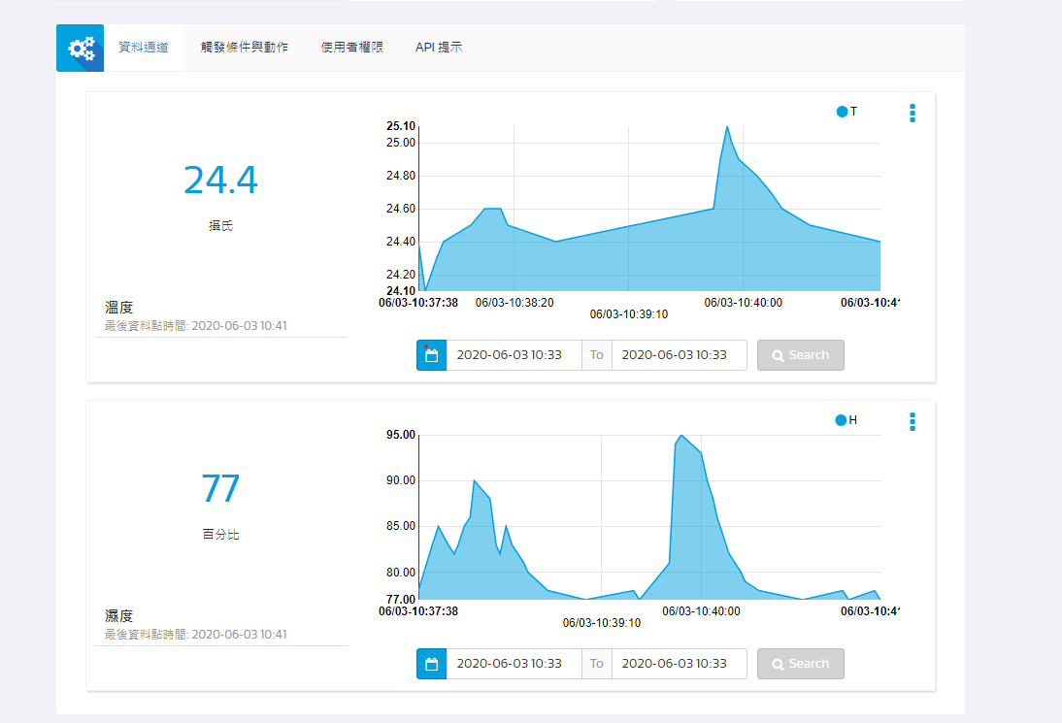
- 心得討論
今天數值上傳很有趣。
- 修正電路圖
- 修正程式碼

