Project Title: Senior Butler

Team Members: Chien Chi Liu, Cassidy Hoang, Chon Him Ip, Vasanti Dholaria

**Short Abstract:**

Senior Butler is a platform that provides seniors and their family a simple one shop of bundled and on-demand services. Since seniors feel more comfortable to remain in their home, safety checks and home maintenance are necessary to keep the home in the best condition for aging in place. Therefore, Senior Butler is designed to offer and help seniors arrange package of services for their home with a fair pricing, while provide constant feedback to their family members. In this way, both parties can assure that the living place is safe and secured.

**EXECUTIVE SUMMARY**

1. **INTRODUCTION**

Senior Butler makes aging in place a reality by providing a simple one stop shop of bundled and on-demand services. The objective of our project is to create a platform that allows seniors and their family to buy quality services in order to keep their home safe and sound. At the same time, we also build website interface for the back office to access the database and a mobile application for the service providers to read the information of customers and the services they need to do.

There are different types of service providers out there, but it is not grouped into a single shop, so Senior Butler will be the first one to offer that. Our advantage is to provide on-demand packages of service in one stop shop with service guarantee and fair pricing. Also, we send service information to their family members, so they will know what is happening in their parents’ house.

1. **DISCUSSION**

We usually talked with our team members first during our twice a week meeting. If the problem still existed, then we will search for help from Professor Jorge or Robert and Dave. We expects our solutions to be the optimal in term of the efficiency and user friendly. As a result, we usually have several solutions for the problems and do the comparison and come up with best one.

1. **RESOURCES**

Nancy Scroggins, the administrative assistant of the UTDesign team is the resources that we used for our meeting location.

Professor Jorge also helped us a lot during the meeting and technical problem, especially helped us set up virtual machine with CS-tech group.

Robert and Dave, the company representatives, give us direction on what the project is doing.

1. **KEY** **ROLES**

Andy is doing the database, Vasanti is doing the website development, Chon Him is doing mobile apps with Android and iOS, and Cassidy is doing the notification function (email & text message). We usually talked with team members in Groupme, and send one email to the company representatives to avoid duplicate communication.

1. **Communication Plan**:

We meet up every Friday morning 10am-noon with your company representatives Robert, Dave and Professor Jorge in SPN building. We also meet up one to two times a week ourself to keep up our progress, and we communicate using Groupme whenever we have concern or advise with each others.

1. **RISK ANALYSIS/CONTINGENCY PLAN**

As discussed above that we are using Groupme app to communicate. Also, we send out email for our progress. In case of absence of any team member, they will be still in communication loop and if any circumstances arrive we will reassign duties during time of absence. We have our tech person in contact for any technical problems or any urgent help.

1. **COSTS**

Looking at current setup we are not expecting any expenses. We will follow process to get our expense authorized if needed in future.

1. **TIMETABLE**
   * Phase I: due September 29th
     1. Design and build the Database.
     2. Find development tools (for building a Database, web development, Mobile development, and communication/notification function).
     3. Choose a Programming language to develop a website.
     4. Setup Virtual Machine and get access to it.
   * Phase II: due end of October
     1. Build checklist apps
     2. Development the text message and email notify system
     3. Development for website, mobile apps
   * Phase III: due end of November
     1. Test checklist apps
     2. Setup the connection between the website and the database
     3. Test for website, mobile apps, and communication methods
2. **EVALUATION**

The project can be deemed as successful if the group has made some progress on the project by the end of the semester. Ideally, the group will have an end product/prototype so that the company may begin work through the actual product. The product will be considered on time if the different phases (and end product) are delivered by the due dates. Team members will monitor the project weekly in order to determine the amount of progress made. Test plans include the successful running of the app/website and the working connections between the database, app, and website.

One form of quantitative feedback is the mentor’s feedback. The mentor’s feedback would be most valuable such that he is aware of what happens with/during the project and can determine how successful the project was.

1. **CONCLUSION**

Senior Butler is a good project in which it provides a primary means for the elderly (and possibly others) to “age well in place.” In particular, customers will be able to purchase packages of services so that they can age in the comfort of their home. This is important due to the growth of the elderly population in the United States. According to the Census Bureau, there will be an estimated 83.7 million people that are 65 years or older by 2050. It is important to note that this is almost double the estimated 43.1 million people over 65 years old in 2012. As people get older, they will no longer have the ability to (safely) complete everyday tasks that they used to be able to do. Senior Butler addresses this problem by providing a one-stop shop for packages of services that will make the once easy/everyday chores and tasks easier to complete for those who will need it.

1. **CONTACT INFORMATION**

Cassidy Hoang | 469-693-9226 | [cth130030@utdallas.edu](mailto:cth130030@utdallas.edu)

I am a senior student attending the University of Texas at Dallas in pursuit of a Bachelor’s Degree in Computer Science. I was born in Arlington, TX and later moved to Plano Texas where I have lived since then. I am proficient in programming languages such as Java and C++.

Chien-Chi Liu | 206-866-8813 | [cxl153330@utdallas.edu](mailto:cxl153330@utdallas.edu)

I am a senior student in University of Texas at Dallas major in Computer Science. I was born in Taiwan and moved to Seattle for Associate of Science degree when I was 18. My interests include software development and database management. The programming language that I learned are java, C/C++, Python, R, SQL, and Mips.

Chon Him Ip | 512-698-0718 | [cxi150030@utdallas.edu](mailto:cxi150030@utdallas.edu)

I am a senior student majoring in Computer Science in the University of Texas at Dallas, and will be graduating this semester. I came from Macau, China to study abroad in 2012. I have classes on database, computer network and data security, and I usually program in Java.

Vasanti Dholaria | 469-230-6006 | [vmd140230@utdallas.edu](mailto:vmd140230@utdallas.edu)

I am a senior student at UT Dallas majoring in Computer Science and will be graduating in this December. I received my Associate of Science degree from Collin County Community College in Plano. I came from India in 2007 and currently live in Wylie, TX. Programming languages that I have learned are Java, C++, Python, HTML/CSS.

1. **SOURCES** (REFERENCES, BIBLIOGRAPHY)

* <https://www.twilio.com/>
* <https://facebook.github.io/react-native/>
* <https://facebook.github.io/react/>
* <http://buildwithreact.com/>
* <https://www.tutorialspoint.com/reactjs/index.htm>
* https://www.gocanvas.com/

1. APPENDIX (references, and all extra documents that you may need to consult)

**Major Function Document**

Actor – Customer (senior getting service)

Use Case: Create Account

Logic: Use template for Username, verify email is valid and unique (send verification code)

Use Case: Create Profile

Logic: User get verification link (email), click on link to complete

Profile

Use Case: Add Family members

Logic: Add name, contact info, communication preference

Use case: Log into Customer (senior account)

Logic: Ability to change profile info and family members

Actor – Back Office Admin

Use Case: Create Back Office Account

Logic: Use template for Username, verify email is valid and unique (send verification code)

Use Case: Create Profile

Logic: User get verification link (email), click on link to complete Profile

Use Case: Add service

Logic: Add service detail (see database entity)

Use case: Create Package

Logic: Combine services to create package

Use case: Tie Package to Customer

Logic: Attach customer to package

Use case: View customer and any completed forms (checklists)

Logic: Find customer, view completed checklist, email checklist to customer and family

Use case: Log into Back Office Account

Logic: Ability to change all info above

Use case: Log into Customer (senior account)

Logic: Ability to change all info in customer account

Actor – Service Provider (using back office admin account)

Use Case: Log into on mobile device

Logic: - Find customer

- Check-in (collect date/time)

- View and complete form/checklist (allow pics to be inserted)

- Check-out (collect date/time), auto send checklist to customer/family

**Use Cases Document**

Customer (Senior / Family) – *Web based*

* 1. Create account
     1. Name, physical address, phone#, text phone#, email
     2. Add family members (used for communication)
  2. View/request “package” (set up by Senior Butlers) a. Ability to view all “service” checklist components of “package”
  3. View “service” schedule or request change (scheduled by Senior Butlers)
  4. View/print completed “service” checklist (completed by Service Provider Worker)
  5. Manage billing/credit card info
  6. View billing invoice(s)
  7. Provide service feedback

Senior Butlers - *Web based*

* 1. Add/manage “services” (i.e. safety check package)
     1. Manage service checklist/detail
  2. Add/manage “packages” database (1 or more services make up a package)
  3. Assign/manage Customer to a “package” a. Store T&C and Price
  4. Create/manage Service Provider Company a. Store T&C
  5. Assign Service Provider Company to a Customer “service”
  6. Assign and schedule a Service Provider Worker to a Customer “service”
  7. View Customer feedback
  8. View Service Provider Worker feedback
  9. Send alerts/communications of scheduled services (day before service – text/email) a. Include picture/profile of Service Provider Worker
     1. Include services to be performed
  10. View completed Customer “services” a. Ability to view and re-sent checklist/reports to Customers and Service Provider Company
  11. View late/missed service calls (TBD - text alerting?)
  12. Process Customer payments (using Paypal?)
  13. General Reporting (TBD)

Service Provider Company, *Web based* FYI - Account Created by Senior Butlers

* 1. Manage company profile
  2. Add/manage Service Provider Worker profile
     1. Create user ID for Service Provider Worker Mobile App
     2. Upload picture, background info (30 characters or less)
     3. Attestation that background check was done (free of felony’s)
  3. View Customer “service” Commitments / schedule (scheduled by Senior Butler) a. Ability to print
  4. View “service” checklist (created by Senior Butlers)
  5. View completed “service” checklist (completed by Service Provider Worker)
  6. View missed / late “service” calls (text/email alerting)
  7. View Customer “service” feedback

Service provider Worker, *Mobile App based*

FYI - Account Created by Service Provider Company

* 1. View my “service” schedule
  2. Check into Customer’s home for “service” , Send alerts that Service Provider Worker has arrived
     1. Collect GPS coordinates
  3. Complete and document services using checklist
  4. Check out of Customers home, send alerts that Service Provider Worker has left along with link to completed checklist a. Collect GPS coordinates
  5. View customer feedback

1. **INDIVIDUAL CONTRIBUTION**

Andy: Complete the database in mySQL for Senior Butler, and the subscriber(customer) registration website. Also, working along with Gary in GoCanvas application which allow company’s workers able to retrieve customer information by using dispatch.

Cassidy: Looked into the notification system (for email and text) and Twilio software/API before changing goals. Developed, edited, and changed code in html and php. Wrote php code to output all of the secretary form information from the database for confirmation.

Vasanti: Created many web pages/forms using HTML, CSS and JavaScript for back office and subscriber(Client) including login form for provider. For back office: created landing page, client page to create and edit profile for client, Package page to create and edit packages, providers page to create and edit companies and workers, Services page to create and edit services and checklist. For Subscriber(Client): created client landing page, Profile page, Family member page, and Service Schedule page for secretary. Also, worked with Andy to connect webpages to the database using PHP.

Chon Him: Researched on coding mobile apps (iOS and android) and different existing tools online for checklist function. Testing GoCanvas function and API to see what it can do and how we can use it. Helped to connect our code to the database. Update CSV file using php and html for Senior Butler secretary to dispatch inspection to workers.

1. **ISSUES AND LESSONS LEARNT**

Andy: The knowledge that I had before started this project that I am able to contribute to the team is my database knowledge. However, in this project I learned how to edit and change the code in php and html. The issues that I still unable to overcome is in the subscriber (customer) registration website, the notification emails are not able to send out. So the system is not able to confirm the email exist or not is not able to send out.

Cassidy: One of the biggest issues that I had to face during this project was the lack of knowledge. I did not know much about databases, php, or html before starting this project. In order to overcome these issues, I researched some of the topics online and practiced coding from examples I found there. I’ve learned that web development is not easy and that there are a lot more parts to a website/web development than I thought there was.

Vasanti: I had some knowledge with HTML and CSS which helped me along to create website. while working on this project I got an understanding of how JavaScript works and what it does. But, some of issues that I had while working on this project is to understand and learn some new concepts, and tools from scratch. I had to look over many PHP code examples and understand the how PHP links to the database that we have created. However, to overcome this issue and to help improve my knowledge, I was watching videos and looking up examples and concepts online. One lesson that I have learnt to complete the task in limited time frame is to think and plan ahead of time that what would be the next step and how can I achieve it.

Chon Him: Limited knowledge in the field of client software is one of the issues of this project, as most of the goal of projects in class were to demonstrate specific results on screen. However, in this project we need to configure the product for customers in order to meet the expectation of the company. Additionally, picking new languages up in a short amount of time is challenging. I did not code in html and php before this project, so the way to overcome this is to do research on different topics and read examples in websites and videos. After this project, I understand how html and php work together, and also the importance of teamwork, since supports and advices from teammates are very crucial to succeed.

1. **FUTURE WORK**

Some future updates include the implementation of the notification system/sending notifications with triggers, a paypal/payment system, and a mobile application of Senior Butler. If more time was allotted, we would work on maintaining the website and adding more links/functions to the website.

1. **ETHICS DISCUSSION**

There is an abundance of code online that can be used for almost anything. Code online can be borrowed or referenced for projects. The online code was looked at for reference in understanding how certain code (php, html, etc.) worked. From there, code was rewritten and/or developed using the online code as a reference. Of course, if code was borrowed there was some hesitation as if it is ethical or not. However, most of the code that was used was general knowledge/examples; everything else was created based on examples/code references.

1. **IMPACT AND SECURITY ISSUES**

In the registration website, we use encryption on the password field. The back office employees will not be able to see the password. This use of encryption prevents the customer's password from leaking out if the system breaks down. However, all the other fields are not encrypted. Most of the customers’ variable (fields) that we have not done do not include any personal information (i.e. social security number or credit card number). If sensitive data is incorporated into the project later on in the future, we will need to include further protective services and encryption methods to protect the system and sensitive information.

1. **INDIVIDUAL ASSESSMENT**

Cassidy: One major concept I used from my previous courses was my database knowledge. I actually took the database course at UTD this semester, so even though my knowledge was limited at the time the project started, I got to learn more about database as the semester progressed and thus tried to apply the knowledge to the project. One major item I learned during this term was php and its basic; it was applicable in the development of this website (as well as applicable for outside of this course as well).

ChienChi: One concept that I contributed to the team is the knowledge that I learned in the Database Design class from last semester. Even though the use of database knowledge required us to do more research. The database application that we used in this senior butler project is mySQL, and it’s the same application that the other teammates and I learned from school. However, applying the database to the website by using php and html coding is new to me. I have to do some research on how to write php programming, as a result, a challenge for me in this project.

Vasanti: I used my knowledge from introduction of web development class where i was taught very basic concept for HTML and CSS. Therefore, for our website i contributed my team for doing front end part, by designing and creating Web Pages/Web forms for our website including login forms. from this project i learned many new concepts which include JavaScript and learning php to connect webpages to the database.

Chon Him: The major concept that I used from the previous class is the knowledge from Software Engineering Class, which is how a team project works. From brainstorming to diagrams, and then coding and debugging. Although it is not a specific programming language that I can code with, it is a general concept that I can apply into every programing project. The thing I learned from this class is how html and php works, which is valuable for my future as it is a basic and used widely in the field.

1. **Design Documents**

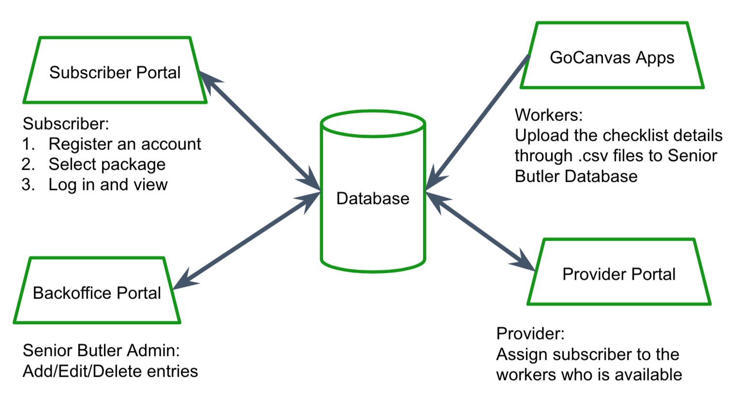

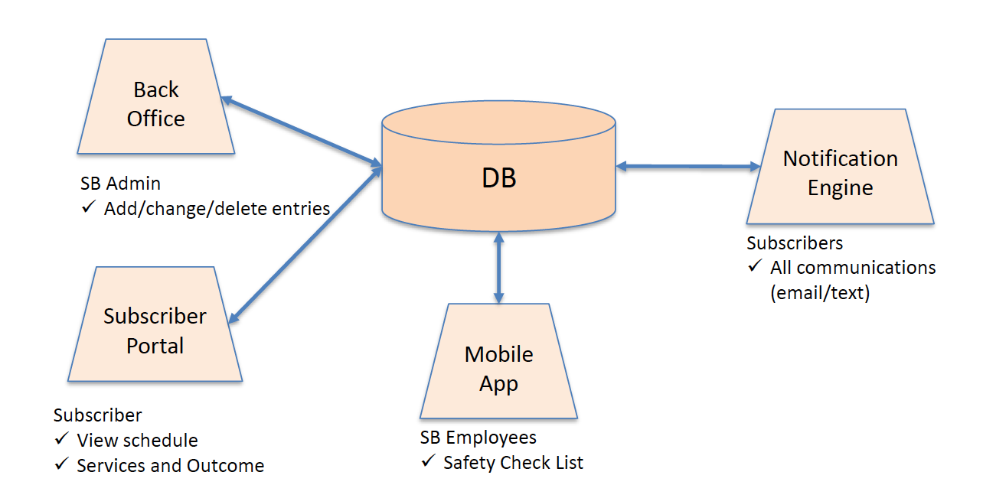

1. **Print Name/Signatures/Date**: **Company mentor, faculty advisor, and each team member should read and agree by signing this document**. **The proposal printed copy will be collected at the beginning of class the day the proposal is due. You should also submit an electronic version (PDF/DOC) through elearning. Make sure to write the full name of each person signing this document**

|  |  |
| --- | --- |
| Chien Chi Liu | Cassidy Hoang |
| Cho Him Ip | Vasanti Dholaria |
| Company Mentor - Robert Andreyka | Faculty Advisor - Jorge Cobb |