Guiquan Li

SID:862083861

Phase 1

In this project, we write the code to make a phaser to check the typing from minijava.

The main java file is Typecheck: which using other java from the typecheck file.

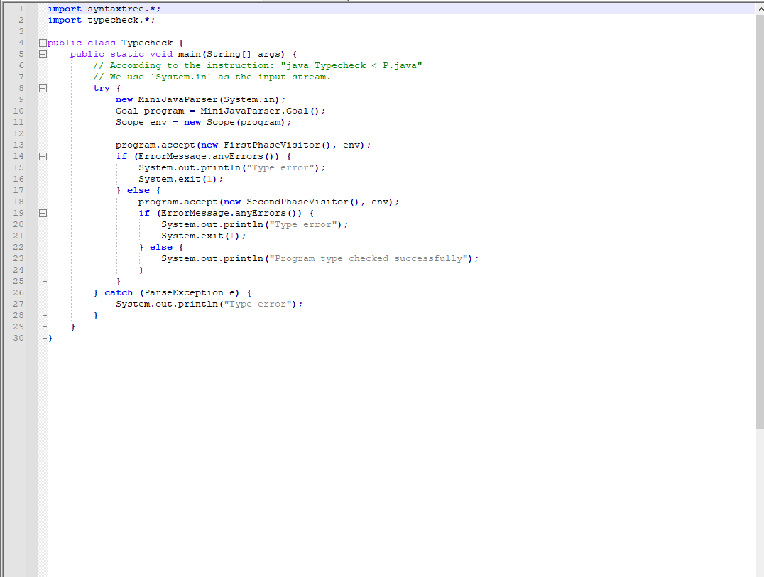

Test Result:

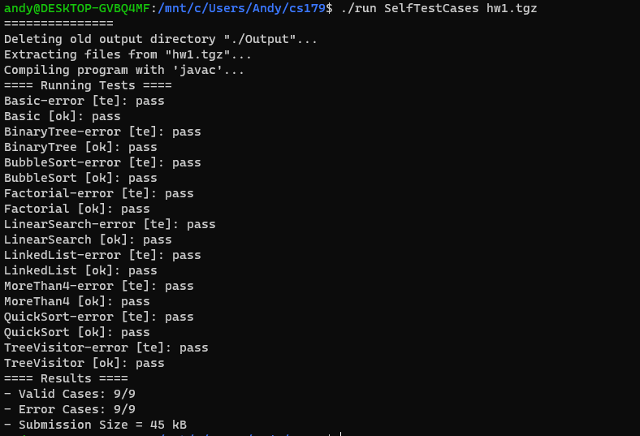

I have code files include:

Binder: get symbol and insert node type to scope

ErrorMessage: output error

ExpressionType: check type

FirstPhaseVisitor: Extend from GJvoidDepthFirst

MethodType: return type and Boolean for methodtype

Scope: set hashmap and parent node.

SecondPhaseVisitor extend GJDepthFirst

SubtypingRelation:

Symbol