**Phase 2: Intermediate Code Generation for Object-oriented Languages**

**J2V.java:**

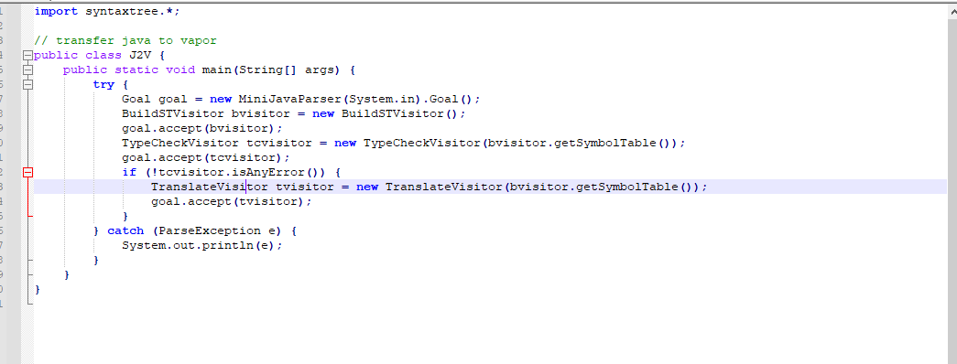

Other java file and purpose:

**BuildSTVisitor.java**: building symbol table

**ErrorMsg.java**: Return false when there is any error

**Printer.java**: print indent and var.

**TranslateVisitor.java**: create vapor file, also get scope and symbol table from symbol files.

**TypeCheckVisitor.java**: type-checking.

Symbol files include :

Class for symbols of classes

Class for Class-Method Pair

Class for methods

parameters symbols

base class for all symbols

final symbol table

local variables symbols

V-Table

**Test Result:**

