Persistance of the value factor in US stock market returns from 1926 to date

Nearly all of the difference in returns between stocks portfolios can be explained with exposure to fundamental factors. The first paper to offer an empirically and theoretically consistent model of stock reurns was “Common risk factors in the returns of stocks and bonds” published in 1992 by Eugene Fama and Kenneth French.
Though an anaysis of historical series of US stocks the authors found that, on average, stocks with small capitalization tend to perform better than large capitalization ones and that “cheap” stocks (low price respect to the actual actual book value) tend to do the same in respect to “growth” stocks (high price to book ratio). This differences, theoretically, find an explanation in the intrinsic risk that these segment of the stock market inherently have, small companies have a higher probability to fail, same as for cheap stocks, in whih the market is pricing in a high degree of uncertainty.

Fama and French came up with a model to predict a stock returns that accounts for the exposure to the market risk, the size risk and Book-to-Market risk and can explain ~95% of the differences between two portoflios returns.

The Value factor has always been persistent historically, with average returns well in excess of the 2market. In the last 10 years however, has underperformed the market heavily, in particular large cap tech growth stocks in the US market. The aim of this small project is to use the historical returns of 4 model portfolios from Kenneth’s French website (https://mba.tuck.dartmouth.edu/pages/faculty/ken.french/Data_Library/six_portfolios.html) built on SmallCap Value stocks, SmallCap Growth stocks, LargeCap Value stocks and LargeCap Growth stocks to estimate the probability of LargeCap Growth stocks (lowest historical return) stocks outperforming SmallCap Value stocks (highest historical return) in the US stock market.

The original dataset contains the monthly returns of 6 portfolios for the following combination of factors:
- 3 Book to Market groups of stocks: Value (<30th percentile Price/Book), Core (30th-70th), Growth (>70th)
- 2 Size groups divided by the median capitalization of US market stocks: LargeCap and SmallCap

As a side note, in the original dataset the P/B is actually B/P but I think the former is more intuitive.
The dataset is the best I could find since the original historical returns for the single stoks and their fundamentals are not publicly available (CRSP dataset). There were no problems with the dataset other that a very annoying formatting that required a couple of steps to a final CSV file.

I calculate the compounded returns of each of the portfolios (leaving out the 2 Core portfolios because they are not informative) for each of the possible 10 year windows obtaining 1010 observations for each of the 4 portfolios. I acknowledge that this problem could have been approached a lot more effectively by using appropriate time-series bayesian models, but those are well beyond the scope an level of the course.

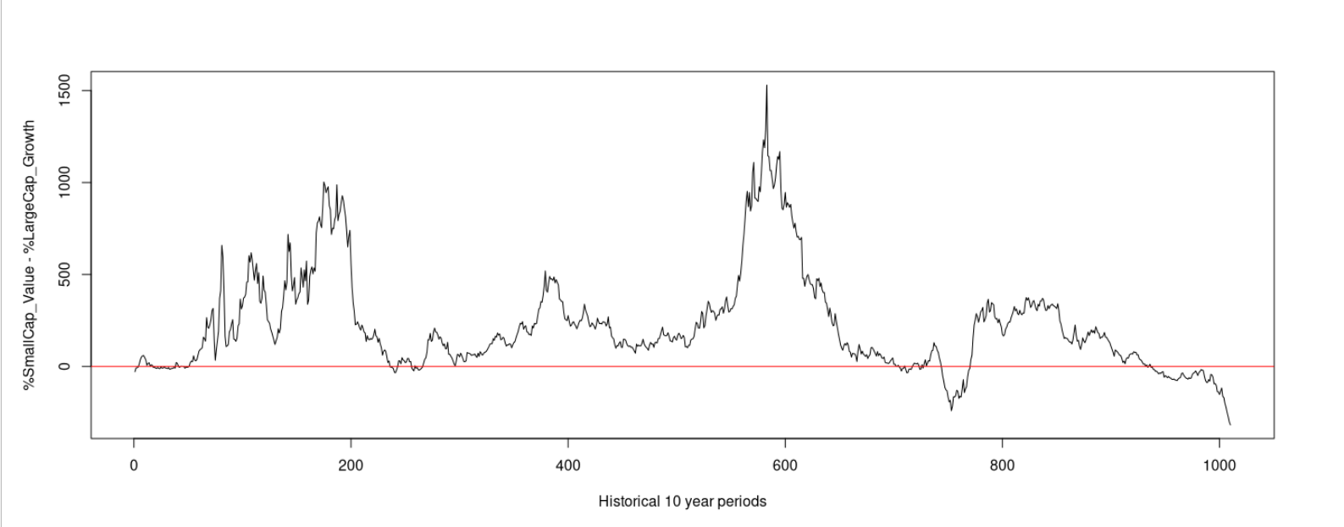

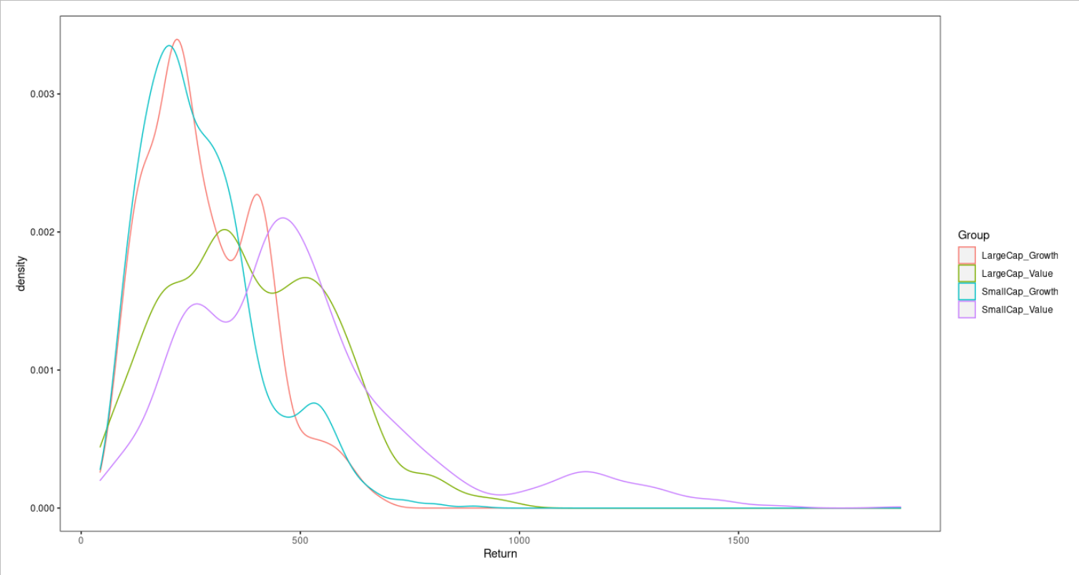

In the returns calculation I compounded an initial capital of 100 euros, to make it easier to generalize to the percentage returns. The nature of the data is based on the return in fixed periods and is strictly positive, for those two reasons the returns follow a gamma distribution, a generalization of the poisson for continuous variables. I decide to make the shape and rate of the gamma distribution dependent from categorical variables for Size and Value (P/B) using two linear model with two separate intercepts b0 and b parameters. The estimation of the b coefficients will tell how strong is the effect of the Size and Value variables on the shape and rate of the gamma distribution and in turn is mean and variance. The intercept b0 represents the dummy variable with Size = LargeCap and Value = Growth, theoretically the portfolio with the lowest historical average returns.

Full hierarchical representation of the model:

Return[i] ~ dgamma(shape[i], rate[i])
shape[i] = b0_s + bs[1]*Size[i] + bs[2]*Value[i]
rate[i] = b0_r + br[1]*Size[i] + br[2]*Value[i]

br[1] ~ dunif(0,1e5)
br[2] ~ dunif(0,1e5)
bs[1] ~ dunif(0,1e5)
bs[2] ~ dunif(0,1e5)
b0_s ~ dunif(0,1e5)
b0_r ~ dunif(0,1e5)

I used uniform priors on the model because I wanted the non informative priors, while constraining the parameters distributions to be strictly positive.

The model diagnostics doesn’t reveal any particular problem, the convergence is seen after 1000 updates and the model was then run for 6000 iterations each for 4 chains. There basically no autocorrelation after lag 1 for the the br/bs coefficients and slightly more persistent autocorrelation for the b0_s/b0_r until lag 4-5. the effective sample sizes are ~2000 for the b0_s/b0_r and >6500 for the br/bs coefficients. The residuals don’t reveal any particular bias other that a heavy tail in the distribution of the SmallCap Value portfolio due to the a single cluster of extremely high returns around 1200 (Fig. 3).

I tried to fit a second model adding an interaction term to both the linear models (br[3] and bs[3]) drawing respectively the shape and rate parameters of the gamma distribution fit on the Returns and this slightly improved the performance of the model (DIC1 = 52920, DIC2 = 52832). I therefore used the second model for subsequent analysis.

Posteriors summary:
Mean SD Naive SE Time-series SE
b0_r 1.039e-02 2.477e-04 1.599e-06 5.952e-06
b0_s 3.069e+00 7.283e-02 4.701e-04 1.649e-03
br[1] 1.378e-04 1.180e-04 7.614e-07 1.481e-06
br[2] 3.184e-05 3.131e-05 2.021e-07 3.512e-07
br[3] 3.943e-05 3.918e-05 2.529e-07 4.353e-07
bs[1] 4.381e-02 3.674e-02 2.371e-04 4.236e-04
bs[2] 8.931e-01 7.507e-02 4.846e-04 1.061e-03
bs[3] 1.055e+00 1.077e-01 6.955e-04 1.424e-03

The mean of the gamma distribution in shape/rate and the variance is shape/rate**2, therefore is clear that the the interaction term drives up the mean of the return for a portfolio exposed to SmallCap Value stocks and being the biggest effect at the numerator. Conversely it has a negligible effect on the rate, which means that SmallCap Value portfolios will have the highest variance. This is all consistent with empirical evidence. Moreover, is interesting to note that the effect of the Value factor is amplified in conjunction with the Size factor, hence the high effect of the interaction term in the shape of the gamma distribution. There is little or no difference in the distribution of the returns for SmallCap Growth or LargeCap Growth but SmallCap Value stocks beat Large Cap Value stocks by a considerable margin. In either case the Value portfolios strongly outperform the Growth portfolios.
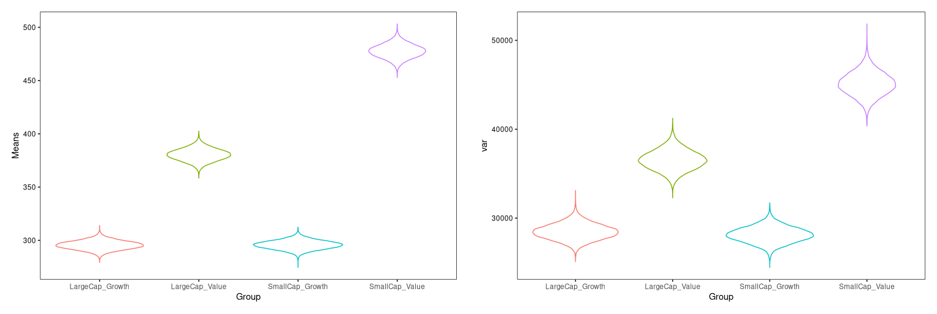

That ha always been the problem with SmallCap Value portfolios, they can trail the market for extended periods of time but they deliver sporadically etremely high returns, because the tail of the gamma distribution spreads further than other portfolios exposed to growth stocks. But is this still true? Is the Value factor still persistent today? Or we should all go against historical evidence and buy only high growth tech stocks that performed so well the last 10 years?

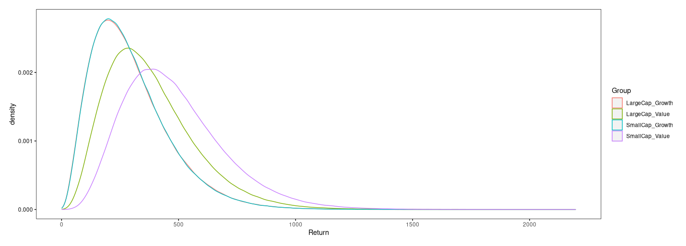

I drew samples from the gamma distributions corresponding to each respective parameter and asked how likely was the SmallCap Value portfolio to perform worse than it has in the last 10 years and the LargeCap Growth to perform better:

- Probability of SmallCap Value > 206.2785 = 0.066693 = 6.67 %
- Probability of SmallCap Value > 524.0584 = 0.098043 = 9.80 %

The observations are not that improbable, they are however on the extremes of their respective distributions. The joint probability of the two events in 0.65 %, very low, but it doesn’t really make sense to look at it since the draws were randomly performed on the respective gamma distribution indipendently. The returns at any given month are definetely not indipendent in the real world hence is safer to look at the probabilities separately.

In conclusion, is not yet the moment to rush towards Growth stocks but is better to keep a tilt in the portfolio towards value, in particular SmallCap Value stocks, knowing very well that they can underperform the market for extended period of times.

