Andy Appeldorn - C13999

Microchip Technology, INC  2355 W Chandler Blvd, Chandler, AZ 85224

SAML10-QT8 Low Power

Contents

Hardware 2

SAML10 XPRO 2

QT8 XPRO Eval Kit 2

System Block Diagram 3

SAML10 Low Power Single Button Demo 4

Active Mode Performance: 4

SAML10 Low Power 2D demo 5

Power Modes 5

Active mode 5

Sleep Mode 5

Active Mode Performance 5

Low Power Performance 6

Lower Power by increasing drift calibration time 8

SAML10 + QT8 1D Sensors w/ low power 10

SAM L10 Family Features 11

ATSAML10 XPRO using QT8 2D Sensor Board

# Hardware

## [SAML10 XPRO](https://www.microchip.com/DevelopmentTools/ProductDetails/dm320204)

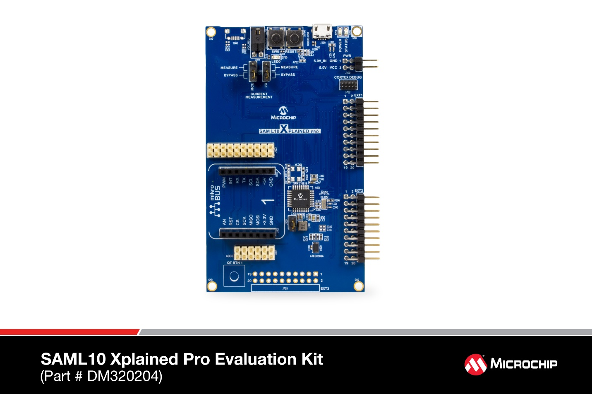

## [QT8 XPRO Eval Kit](https://www.microchip.com/DevelopmentTools/ProductDetails/PartNO/AC164161)

Machine generated alternative text:



## System Block Diagram

Machine generated alternative text:



# SAML10 Low Power Single Button Demo

Hardware: SAML10 XPRO

Running: QTouch-SAML10-XPro-Low-power-Touch-Project from START

Sensor: on XPRO

Using as a reference for lowest possible power consumption of SAML10

## Active Mode Performance:

16MHz POSC, 32.768kHz SOSC

No serial debug enabled

Avg Current: 17.7uA

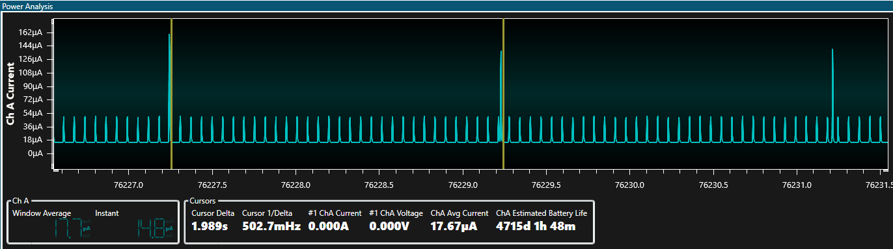

Changed POSC to 4MHz

Avg Current:

# SAML10 Low Power 2D demo

Hardware: SAML10 XPRO and QT8

Running: 2D Touchpad demo w/ low power enabled

Git: <https://bitbucket.microchip.com/scm/~c13999/saml10_qt8_lowpower.git>

Sensor: 5x5 diamond pattern sensor array

## Power Modes

Active mode – Continuous scanning, decoding, and reference calibration.

Sleep Mode – After period of inactivity, enters sleep mode. Sleep mode auto scans all sensor nodes for touch while sleeping. Will periodically wake up CPU to update reference calibration for all nodes to compensate for environmental changes. Lump mode not currently implemented.

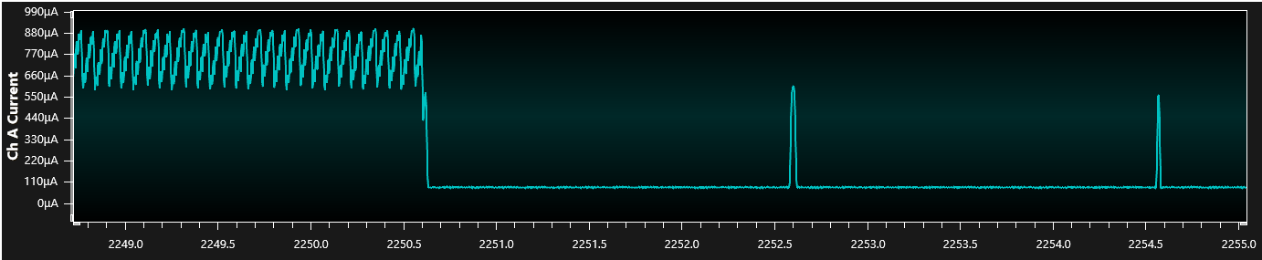

**QTM_AUTOSCAN_TRIGGER_PERIOD** – defines auto scan trigger period, auto scan rate while in sleep

**DEF_TOUCH_DRIFT_PERIOD_MS** – defines drift measurement period, frequency to wake and recalibrate reference values

## Active Mode Performance

16MHz POSC, 32.768kHz SOSC

No serial debug enabled

Avg Current: 759.1uA

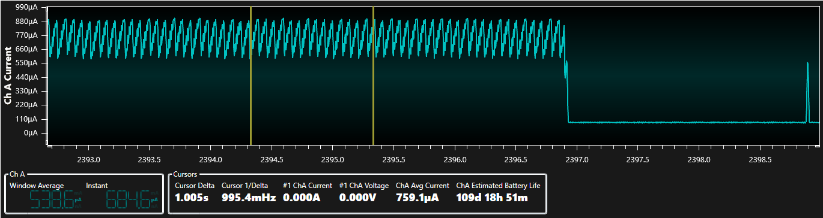

## Low Power Performance

Drift calibration set at 2 seconds

Comms disabled

#define QTM_AUTOSCAN_TRIGGER_PERIOD NODE_SCAN_8MS

Avg current: 86uA

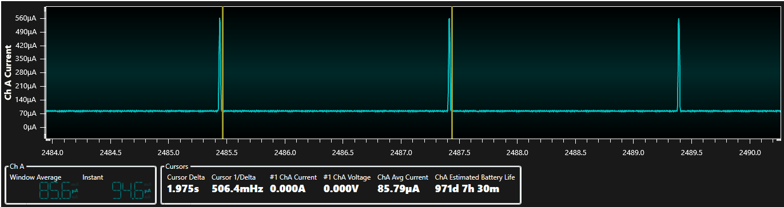

#define QTM_AUTOSCAN_TRIGGER_PERIOD NODE_SCAN_16MS

Avg current: ~54uA

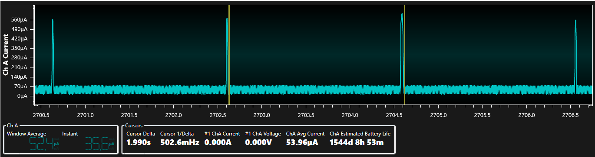

#define QTM_AUTOSCAN_TRIGGER_PERIOD NODE_SCAN_32MS

Avg current: ~32.5uA

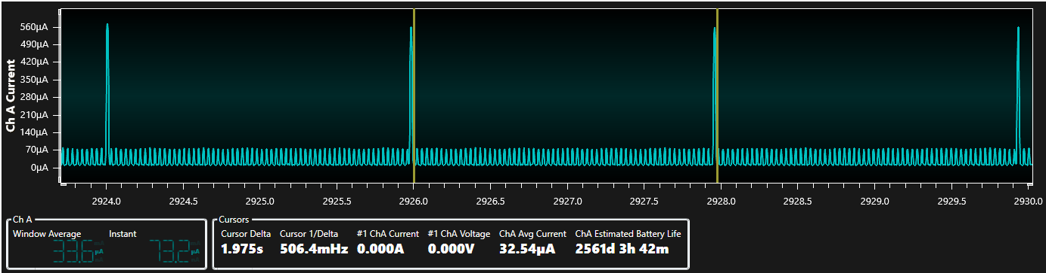

#define QTM_AUTOSCAN_TRIGGER_PERIOD NODE_SCAN_64MS

Avg current: ~23.7uA

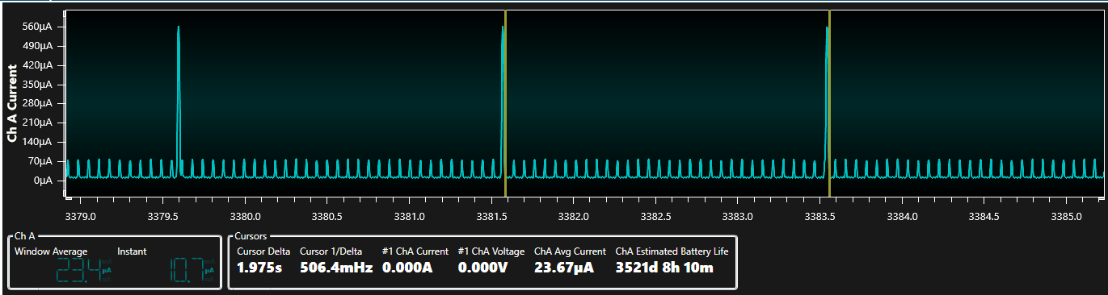

#define QTM_AUTOSCAN_TRIGGER_PERIOD NODE_SCAN_128MS

Avg current: ~19uA

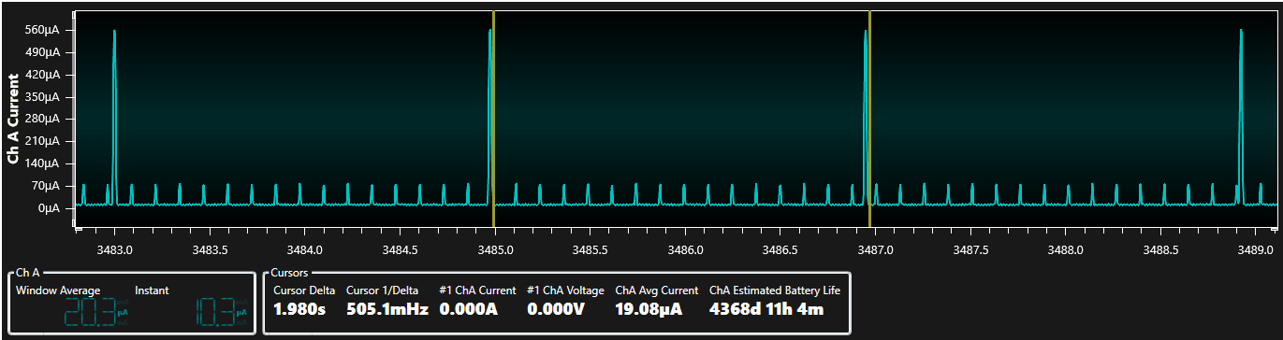

#define QTM_AUTOSCAN_TRIGGER_PERIOD NODE_SCAN_256MS

Avg current: ~17uA

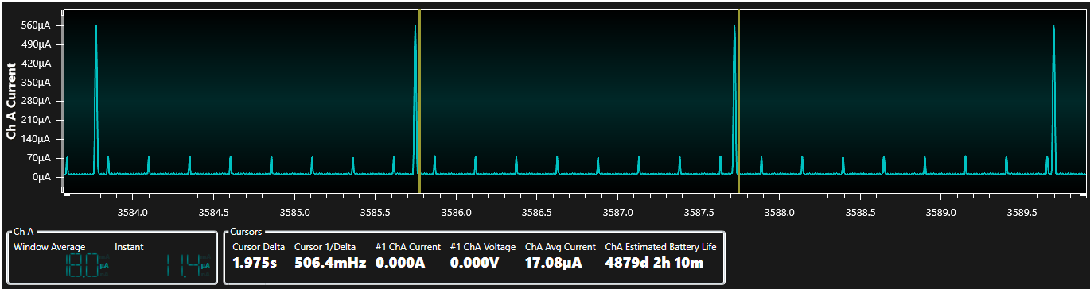

#define QTM_AUTOSCAN_TRIGGER_PERIOD NODE_SCAN_512MS

Avg current: ~16uA

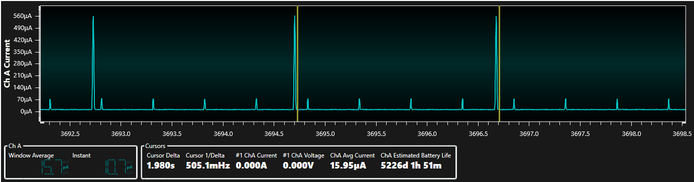

#define QTM_AUTOSCAN_TRIGGER_PERIOD NODE_SCAN_1024MS

Avg current: ~15.3uA

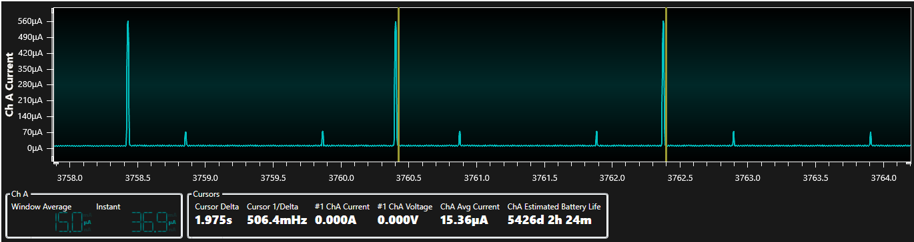

## Lower Power by increasing drift calibration time

All charts taken using:

#define QTM_AUTOSCAN_TRIGGER_PERIOD NODE_SCAN_32MS

#define DEF_TOUCH_DRIFT_PERIOD_MS 1000

Avg current: ~36uA

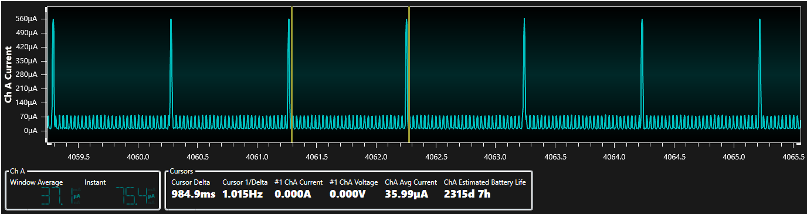

#define DEF_TOUCH_DRIFT_PERIOD_MS 2000

Avg current: ~32.7uA

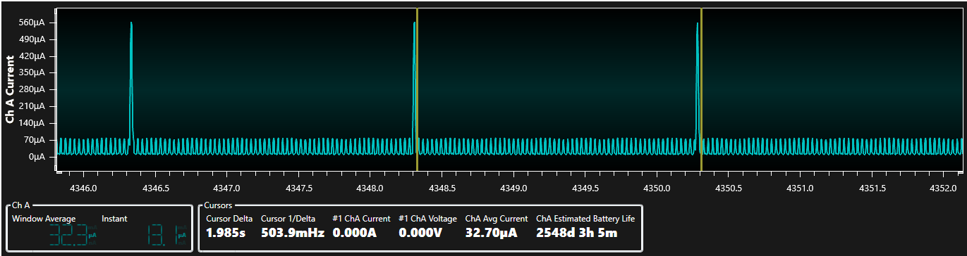

#define DEF_TOUCH_DRIFT_PERIOD_MS 4000

Avg current: ~30.7uA

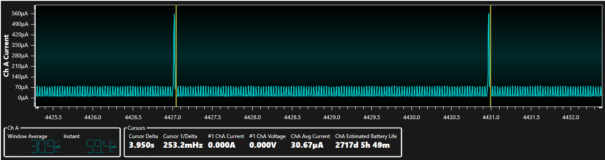

#define DEF_TOUCH_DRIFT_PERIOD_MS 8000

Avg current: ~29.7uA

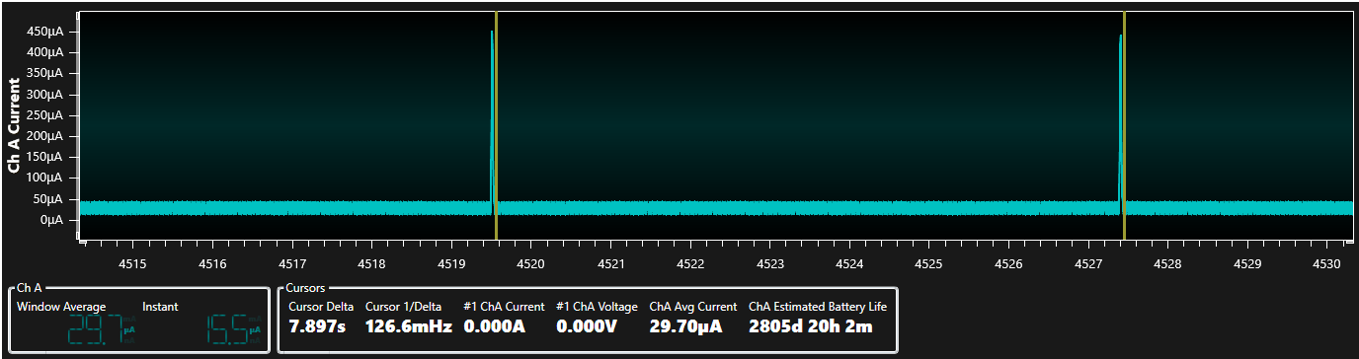

#define DEF_TOUCH_DRIFT_PERIOD_MS 16000

Avg current: ~29.12uA

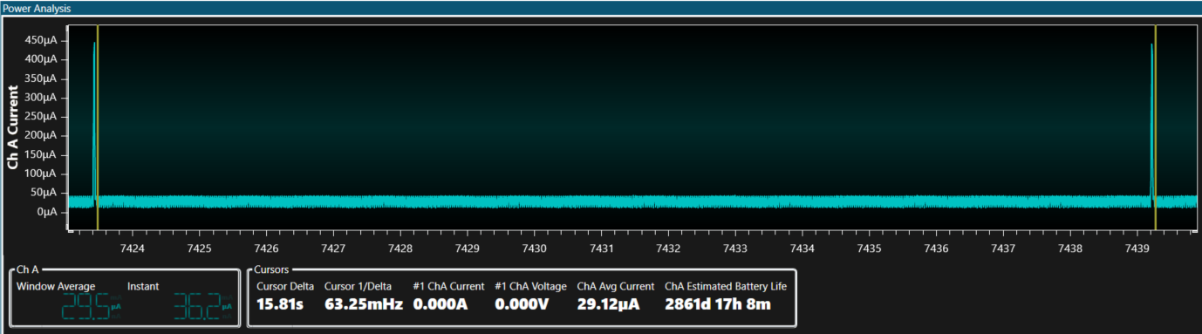

#define DEF_TOUCH_DRIFT_PERIOD_MS 32000

Avg current: ~28.91uA

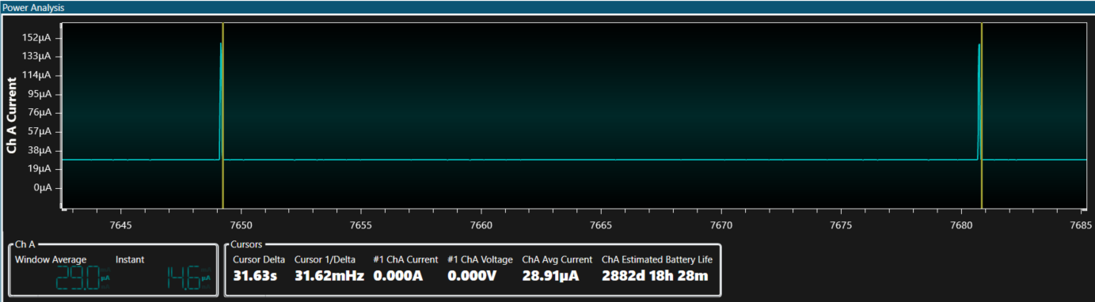

# SAML10 + QT8 1D Sensors w/ low power

Buttons FW – can use START code generator to change clocks

1.8Vdc

16MHz, no sleep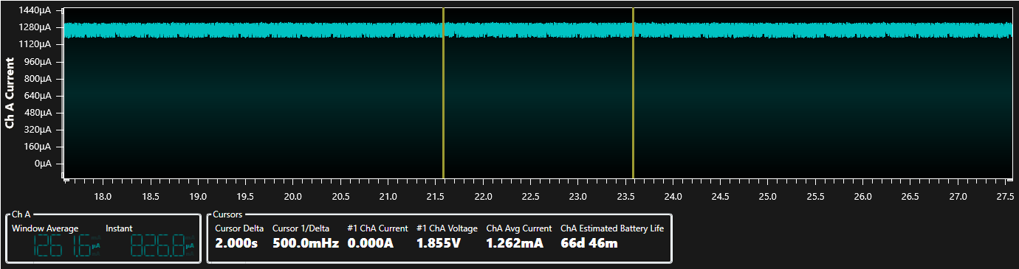

16MHz, sleep, 64mS auto scan

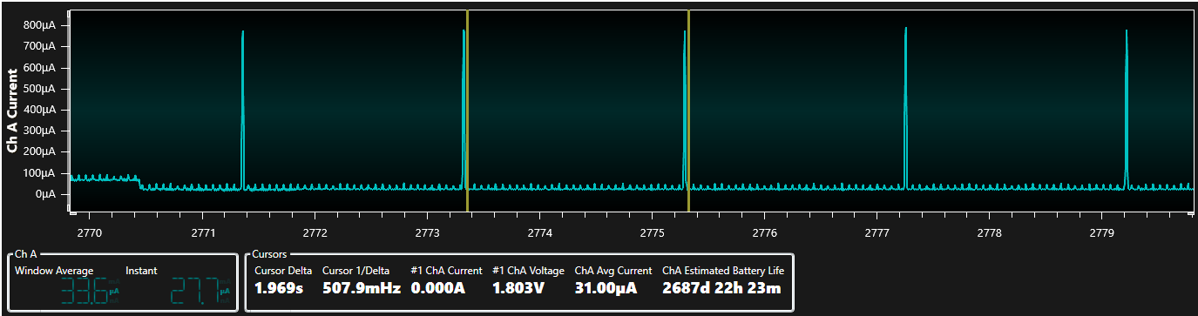

# SAM L10 Family Features

* Operating Conditions: 1.62V to 3.63V, -40ºC to +125ºC, DC to 32 MHz
* Core: 32 MHz (2.64 CoreMark/MHz and up to 31 DMIPS) Arm® Cortex®-M23 with:
  + Single-cycle hardware multiplier
  + Hardware divider
  + Nested Vector Interrupt Controller (NVIC)
  + Memory Protection Unit (MPU)
  + Stack Limit Checking
  + TrustZone® for ARMv8-M (optional)
* System
  + Power-on Reset (POR) and programmable Brown-out Detection (BOD)
  + 8-channel Direct Memory Access Controller (DMAC)
  + 8-channel event system for Inter-peripheral Core-independent Operation
  + CRC-32 generator
* Memory
  + 64/32/16 KB Flash
  + 16/8/4 KB SRAM
  + 2 KB Data Flash Write-While-Read (WWR) section for non-volatile data storage
  + 256 bytes TrustRAM with physical protection features
* Clock Management
  + Flexible clock distribution optimized for low power
  + 32.768 kHz crystal oscillator
  + 32.768 kHz ultra low-power internal RC oscillator
  + 0.4 to 32 MHz crystal oscillator
  + 16/12/8/4 MHz low-power internal RC oscillator
  + Ultra low-power digital Frequency-Locked Loop (DFLLULP)
  + 32-96 MHz fractional digital Phase-Locked Loop (FDPLL96M)
  + One frequency meter
* Low-Power and Power Management
  + Active, Idle, Standby with partial or full SRAM retention and off sleep modes:
    - Active mode (< 25 μA/MHz)
    - Idle mode (< 10 μA/MHz) with 1.5 μs wake-up time
    - Standby with Full SRAM Retention (0.5 μA) with 5.3 μs wake-up time
    - Off mode (< 100 nA)
  + Static and dynamic power gating architecture
  + Sleepwalking peripherals
  + Two performance levels
  + Embedded Buck/LDO regulator with on-the-fly selection
* Advanced Analog and Touch
  + One 12-bit 1 Msps Analog-to-Digital Converter (ADC) with up to 10 channels
  + Two Analog Comparators (AC) with window compare function
  + One 10-bit 350 kSPS Digital-to-Analog Converter (DAC) with external and internal outputs
  + Three Operational Amplifiers (OPAMP)
  + One enhanced Peripheral Touch Controller (PTC):
    - Up to 20 self-capacitance channels
    - Up to 100 (10 x 10) mutual-capacitance channels
    - Low-power, high-sensitivity, environmentally robust capacitive touch buttons, sliders, and wheels
    - Hardware noise filtering and noise signal desynchronization for high conducted immunity
    - Driven Shield Plus for better noise immunity and moisture tolerance
    - Parallel Acquisition through Polarity control
    - Supports wake-up on touch from Standby Sleep mode
* Packaging
  + 24-pin VQFN – 4x4mm, .85mm tall
  + 32-pin VQFN – 5x5mm, .85mm tall