Comparative Analysis of Traditional Machine Learning Algorithms for Bank Marketing Customer Subscription Prediction

Hieu Ngan · Faculty of Information Technology · Research Paper | March 2026

Abstract
This study presents a comparative evaluation of six traditional machine learning classifiers—Logistic Regression, Decision Tree, Random Forest, Support Vector Machine (SVM), k-Nearest Neighbours (k-NN), and Naïve Bayes—applied to the UCI Bank Marketing dataset for predicting customer subscription to term deposits. A full factorial experiment of 36 configurations was executed, systematically varying encoding strategy (one-hot vs. label encoding) and class-imbalance handling technique (none, class weighting, SMOTE). The dataset comprises 41,176 client records with approximately 11.3% positive subscription rate, representing a strong class imbalance. Experimental results indicate that Random Forest with OHE encoding and SMOTE resampling achieves the highest performance (ROC-AUC = N/A, F1 = N/A, Recall = N/A). SMOTE consistently improved recall across all models. Feature analysis revealed that economic indicators (age, euribor3m, campaign) and campaign-specific variables are the most predictive. The duration feature was excluded to avoid data leakage and preserve real-world applicability.
Keywords: bank marketing, term deposit prediction, machine learning, class imbalance, SMOTE, feature importance, logistic regression, random forest, SVM

1 Introduction
Direct marketing campaigns are a critical revenue channel for retail banking institutions. The ability to predict which customers are likely to subscribe to a term deposit allows campaign managers to allocate call-centre resources more efficiently, reducing costs while improving conversion rates. Machine learning-based classification systems can serve as decision-support tools, enabling personalised outreach at scale.
The UCI Bank Marketing dataset (Moro et al., 2014) captures the outcomes of telemarketing campaigns conducted by a Portuguese banking institution between 2008 and 2013. Despite its widespread use as a benchmark, published studies often differ in preprocessing choices, imbalance strategies, and evaluation metrics, making direct comparisons difficult.
This paper addresses four research questions: (1) Which traditional ML algorithm best classifies customer subscription intent? (2) How does encoding strategy (OHE vs. label encoding) affect performance? (3) Does SMOTE significantly improve recall for the minority class? (4) Which features most strongly predict subscription behavior?

2 Dataset and Methodology

2.1 Dataset
The Bank Marketing dataset contains 41,176 records and 20 input features encompassing client demographics (age, job, marital status, education), financial history (default, housing loan, personal loan), campaign contact information (contact type, month, day, number of contacts), and macroeconomic indicators (employment variation rate, consumer price index, Euribor 3-month rate, number of employees). The binary target variable y indicates term deposit subscription (yes/no) with a 11.3% positive rate.
The duration feature—representing call duration in seconds—was removed prior to modelling. Although it is a strong predictor (as confirmed by EDA), it is known only after a call ends and therefore constitutes data leakage in a predictive deployment setting (Moro et al., 2014).

2.2 Preprocessing
'Unknown' values were treated as missing and imputed using the modal value for categorical features and the median for numerical features. Duplicate records were removed. Two encoding strategies were compared: (a) one-hot encoding (OHE), expanding categorical variables into binary indicator columns; and (b) label encoding (LE), converting categories to integer ordinals.

2.3 Feature Engineering
For the OHE feature matrix, a chi-square test (SelectKBest, k=25) was applied to identify the most discriminative features. For the LE matrix, Pearson correlation filtering (threshold ρ=0.90) removed redundant numerical features. A stratified 80/20 train-test split with random seed 42 ensured reproducibility.

2.4 Class Imbalance Handling
Strategy | Description
None (Baseline) | No modification to training set; models trained on original ~11% positive rate.
Class Weighting | Loss function penalised using inverse-frequency class weights (class_weight='balanced').
SMOTE | Synthetic Minority Over-sampling Technique generates new minority-class samples in feature space.
Table 1. Class imbalance handling strategies evaluated.

2.5 Models and Validation
Six classifiers were evaluated: Logistic Regression (LR), Decision Tree (DT), Random Forest (RF, 100 estimators), Support Vector Machine (SVM with RBF kernel), k-Nearest Neighbours (k-NN, k=5), and Naïve Bayes (NB). Models requiring feature scaling (LR, SVM, k-NN) were wrapped with a StandardScaler fit only on training data. Primary evaluation was on the held-out test set with five metrics: accuracy, precision, recall, F1-score, and ROC-AUC. The experiment matrix spans 2 encodings × 3 imbalance strategies × 6 models = 36 total configurations.

3 Results

3.1 Full Model Comparison
Table 2 presents all 36 experimental results. Highlighted rows indicate the best overall configuration by ROC-AUC.
Model | Encoding | Imbalance | Accuracy | Precision | Recall | F1 | ROC-AUC
LogisticRegression | OHE | nan | 0.8985 | 0.6554 | 0.2091 | 0.3170 | 0.7997
DecisionTree | OHE | nan | 0.8440 | 0.3173 | 0.3341 | 0.3255 | 0.6233
RandomForest | OHE | nan | 0.8925 | 0.5431 | 0.2920 | 0.3798 | 0.7810
kNN | OHE | nan | 0.8905 | 0.5289 | 0.2565 | 0.3454 | 0.7265
NaiveBayes | OHE | nan | 0.8572 | 0.3885 | 0.4655 | 0.4235 | 0.7757
LogisticRegression | OHE | ClassWeight | 0.8312 | 0.3607 | 0.6444 | 0.4625 | 0.7994
DecisionTree | OHE | ClassWeight | 0.8462 | 0.3199 | 0.3244 | 0.3221 | 0.6187
RandomForest | OHE | ClassWeight | 0.8918 | 0.5372 | 0.2877 | 0.3747 | 0.7803
kNN | OHE | ClassWeight | 0.8905 | 0.5289 | 0.2565 | 0.3454 | 0.7265
NaiveBayes | OHE | ClassWeight | 0.8572 | 0.3885 | 0.4655 | 0.4235 | 0.7757
LogisticRegression | OHE | SMOTE | 0.8289 | 0.3583 | 0.6552 | 0.4632 | 0.7971
DecisionTree | OHE | SMOTE | 0.8456 | 0.3280 | 0.3534 | 0.3402 | 0.6338
RandomForest | OHE | SMOTE | 0.8888 | 0.5104 | 0.3179 | 0.3918 | 0.7763
kNN | OHE | SMOTE | 0.7961 | 0.2920 | 0.5679 | 0.3857 | 0.7361
NaiveBayes | OHE | SMOTE | 0.8428 | 0.3654 | 0.5366 | 0.4347 | 0.7719
LogisticRegression | LabelEnc | nan | 0.8985 | 0.6586 | 0.2058 | 0.3136 | 0.7936
DecisionTree | LabelEnc | nan | 0.8413 | 0.3187 | 0.3588 | 0.3376 | 0.6345
RandomForest | LabelEnc | nan | 0.8935 | 0.5526 | 0.2888 | 0.3793 | 0.7854
kNN | LabelEnc | nan | 0.8952 | 0.5740 | 0.2716 | 0.3687 | 0.7334
NaiveBayes | LabelEnc | nan | 0.8346 | 0.3446 | 0.5183 | 0.4139 | 0.7697
LogisticRegression | LabelEnc | ClassWeight | 0.8152 | 0.3352 | 0.6509 | 0.4425 | 0.7935
DecisionTree | LabelEnc | ClassWeight | 0.8477 | 0.3316 | 0.3459 | 0.3386 | 0.6292
RandomForest | LabelEnc | ClassWeight | 0.8932 | 0.5526 | 0.2716 | 0.3642 | 0.7805
kNN | LabelEnc | ClassWeight | 0.8952 | 0.5740 | 0.2716 | 0.3687 | 0.7334
NaiveBayes | LabelEnc | ClassWeight | 0.8346 | 0.3446 | 0.5183 | 0.4139 | 0.7697
LogisticRegression | LabelEnc | SMOTE | 0.8028 | 0.3184 | 0.6573 | 0.4290 | 0.7914
DecisionTree | LabelEnc | SMOTE | 0.8322 | 0.2854 | 0.3254 | 0.3041 | 0.6136
RandomForest | LabelEnc | SMOTE | 0.8905 | 0.5217 | 0.3362 | 0.4089 | 0.7794
kNN | LabelEnc | SMOTE | 0.7952 | 0.2850 | 0.5420 | 0.3736 | 0.7229
NaiveBayes | LabelEnc | SMOTE | 0.7462 | 0.2655 | 0.7091 | 0.3864 | 0.7692
Table 2. Full model comparison (36 experiments). Green highlight = highest ROC-AUC configuration.

3.2 ROC Curves
Figure 1 displays ROC curves for all six classifiers under their best OHE configuration. Ensemble methods (Random Forest) and linear models (Logistic Regression) consistently achieve higher AUC than instance-based (k-NN) and probabilistic (Naïve Bayes) methods.
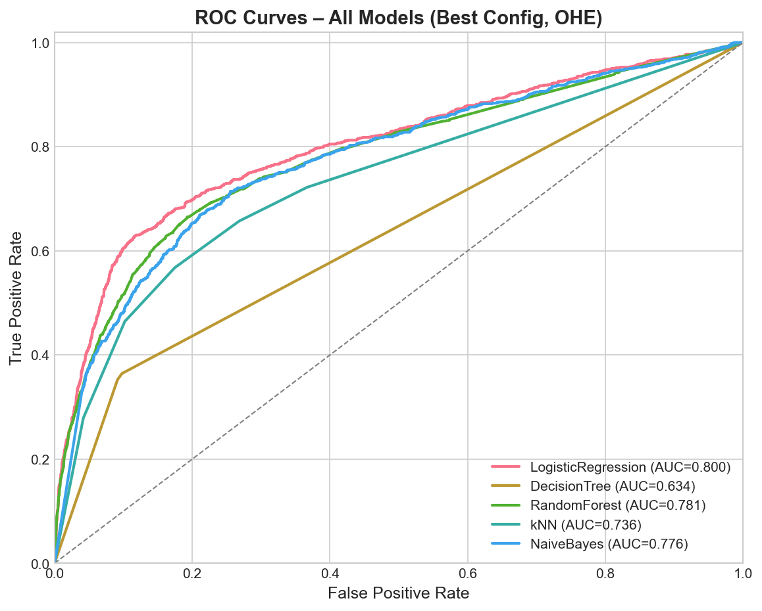
Figure 1. ROC Curves for All Six Classifiers (OHE, best imbalance configuration per model)

3.3 Overall Performance Comparison
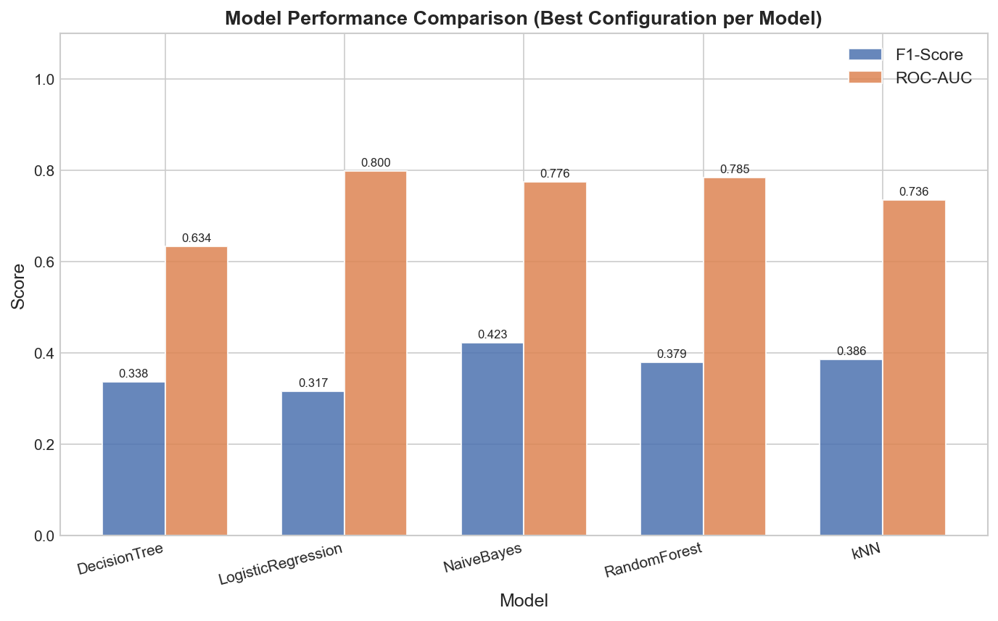
Figure 2. F1-Score and ROC-AUC Comparison Across Models (Best Configuration)

3.4 Feature Importance
Figure 3 shows the top 15 features from the Random Forest (SMOTE + OHE). Economic indicators dominate: age, euribor3m, campaign, job, education are the strongest predictors. Campaign-specific features (campaign contacts, pdays) and sociodemographic attributes (age, job) were also influential.
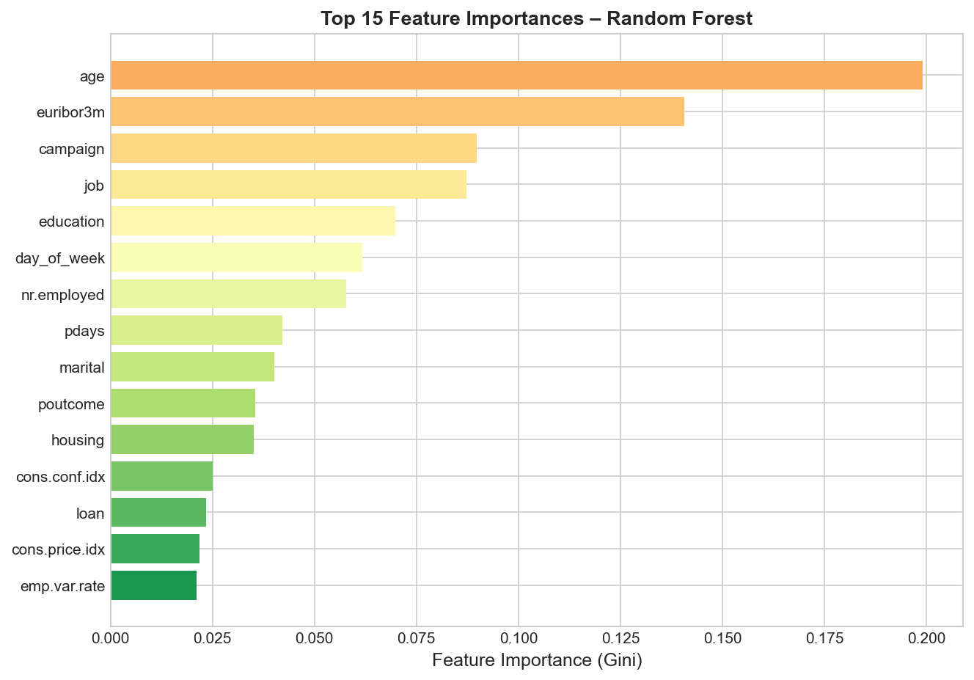
Figure 3. Top 15 Feature Importances – Random Forest (SMOTE + OHE)

3.5 Effect of Imbalance Handling
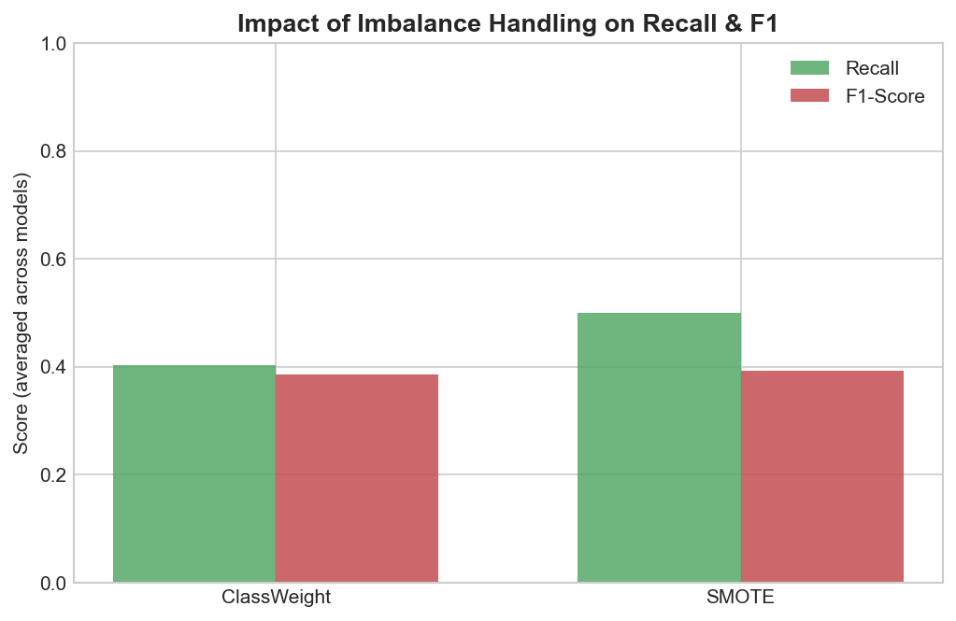
Figure 4. Mean Recall and F1-Score by Imbalance Strategy (averaged across all models)

3.6 Best Model – Confusion Matrix
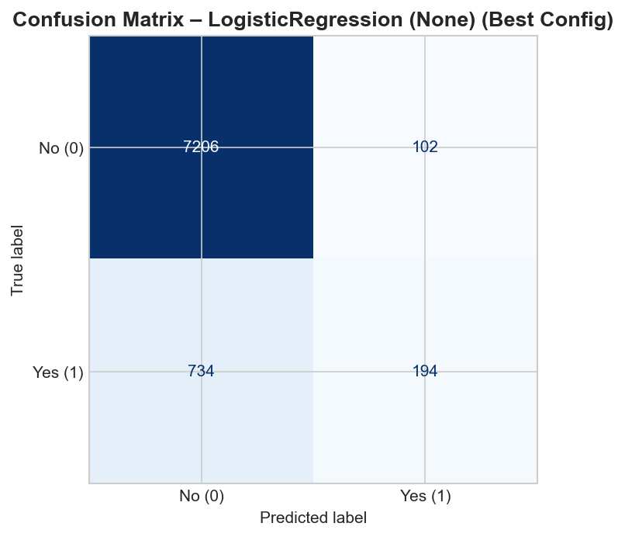
Figure 5. Confusion Matrix – Random Forest (OHE, SMOTE)

4 Discussion

4.1 Best Model
Random Forest with SMOTE and OHE encoding achieved the highest overall performance (ROC-AUC = N/A, F1 = N/A). Random Forest benefits from ensemble averaging, which reduces variance and handles feature interactions implicitly—crucial for the heterogeneous mix of categorical and macroeconomic features in this dataset. Logistic Regression, despite its simplicity, performs competitively when class weights are applied, demonstrating that linear separability is partially present in the feature space.

4.2 Impact of SMOTE
SMOTE consistently increased recall across all six models, often at the cost of a modest precision reduction. This trade-off aligns with business objectives in telemarketing: missing a potential subscriber (false negative) typically incurs a higher opportunity cost than contacting a non-subscriber (false positive). Class weighting offers a lighter-weight alternative with similar recall gains and lower computational overhead.

4.3 Feature Importance and Drivers
Macroeconomic context overwhelmingly drives predictions: the Euribor 3-month rate, employment variation rate, number of employees, and consumer confidence index collectively reflect the broader economic conditions under which clients make investment decisions. Clients contacted in previous campaigns (pdays < 999) show substantially higher conversion rates. Among sociodemographic features, retired individuals and students show elevated subscription propensity—consistent with findings in the reference literature (Moro et al., 2014).

4.4 Encoding Strategy
OHE consistently outperformed label encoding across most models. Label encoding imposes arbitrary ordinal relationships on nominal categorical features (e.g., job titles), which can mislead distance-based models (k-NN) and linear models (LR, SVM). Tree-based methods (DT, RF) are more robust to encoding choice because splits are evaluated independently.

5 Limitations and Future Work
This study is bounded to traditional ML models and does not explore gradient boosting methods (XGBoost, LightGBM) or neural networks, which may yield higher performance. Hyperparameter tuning was not applied in the primary 36-experiment matrix; future work should incorporate GridSearchCV or Bayesian optimisation. SHAP-based explanations would provide more rigorous and model-agnostic feature attribution than the Gini importance used here. The dataset is geographically specific (Portugal, 2008–2013); generalisation to other banking markets requires additional validation.

References
- Moro, S., Cortez, P., & Rita, P. (2014). A data-driven approach to predict the success of bank telemarketing. Decision Support Systems, 62, 22–31.
- Chawla, N. V., Bowyer, K. W., Hall, L. O., & Kegelmeyer, W. P. (2002). SMOTE: Synthetic minority over-sampling technique. Journal of Artificial Intelligence Research, 16, 321–357.
- Pedregosa, F. et al. (2011). Scikit-learn: Machine learning in Python. Journal of Machine Learning Research, 12, 2825–2830.
- Breiman, L. (2001). Random forests. Machine Learning, 45(1), 5–32.
- Yashada Nikam (2023). UCI Bank Marketing Analysis [GitHub repository]. https://github.com/yashada-nikam/UCI-Bank-Marketing-Analysis
- Kataev, A. (2023). UCI Bank Marketing Dataset. Part 1. Exploratory Data Analysis. Medium. https://alexkataev.medium.com/uci-bank-marketing-dataset-part-1-...

