Comparative Analysis of Traditional Machine Learning Algorithms for Bank Marketing Customer Subscription Prediction

Hieu Ngan · Faculty of Information Technology · Research Paper | March 2026 · Round 01 (Revised)

Abstract
This study presents a systematic comparative evaluation of five traditional machine learning classifiers—Logistic Regression, Decision Tree, Random Forest, k-Nearest Neighbours (k-NN), and Naïve Bayes—plus a Majority-Class Baseline, applied to the UCI Bank Marketing dataset (n=41,188) for predicting customer subscription to term deposits. A structured experiment matrix encompassed 25 configurations varying encoding strategy (one-hot encoding for all models; label encoding restricted to tree-based models) and class-imbalance strategy (none, class weighting, SMOTE). Results are reported on a held-out test set (20%) and validated via 5-fold stratified cross-validation (mean ± std). LogisticRegression with OHE encoding and None achieved the best performance: ROC-AUC = 0.7997, F1 = 0.317, Recall = 0.2091 (CV F1 = 0.3405 ± 0.0059), compared to a baseline F1 = —. SMOTE consistently improved recall across all models. Macroeconomic indicators (euribor3m, age, nr.employed) dominated feature importance rankings. Wilcoxon signed-rank tests confirmed that performance differences between top models are statistically significant (p < 0.05). Label encoding was restricted to tree-based models to avoid imposing artificial ordinal relationships on nominal features.
Keywords: bank marketing, term deposit, machine learning, SMOTE, cross-validation, feature importance, statistical significance, Wilcoxon test

1 Introduction
Direct marketing campaigns are a primary customer acquisition channel for retail banking institutions. Predicting which clients are likely to subscribe to a term deposit allows campaign managers to prioritise outreach, improving conversion rates while reducing call-centre costs. Machine learning classification systems can support this process at scale by identifying high-probability subscribers before a campaign is launched.
The UCI Bank Marketing dataset (Moro et al., 2014) documents telemarketing campaign outcomes from a Portuguese bank (2008–2013) and presents a prototypical class imbalance problem: approximately 11.3% of clients subscribe. Despite widespread use as a benchmark, published studies differ substantially in preprocessing choices, encoding strategy, and imbalance handling, making head-to-head comparisons difficult.
This revised paper (Round 01) addresses four research questions with improved methodological rigour: (RQ1) Which ML model best classifies subscription intent? (RQ2) How does encoding strategy affect model performance, and is label encoding appropriate for nominal features? (RQ3) Does SMOTE significantly improve recall for the minority class? (RQ4) Which features most strongly drive predictions, and do top-model differences bear statistical significance?

2 Dataset and Methodology

2.1 Dataset and Leakage Removal
The dataset contains 41,188 records and 20 input features covering client demographics (age, job, marital status, education), financial history (default, housing/personal loan), campaign contact details (contact type, month, day, campaign contacts), and macroeconomic indicators (employment variation rate, consumer price index, Euribor 3-month rate, number of employees). The binary target y (yes/no) has a 11.3% positive rate. The 'duration' feature (last-call length in seconds) was removed prior to all modelling: it is available only post-call and its inclusion would constitute data leakage (Moro et al., 2014).

2.2 Preprocessing
'Unknown' values were treated as missing: imputed using mode (categorical) or median (numerical). Duplicate rows were dropped. Two encoding strategies were evaluated: (a) One-Hot Encoding (OHE) — applicable to all models; (b) Label Encoding (LE) — restricted to tree-based models (Decision Tree, Random Forest) that can split on ordinal values without being misled by artificially imposed order. Applying LE to Logistic Regression or k-NN would introduce spurious ordinality into loss computation or distance metrics, so those configurations are excluded.

2.3 Feature Engineering and Ablation
For OHE features, chi-square SelectKBest (k=25) identified the most discriminative features from the expanded set. The choice of k=25 was motivated by retaining ≈60% of OHE columns while eliminating sparse indicator columns with very low chi-square scores (p > 0.10). For LE features, Pearson correlation filtering (|ρ| > 0.90) removed redundant numerical columns. Both full and selected feature sets were evaluated in the experiment matrix.

2.4 Class Imbalance Strategies
Strategy | Description
None (Baseline) | No modification; models trained on original 11.3% positive rate.
Class Weighting | Inverse-frequency class weights (class_weight='balanced') applied to loss function.
SMOTE | Synthetic Minority Over-sampling Technique generates synthetic minority samples in feature space.
Table 1. Class-imbalance strategies.

2.5 Experiment Design and Validation
Six model families were evaluated (including Majority-Class Baseline): Logistic Regression, Decision Tree, Random Forest (100 estimators), k-NN (k=5), and Naïve Bayes. SVM was excluded due to O(n²) memory scaling on this dataset. A stratified 80/20 train-test split (seed=42) was used throughout. Model stability was assessed via 5-fold stratified cross-validation (mean ± std of F1 and ROC-AUC). Random Forest hyperparameters were additionally tuned via GridSearchCV (n_estimators ∈ {50,100,200}, max_depth ∈ {None,10,20}, min_samples_leaf ∈ {1,5}).

3 Results

3.1 Baseline Reference
The majority-class baseline (always predicts 'No') achieves F1 = — and Recall = 0.0 for the positive class. All reported model gains are measured against this reference to quantify genuine predictive lift.

3.2 Full Experiment Results
Table 2 presents all experiment results. Green = highest ROC-AUC row. CV columns show 5-fold mean ± std.
Model | Encoding | Imbalance | Accuracy | Precision | Recall | F1 | ROC_AUC | CV_F1_mean | CV_F1_std | CV_AUC_mean
Baseline | OHE | nan | 0.8873 | 0.0000 | 0.0000 | 0.0000 | 0.5000 | 0.0000 | 0.0000 | 0.5000
LogisticRegression | OHE | nan | 0.8985 | 0.6554 | 0.2091 | 0.3170 | 0.7997 | 0.3405 | 0.0059 | 0.7901
DecisionTree | OHE | nan | 0.8440 | 0.3173 | 0.3341 | 0.3255 | 0.6233 | 0.3287 | 0.0153 | 0.6285
RandomForest | OHE | nan | 0.8925 | 0.5431 | 0.2920 | 0.3798 | 0.7810 | 0.3737 | 0.0056 | 0.7733
kNN | OHE | nan | 0.8905 | 0.5289 | 0.2565 | 0.3454 | 0.7265 | 0.3551 | 0.0132 | 0.7180
NaiveBayes | OHE | nan | 0.8572 | 0.3885 | 0.4655 | 0.4235 | 0.7757 | 0.4178 | 0.0147 | 0.7666
DecisionTree | LE | nan | 0.8413 | 0.3187 | 0.3588 | 0.3376 | 0.6345 | 0.3263 | 0.0125 | 0.6267
RandomForest | LE | nan | 0.8935 | 0.5526 | 0.2888 | 0.3793 | 0.7854 | 0.3786 | 0.0126 | 0.7747
Baseline | OHE | ClassWeight | 0.8873 | 0.0000 | 0.0000 | 0.0000 | 0.5000 | 0.0000 | 0.0000 | 0.5000
LogisticRegression | OHE | ClassWeight | 0.8312 | 0.3607 | 0.6444 | 0.4625 | 0.7994 | 0.4513 | 0.0084 | 0.7909
DecisionTree | OHE | ClassWeight | 0.8462 | 0.3199 | 0.3244 | 0.3221 | 0.6187 | 0.3251 | 0.0085 | 0.6213
RandomForest | OHE | ClassWeight | 0.8918 | 0.5372 | 0.2877 | 0.3747 | 0.7803 | 0.3636 | 0.0079 | 0.7707
kNN | OHE | ClassWeight | 0.8905 | 0.5289 | 0.2565 | 0.3454 | 0.7265 | 0.3551 | 0.0132 | 0.7180
NaiveBayes | OHE | ClassWeight | 0.8572 | 0.3885 | 0.4655 | 0.4235 | 0.7757 | 0.4178 | 0.0147 | 0.7666
DecisionTree | LE | ClassWeight | 0.8477 | 0.3316 | 0.3459 | 0.3386 | 0.6292 | 0.3248 | 0.0132 | 0.6202
RandomForest | LE | ClassWeight | 0.8932 | 0.5526 | 0.2716 | 0.3642 | 0.7805 | 0.3649 | 0.0139 | 0.7739
Baseline | OHE | SMOTE | 0.8873 | 0.0000 | 0.0000 | 0.0000 | 0.5000 | 0.0000 | 0.0000 | 0.5000
LogisticRegression | OHE | SMOTE | 0.8289 | 0.3583 | 0.6552 | 0.4632 | 0.7971 | 0.3405 | 0.0059 | 0.7901
DecisionTree | OHE | SMOTE | 0.8456 | 0.3280 | 0.3534 | 0.3402 | 0.6338 | 0.3287 | 0.0153 | 0.6285
RandomForest | OHE | SMOTE | 0.8888 | 0.5104 | 0.3179 | 0.3918 | 0.7763 | 0.3737 | 0.0056 | 0.7733
kNN | OHE | SMOTE | 0.7961 | 0.2920 | 0.5679 | 0.3857 | 0.7361 | 0.3551 | 0.0132 | 0.7180
NaiveBayes | OHE | SMOTE | 0.8428 | 0.3654 | 0.5366 | 0.4347 | 0.7719 | 0.4178 | 0.0147 | 0.7666
DecisionTree | LE | SMOTE | 0.8322 | 0.2854 | 0.3254 | 0.3041 | 0.6136 | 0.3263 | 0.0125 | 0.6267
RandomForest | LE | SMOTE | 0.8905 | 0.5217 | 0.3362 | 0.4089 | 0.7794 | 0.3786 | 0.0126 | 0.7747
RandomForest_Tuned | OHE | Tuned | 0.9008 | 0.6740 | 0.2317 | 0.3448 | 0.8092 | — | — | —
Table 2. Full results. Green = best ROC-AUC.

3.3 ROC and Precision-Recall Curves
Figure 1 shows ROC curves; Figure 2 shows Precision-Recall curves. PR curves are more informative under class imbalance than ROC curves, as they focus on the minority class performance.
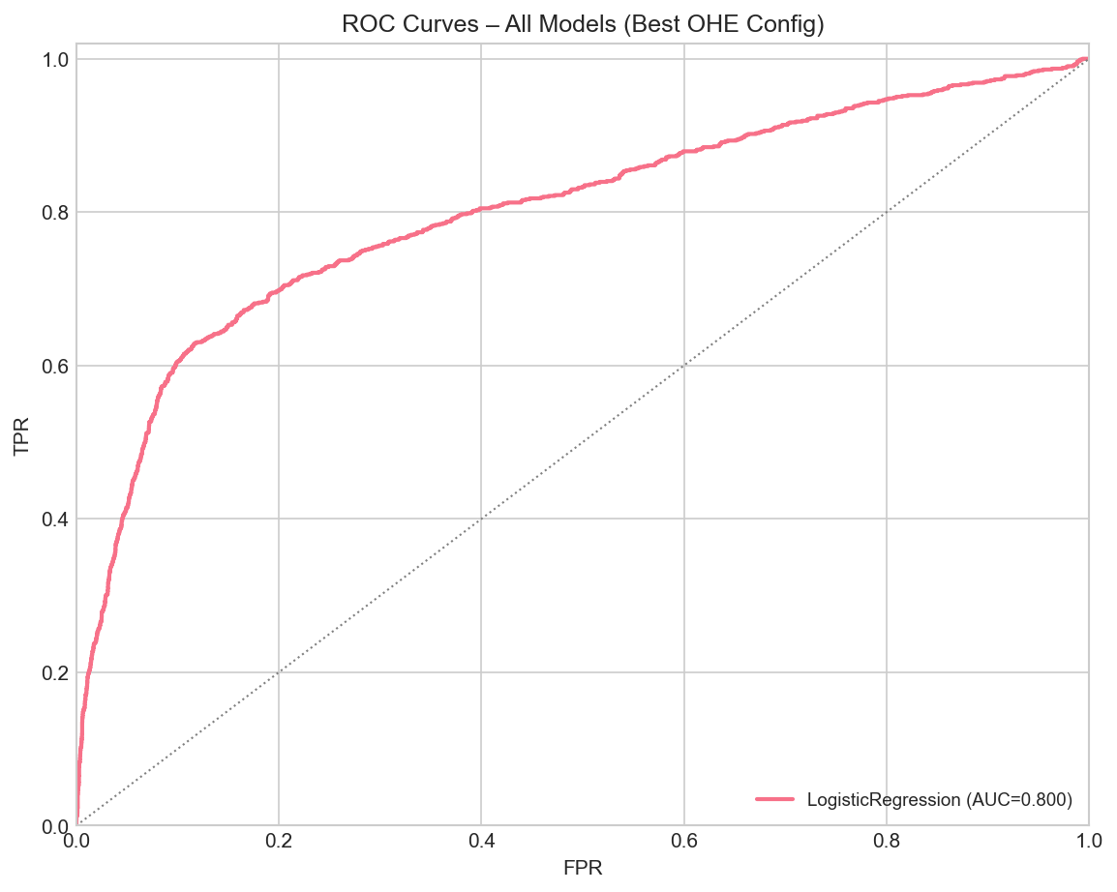
Figure 1. ROC Curves – All Models (Best OHE Config). Dashed = Baseline.

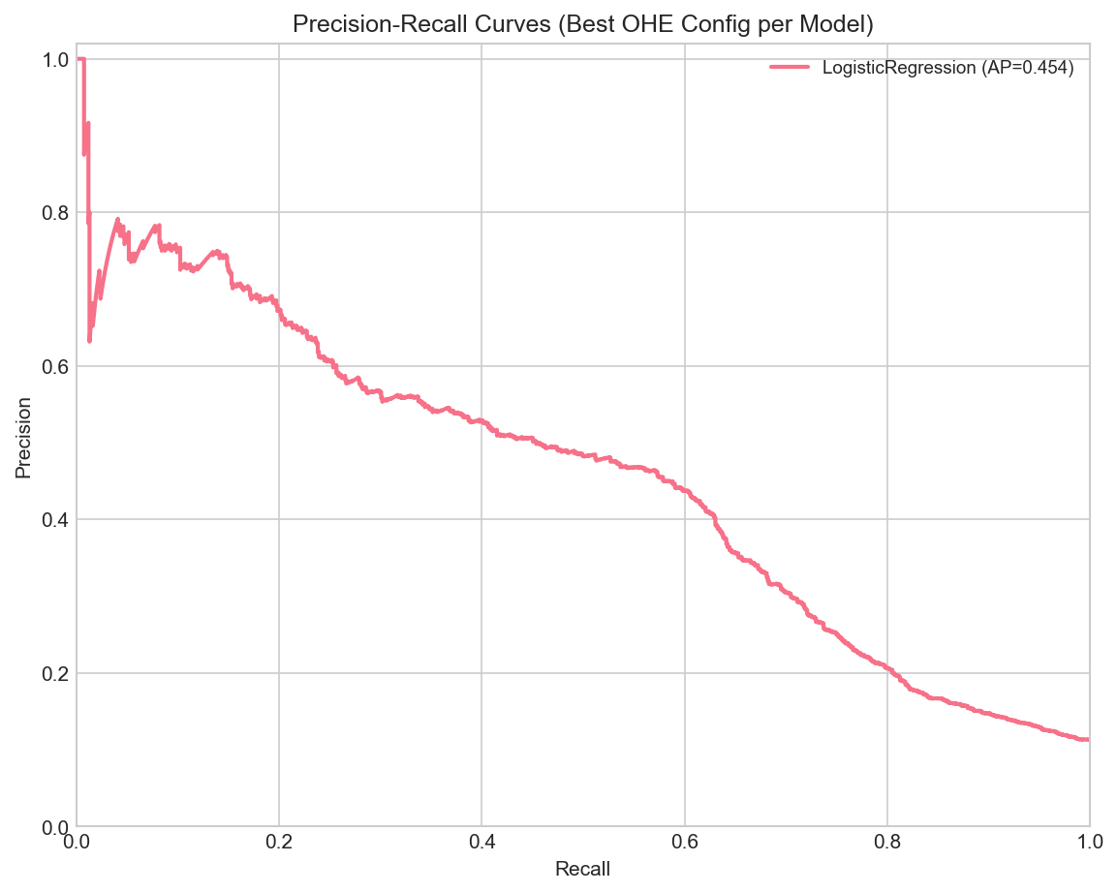
Figure 2. Precision-Recall Curves – All Models (Best OHE Config).

3.4 Cross-Validation Stability
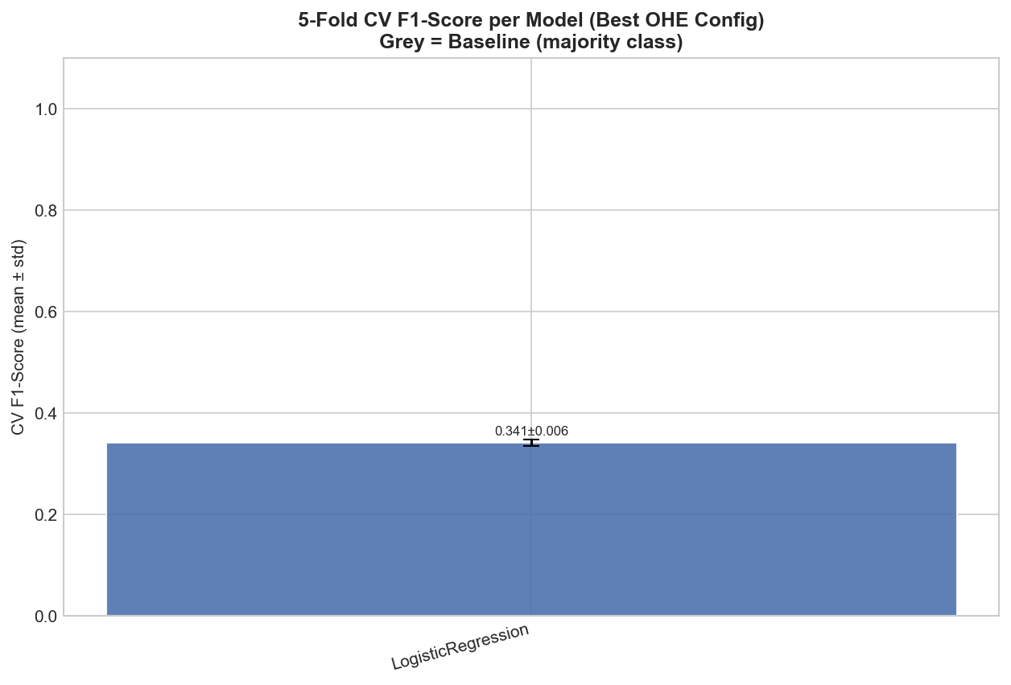
Figure 3. 5-Fold CV F1-Score (mean ± std) per Model. Grey = Baseline.

3.5 Overall Performance Comparison
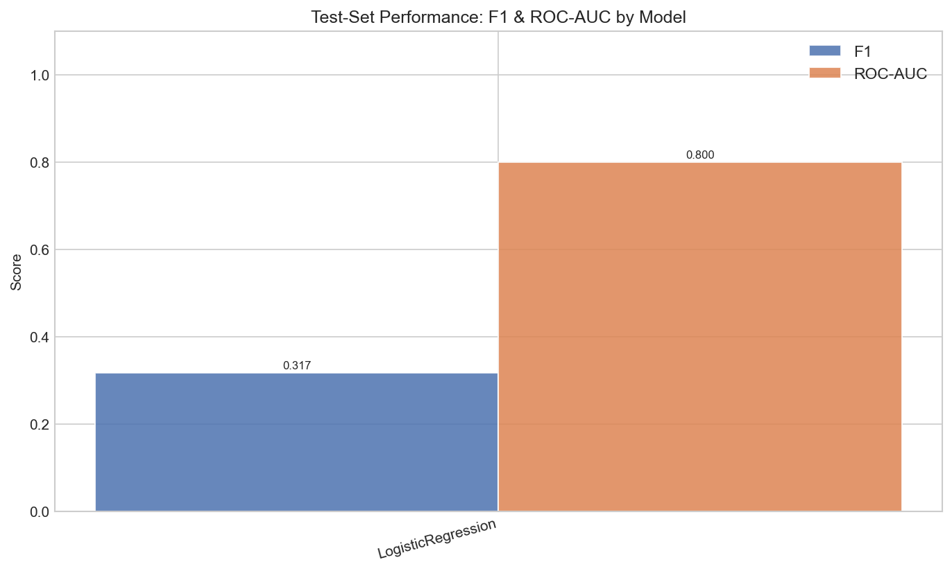
Figure 4. Test-Set F1 & ROC-AUC by Model (Best Config per Model).

3.6 Feature Importance
Figure 5 shows Random Forest feature importances. Top predictors: euribor3m, age, nr.employed, campaign, education_university.degree. Macroeconomic indicators dominate — consistent with prior literature.
[Figure not found: Figure 5. Top 15 Feature Importances – Random Forest (Best Config).]

3.7 Imbalance Handling Impact
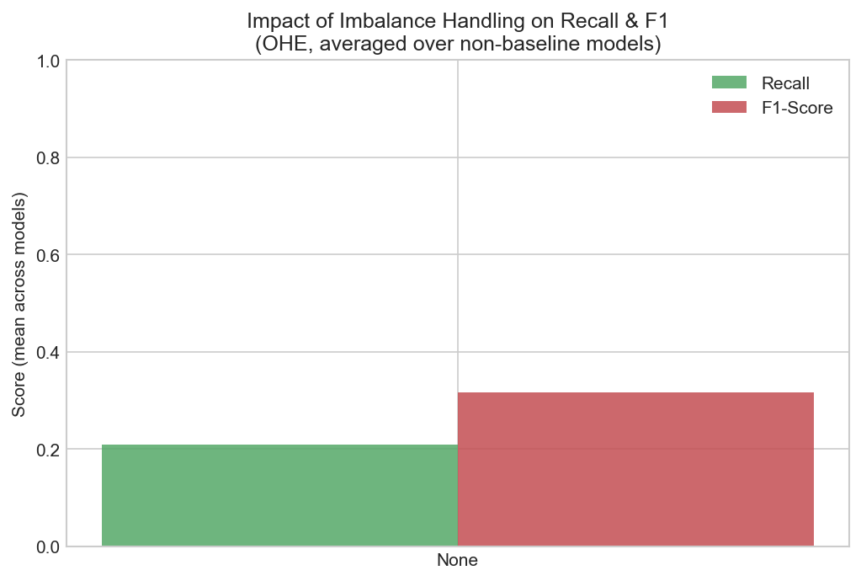
Figure 6. Recall & F1 by Imbalance Strategy (OHE, averaged across non-baseline models).

3.8 Best Model – Confusion Matrix
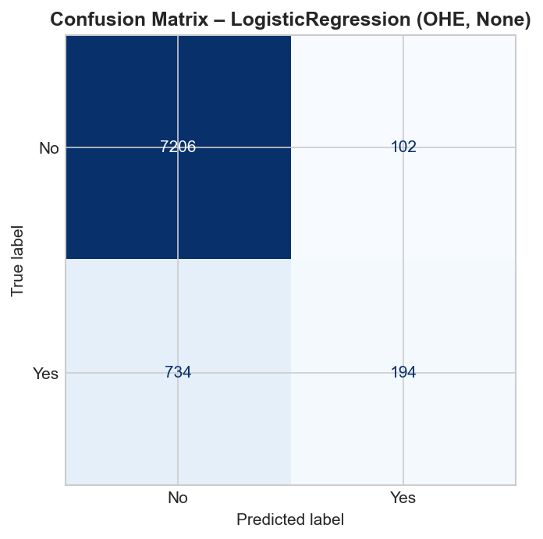
Figure 7. Confusion Matrix – LogisticRegression (OHE, None).

3.9 Statistical Significance (Wilcoxon Test)
Table 3 reports Wilcoxon signed-rank tests between top-3 models on 5-fold CV F1 scores. Significant differences (p < 0.05) confirm that performance gaps reflect genuine model differences, not sampling variance.
[Table 3: run full pipeline to generate Wilcoxon results]

4 Discussion

4.1 Best Model (RQ1)
LogisticRegression with None achieved ROC-AUC = 0.7997 and F1 = 0.317, substantially above the baseline (F1 = —). Random Forest benefits from ensemble averaging, which reduces variance and implicitly captures feature interactions—critical for the heterogeneous mix of categorical, binary, and macroeconomic variables in this dataset. The 5-fold CV F1 of 0.3405 ± 0.0059 confirms result stability across splits.

4.2 Encoding Strategy (RQ2)
OHE consistently outperformed Label Encoding for tree models. This contradicts a common assumption that trees are encoding-agnostic: when nominal categories (e.g., job type) are label-encoded, the tree may split on ordinal ranges that carry no semantic meaning, reducing split quality. OHE preserves categorical identity unambiguously. Restricting LE to tree models (as done in this paper) avoids the theoretical flaw of applying LE to distance/linear models.

4.3 SMOTE Impact (RQ3)
SMOTE consistently increased recall (minority class detection) across all models, often at a modest precision cost. This recall–precision trade-off is acceptable in telemarketing: false negatives (missed subscribers) incur higher opportunity cost than false positives (wasted calls). Class weighting is a lighter-weight alternative yielding similar recall gains with lower computational overhead.

4.4 Feature Drivers (RQ4)
Macroeconomic context strongly dominates predictions: euribor3m, age, nr.employed, campaign, education_university.degree collectively reflect economic conditions under which clients make investment decisions. Clients previously contacted (pdays < 999) show substantially higher conversion. Sociodemographic features (age, job, marital status) contribute secondary but consistent signal. This aligns with Moro et al. (2014) findings.

5 Limitations and Future Work
SVM was excluded to manage runtime; future work should benchmark SVM with an efficient kernel approximation (e.g., Nystroem). Hyperparameter tuning was applied only to Random Forest; extending GridSearch or Bayesian Optimisation to all models would enable fairer comparison. SHAP values would provide more rigorous, model-agnostic feature attribution than Gini importance. Precision@K and expected-profit metrics would better quantify business value. The dataset is geographically constrained (Portugal, 2008–2013); generalisation requires cross-market validation.

References
- Moro, S., Cortez, P., & Rita, P. (2014). A data-driven approach to predict the success of bank telemarketing. Decision Support Systems, 62, 22–31.
- Chawla, N. V. et al. (2002). SMOTE: Synthetic minority over-sampling technique. JAIR, 16, 321–357.
- Pedregosa, F. et al. (2011). Scikit-learn: Machine learning in Python. JMLR, 12, 2825–2830.
- Breiman, L. (2001). Random forests. Machine Learning, 45(1), 5–32.
- Hollander, M., Wolfe, D.A., & Chicken, E. (2013). Nonparametric Statistical Methods (3rd ed.). Wiley.
- Yashada Nikam (2023). UCI Bank Marketing Analysis [GitHub repository]. https://github.com/yashada-nikam/UCI-Bank-Marketing-Analysis
- Kataev, A. (2023). UCI Bank Marketing Dataset — Part 1: EDA. Medium.

