API Technical Specification

Overview
This API Technical Specification (“Tech Spec”) is the source of truth for the scope and design of your integration with athenahealth, and will be used for integration design as well as ongoing support. This Tech Spec should be continuously updated through your scoping, design, and build efforts. A finalized version of this Tech Spec will be reviewed by athenahealth during the Solution Validation process, and signed by you, prior to your integration being granted access to the applicable athenaOne Production environment(s).

Action
Please begin by filling out the information below to provide a draft scope of your integration. Include as much detail as possible and take into consideration the guidance provided below.
You will continue to update and refine this Tech Spec as the project advances, until a final version is approved by athenahealth and signed by you.

Before you begin, please keep the following in mind as you complete this Tech Spec:
- Please refer to the API Terms of Service.
- Please refer to the Developer Portal Documentation as you design your integration and document within this form to verify the functionality and usage of the API calls you plan to use, as well as common and recommended workflows.
  - You can test the API calls in our Sandbox.
- Please review our Application Security Best Practices for guidelines on how to build your application in a safe, secure, and compliant manner.
- Applications should be designed in an efficient manner to remain within the call limits outlined on the Developer Portal.
- You can register on the Developer Portal here.

Please note that API integrations are prohibited from performing the following:

- Large data pulls, e.g., querying appointments booked in a practice for a timeframe greater than 7 days, or attempting to retrieve a list of all patients in a practice. Please review our Server Load Mitigation document on the Developer Portal for more details.
- Data imports (or data conversion) from a legacy system.
- Single Sign-On (SSO) into athenaNet from your application.

General Information
athenahealth Client Name: Jack Ford MD PC
athenahealth Practice ID (i.e., “Context ID”): 13681
Primary API developer Name: Andrew Barilla
Primary API developer Contact Information: andy@janushc.com
Registered Developer Portal Email with Preview Access: andy@janushc.com
Registered Developer Portal Email with Production Access (if applicable): andy@janushc.com
Please list the vendor(s) involved in the development of this integration solution: Andrew Barilla

Application Security Questions
(Please answer the questions that are applicable to your integration)
Question | Answer
How/Where will you be storing your key and secret? Is it encrypted at rest? | Client ID/secret are stored server-side only, injected as environment variables into the Go API container; never exposed to the browser/SPA. Stored in managed secrets store (AWS Secrets Manager)
Who will have access to your application? (Patient, Provider, third-party vendor, etc.) | Physicians (providers) at the contracted practice. No patient access. No external third parties.
Does your application keep error logs for tracking and resolving technical issues? | Yes — the backend logs API errors and request failures for troubleshooting. PHI is excluded from logs.
Will your application update or add information directly into the patient's chart?  - Who will be making these changes?  - If patients are making updates, do providers review changes prior to updating the chart? | Yes — it writes physician-dictated encounter documentation (HPI, Assessment & Plan, Physical Exam) generated by an ambient scribe, after the provider reviews and approves it.  - The provider. Every write is physician-initiated and physician-reviewed; the app never writes to the chart autonomously.  - N/A — patients do not use the app. All chart writes originate from and are reviewed by the provider before submission.
How will you match users to the correct patient or provider? | Patients/providers/encounters are referenced by their athenahealth IDs returned from the API (patientid, providerid, departmentid, encounterid). The app does not maintain a separate patient identity; it operates on athenahealth-issued IDs scoped to the practice context.
How are you safeguarding PHI? (Encryption, etc.) | TLS in transit; OAuth2 bearer tokens for athenahealth calls; JWT-authenticated app sessions; PHI excluded from logs; least-privilege scopes; access restricted to authenticated practice providers.  The athenahealth chart is the system of record for all clinical documentation. Our database functions as transient working storage for the duration of a documentation session; we do not retain PHI for analytics, model training, or any secondary purpose.  Retention windows:  - Raw transcripts are purged 7 days after the generated note is written back to the EHR, or after session abandonment.  - AI-generated notes and associated edits/approvals are purged no later than 30 days after session completion.  - Usage and operational records are retained only in aggregate form with patient and encounter identifiers removed.  Purging is enforced automatically by a scheduled deletion process. Because the managed database retains a short history window to support point-in-time recovery, deleted records remain recoverable only until that window elapses; the recovery window is configured to 1 day(s), so the maximum effective retention for any PHI record is its stated purge window plus 1 day(s). Upon termination of our agreement, all PHI is purged from the production database and its recovery history.

Workflow Description
1. Provider logs into the Janus dashboard (JWT auth).
2. The app identifies the visit to document with the provider's appointment for a given patient using athenahealth appointment/encounter data.
3. During/after the visit, audio is transcribed and summarized by AI into structured note sections (HPI, Assessment & Plan, Physical Exam).
4. The provider reviews and edits the generated note in the Janus UI.
5. On finalize, the app writes the approved note sections back to the corresponding athenahealth encounter.
6. The provider completes the encounter in athenaOne as usual. Workflow ends when the note is written.

No SSO into athenaNet. No legacy-system data import. No bulk/large data pulls (see cadences below).

Workflow Graphic

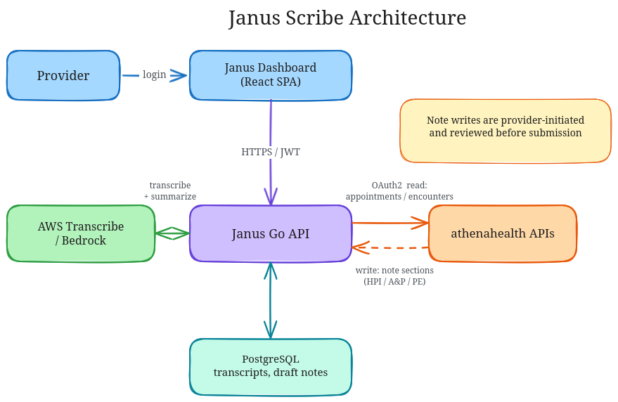
Use Cases
Please explain the solution you have designed by use case. We define a Use Case as an action or series of actions within either application that causes the exchange of information.
- Please list each of the specific API endpoints you are planning to utilize and the sequence you will call to retrieve the information. Include a note on how often you will be calling these endpoints (e.g., pull appointment schedule for the next day as a nightly job).
- Note that the table below is an example of how this section should be filled out. Feel free to add additional tables or rows.

Use Case #1: Identify the provider's encounters to document
Action | Cadence | API Endpoint
Get booked appointments for a department (narrow window, ≤ today/next day) | On dashboard load, per provider session | On dashboard load, per provider session | GET /v1/{practiceid}/appointments/booked?departmentid={id}&startdate={d}&enddate={d}
List encounters for the patient to resolve the encounter to write to | On demand per patient being documented | On demand per patient being documented | GET /v1/{practiceid}/chart/{patientid}/encounters?departmentid={id}
Resolve patient name/details | Per patient being documented | GET /v1/{practiceid}/patients/{patientid}

Use Case #2: Reference data (setup / low frequency)
Action | Cadence | API Endpoint
List practice departments | On setup + as needed | GET /v1/{practiceid}/departments
List providers | On setup + as needed | GET /v1/{practiceid}/providers

Use Case #3: Write ambient-scribe encounter documentation
Action | Cadence | API Endpoint
Write Assessment & Plan (simplest — PUT only) | On provider finalize | PUT /v1/{practiceid}/chart/encounter/{encounterid}/assessment
Read HPI section (preserve existing) | On provider finalize | GET /v1/{practiceid}/chart/encounter/{encounterid}/hpi
Write History of Present Illness | On provider finalize | PUT /v1/{practiceid}/chart/encounter/{encounterid}/hpi
Read Physical Exam section (preserve existing) | Immediately before each PE write | GET /v1/{practiceid}/chart/encounter/{encounterid}/physicalexam
Write Physical Exam | On provider finalize | PUT /v1/{practiceid}/chart/encounter/{encounterid}/physicalexam

The following Go-Live Authorization section should not be completed or executed until this Tech Spec has been completed and after your integration passes Solution Validation as performed by athenahealth. Your integration will not be granted production athenaOne access until this section is completed.

Go-Live Authorization
Reference is made to the athenahealth Services Agreement, athenahealth Master Services Agreement, or similar agreement entered into by and between athenahealth, Inc. (“Athena”) and the client set forth on the signature page below (“Client”, “you” or “your”) in connection with Client’s purchase of athenaOne services (the “Agreement”). In order to grant the integration described herein (the “Integration”) access to your athenaOne production environment, you must attest to the completeness and accuracy of this Technical Specification to represent the Integration and that you have satisfactorily tested the functionality of the Integration by execution of this Go Live Authorization Form. Client has obtained or will obtain all consents, licenses, and waivers and has fulfilled all legal obligations that are necessary to allow Athena enable the Integration in production athenaOne. If you have identified any third party as assisting in the development or implementation of the Integration or otherwise accessing or using your application, you authorize Athena to make its APIs available to such third party and acknowledge that such third party will have access to Client Data via the APIs. You are responsible for ensuring that such third party complies with the terms of the Agreement.
Upon receipt of this signed form, Athena requires a minimum of 2 business days to grant your Integration access to your athenaOne Production environment.
The terms of this Go Live Authorization Form are hereby incorporated into the Agreement and shall become effective upon Client’s signature below. By signing below, Client acknowledges that it is satisfied with the functionality of the Integration and Client authorizes Athena to enable such Integration to be deployed to athenaOne production.

By: _________________________________________
Print Name: Andrew Barilla
Position: CTO
Date: Jun 1, 2026

