Group 12
Basics of Parallel Computing
Assignment 1

Members
Andrews Boateng Okyere
Edward Asante

Question 2.2: Compute Speed-up and Parallel Effeciency for sizes(200,1000)

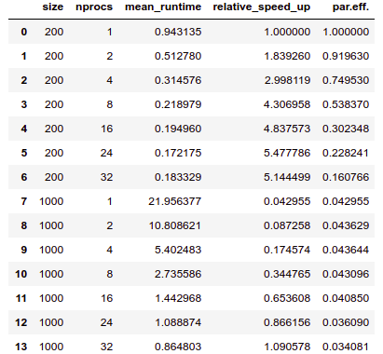

Table 2.2
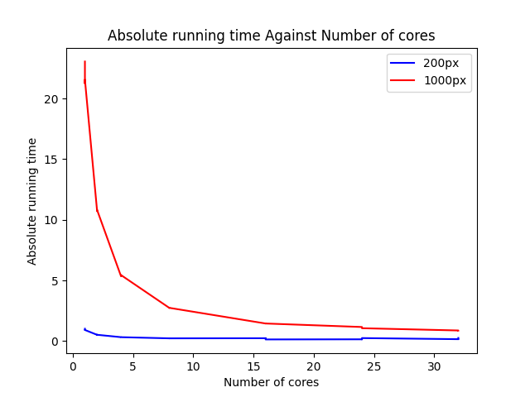
Fig 2.2.1
2.2.1
From figure 2.2.1, It can be seen that the absolute running time decreases as the number of cores increases. Also, the parallel code seems to only be effective when the number of cores is small.

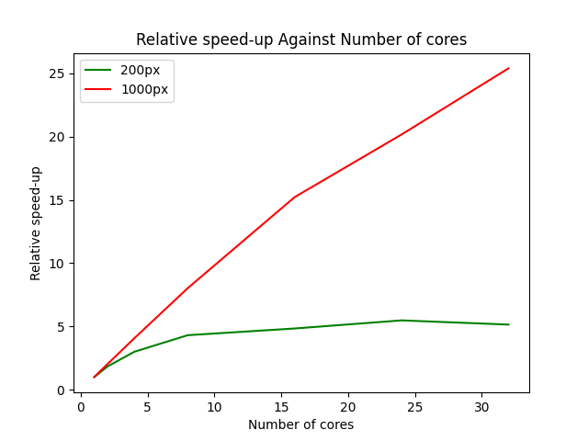
Fig 2.2.2
2.2.2
It can be observed from the graph that relative speed up generally increases as the number of cores increases. When the image size is smaller (200) the speed is lower compared to when the image size is bigger (1000).

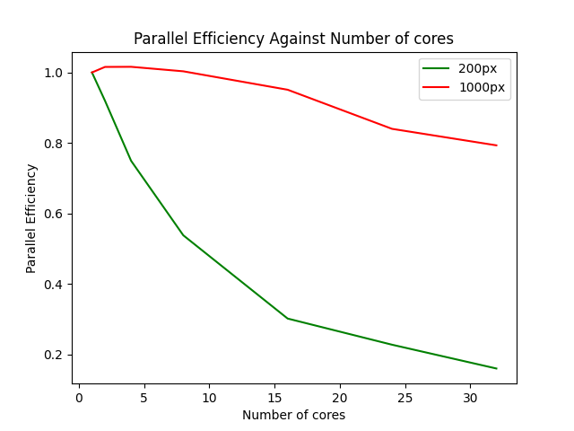
Fig 2.2.3
2.2.3
Due to the nature of the graph above, one can conclude that the parallel code used is not efficient. And that the efficiency decreases as the number of cores increases for both image sizes.
Which assert that large number of cores doesn’t necessary guarantee optimal work.

Question 2.3: Influence of Patch Size

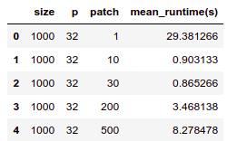

Table 2.3

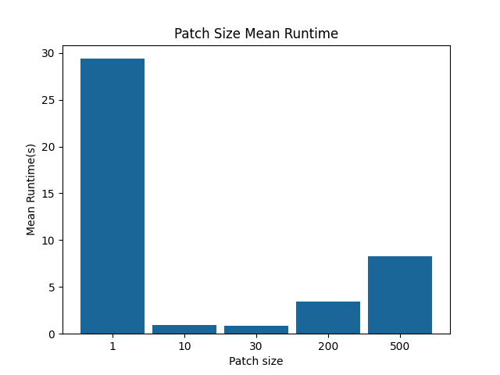
Fig 2.3
It is observed that when the patch size is 1 we obtained a highest Mean run time and least run time when the patch size is 30. The mean run time increases from patch size 10 to 500

Question 2.4: Finding the Best Patch Size

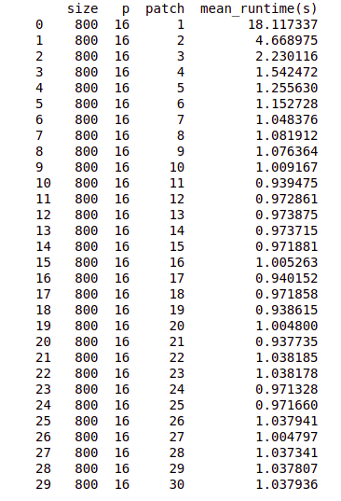

Table 2.4
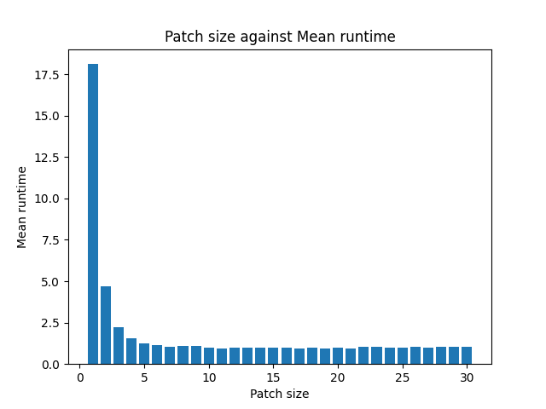
Fig 2.4
Observation:
Clearly, it can be observed that patch size is inversely proportional to the average runtime of the code. And that average mean time decreases as the number of patch increases.

